Guide to finding superseded planning scheme maps

Contents
Schedule 2 Maps 2
Strategic Framework Maps 2
Neighbourhood Plan Maps 2
Zoning & Overlay Maps 5
Suburbs by grid number 6
List of Overlay Maps 10
Other plan maps 11
Schedule 3 - Local Government Infrastructure Plan (LGIP) Maps 12
Plans for Trunk Infrastructure (PFTI) maps 12
Suburbs by grid number 13
List of PFTI Network Maps 22
List of other Local Government Infrastructure Plan (LGIP) Maps 23
Local government infrastructure plan maps 23

Schedule 2 Maps

Strategic Framework Maps
Map number | Map title
SFM-001 | Sub-regional context strategic framework map
SFM-002 | Brisbane Cityshape 2031 land use strategic framework map
SFM-003 | Brisbane selected transport corridors and growth nodes strategic framework map
SFM-004 | Brisbane greenspace system strategic framework map
SFM-005 | Brisbane transport strategic framework map

Neighbourhood Plan Maps

Category | Map number | Map Title
A | NPM-001.1 | Acacia Ridge—Archerfield neighbourhood plan map
 | NPM-001.2 | Albion neighbourhood plan map
 | NPM-001.3 | Algester—Parkinson—Stretton neighbourhood plan map
 | NPM-001.4 | Ashgrove—Grange district neighbourhood plan map
 | NPM-001.5 | Aspley district neighbourhood plan map
 | NPM-001.6 | Australia TradeCoast neighbourhood plan map
B | NPM-002.1 | Banyo—Nudgee neighbourhood plan map
 | NPM-002.2 | Bowen Hills neighbourhood plan map
 | NPM-002.3 | Bracken Ridge and district neighbourhood plan map
 | NPM-002.4 | Bulimba district neighbourhood plan map
C | NPM-003.1 | Calamvale district neighbourhood plan map
 | NPM-003.2 | Capalaba West neighbourhood plan map
 | NPM-003.3 | Carina—Carindale neighbourhood plan map
 | NPM-003.4 | Carindale centre neighbourhood plan map
 | NPM-003.5 | Centenary suburbs neighbourhood plan map
 | NPM-003.6 | Chermside centre neighbourhood plan map
 | NPM-003.7 | City Centre neighbourhood plan map
 | NPM-003.8 | Clayfield—Wooloowin district neighbourhood plan map
 | NPM-003.9 | City west neighbourhood plan
D | NPM-004.1 | Darra—Oxley district neighbourhood plan map
 | NPM-004.2 | Doolandella neighbourhood plan map
E | NPM-005.1 | East Brisbane—Coorparoo district neighbourhood plan map
 | NPM-005.2 | Eastern corridor neighbourhood plan map
 | NPM-005.3 | Enoggera district neighbourhood plan map
 | NPM-005.4 | Everton Park neighbourhood plan map
F | NPM-006.1 | Ferny Grove—Upper Kedron neighbourhood plan map
 | NPM-006.2 | Fig Tree Pocket neighbourhood plan map
 | NPM-006.3 | Forest Lake neighbourhood plan map
 | NPM-006.4 | Fortitude Valley neighbourhood plan map
G | Intentionally left blank
H | NPM-008.1 | Holland Park—Tarragindi district neighbourhood plan map
 | NPM-008.2 | Hemmant—Lytton neighbourhood plan map
I | NPM-009.1 | Indooroopilly centre neighbourhood plan map
 | NPM-009.2 | Ithaca district neighbourhood plan map
J | Intentionally left blank
K | NPM-011.1 | Kangaroo Point peninsula neighbourhood plan map
 | NPM-011.2 | Kangaroo Point south neighbourhood plan map
 | NPM-011.3 | Kelvin Grove urban village neighbourhood plan map
 | NPM-011.4 | Kuraby neighbourhood plan map
L | NPM-012.1 | Lake Manchester neighbourhood plan map
 | NPM-012.2 | Latrobe and Given Terraces neighbourhood plan map
 | NPM-012.3 | Lower Oxley Creek south neighbourhood plan map
 | NPM-012.4 | Lutwyche Road corridor neighbourhood plan map
 | NPM-012.5 | Lower Oxley Creek north neighbourhood plan map
M | NPM-013.1 | McDowall—Bridgeman Downs neighbourhood plan map
 | NPM-013.2 | Milton neighbourhood plan map
 | NPM-013.3 | Milton Station neighbourhood plan map
 | NPM-013.4 | Mitchelton centre neighbourhood plan map
 | NPM-013.5 | Mitchelton neighbourhood plan map
 | NPM-013.6 | Moggill—Bellbowrie neighbourhood plan map
 | NPM-013.7 | Moorooka—Stephens district neighbourhood plan map
 | NPM-013.8 | Moreton Island settlements neighbourhood plan map
 | NPM-013.9 | Mt Coot–tha neighbourhood plan map
 | NPM-013.10 | Mt Gravatt corridor neighbourhood plan map
N | NPM-014.1 | New Farm and Teneriffe Hill neighbourhood plan map
 | NPM-014.2 | Newstead and Teneriffe waterfront neighbourhood plan map
 | NPM-014.3 | Nudgee Beach neighbourhood plan map
 | NPM-014.4 | Nundah district neighbourhood plan map
O | Intentionally left blank
P | NPM-016.1 | Petrie Terrace and Spring Hill neighbourhood plan map (superseded by City West and Spring Hill neighbourhood plan maps)
 | NPM-016.2 | Pinkenba—Eagle Farm neighbourhood plan map
Q | Intentionally left blank
R | NPM-018.1 | Racecourse precinct neighbourhood plan map
 | NPM-018.2 | Richlands—Wacol corridor neighbourhood plan map
 | NPM-018.3 | River gateway neighbourhood plan map
 | NPM-018.4 | Rochedale urban community neighbourhood plan map
S | NPM-019.1 | Sandgate district neighbourhood plan map
 | NPM-019.2 | Sandgate Road neighbourhood plan map
 | NPM-019.3 | Sherwood—Graceville district neighbourhood plan map
 | NPM-019.4 | South Brisbane riverside neighbourhood plan map
 | NPM-019.5 | Spring Hill neighbourhood plan map (16 Feb 2018)
T | NPM-020.1 | Taringa neighbourhood plan map
 | NPM-020.2 | Toombul—Nundah neighbourhood plan map
 | NPM-020.3 | Toowong—Auchenflower neighbourhood plan map
 | NPM-020.4 | Toowong—Indooroopilly district neighbourhood plan map
U | Intentionally left blank
V | Intentionally left blank
W | NPM-023.1 | Wakerley neighbourhood plan map
 | NPM-023.2 | West End—Woolloongabba district neighbourhood plan map
 | NPM-023.3 | Western gateway neighbourhood plan map
 | NPM-023.4 | Willawong neighbourhood plan map
 | NPM-023.5 | Woolloongabba centre neighbourhood plan map
 | NPM-023.6 | Wynnum—Manly neighbourhood plan map
 | NPM-023.7 | Wynnum West neighbourhood plan map
X | Intentionally left blank
Y | NPM-025.1 | Yeerongpilly Transit Oriented Development neighbourhood plan map
Z | Intentionally left blank

Zoning & Overlay Maps
Zoning and overlay maps are on a 55 map tile grid, as shown on the map below. A list of suburbs (or part suburbs) in each map tile is tabled below the map. A list of the overlay map numbers and names can be found here.
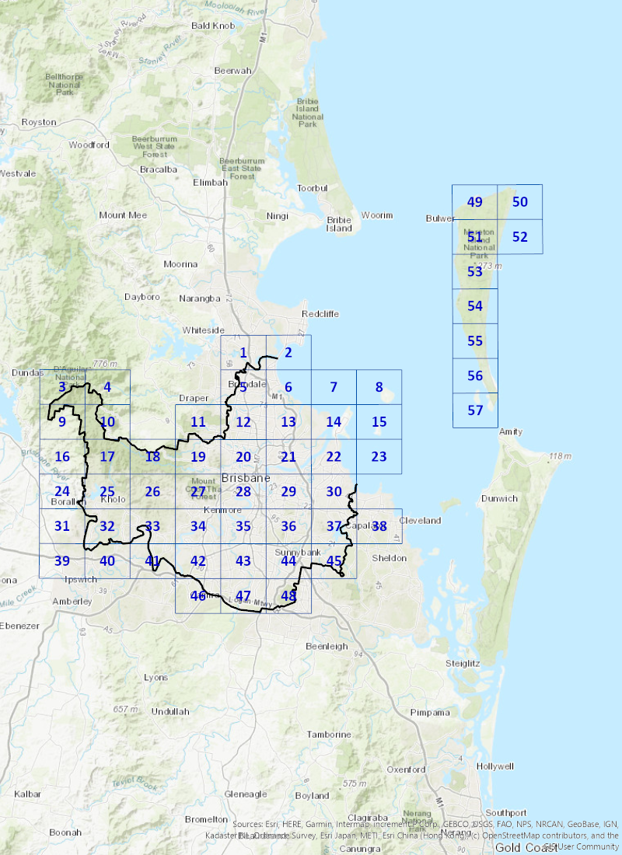

Suburbs by grid number
SUBURBS BY GRID NUMBER
Grid number | Suburb (or parts of)
1 | Bald Hills, Brighton
2 | Bald Hills, Brighton
3 | England Creek
4 | Banks Creek, England Creek
5 | Bald Hills, Bracken Ridge, Bridgeman Downs, Brighton, Carseldine, Deagon, Fitzgibbon, Sandgate, Shorncliffe, Taigum
6 | Boondall, Bracken Ridge, Brighton, Brisbane Airport, Deagon, Nudgee Beach, Sandgate, Shorncliffe, Taigum
7 | Port of Brisbane
8 | Mud Island
9 | Banks Creek, England Creek
10 | Banks Creek, England Creek, Enoggera Reservoir, Lake Manchester
11 | Ferny Grove, Keperra, Mitchelton
12 | Aspley, Bridgemen Downs, Carseldine, Chermside, Chermside West, Everton park, Fitzgibbon, Geebung, Kedron, McDowall, Mitchelton, Stafford, Stafford Heights, Taigum, Wavell Heights, Zillmere
13 | Banyo, Boondall, Brisbane Airport, Geebung, Northgate, Nudgee, Nudgee Beach, Nundah, Taigum, Virginia, Wavell Heights, Zillmere
15 | Saint Helena Island
14 | Brisbane Airport, Pinkenba, Port of Brisbane
16 | Banks Creek, Lake Manchester
17 | Banks Creek, Enoggera Reservoir, Lake Manchester
18 | Enoggera Reservoir, Lake Manchester, Upper Brookfield
19 | Ashgrove, Bardon, Enoggera, Enoggera Reservoir, Ferny Grove, Keperra, Mitchelton, The Gap, Upper Kedron
20 | Albion, Alderley, Ascot, Ashgrove, Bardon, Bowen Hill, Clayfield, Enoggera, Everton Park, Fortitude Valley, Gaythorne, Gordon Park, Grange, Herston, Kedron, Kelvin Grove, Lutwyche, Mitchelton, Newmarket, Newstead, Paddington, Red Hill, Spring Hill, Stafford, Stafford Heights, Teneriffe, Wavell Heights, Wilston, Windsor, Wooloowin
21 | Albion, Ascot, Balmoral, Brisbane Airport, Bulimba, Clayfield, Eagle Farm, Hamilton, Hemmant, Hendra, Morningside, Murarrie, Newstead, Nundah, Pinkenba, Teneriffe, Wavell Heights, Wooloowin
22 | Brisbane Airport, Hemmant, Lytton, Manly, Manly West, Murarrie, Pinkenba, Port of Brisbane, Wynnum, Wynnum West
23 | Green Island
24 | Kholo, Lake Manchester
25 | Kholo, Lake Manchester, Upper Brookfield
26 | Brookfield, Enoggera Reservoir, Kholo, Lake Manchester, Pullenvale, Upper Brookfield
27 | Ashgrove, Bardon, Brookfield, Chapel Hill, Chelmer, Enoggera Reservoir, Indooroopilly, Kenmore, Kenmore Hills, Mount Coot-tha, Pullenvale, Taringa, The Gap, Toowong
28 | Annerley, Ashgrove, Auchenflower, Bardon, Brisbane City, Chelmer, Dutton Park, East Brisbane, Fairfield, Fortitude Valley, Greenslopes, Herston, Highgate Hill, Indooroopilly, Kangaroo Point, Kelvin Grove, Milton, Mount Coot-tha, New Farm, Newstead, Paddington, Petrie Terrace, Red Hill, South Brisbane, Spring Hill, St Lucia, Taringa, Teneriffe, Toowong, West End, Woolloongabba, Yeronga
29 | Balmoral, Belmont, Bulimba, Camp Hill, Cannon Hill, Carina, Carina Heights, Carindale, Coorparoo, East Brisbane, Greenslopes, Hawthorne, Hemmant, Morningside, Murarrie, New Farm, Norman Park, Seven Hills, Teneriffe, Tingalpa, Woolloongabba
30 | Belmont, Carindale, Chandler, Gumdale, Hemmant, Lota, Manly, Manly West, Murarrie, Ransome, Tingalpa, Wakerley, Wynnum, Wynnum West
31 | Kholo
32 | Chuwar, Karana Downs, Kholo, Mount Crosby
33 | Anstead, Bellbowrie, Karana Downs, Kholo, Mount Crosby, Pinjarra Hills, Pullenvale
34 | Bellbowrie, Brookfield, Chapel Hill, Chelmer, Corinda, Darra, Fig Tree Pocket, Graceville, Indooroopilly, Jamboree Heights, Jindalee, Kenmore, Kenmore Hills, Middle Park, Mount Ommaney, Oxley, Pinjarra Hills, Pullenvale, Riverhills, Seventeen Mile Rock, Sherwood, Sinnamon Park, Westlake
35 | Annerley, Archerfield, Chelmer, Coopers Plains, Corinda, Fairfield, Fig Tree Pocket, Graceville, Greenslopes, Indooroopilly, Moorooka, Nathan, Oxley, Rocklea, Salisbury, Sherwood, St Lucia, Tarragindi, Tennyson, Yeerongpilly, Yeronga
36 | Belmont, Camp Hill, Carina Heights, Carindale, Coorparoo, Greenslopes, Holland Park, Holland Park West, MacGregor, Mackenzie, Mansfield, Mount Gravatt, Mount Gravatt East, Nathan, Rochedale, Salisbury, Tarragindi, Upper Mount Gravatt, Wishart
37 | Belmont, Burbank, Carindale, Chandler, Gumdale, Mackenzie, Rochdale
38 | Chandler
39 | Kholo
40 | Chuwar, Kholo
41 | Anstead, Bellbowrie, Moggill, Riverhills, Wacol
42 | Bellbowrie, Darra, Ellen Grove, Forest Lake, Inala, Jamboree Heights, Middle Park, Moggill, Oxley, Richlands, Riverhills, Seventeen Mile Rock, Sinnamon Park, Sumner, Wacol
43 | Acacia Ridge, Algester, Archerfield, Calamvale, Coopers Plains, Doolandella, Durack, Forest Lake, Inala, Oxley, Pallara, Rocklea, Salisbury, Sunnybank, Sunnybank Hills, Willawong
44 | Calamvale, Coopers Plains, Eight Mile Plains, Kuraby, MacGregor, Nathan, Robertson, Rochdale, Runcorn, Salisbury, Sunnybank, Sunnybank Hills, Upper Mount Gravatt, Wishart
45 | Burbank, Rochedale
46 | Ellen Grove, Forest Lake
47 | Algester, Calamvale, Doolandella, Drewvale, Forest Lake, Heathwood, Larapinta, Pallara, Parkinson, Willawong
48 | Calamvale, Drewvale, Karawatha, Kuraby, Runcorn, Stretton, Sunnybank Hills
49 | Bulwer, Moreton Island
50 | Moreton Island
51 | Bulwer, Cowan Cowan, Moreton Island
52 | Moreton Island
53 | Cowan Cowan, Moreton Island
54 | Moreton Island
55 | Moreton Island
56 | Moreton Island
57 | Kooringal, Moreton Island

List of Overlay Maps

Category | Map number | Map Title
A | OM-001.1 | Active frontages in residential zones overlay map
 | OM-001.2 | Airport environs overlay map—Obstacle Limitation Surfaces
 | OM-001.3 | Airport environs overlay map—Procedures for Air Navigation Surfaces – Aircraft Operational Surfaces
 | OM-001.4 | Airport environs overlay map—Bird and bat strike zone and Public safety
 | OM-001.5 | Airport environs overlay map—Light intensity
 | OM-001.6 | Airport environs overlay map—Aviation facilities
 | OM-001.7 | Airport environs overlay map—Australian Noise Exposure Forecast Contour
 | OM-001.8 | Airport environs overlay map— Height restriction zone
B | OM-002.1 | Bicycle network overlay map
 | OM-002.2 | Biodiversity areas overlay map
 | OM-002.3 | Bushfire overlay map
C | OM-003.1 | Coastal hazard overlay map
 | OM-003.2 | Commercial character building overlay map
 | OM-003.3 | Critical infrastructure and movement network overlay map
 | OM-003.4 | Community purposes network overlay map
D | OM-004.1 | Dwelling house character overlay map
E | OM-005.1 | Extractive resources overlay map
F | OM-006.1 | Flood overlay map—Brisbane River
 | OM-006.2 | Flood overlay map—Creek/waterway
 | OM-006.3 | Flood overlay map—Overland flow
G | Intentionally left blank
H | OM-008.1 | Heritage overlay map
I | OM-009.1 | Industrial amenity overlay map
J | Intentionally left blank
K | Intentionally left blank
L | OM-012.1 | Landslide overlay map
M | Intentionally left blank
N | Intentionally left blank
O | Intentionally left blank
P | OM-016.1 | Potential and actual acid sulfate soils overlay map
 | OM-016.2 | Pre-1911 building overlay map
Q | Intentionally left blank
R | OM-018.1 | Regional infrastructure corridors and substations overlay map
 | OM-018.2 | Road hierarchy overlay map
S | OM-019.1 | Significant landscape tree overlay map
 | OM-019.2 | Streetscape hierarchy overlay map
T | OM-020.1 | Traditional building character overlay map
 | OM-020.2 | Transport air quality corridor overlay map
 | OM-020.3 | Transport noise corridor overlay map – Noise corridor – Brisbane: Queensland Development Code MP4.4
 | OM-020.4 | Transport noise corridor overlay map - Designated State Noise corridor - State-controlled road
 | OM-020.5 | Transport noise corridor overlay map - Designated State Noise corridor - rail network
U | Intentionally left blank
V | Intentionally left blank
W | OM-023.1 | Water resource catchments overlay map
 | OM-023.2 | Waterway corridors overlay map
 | OM-023.3 | Wetlands overlay map
X | Intentionally left blank
Y | Intentionally left blank
Z | Intentionally left blank

Other plan maps
Map number | Map title
OPM-012.1 | Long term infrastructure plans Other plan map Stormwater Network

Schedule 3 - Local Government Infrastructure Plan (LGIP) Maps

Plans for Trunk Infrastructure (PFTI) maps
LGIP Plans for Trunk Infrastructure (PFTI) maps work have their own Network map tile grid, as shown on the map below. A list of each suburb (or part suburb) that is in each tile is table below the map.
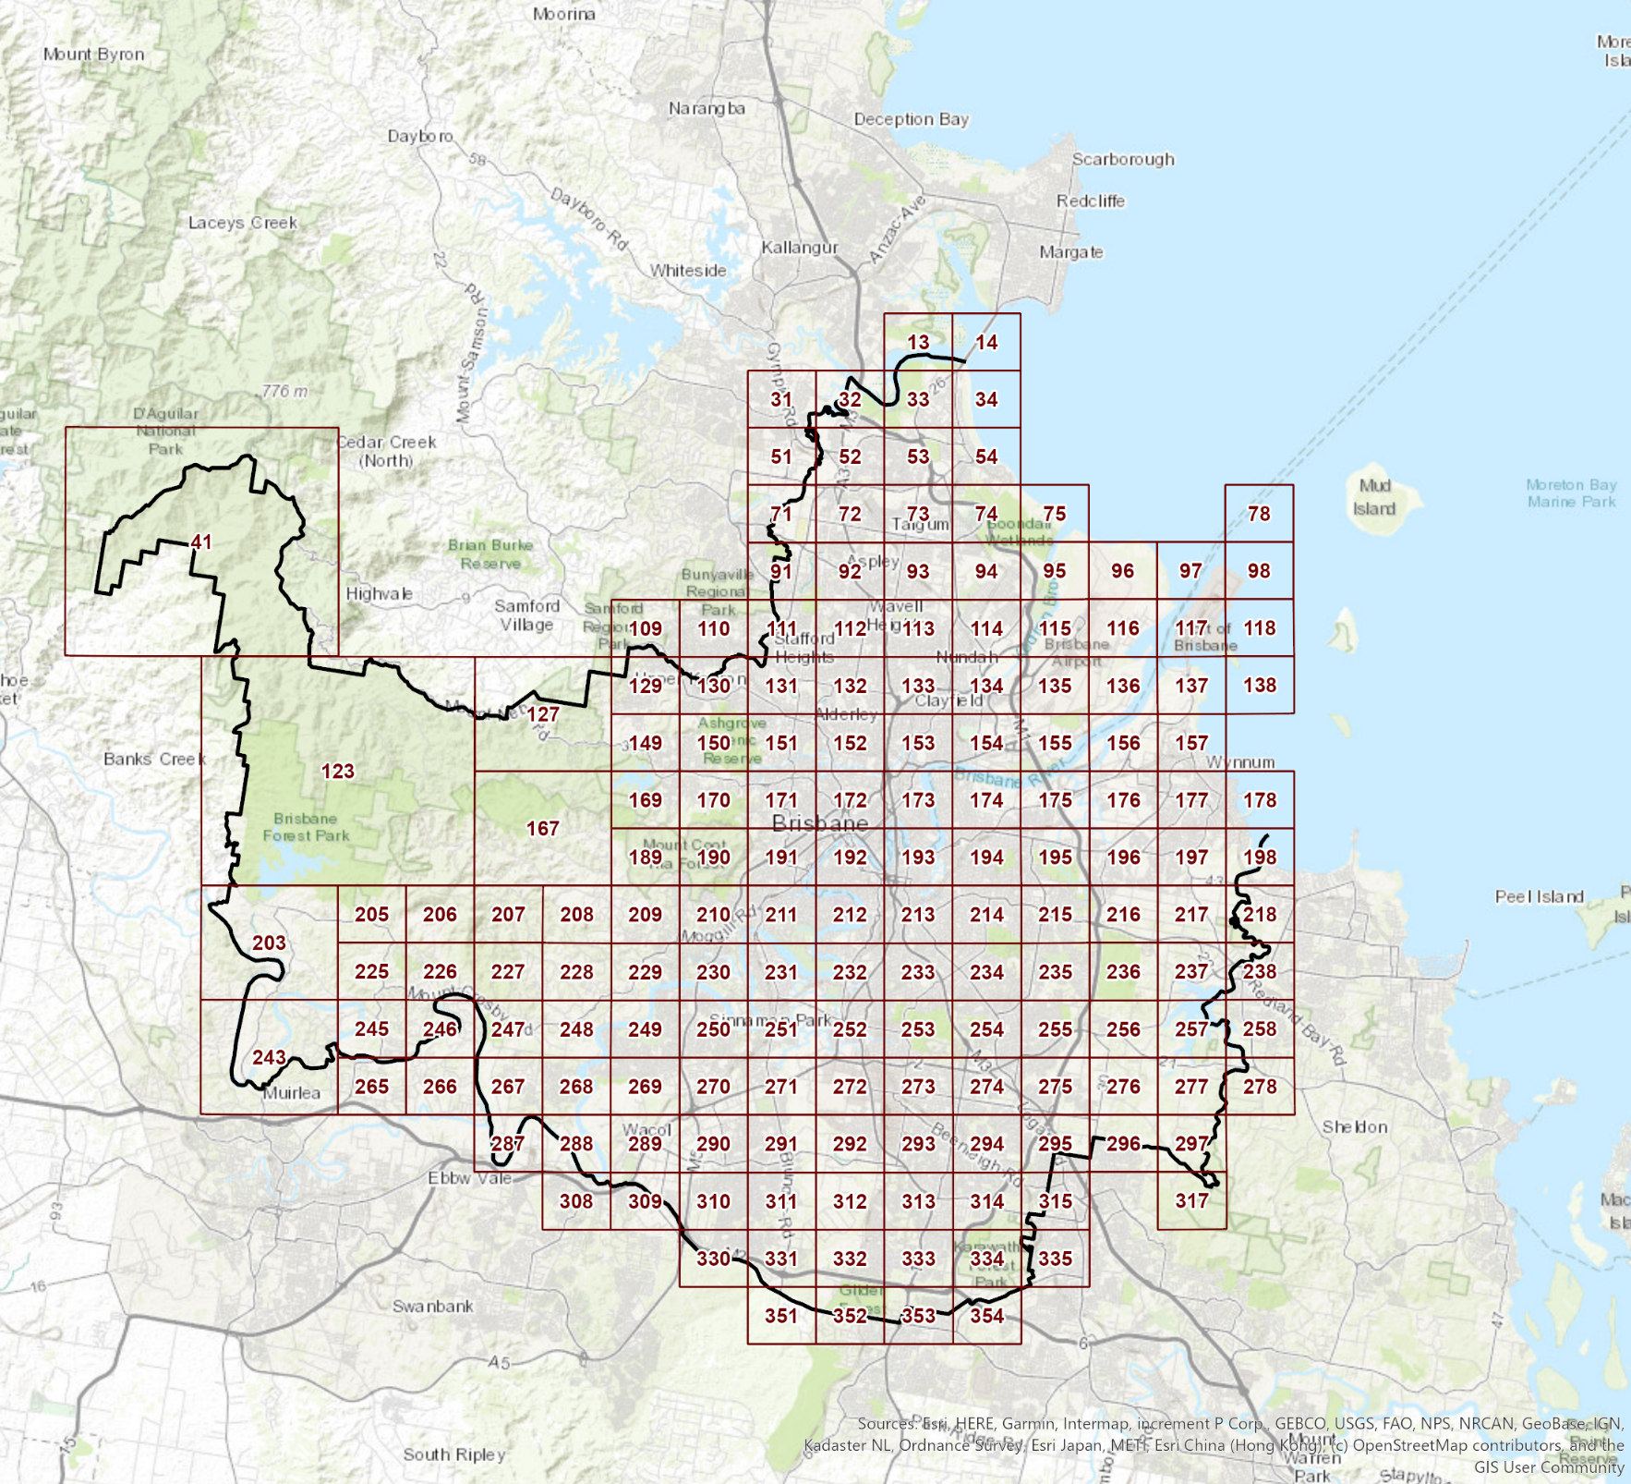

Suburbs by grid number
Grid number | Suburb (or part of)
13 | Bald Hills, Brighton
14 | Brighton
31 | Bald Hills
32 | Bald Hills
33 | Bald Hills, Bracken Ridge, Brighton
34 | Brighton, Sandgate
41 | Banks Creek, England Creek, Lake Manchester
51 | Bald Hills, Bridgeman Downs
52 | Bald Hills, Bracken Ridge, Fitzgibbon
53 | Bald Hills, Bracken Ridge, Brighton, Deagon, Sandgate
54 | Boondall, Brighton, Deagon, Nudgee Beach, Sandgate, Shorncliffe
71 | Bald Hills, Bridgeman Downs
72 | Aspley, Bald Hills, Bracken Ridge, , Bridgeman Downs, Carseldine, Fitzgibbon
73 | Boondall, Bracken Ridge, Carseldine, Deagon, Fitzgibbon, Taigum, Zillmere
74 | Boondall, Deagon, Nudgee Beach, Shorncliffe
75 | Boondall, Eagle Farm, Nudgee Beach
78 | Port of Brisbane
91 | Bridgeman Downs, Mcdowall
92 | Aspley, Bridgeman Downs, Carseldine, Chermside, Chermside West, Mcdowall, Zillmere
93 | Aspley, Boondall, Carseldine, Chermside, Fitzgibbon, Geebung, Virginia, Zillmere
94 | Banyo, Boondall, Nudgee, Nudgee Beach, Virginia
95 | Banyo, Eagle Farm, Nudgee, Nudgee Beach
96 | Eagle Far, Pinkenba
97 | Pinkenba, Port of Brisbane
98 | Port of Brisbane
109 | Ferny Grove
110 | Keppera, Mitchelton
111 | Everton Park, McDowall, Stafford Heights
112 | Aspley, Chermside, Chermside West, Kedron, Mcdowall, Stafford Heights
113 | Aspley, Chermside, Geebung, Kedron, Northgate, Nundah, Virginia, Wavell Heights
114 | Banyo, Eagle Farm, Geebung, Northgate, Nudgee, Nundah, Virginia
115 | Banyo, Eagle Farm, Nudgee, Nudgee Beach
116 | Eagle Farm, Pinkenba
117 | Pinkenba, Port of Brisbane
118 | Port of Brisbane
123 | Banks Creek, Enoggera Reservoir, Kholo, Lake Manchester, Upper Brookfield
127 | Enoggera Reservoir, Upper Kedron
129 | Ferny Grove, Keperra, Upper Kedron
130 | Ferny Grove, Keperra, Mitchelton, Upper Kedron
131 | Alderley, Enoggera, Everton Park, Gaythorne, Mitchelton, Stafford, Stafford Heights
132 | Alderley, Enoggera, Gordon Park, Grange, Kedron, Stafford, Stafford Heights
133 | Clayfield, Gordon Park, , Hendra, Kedron, Lutwyche, Nundah, Wavell Heights, Wooloowin
134 | Clayfield, Eagle Farm, Hendra, Northgate, Nundah
135 | Eagle Farm, Pinkenba
136 | Eagle Farm, Lytton, Pinkenba, Port of Brisbane
137 | Lytton, Pinkenba, Port Of Brisbane, Wynnum
138 | Port of Brisbane
149 | Enoggera Reservoir, Keperra, The Gap, Upper Kedron
150 | Ashgrove, Enoggera, Keperra, Mitchelton, The Gap
151 | Alderley, Ashgrove, Enoggera, Gaythorne, Mitchelton
152 | Alderley, Ashgrove, Gordon Park, Grange, Herston, Kelvin Grove, Lutwyche, Newmarket, Wilston, Windsor
153 | Albion, Ascot, Bowen Hills, Bulimba, Clayfield, Gordon Park, Hamilton, Hendra, Lutwyche, Newstead, Windsor, Wooloowin
154 | Ascot, Bulimba, Clayfield, Eagle Farm, Hamilton, Hendra
155 | Eagle Farm, Hemmant, Murarrie, Pinkenba
156 | Hemmant, Lytton, Murarrie, Pinkenba, Wynnum West
157 | Lytton, Port of Brisbane, Wynnum, Wynnum West
167 | Brookfield, Enoggera Reservoir, Upper Brookfield
169 | Brookfield, Enoggera Reservoir, Mount Coot-Tha, The Gap
170 | Ashgrove, Bardon, Mount Coot-Tha, The Gap,
171 | Ashgrove, Bardon, Paddington, Red Hill, Toowong
172 | Ashgrove, Bowen Hills, Brisbane City, Fortitude Valley, Herston, Kelvin Grove, Milton, Newmarket, Paddington, Petrie Terrace, Red Hill, Spring Hill, Windsor
173 | Bowen Hills, Brisbane City, Bulimba, Fortitude Valley, Hawthorne, Kangaroo Point, New Farm, Newstead, Spring Hill, Teneriffe, Windsor
174 | Balmoral, Bulimba, Cannon Hill, Eagle Farm, Hamilton, Hawthorne, Morningside, Murarrie
175 | Cannon Hill, Eagle Farm, Hemmant, Murarrie, Tingalpa
176 | Hemmant, Murarrie, Tingalpa, Wynnum West
177 | Lota, Manly, Manly West, Wynnum, Wynnum West
178 | Lota, Manly, Manly West, Wynnum
189 | Brookfield, Chapel Hill, Kenmore Hills, Mount Coot-Tha, The Gap
190 | Bardon, Chapel Hill, Mount Coot-Tha, Taringa
191 | Auchenflower, Bardon, Milton, Mount Coot-Tha, Paddington, Taringa, Toowong, West End
192 | Auchenflower, Brisbane City, Highgate Hill, Kangaroo Point, Milton, Paddington, Petrie Terrace, South Brisbane, Spring Hill, West End, Woolloongabba
193 | Brisbane City, Coorparoo, East Brisbane, Hawthorne, Kangaroo Point, New Farm, Norman Park, South Brisbane, Woolloongabba
194 | Camp Hill, Cannon Hill, Carina, Coorparoo, Hawthorne, Morningside, Norman Park, Seven Hills
195 | Belmont, Cannon Hill, Carina, Carindale, Murarrie, Tingalpa
196 | Belmont, Carindale, Gumdale, Manly West, Murarrie, Tingalpa, Wakerley, Wynnum West
197 | Lota, Manly West, Ransome, Tingalpa, Wakerley, Wynnum West
198 | Ransome, Lota
203 | Chuwar, Kholo, Lake Manchester, Mount Crosby
205 | Kholo, Lake Manchester, Mount Crosby
206 | Anstead, Kholo, Mount Crosby, Pullenvale, Upper Brookfield
207 | Anstead, Pullenvale, Upper Brookfield
208 | Brookfield, Pullenvale, Upper Brookfield
209 | Brookfield, Chapel Hill, Kenmore, Kenmore Hills
210 | Chapel Hill, Chelmer, Indooroopilly, Kenmore, Kenmore Hills, Mount Coot-Tha, Taringa
211 | Chelmer, Indooroopilly, St Lucia, Taringa, Toowong, West End, Yeronga
212 | Annerley, Dutton Park, Fairfield, Highgate Hill, Indooroopilly, South Brisbane, St Lucia, West End, Woolloongabba, Yeronga
213 | Annerley, Coorparoo, Dutton Park, East Brisbane, Greenslopes, Holland Park, Woolloongabba
214 | Camp Hill, Carina, Carina Heights, Coorparoo, Holland Park
215 | Carina, Carina Heights, Carindale, Tingalpa
216 | Belmont, Carindale, Chandler, Gumdale, Tingalpa, Wakerley
217 | Chandler, Gumdale, Ransome, Wakerley
218 | Chandler, Ransome
225 | Karana Downs, Kholo, Mount Crosby
226 | Anstead, Karana Downs, Kholo, Mount Crosby
227 | Anstead, Mount Crosby, Pullenvale
228 | Brookfield, Pinjarra Hills, Pullenvale
229 | Brookfield, Jindalee, Kenmore, Pinjarra Hills, Pullenvale
230 | Chapel Hill, Chelmer, Fig Tree Pocket, Graceville, Indooroopilly, Jindalee, Kenmore, Sinnamon Park
231 | Chelmer, Fig Tree Pocket, Graceville, Indooroopilly, Rocklea, Sherwood, Tennyson, Yeronga
232 | Annerley, Fairfield, Indooroopilly, Moorooka, Rocklea,T ennyson, Yeerongpilly, Yeronga
233 | Annerley, Greenslopes, Holland Park, Holland Park West, Moorooka, Tarragindi
234 | Camp Hill, Carina Heights, Coorparoo, Holland Park, Holland Park West, Mount Gravatt, Mount Gravatt East
235 | Carina Heights, Carindale, Mansfield, Mount Gravatt East
236 | Belmont, Burbank, Carindale, Chandler, Mackenzie
237 | Burbank, Chandler
238 | Chandler
243 | Chuwar, Kholo, Mount Crosby
245 | Chuwar, Karana Downs, Mount Crosby
246 | Anstead, Karana Downs, Mount Crosby
247 | Anstead, Bellbowrie, Pullenvale
248 | Anstead, Bellbowrie, Pinjarra Hills, Pullenvale, Westlake
249 | Jamboree Heights, Jindalee, Middle Park, Mount Ommaney, Pinjarra Hills, Westlake
250 | Corinda, Darra, Fig Tree Pocket, Jamboree Heights, Jindalee, Mount Ommaney, Oxley, Seventeen Mile Rocks, Sinnamon Park
251 | Corinda, Fig Tree Pocket, Oxley, Rocklea, Sherwood
252 | Moorooka, Rocklea, Salisbury, Yeerongpilly
253 | Holland Park West, Moorooka, Mount Gravatt, Nathan, Salisbury, Tarragindi
254 | Holland Park West, Macgregor, Mount Gravatt, Mount Gravatt East, Nathan, Upper Mount Gravatt, Wishart
255 | Carindale, Mackenzie, Mansfield, Mount Gravatt East, Rochedale, Upper Mount Gravatt, Wishart
256 | Belmont, Burbank, Carindale, Mackenzie, Rochedale
257 | Burbank
258 | Burbank
265 | Karana Downs, Mount Crosby
266 | Karana Downs
267 | Anstead, Bellbowrie, Moggill
268 | Bellbowrie, Moggill, Riverhills, Wacol, Westlake
269 | Darra, Jamboree Heights, Middle Park, Riverhills, Sumner, Wacol, Westlake
270 | Darra, Inala, Jamboree Heights, Oxley, Richlands, Seventeen Mile Rocks, Sinnamon Park, Sumner, Wacol
271 | Acacia Ridge, Archerfield, Durack, Inala, Oxley, Rocklea, Willawong
272 | Acacia Ridge, Archerfield, Coopers Plains, Rocklea, Salisbury
273 | Acacia Ridge, Coopers Plains, Nathan, Robertson, Salisbury, Sunnybank, Sunnybank Hills
274 | Eight Mile Plains, Macgregor, Nathan, Robertson, Sunnybank, Upper Mount Gravatt, Wishart
275 | Eight Mile Plains, Rochedale, Wishart
276 | Burbank, Rochedale
277 | Burbank
278 | Burbank
287 | Moggill
288 | Moggill
289 | Darra, Richlands, Wacol
290 | Darra, Forest Lake, Inala, Richlands, Wacol
291 | Acacia Ridge, Durack, Inala, Willawong
292 | Acacia Ridge, Algester, Willawong
293 | Acacia Ridge ,Algester, Sunnybank, Sunnybank Hills, Willawong
294 | Eight Mile Plains, Kuraby, Runcorn, Sunnybank, Sunnybank Hills
295 | Eight Mile Plains, Kuraby, Rochedale, Runcorn
296 | Burbank, Rochedale
297 | Burbank
308 | Moggill, Wacol
309 | Carole Park, Ellen Grove, Wacol
310 | Ellen Grove, Forest Lake, Inala, Richlands, Wacol
311 | Doolandella, Durack, Forest Lake, Heathwood, Inala, Pallara, Willawong
312 | Algester, Pallara, Willawong
313 | Acacia Ridge, Algester, Calamvale, Stretton, Sunnybank Hills, Willawong
314 | Calamvale, Karawatha, Kuraby, Runcorn, Stretton, Sunnybank Hills
315 | Karawatha, Kuraby
317 | Burbank
330 | Ellen Grove, Forest Lake
331 | Forest Lake, Heathwood, Larapinta, Pallara
332 | Algester, Heathwood, Larapinta, Pallara, Parkinson
333 | Algester, Calamvale, Drewvale, Parkinson, Stretton
334 | Drewvale, Karawatha, Stretton
335 | Karawatha
351 | Heathwood, Larapinta
352 | Heathwood, Larapinta, Parkinson
353 | Drewvale, Parkinson
354 | Drewvale, Karawatha

List of PFTI Network Maps
Trunk infrastructure network | Plans for trunk infrastructure reference
Stormwater network | Map Grid, prefixed by SW e.g. SW13
Transport network (road network) | Map Grid, prefixed by R e.g. R13
Transport network (pathway network and ferry terminals network) | Map Grid, prefixed by APT e.g. APT13
Public parks and land for community facilities network (public parks network and land for community facilities network) | Map Grid, prefixed by PCF eg PCF13

List of other Local Government Infrastructure Plan (LGIP) Maps

Local government infrastructure plan maps
Map number | Title of map | Purpose of map
Map A1 | Priority Infrastructure Area | Identifies the areas that the local government prioritises in order to provide trunk infrastructure for urban development (see section 4.3). The purpose of the priority infrastructure area is to align the footprint for development with the plans for trunk infrastructure
Map A2 | Priority Infrastructure Area and Projection Areas | Identifies the projection areas (see section 4.2) contained within the priority infrastructure area
Map A3 | Stormwater Network Service Catchments | Identifies the service catchment boundaries for the stormwater network
Map A4 | Transport Network (Road Network) Service Catchments | Identifies the service catchment boundaries for the transport network
Map A5 | Public Parks Network Service Catchments | Identifies the service catchment boundaries for the public parks network
Map A6 | Land for Community Facilities Network Service Catchments | Identifies the service catchment boundaries for the land for community facilities network
Map A7 | Active and Public Transport Network Service Catchments | Identifies the service catchment boundaries for the transport network (ferry terminals network and pathway network)
Map B1 | Plans for Trunk Infrastructure – Stormwater Network Key | Provides a guide to the plans for trunk infrastructure and schedule of works for the stormwater network
Map C1 | Plans for Trunk Infrastructure – Road Network Key | Provides a guide to the plans for trunk infrastructure and schedule of works for the transport network (road network)
Map C2 | Plans for Trunk Infrastructure – Active and Public Transport Network Key | Provides a guide to the plans for trunk infrastructure and schedule of works for the transport network (pathway network and public transport (ferry terminals network))
Map C3 | Transport Network DSS Mode Share Targets | Assists in the interpretation of desired standards of service for the transport network (road network) (see section 4.4.2)
Map D1 | Plans for Trunk Infrastructure – Public Parks and Land for Community Facilities Network Key | Provides a guide to the plans for trunk infrastructure and schedule of works for the public parks and land for community facilities network
Map D2 | Public Parks Network DSS Areas | Assists in the interpretation of desired standards of service for the public parks network (see section 4.4.3)
Map D3 | Land for Community Facilities Network DSS Areas | Assists in the interpretation of desired standards of service for the land for community facilities network (see section 4.4.3)

