Nathan, Salisbury, Moorooka Neighbourhood Plan
Community Planning Team meeting notes

Meeting No 1 — 21 October 2019

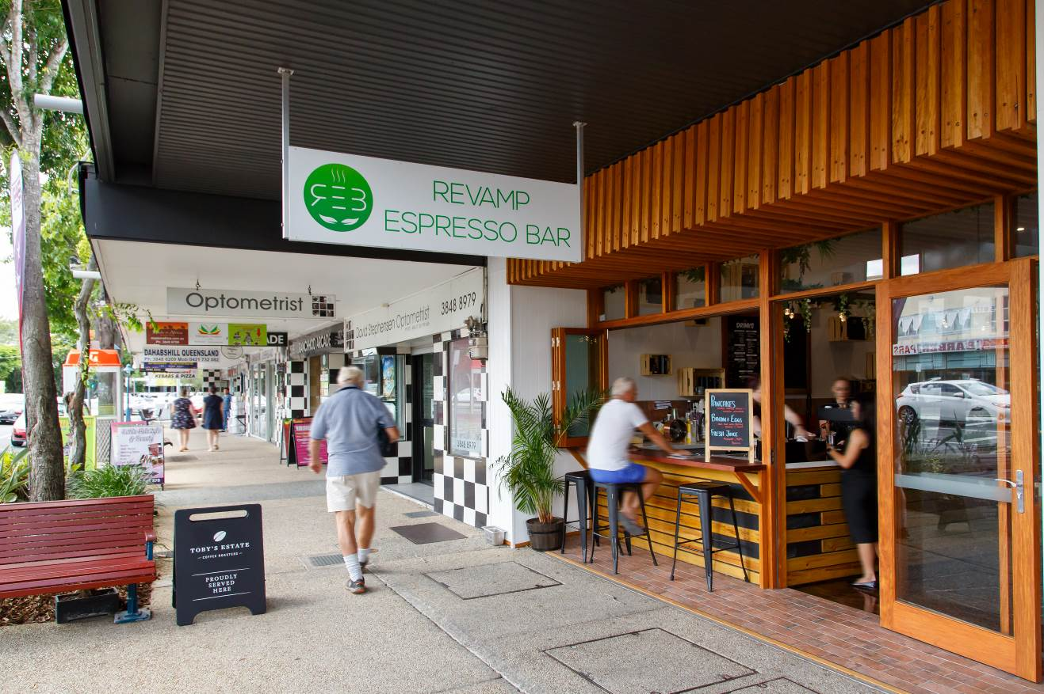

Meeting details
Date: Monday 21 October 2019
Time: 6:00pm to 8:30pm
Location: Salisbury Community Sports Club, 37 Ainsworth Street, Salisbury

Attendees

Community planning team members:
Alison, Allison, Annamarie, Anthony, Ava, Barbara, Beryl, Bradley, Corbin, Courtney, Daniel, Diego, Emma, Jackie, John E, John Mc, Kathleen, Kevin, Matthew, Narelle, Nathan, Neville, Nicola, Paige, Pam, PJ, Robert and William.

Council Officers and Consultants:
Dyan Currie (Chief Planner, Brisbane City), Sean Cullen (Manager, Neighbourhood Planning and Urban Renewal), Sonia Kirby (Principal Urban Planner), Lisa Edgerton (meeting facilitator), Ruth Cutler, Lisa Murphy, William Back, Erin Chalk, Georgina Aitchison, Rose Bateman, Brendan Barnes, Hayley Seears, Jamie Parsons, Kathryn Kelly (facilitators and scribes), Vesna Simic (registration), James Cole (note taker).

Observers:
Councillor Steve Griffiths (Councillor for Moorooka Ward).

Apologies:
CPT members Alan and Loukas.

Agenda
- Welcome
- About the CPT
- Activity 1: Getting to know each other
- About neighbourhood planning
Break for light refreshment
- Community insights
- Activity 2: Your local knowledge
- Activity 3: What’s your vision?
- Next steps

Welcome and introductions
Lisa Edgerton began by acknowledging the traditional owners of the meeting place and welcomed everybody to the first Community Planning Team (CPT) meeting for the Nathan, Salisbury, Moorooka Neighbourhood Plan (NSMNP).

Lisa thanked everyone for giving up their time to contribute to the project and for providing initial comments through the survey. Lisa introduced the Council team that will be managing the planning process and assisting to guide the evening’s activities, and acknowledged Councillor Steve Griffiths, Councillor for Moorooka Ward, attending as an observer.

Lisa also explained the role of the Council facilitators and scribes during the activity and that notes from all CPT meetings will be distributed to members and will be published on the website.

An overview of the agenda was then presented to CPT members.

About the CPT
Continuing, Lisa spoke about the formation of the CPT, noting that its purpose is to:

- Provide different community perspectives;
- Engage in workshop activities;
- Learn about the planning process; and
- Provide feedback to inform the neighbourhood plan.

The CPT is made up of a cross-section of ages, genders, places and periods of residence or business, and local interests, relative to the nominations received, as illustrated below.

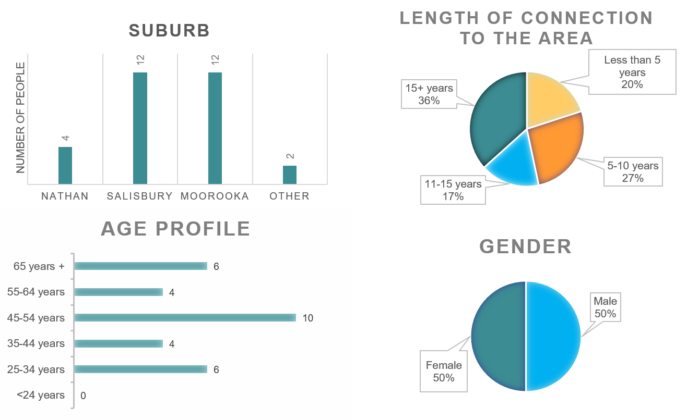

Working together as a CPT
Lisa then explained the role of CPT members and Council through the process, including opportunities for community input, both through the CPT and for the wider community. Lisa emphasised Council’s intention to conduct CPT meetings in a collaborative and open manner, encouraging contributions from all participants.

Lisa explained the CPT Terms of Reference (ToR) and asked that members respect the CPT process in their use of external platforms including social media. Council officers will make it clear if any information presented to the CPT should not be shared outside the CPT. Other than that, members should feel free to share information and ideas across their various professional and personal networks. Lisa emphasised that some members have not consented to their photo being taken, and request that all respect each other’s right to privacy.

A group agreement around the conduct of the CPT meetings was discussed, with core principles agreed as follows:
- No photography without consent.
- Respect for each other.
- One person to speak at a time.
- Listen respectfully.
- Everyone is entitled to contribute.
- No judgement – all opinions are valid.
- Follow instructions.
- Do the homework.
- Be punctual.

Council needs the participation of the CPT members in the process, to provide valuable local knowledge and insight to inform the draft strategy and neighbourhood plan. In addition to the feedback from the CPT, Council will also factor in a range of other inputs, including formal opportunities for feedback from the wider community and interested stakeholders.

Activity #1: Getting to know each other
Lisa then noted that input to date has already identified a number of points of interest in the neighbourhood plan (NP) area. CPT members completed a brief introductory activity, where they shared information about each other’s backgrounds and discussed their personal points of interests in and connection to the Nathan, Salisbury, Moorooka area.

About neighbourhood planning
Sonia Kirby then continued the conversation. Sonia explained that members of the community planning team bring a unique set of experiences and knowledge that will help set the future planning agenda for the Nathan, Salisbury, Moorooka area. The issues in Nathan, Salisbury and Moorooka about which CPT members are passionate will be central to all discussions, and members are encouraged to raise and advocate for those issues whenever appropriate.

Sonia noted that all work done to create neighbourhood plans fits within a legal planning framework and contributes to delivery of the objectives set by the Queensland Government through the Planning Act 2016 and the South East Queensland Regional Plan 2017 (SEQRP).

Under the State system, Council has a planning scheme known as Brisbane City Plan 2014 (City Plan). City Plan includes the Strategic Framework, which identifies at a broad, strategic level the future land use pattern in Brisbane, including major centres, existing and future industrial, residential and open space land uses, and infrastructure.

Within City Plan, neighbourhood plans describe locally-specific planning provisions, catering for local circumstances and seeking to advance the aspirations of the local community. The neighbourhood planning process provides a framework to manage development in local communities, to ensure that each area retains and enhances its own special character and qualities. A neighbourhood plan project provides an opportunity for everyone to have their say on how their community develops in the future

Sonia explained that the neighbourhood planning process comprises two components, each of which includes opportunities for the community to have its say:
- Development of a draft neighbourhood plan strategy as a highly-visual document, written in plain English, including both statutory and non-statutory actions to inform the future of the area. The draft strategy forms the basis for the statutory neighbourhood plan. Sonia referred CPT members to the recently released Sandgate District Neighbourhood Plan draft strategy as an example.
- Production of a statutory neighbourhood plan, a formal legal document that amends City Plan.

In considering the process for the Nathan, Salisbury, Moorooka neighbourhood plan, Sonia advised that the project is currently in the background research phase, which involves gathering information and advice from a wide range of sources, notably from the community through the CPT and other community input such as the preliminary consultation activities, and also from reports and investigations by technical experts, as well as feedback from the Queensland Government. Local business groups may also be engaged to understand their priorities and to promote business, industry growth and jobs in the Nathan, Salisbury, Moorooka neighbourhood plan area.

This phase will continue into next year, with a draft neighbourhood plan strategy expected to be available for consideration and public consultation in mid-2020. Following assessment of all feedback received, Council will then draft a statutory neighbourhood plan that will be released for further public consultation and review by the State Government in late 2020 or early 2021, with the final plan expected to be adopted and gazetted in early 2022. Sonia acknowledged that the proposed timeframe is in part influenced by the legal requirement to seek formal approval from the Queensland Government at a number of key milestones during plan development. Nevertheless, Council commits to bringing CPT members and the community along the journey and to provide regular updates on progress.

Next, Sonia spoke about the scope of the neighbourhood plan to drivers for change in the local area, as well as those elements that a neighbourhood plan can and cannot affect.

Members then raised a number of questions about the process and the plan area, including:
- How often are neighbourhood plans are typically updated? Response confirmed that Council endeavours to update plans within 10 to 20 years, however, the timing is relative to the need and urgency to update planning provisions in local areas, depending on the local issues.
- What is the definition of development in a neighbourhood plan context? The term ‘development’ is used broadly in the neighbourhood planning and it does usually refer to ‘development of the built environment’.
- Is it possible to identify land owned by various levels of government? Council does have access to this information through our land ownership database, however, public access to this information is limited.
- How does Council use neighbourhood plans to inform infrastructure improvements for areas needing upgrades? Neighbourhood planning staff work with other Council staff to ensure that any changes proposed through the neighbourhood planning process are tested with the infrastructure providers and the planning assumptions for infrastructure provision are updated following the adoption of the neighbourhood plan.
- How does Council manage available kerb-side parking space in the face of suburban development and car parking issues at or near railway station? Council uses a number of mechanisms to manage kerbside parking in suburban locations, and the Queensland Government does provide some parking around rail stations. Council has also recently publicly notified a proposed amendment to the City Plan to increase car parking for suburban multiple dwellings (https://www.brisbane.qld.gov.au/planning-and-building/planning-guidelines-and-tools/brisbane-city-plan-2014/amendments-to-city-plan-2014/city-plan-amendments-in-progress/proposed-citywide-amendment-increased-car-parking-for-suburban-multiple-dwellings).

The Nathan, Salisbury, Moorooka Neighbourhood Plan area
Sonia then provided an overview of the neighbourhood plan study area, which covers all three suburbs in their entirety, and explained that a range of background technical studies are already underway. These will combine with significant community input, including the CPT’s views and other community consultation activities.

The Nathan, Salisbury, Moorooka area needs a new neighbourhood plan for a number of reasons including: the existing plan is over 15 years old and some provisions may need updating or strengthening, the area has a diverse and changing community for whom different needs may be emerging, and strategic future growth nodes have been identified by Council’s Strategic Framework at Moorooka and Salisbury railway stations.

Sonia advised that the area also contributes to one of the city’s strategically-important Global Precincts, an initiative to identify precincts that can accommodate strong economic performance with scalable industry activity, world-class business environments and global reach. Griffith University, Queensland Sport & Athletics Centre (QSAC) and the QEII Hospital, plus the Health and Food Sciences precinct, are all included in the Upper Mt Gravatt / Eight Mile Plains Global Precinct.

In addition, the area will benefit from major infrastructure projects and upgrades, especially for Cross River Rail and Brisbane Metro. The area also has some locations that appear to be undergoing transition, particularly industrial areas where new businesses and social enterprises are emerging, potential changes to the Moorooka shops to reflect the changing community, and the future use of vacant car yards on the Moorooka Magic Mile.

Sonia explained that Council’s Economic Development team has worked with local businesses in Moorooka to develop the Moorooka Local Business Partnership Initiative (https://www.brisbane.qld.gov.au/about-council/governance-and-strategy/business-in-brisbane/growing-brisbanes-economy/local-business-partnership-initiative).

Also in the latest budget, Council announced the Better Suburbs Initiative. Council has now established a Better Suburbs Initiative board, to investigate opportunities for renewal in suburbs that are outside the city's inner five kilometres, with Moorooka announced as a pilot area. It is expected that the board will focus on projects and services that will stimulate renewal and be a catalyst for change.

Sonia then explained that the objectives for the neighbourhood plan process are to:
- Review the development potential of industrial and residential areas to facilitate employment growth and enhance liveability
- Capitalise on the significant infrastructure investment in the area
- Preserve the suburban and traditional character of residential areas
- Protect and enhance the environment and biodiversity in Toohey Forest and local waterways
- Enhance wayfinding, streetscapes and walkability between major employment hubs, residential areas, and public transport infrastructure.

Members raised additional questions about the process, including:
- Opportunities for members to learn from Council about both desirable and undesirable outcomes that can result from planning decisions.
- Information about flagship or cornerstone projects, both public and private, that may be relevant to the neighbourhood plan
- What the various levels of development density mean.

Additional questions unable to be addressed within the allocated time were written on post-it notes and placed on the relevant board by the wall. See APPENDIX B for questions and answers.
Members then took a short break before continuing the meeting.

Online Survey results
Ruth Cutler provided an overview of the results of the community survey which was recently conducted to commence the process of community engagement for the neighbourhood plan. The survey attracted 757 complete responses, indicating a very strong level of interest, with the richness of information sure to prove invaluable to Council in developing the plan.

Responses came from a range of people, including residents both new and established, business owners and employees, as well as several CPT members. Most respondents either live in or own a property in the area. Survey participants were asked questions about the local area such as “What do you value most?” and “What could be improved?”, as well as having the opportunity to ‘drop a pin’ on a map to indicate the areas where these responses applied.

Ruth indicated that while the results are still being analysed, early findings indicate that the things that people value most about the NSM area are:
- Parks and greenspace, including Toohey Forest and local parks for wildlife, recreation and community gathering opportunities
- Proximity to the Brisbane CBD, including access to the freeway and other transport routes
- Access to public transport
- Safe neighbourhood and sense of community
- Character housing

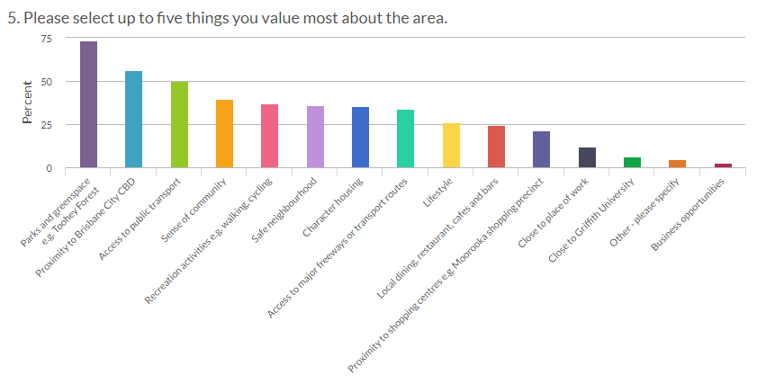

Respondents then made a number of suggestions about areas for improvement with the highest priorities being:
- More or improved local dining, cafes, shops and markets
- More or improved parks, playgrounds and sporting facilities
- Streetscape and pedestrian and cycle connectivity improvements and more trees and shade.

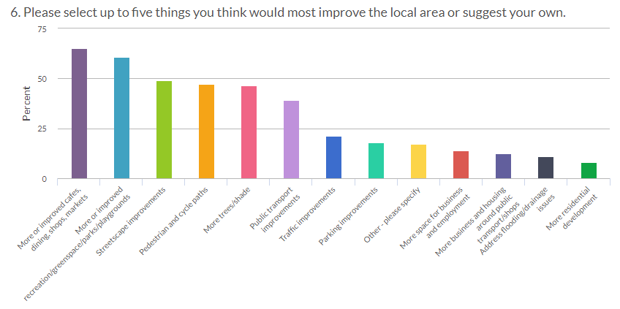

Highlights from responses to other survey questions include:
- Moorooka shops, while considered vibrant and attractive, have room for improvement
- The Moorooka Magic Mile was more likely to be rated negatively, mostly because it was considered unattractive / inappropriate for the area
- Strong support for more live/work units, aged care accommodation and affordable housing
- A range of views was expressed regarding townhouses, across those who feel more are required, those who think the amount is just right, and others who think the area has too many
- There was a generally negative perceptions of apartments
- For the industrial area, there was a mixture of positive (e.g. access to cafes, bars etc) and negative (e.g. pollution) comments.

Ruth then displayed a map showing the location of significant ‘pin drop’ responses, with 115 pins nominating areas to stay the same, and 315 pins that identified places suitable for growth or change.

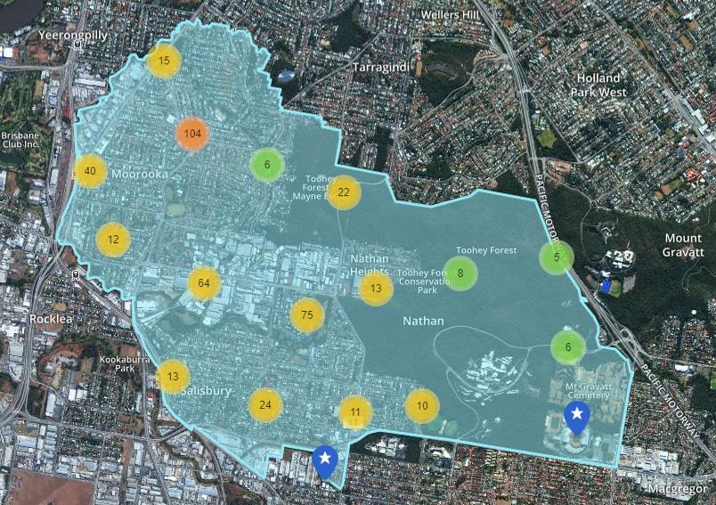

Activity #2: Your local knowledge
During this activity, CPT members took part in facilitated discussions to gather members’ knowledge of and aspirations for the plan area regarding:
- Greenspace and environment.
- Employment and industry.
- Culture and community.
- Housing and character.
- Getting around.

For each topic, CPT members were invited to respond to two prompt questions:
- “What do you currently value?” and
- “What are your ideas and future aspirations?”

Members moved among five topic stations, providing their input via comments, drawings and notations on activity sheets as well as written notes taken by the activity scribes.

A full summary is included at APPENDIX A to these minutes. This information will be used to inform the topics for the next two CPT meetings.

Activity #3: What’s your vision?
Sonia explained that the CPT’s insight is needed to develop a vision statement for the area. She suggested that a meaningful vision statement:
- Describes what the area will look and feel like in 20 years’ time
- Identifies the area’s unique features
- Is written in non-technical, plain language that the community can understand, embrace and use to identify their own place in the area
- Will be shared with the community so that they can comment and make suggestions, as part of the draft NP strategy
- Provides the building blocks for strategic intent of neighbourhood plan strategy
- Does not need to explain and describe everything about the area, but rather ‘captures the essence’ of the area.

As a starting point, Sonia suggested that members might wish to consider some of the following elements from the Banyo-Northgate Neighbourhood Plan strategy, as an example of what might be included in the Vision statement for Nathan, Salisbury and Moorooka:

Banyo-Northgate area is well-connected by frequent public transport services and roads to Central Brisbane and the rest of South East Queensland.
There are a variety of centres that provide residents with housing, commercial and recreational opportunities, whilst the existing local character and heritage of neighbourhoods will continue to be protected.
Lively commercial, industrial and education precincts will be hubs for innovation and research to support future business and employment in the area.
A well-connected community is supported by plenty of green spaces, community facilities, schools and other opportunities for people to connect.

Homework
Sonia asked members to consider the types of words and phrases that might be included in a Vision statement for the area. As part of their homework, CPT members were asked to compile a list of desired content for consideration at the next meeting.

Sonia then invited members to access Council’s free online City Plan and City Plan Interactive Mapping platform to find out more about their properties or other areas of interest.

This will assist members to become more familiar with City Plan in preparation for discussions at the next CPT meeting about land use and zoning. A reminder email with instructions will be sent to all members.

Next steps and meeting conclusion
Sonia then thanked all present for their enthusiasm, passion and commitment to tonight’s activities, and advised that all information provided during the meeting will now be collated and used as valuable input as the next stages are progressed.

Notes from the meeting will be made available on the website in the near future and CPT members will be advised accordingly. Additional input and comment is welcome at any time and should be directed to the Neighbourhood Planning Brisbane Team on the contact details below.

Members were also advised that they will receive an email with a link to provide Council with feedback on tonight’s session, so that any adjustments or changes can be made before the CPT reconvenes for its second meeting.

The next CPT meeting will be on Thursday 14 November 2019 from 6pm, with the Council team available onsite from approximately 5.15pm to respond to any enquiries from members.

The third and final CPT meeting will be held on Thursday 5 December 2019, also from 6pm.

The meeting closed at 8.35pm.

Further Contact
Phone: The Project Team on 3403 8888
Email: neighbourhood_planning@brisbane.qld.gov.au
Visit: www.brisbane.qld.gov.au and search for ‘Nathan Salisbury Moorooka Neighbourhood Plan’
Subscribe: to updates via email on the project page

Minutes checked/approved

Checked: LM/RC
Approved: SK

APPENDIX A

Activity #2: Your Local Knowledge

Station 1 – Greenspace and environment (Lisa and Brendan assisting):
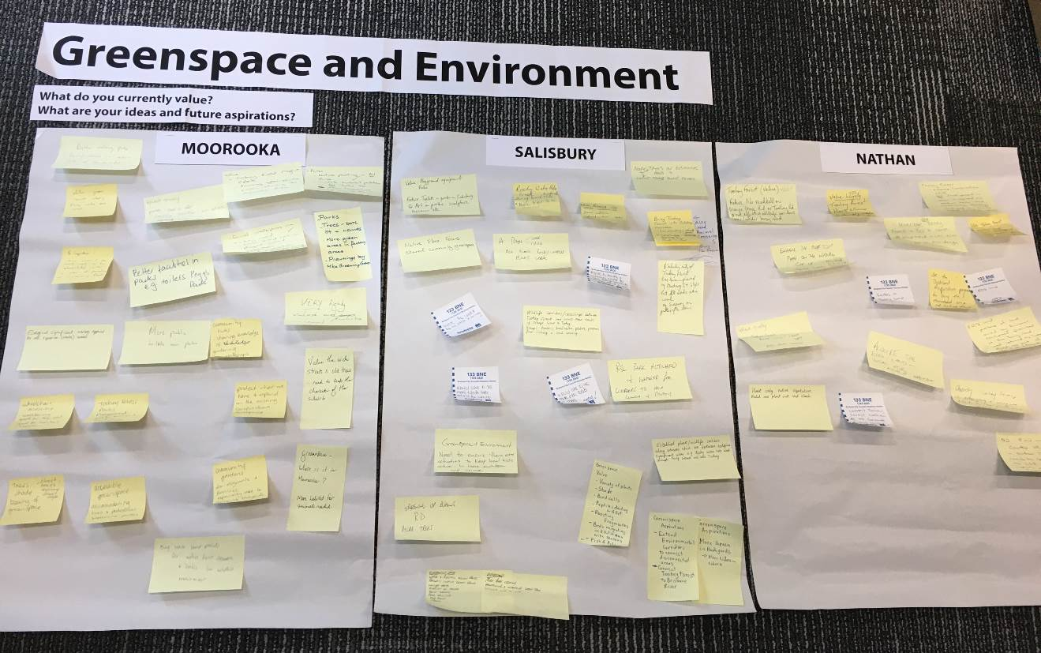

Moorooka
- Value local green spaces including Toohey Forest, Rocky Water Holes Creek, Mayne Estate etc. and the wildlife habitat and native planting they provide.
- Aspire to the following for green spaces:
  - Improved facilities including public toilets.
  - Areas around creeks rehabilitated and protected to minimising flooding and provide habitat for wildlife.
  - Community hubs to share knowledge and provide learning opportunities.
  - Accessible by wheelchairs, bikes and prams.
- Aspire to improved streetscapes and more green space in industrial areas.
- Maintain the character of the suburb with old streets and wide streets.
- Better walking paths through streets on western side of Beaudesert Road

Salisbury
- Value local parks and playground equipment, with the following aspirations:
  - Public toilets and facilities such as barbeques in parks.
  - Art and lighting in parks.
  - Shared community greenspaces.
  - Native flora focus.
  - Activities for local children.
  - Maintain and increase greenspace.
- Value Rocky Water Holes Creek and associate wildlife, with the following aspirations:
  - Replant native trees along creeks.
  - A path for walking and cycling along the creek.
- Aspiration for more (native) planting throughout the area including streetscapes, open space and backyards.
- Value Toohey Forest including wildlife, with the following aspirations:
  - Provide wildlife crossings over busy roads and provide planting along key corridors.
  - Erosion prevention on Salisbury side of the forest.
- More rubbish bins throughout the suburb

Nathan
- Strongly value Toohey Forest including flora and fauna such as koalas.
- Aspirations for Toohey Forest:
  - Enhance the conservation value of Toohey Forest.
  - Provide effective wildlife corridors over or under busy roads, reduce road speeds.
  - Griffith University conservation strategy — opportunities to protect vulnerable species and leverage circular economy businesses and eco-design.
  - No development in the Forest, and avoid large-scale development near the forest in bushfire areas.
  - Enhance the clifftop path on the northern side of Toohey Forest.
  - Opportunity to acquire more of Toohey Forest (EDQ land) to ensure its use for conservation.
  - Plant only native vegetation

Station 2 – Employment and industry (William and Hayley assisting):
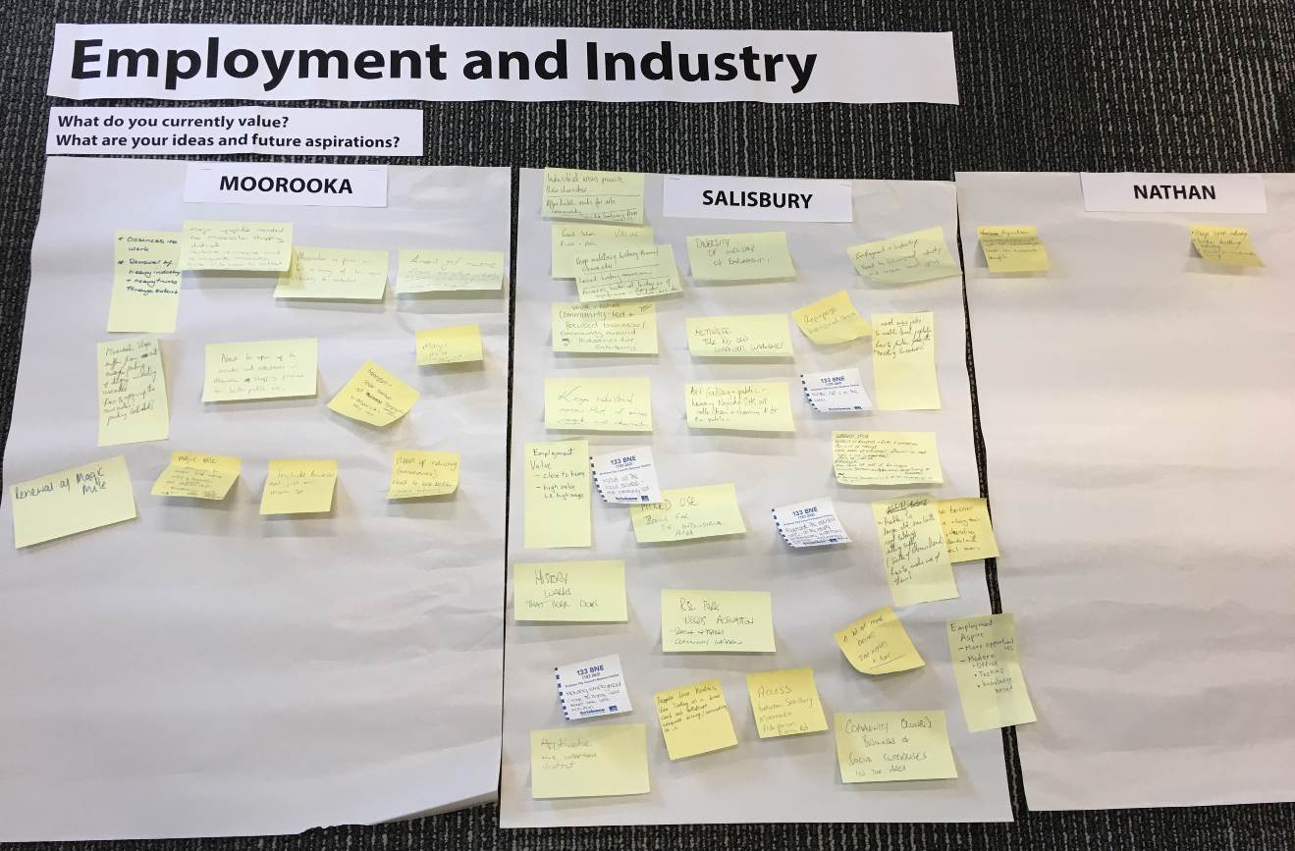

Moorooka
- Value location being close to employment
- Opportunity to rezone and expand the variety of uses in existing industrial areas as they provide employment, or redevelopment and clean-up of industrial land for residential
- Aspirations for improvements to Moorooka shops including parking, access to arcades and side streets for public use.
- Opportunity to revitalise, reimagine and reinvigorate Moorooka Bowls Club area to reflect changing demographic while retaining history of the club.
- Provide safety and equitable access at Moorooka railway station
- Aspirations for the Moorooka magic mile:
  - Renewal of magic mile with possible change of purpose.
  - Improve appearance and encourage indoor showrooms rather than outdoor car sales.
- Opportunity to have businesses spread throughout the suburb.
- More schools and community hubs.

Salisbury
- Value diversity of industry and employment providing local jobs – continue this into the future to provide more jobs and business growth.

- Value historic industrial areas and aspire to maintain or create the following:
  - Preserve the character and history of the area, local history tours and museum.
  - Provide affordable rents for the arts community.
  - Future proof industry to create local jobs.
  - Community-led and focused businesses providing activation to the area.
  - Allow for different types of uses (e.g. mixed use, technology and knowledge focused uses) to ensure buildings are occupied.
  - Activate RSL park (seating, tables, community garden).
- Public art gallery showing Nyanda SHS art collection.
- Great schools – private and public.
- Provide more medical facilities (GPs) in the area.
- Provide a noise barrier along the railway line.
- Provide connection to Toohey Forest to attract people to local businesses.
- Improve pedestrian access between Moorooka and Salisbury along Evans Road.

Nathan
- Industry engagement with Griffith University to create economic benefits.
- Maintain light industry.
- Single dwelling house – focus on sustainable living.

Station 3 – Culture and community (Ruth and Rose assisting):
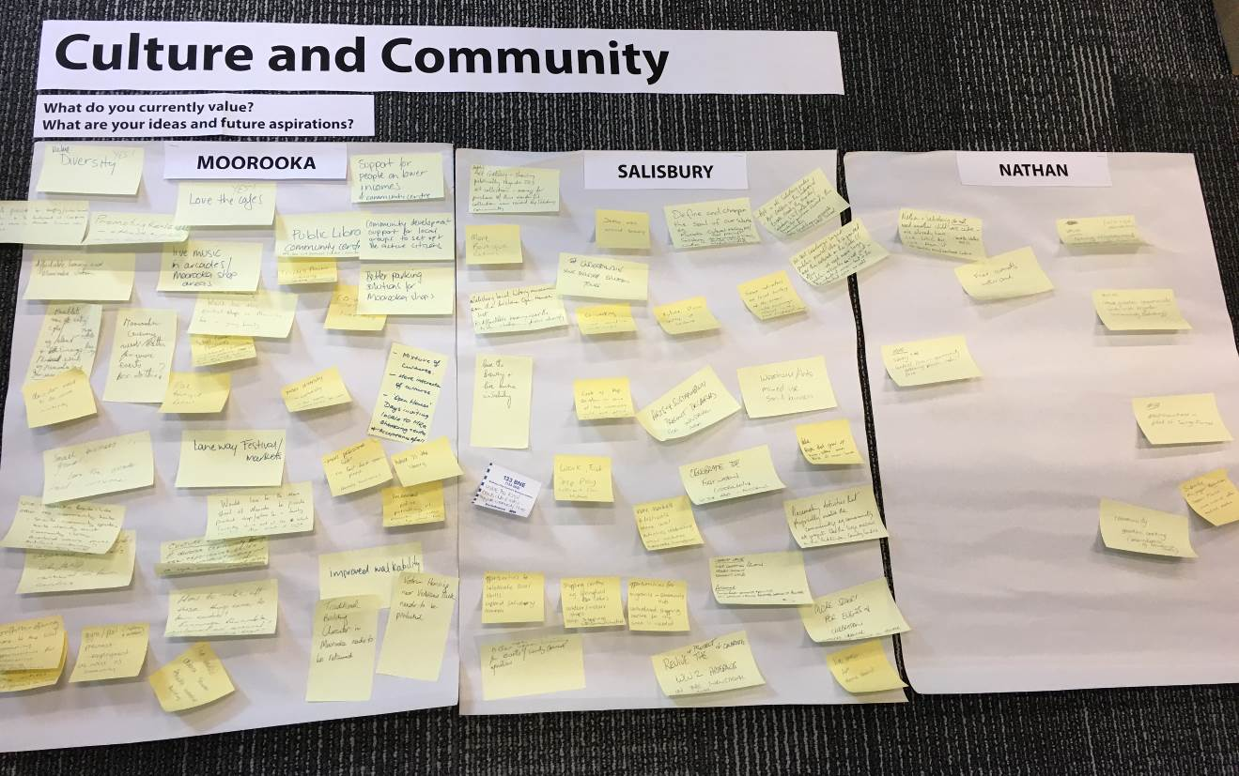

Moorooka
- Value the diversity of the community, with an opportunity to have more interaction between cultures and bring people together.
- Value local cafes and businesses, and community events such as the laneway festival and markets.
- Value existing Scouts and community gardens.
- Value the nearby Coopers Plains Library but would also like a library in Moorooka.
- Support for people on lower incomes – Affordable housing and Community Centre.
- Create a wider range of uses in the Moorooka shops such as different retail, entertainment (cinemas, bars, live music, events), cafes, offices to cater for the local community.
- Improve safety, parking, shelter and appeal of Moorooka shops and arcades.
- Community development support for local groups to set up and be active citizens.
- Opportunity to use Moorooka Bowls Club as a community hub.
- Opportunity to reinstate public community art.
- Opportunity to create artificial waterway, eg, Seventeen Mile Rocks or a sporting precinct.
- Opportunity to create closer connection between the community and Griffith University.
- Improve walkability.
- Flexible industrial buildings allow for live music and dance studios etc.
- Retain Traditional Building Character and Veteran Housing in Moorooka

Salisbury
- Value the friendly community, local businesses, bowls club and live music in the area.
- Opportunities for public art including:
  - Art Gallery showing the Nyanda SHS art collection.
  - Art in local parks.
  - Public murals in industrial and residential areas.
  - Arts supported in industrial areas.
  - Placemaking activities that involve the local community and celebrate local skills.
- Opportunities for broader uses including:
  - More boutique retail.
  - Co-working and creative and technology workshops.
  - Affordable housing near train station.
  - Re-use of warehouses could use similar concept to ‘Pop Brixton’.
  - Markets and festivals.
  - Community hub.
  - Centralised shopping hub with a community feel.
  - Spaces for events and celebration including opportunities for nightlife.
- Celebrate First Nations custodianship and local history through education/history/architecture tours, local history museum, local activities celebrating diverse cultures.
- Define and champion the soul of our suburbs, e.g. Moorooka: Cultural melting pot / food precinct, Salisbury: Heritage connection new vs. old/ arts, Nathan: Nature and wildlife.
- Improve streetscaping opposite Salisbury State School.

Nathan
- Community is proud of Toohey Forest.
- Opportunity for a central community space with facilities such as a garden, shared cooking space (e.g. Wandering Cooks), cafés, parks, library, water park.
- Opportunity to grow neighbourhood relationships with families and community led initiatives, including broader community links with Salisbury.
- Do not need more child care centres.

Station 4 – Housing and character (Georgina and Jaime assisting):
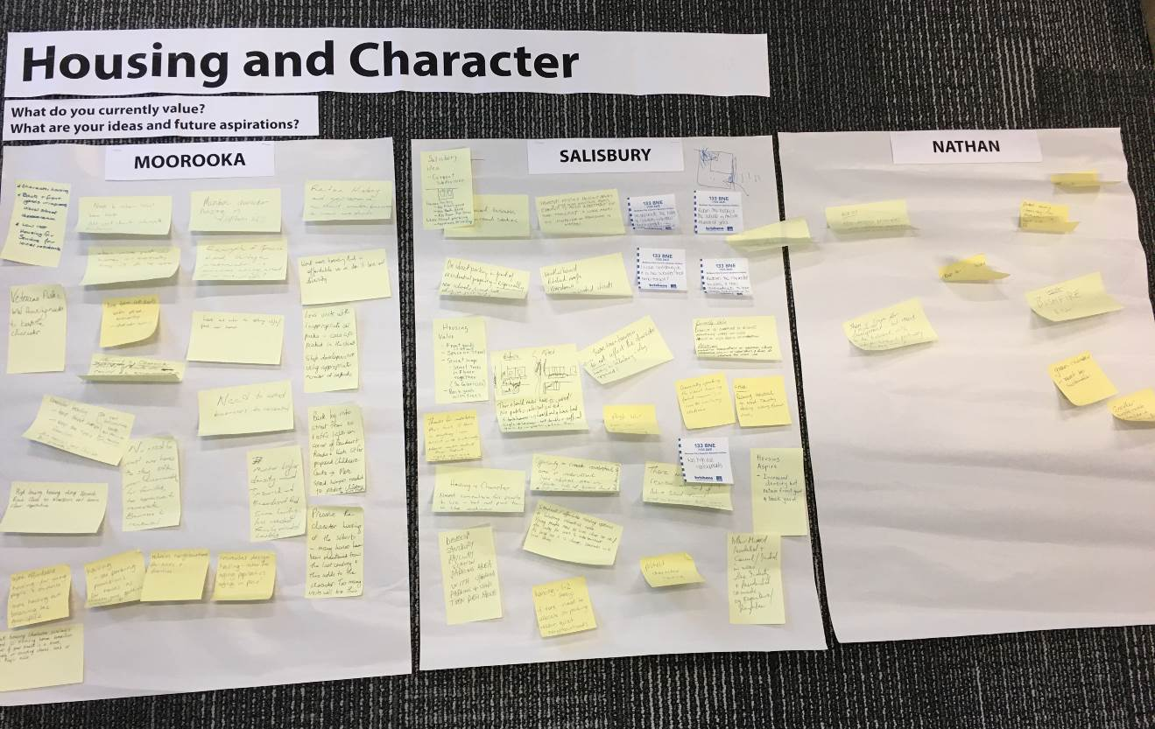

Moorooka
- Value and continue to protect character housing and traditional lots.
- Value front and back yards with trees which improve the street appearance.
- Prevent barriers to providing housing for new residents – opportunities for different housing types along Ipswich Road and near railway station.
- Encourage units and townhouses that are designed to complement character homes, include universal design, and provide appropriate car parking.
- Provide affordable housing for seniors, migrants, young people and students.
- Support new housing with suitable greenspace to allow families to stay in the area.

Salisbury
- Value traditional character housing, yards and streetscapes.
- New houses being built on subdivided lots provide no front or back yard, no room for trees and increase the number of driveways (less street parking).
- Provide units or apartments around railway stations and employment hubs, which may incorporate more retail space for local businesses.
- Retain the history of the suburb and incorporate history into new developments.
- Allow for higher density, but prevent new development that does not provide a front or back yard, reduces street car parking and does not reflect the character of the suburb.
- Opportunity to re-use light industrial areas for innovative residential development.
- Provide student and affordable housing close to Griffith University.

Nathan
- Opportunity to use eco-design principles to connect housing to Toohey Forest.
- Allow for future residential development where it reflects the character of the area and is balanced with infrastructure (including access), conservation of Toohey Forest and Bushfire risk.
- Maintain the liveability of the area.

Station 5 – Getting around (Erin and Kathryn assisting):
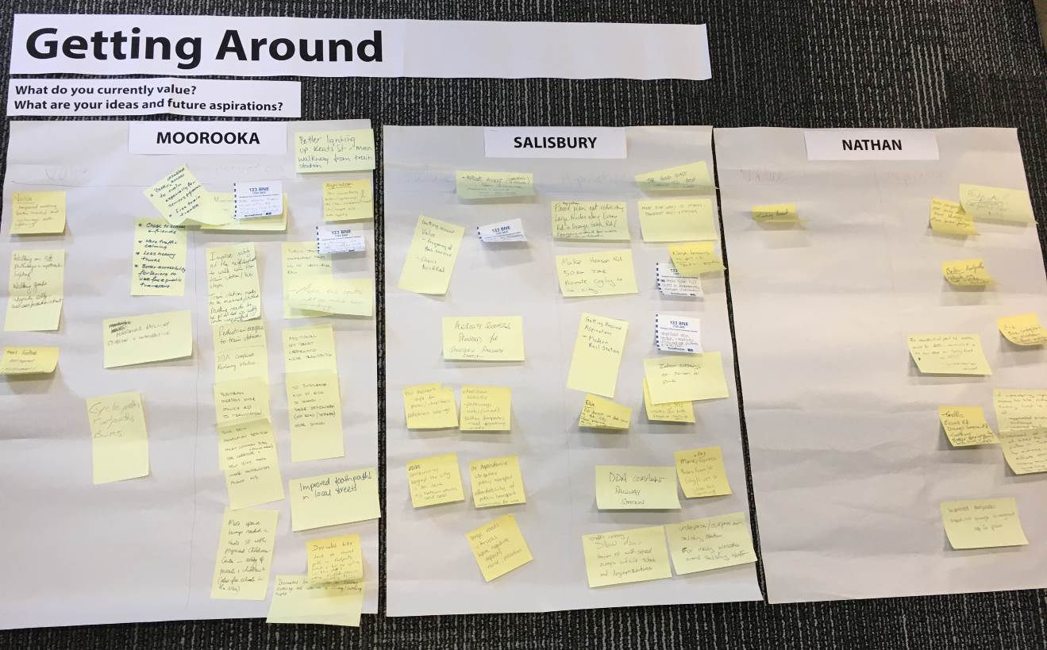

Moorooka
- Value being close to school and friends.
- Provide equitable access, better lighting and appearance improvements to train station and key pedestrian access routes.
- Improve footpaths and lighting on local streets and cycle paths to increase safety.
- Provide or improve walking and cycling connections to Toohey Forest, Brisbane CBD, train stations, schools, shops, Oxley, Rocklea markets, and Yeronga / Fairfield.
- Improve public transport connections from Griffith University to Cross River Rail and increase services on weekend/evenings.
- Changes to car parking to provide additional off-street car parking near train station.
- Manage traffic from Childcare centres and schools to ensure low speeds and safe pedestrian environments for children.
- Reduce the number of heavy trucks on roads.
- Encourage kids to ride to school by provide safe designated paths near schools.

Salisbury
- Value frequency of bus services and choice of bus and rail.
- Improve pedestrian and cycle access from residential Moorooka and Salisbury to the Salisbury industrial area and transport hubs and stations, and promote cycling to the city.
- Improve access and appearance of railway station and provide noise attenuation.
- Increase variety of services including Gold Coast train services to Salisbury and northern suburbs and peak hour bus services to the city to reduce car dependence.
- Improve bus shelters to be safe for prams / wheelchairs and access to pedestrian crossings.
- Reduce speed limit on Henson Road and provide pedestrian crossings.
- Improve pedestrian environment on Evans Road and provide pedestrian crossings.
- Manage heavy vehicle movement so that it does not disrupt residential areas or emergency accommodation for low income people.
- Opportunity to improve footpaths and provide interesting story walks for children.
- Review submissions from Active School Travel to make changes to parking.

Nathan
- Value Toohey Forest.
- Improvements to public transport services such as more buses and provide better access to bus stops from residential areas.
- Improve footpath surfaces, increase width and provide lighting.
- Create alternatives access to Nathan before major development occurs.
- Manage traffic on Evans Road, Orange Grove Road and Toohey Road.
- Provide dedicated bike paths in Toohey Forest and close illegal paths to prevent erosion.

APPENDIX B

Questions

Q: Is the CPT representative of all community e.g. cross-section of cultural diversity in this area?
A: The CPT was chosen to represent as many diverse views as possible, based on the nominations received. Please see the “About the CPT” section of these minutes for an overview of the CPT.

Q: How will you balance perspectives, i.e. what is included or not from the CPT?
A: The role of the CPT is to provide local knowledge and input during the preparation of the neighbourhood plan draft strategy. CPT feedback will be considered by Council along with a range of other inputs when developing the draft strategy.

Q: Why is our elected Councillor only an observer? How will he be involved otherwise as our representative?
A: Councillors are offered ‘observer' status for Community Planning Team (CPT) meetings. This has been the standard practice in the conduct of CPT's for many years. Council officers are aiming to encourage honest and open feedback and ideas from the CPT members about the future of their neighbourhoods.

During the conduct of the CPT meetings, all Councillors have respected the ‘observer' status, which limits the Councillors from 'contributing directly to the Workshop activities (ie. no direct presentations or formal addresses to the CPT meetings, and no active participation in workshop activities and exercises such as small group activities). Councillors are strongly encouraged and supported to listen in on the activities, hear the presentations that are being delivered and are formally acknowledged as being present in the ‘observer' capacity at the beginning of each meeting.

There are many ways that ward Councillors may contribute to the neighbourhood planning process, beyond the CPT meetings. There are numerous examples where the ward Councillors have contributed through various methods such as write/email to the City Planning Chair directly, contact the Project Team, write letters to their local residents, host petitions, promote the opportunity to have a say through social media, and provide feedback on documents during submission periods and public notification.

Q: What pressure can Council put on unit / townhouse developments to provide more parking within the complex and not on the roadside?
A: Parking provisions are included in City Plan. Council is currently progressing an amendment to City Plan to increase car parking requirements for new multiple dwellings in suburban areas. See this webpage for more information https://www.brisbane.qld.gov.au/planning-and-building/planning-guidelines-and-tools/brisbane-city-plan-2014/amendments-to-city-plan-2014/city-plan-amendments-in-progress/proposed-citywide-amendment-increased-car-parking-for-suburban-multiple-dwellings

Q: Who will stop developers using public parking on our streets from being used for private residential or commercial use only? Refer to development at the top of Blackwood Road near Scout Hall and School – 5 townhouses all with double driveways – no public parking, no public interest served, permanently.
A: Access and parking requirements are included in City Plan and are assessed during the development application process. A neighbourhood plan may include local provisions relating to number of driveways. However, Council cannot change or retrospectively apply new provisions to existing, approved or under-construction development.

Q: Are we able to have overlays of all the land publicly owned?
There is no overlay in City Plan that shows publicly owned land and this information is not included in Brisbane’s Open Data. Land titles are managed by the Queensland Government Department of Natural Resources, Mines and Energy.
Please contact the project team for more information.

Q: How can Moorooka Station ignore the needs (ramps etc.) of people with a disability, mothers with prams etc. when businesses, school have to provide access for all people?
A: Railway stations are managed by Queensland Rail. See the Queensland Rail website for more information about access to rail services https://www.queenslandrail.com.au/forcustomers/access. The Queensland Government has announced that stations from Fairfield to Salisbury (including Moorooka) will be upgraded as part of the Cross River Rail project https://crossriverrail.qld.gov.au/stations-routes/salisbury-to-fairfield-line/

Q: How are BCC conflicts of interest disclosed?
Brisbane City Council’s Code of Conduct outlines Council’s approach to conflicts of interest and how these are managed. A register of Councillor’s Conflicts of Interest is also available on Council’s website.

Q: Can all the slides be sent out with the minutes from tonight’s presentation?
Material content from the presentation has been included in these minutes.

Q: What is the relationship of BCC to the group The Suburban Alliance?
The Suburban Alliance is not part of Brisbane City Council. The Suburban Alliance’s Reimagining Salisbury document is not a Council document.

Q: Is there any member of The Suburban Alliance in this CPT? If so, why? As I understand that a Suburban Alliance representative is Chair of the Board of the Better Suburbs Initiative. It is a conflict of interest.
There are no members of The Suburban Alliance on the CPT.

