Nathan, Salisbury, Moorooka Neighbourhood Plan
Community Planning Team meeting notes

Meeting No 2 — 14 November 2019

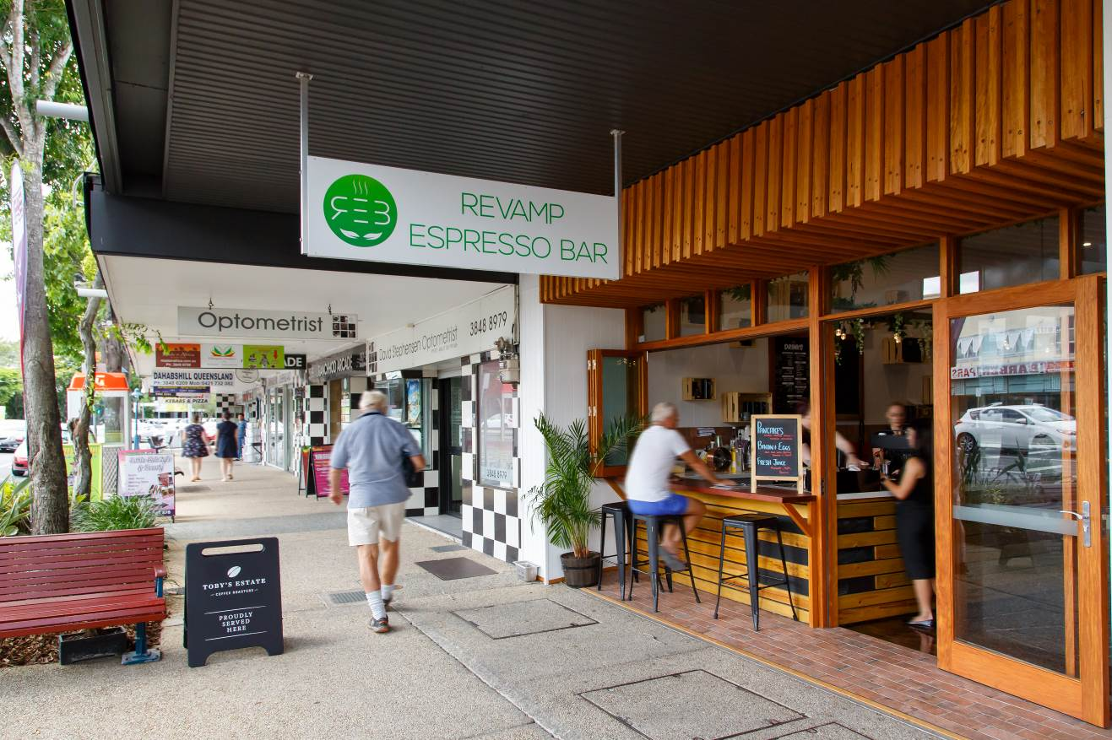

Meeting details
Date: Thursday 14 November 2019
Time: 6:00pm to 8:30pm
Location: Salisbury Community Sports Club, 37 Ainsworth Street, Salisbury

Attendees

Community planning team members:
Alison, Allison, Annamarie, Ava, Barbara, Bradley, Corbin, Daniel, Diego, Emma, John E, Kathleen, Kevin, Loukas, Matthew, Nathan, Neville, Nicola, Paige, Pam, Robert and William.

Council Officers and Consultants:
Sean Cullen (Manager, Neighbourhood Planning and Urban Renewal), Sonia Kirby (Principal Urban Planner), Annete Cupitt (meeting facilitator), Ruth Cutler, Lisa Murphy, William Back, Georgina Aitchison, Brendan Barnes, Kathryn Kelly, Elizabeth Butterworth, Phillip Ng, Asiya Mohammad Raza, Daniel Pirie, Tim Sergiacomi (facilitators and scribes), James Cole (registration and note taker).

Observers:
Councillor Steve Griffiths (Councillor for Moorooka Ward), and Jess Carmichael (Consultant, Urbis).

Apologies:
CPT members Alan, Anthony, Beryl, Courtney, Jackie, John Mc, Narelle and PJ.

Agenda
- Welcome
- CPT1 Review
- Activity 1: Draft vision statement
- Land use planning in the study area
Break for light refreshment
- Activity 2: Looking forward – identifying opportunities
- Next steps

Welcome and introductions
Annete Cupitt began by acknowledging the traditional owners of the meeting place and welcomed everybody to the second Community Planning Team (CPT) meeting for the Nathan, Salisbury, Moorooka Neighbourhood Plan (NSMNP).

Annete thanked everyone for giving up their time to once again contribute to the project and for providing additional feedback through their CPT1 homework exercise. Annete introduced the Council team that will be managing the planning process and assisting to guide the evening’s activities, and acknowledged Jess Carmichael, representing the project consultants, Urbis, attending as an observer. Councillor Steve Griffiths, Councillor for Moorooka Ward was acknowledged as attending as an observer.

Annete explained the role of the Council facilitators and scribes for tonight’s activities and advised everyone that notes from all CPT meetings will be distributed to members and will be published on the project website.

Annete reminded members about the CPT Terms of Reference (ToR) and also displayed the group agreement made at the previous meeting, with core principles agreed as follows:
- No photography without consent.
- Respect for each other.
- One person to speak at a time.
- Listen respectfully.
- Ensure everyone has an opportunity to speak.
- No judgement – all opinions are valid.
- Follow instructions.
- Do the homework.
- Be punctual.

An overview of the agenda was then presented to CPT members.

CPT1 Review
Annete recapped the discussions and information shared at the first CPT meeting in October, highlighting the following:
- Presentations about the neighbourhood planning process and the community insights gathered so far.
- An activity to provide feedback on the five themes identified from initial community consultation.
- Homework to consider appropriate wording for a vision statement (see the ‘word cloud’ below), and to research the planning provisions affecting our own properties.
- Feedback forms to help Council to host effective CPT meetings.

Activity #1: Draft vision statement
Lisa Murphy thanked everyone who had provided their input and ideas for words, phrases and concepts that might be included in a vision statement for the neighbourhood plan.
Some of the common themes to emerge included:
- The idea of community – being diverse, inclusive, creative, friendly.
- Toohey Forest and natural spaces and the environment and wildlife.
- Ideas around sustainability emerged.
- Housing – traditional character, design, heritage.

Lisa explained that the vision will set the aspirations for the plan area and provide a common point of reference and check-in about how the plan should develop.

CPT members then took part in a brief activity, where at their tables, they considered a list of phrases that could make up a vision statement. Each member then indicated their five priority words/phrases by placing stickers alongside their preferred phrases. The addition of new ideas and phrases was also encouraged.

The most strongly-supported ideas will be used to help draft a vision statement for the CPT to consider. Some of the initial ideas with the most support appeared to be:
- Renowned hub for education, knowledge and innovative industries.
- The unique wildlife that calls Toohey Forest home is valued.
- Preservation and celebration of the natural environment.
- Vibrant mix of commercial, industrial and educational uses.

Full details are provided at APPENDIX A to these Minutes.

Land use planning in the study area
Sonia Kirby then took up the conversation, inviting members to consider what is meant by the term “neighbourhood”. Sonia suggested that when people talk about their neighbourhoods, they can use many concepts to describe and define them, including:
- It’s where we live.
- It’s where we tell people we live.
- It’s the look and feel, and it’s “the vibe.”
- It’s physical.
- It’s emotional.

Sonia remarked that importantly, neighbourhoods are places, and planning is about place-making. For the Nathan, Salisbury, Moorooka area, some of the elements that make up the neighbourhood may include:
- The people: residents, workers and visitors.
- Streetscape: leafy streets, building setbacks and open space.
- Views and vistas: Toohey Forest, the mountain ranges in the distance, and views to the city.
- Natural features: Toohey Forest, waterways.
- Built form: types of housing and character buildings.
- The mixture of uses: housing, shops, offices, cafes, etc.
- Access to jobs: Griffith University, Moorooka shops and industrial areas.
- Access to public and active transport.
- Access to local services and facilities.
- The stories: indigenous, colonial heritage, cultural diversity.

Sonia noted that in the planning context, there are many different neighbourhoods across the plan area, each with different features that are valued by the community. Sonia commented that maintaining a strong sense of community is important. Brisbane’s population will continue to grow and it is important that opportunities are identified for housing choice, employment, recreation, services and infrastructure.

In addition, housing needs and lifestyles are changing in Brisbane, and we need to make sure that we are providing the range of housing choice and access to services that residents need. The Nathan, Salisbury, Moorooka area is also a desirable place to live.

Sonia emphasised that Council wants to work with the CPT and the local community to understand the future of the neighbourhood, including where change could be supported, and where existing neighbourhoods should remain largely unchanged. It is important to note that change does not have to come at the expense of a desirable look and feel for a neighbourhood.

Sonia then spoke about some places where the local area has undergone significant change over time, such as the Salisbury industrial area’s key historical association with wartime munitions works, where some original buildings remain but have been re-purposed for different uses like cafes, creative arts and local shops, and Moorooka’s transformation from banana plantations and poultry farms to houses, car yards and the Moorooka shops.

In thinking about the future of the area, and considering which areas might be suitable for change,
Sonia suggested that there are several factors to consider such as:
- A lack of retirement facilities in the area, which may be needed in the future as the population ages.
- The number of jobs is expected to increase substantially.
- Opportunities for housing choice.
- Employment, study and training opportunities.
- Access to services and infrastructure.
- Road access, topography, street layout, physical and environmental features.

Members then raised a number of questions and issues, including:
- Details of growth projections.
- Car parking provisions for unit and townhouse developments and how they are applied through the development application process.
- On-street car parking availability in the vicinity of railway stations.
- Ensuring that the planning framework and decisions complement the railway network and its requirements, particularly in the precincts around stations.
- Consideration of sustainable design elements (solar, ventilation, shade etc) that should be mandatory inclusions in future developments.
- Access to flood mapping information.
- Increased dwelling heights allowed in the interest of flood resilience, and the subterranean depth to which developments can be excavated to reduce the impact of larger buildings.

Full details of the responses to these questions are provided at APPENDIX B to these Minutes.

Members then took a short break for refreshments before continuing the meeting.

Activity #2: Looking forward – identifying opportunities
During this activity, CPT members took part in facilitated discussions to consider potential areas for change, and areas to stay the same, based on those areas already identified through responses to the online survey, nominations from the pin-drop map, and the CPT discussions to date. Change can mean anything that defines a local neighbourhood – housing, cafes, parks, infrastructure, shops, employment etc.

Maps were provided that summarised much of the information collected to date by location, showing a range of trends or clusters of feedback. This provides a strong starting point for further investigation in the activity.

Members were urged to use the activity to consider whether they agree with the areas chosen, and why, whether the feedback has missed anything, including areas that are not identified one way or another but should be, whether the nominated boundaries are correct, or whether they should be refined, expanded or reduced.

The five themes that emerged from the online survey were again used as the basis for these discussions, with all members able to contribute across all themes as follows:
- Greenspace and environment.
- Employment and industry.
- Culture and community.
- Housing and character.
- Getting around.

The theme facilitators moved among the five tables, with members providing their input via comments, drawings and notations on activity sheets as well as written notes taken by the activity scribes.

A full summary is included in to these Minutes. This information will be used to further inform development of the neighbourhood plan draft strategy.

Next steps and meeting conclusion
Annete then thanked all present for their enthusiasm, passion and commitment to tonight’s activities, and advised that all information provided during the meeting will now be collated and used as valuable input as the next stages are progressed and preparations are made for the third and final CPT meeting.

Minutes from the meeting will be made available on the website in the near future and CPT members will be advised accordingly. Additional input and comment are welcome at any time and should be directed to the Neighbourhood Planning Brisbane Team on the contact details below.

Members were also advised that they will receive an email with a link to provide Council with feedback on tonight’s session, so that any adjustments or changes can be made before the CPT reconvenes for its third meeting.

The third and final CPT meeting will be held on Thursday 5 December 2019 from 6pm, with the Council team available onsite from approximately 5.15pm to respond to any enquiries from members.

The meeting closed at 8.30pm.

Further Contact
Phone: The Project Team on 3403 8888
Email: neighbourhood_planning@brisbane.qld.gov.au
Visit: www.brisbane.qld.gov.au and search for ‘Nathan Salisbury Moorooka Neighbourhood Plan’
Subscribe: to updates via email on the project page

Minutes checked/approved

Checked: LM/AC
Approved: SK

APPENDIX A

Activity #1: Draft vision statement

CPT members were invited to identify their priority five statements to be reflected in a draft vision statement for the area. The below lists those statements in order of priority:

- Renowned hub for education, knowledge and innovative industries (15 ½ votes)
- Effective and convenient transport connections locally and regionally (10 votes)
- Vibrant mix of commercial, industrial and educational uses (10 votes)
- The unique wildlife that calls Toohey Forest home is valued (10 votes)
- Local businesses contribute to local identity and community (9 votes)
- Preservation and celebration of the natural environment (9 votes)
- Shaded (shared) paths provide comfortable pedestrian and cycle connections (7 votes)
- Cohesive community that embraces its diversity (6 votes)
- Variety of housing provides choices for different lifestyles (6 votes)
- Network of green spaces provide family friendly recreation (6 votes)
- Fosters and celebrates the arts and the local arts industry thrives (5 ½ votes)
- Enhance heritage and character buildings (4 votes)
- Employment opportunities close to home (3 votes)
- Housing is designed for the subtropical environment (3 votes)
- A resilient and connected community that embraces diversity and local economies (1 vote)
- Honours the past and looks to the future.

APPENDIX B

Questions

Q: What are the growth projections for the area?
A: Projections are a guide only and are subject to change.

Council’s Planning Assumptions listed in Schedule 3 of Brisbane City Plan 2014 (City Plan) outline the planning assumptions for population, employment, residential dwellings and non-residential floorspace across the city. Planning assumptions can be downloaded from Council’s website.

Other interesting population, social and economic data, including population projections, can be downloaded for every Brisbane suburb through the Community Profiles on Council’s website.

Q: How are car parking provisions calculated for unit and townhouse developments, can they be increased to minimise the impacts on neighbourhoods of on-street parking, and how are car parking allocations applied through the development application process?
A: Parking provisions are included in City Plan and development proposals are assessed against these provisions during the development application process.

On 19 November 2019, Council adopted an amendment to City Plan to increase car parking requirements for new multiple dwellings in suburban areas. Key changes include increasing to two parking spaces for two and three bedroom units and two and a half parking spaces for four or more bedroom units. Visitor parking is also being increased. The amendment will become effective in City Plan later this year. See this webpage for more information https://www.brisbane.qld.gov.au/planning-and-building/planning-guidelines-and-tools/brisbane-city-plan-2014/amendments-to-city-plan-2014/city-plan-amendments-in-progress/proposed-citywide-amendment-increased-car-parking-for-suburban-multiple-dwellings.

Q: Can measures be taken to ensure that the planning framework and decisions complement the railway network and its requirements, particularly in the precincts around stations, and how can we improve the availability of on-street car parking in the vicinity of railway stations?
A: Railway stations are managed by Queensland Rail. Council will continue working the Queensland Government regarding these matters.

Q: What steps is Council taking to require the inclusion of sustainable design elements (solar panels, ventilation, shade etc) that should be mandatory inclusions in future developments?
A: City Plan includes provisions for certain developments to provide landscaping and shade. Council has recently developed a design strategy that outlines Council’s commitment to quality design including sustainable design elements. This is to be supported by a number of design guidelines in preparation that provide advice and guidelines about specific development types including low-to-medium density residential development.

Q: Where and how can we access flood mapping information in an easy-to-understand format?
A: There are a number of ways to find information about flooding in Brisbane.
- The Flood Awareness Map shows how flooding affects properties and areas in Brisbane, including likelihood and sources of flooding, as well as the extent of flooding in January 2011 and January 1974.
- The City Plan Flood overlay can also be accessed through City Plan Interactive Mapping.
- Council also provides Floodwise Property Reports that show the risk and type of flooding at a specific property.
- More information about flooding can be found at this webpage https://www.brisbane.qld.gov.au/community-and-safety/community-safety/disasters-and-emergencies/be-prepared/flooding-in-brisbane.

Q: With City Plan allowing for increased dwelling heights in the interest of flood resilience, to what subterranean depth can developments be excavated to reduce the impact of larger buildings?
A: Generally, City Plan does not limit subterranean development to a certain depth but may require construction and engineering advice. The possible extent of subterranean development may be limited by a number of factors including underground tunnels, flooding, and geotechnical matters. Advice should be sought on an individual site basis to ensure accurate information is obtained.

Q: What is the plan for Ipswich Rd upgrades?
A: The Ipswich Motorway is currently being upgraded from Rocklea to Darra. Information on this project is available on the Department of Transport and Main Roads website https://www.tmr.qld.gov.au/Projects/Name/I/Ipswich-Motorway-Upgrade-Rocklea-to-Darra-Stage-1-Granard-Road-to-Oxley-Road.

APPENDIX C

Activity #2: Looking ahead – identifying opportunities

The activity was based around the following themes:
- Greenspace and environment.
- Employment and industry.
- Culture and community.
- Housing and character.
- Getting around.
See Figure 1 to Figure 5 on pages 11 to 13 for a photo of each activity sheet.

CPT members were asked to consider areas to stay the same and areas suitable for change. There were extensive notes taken during the activity and these will be considered in the further background research activities. Some feedback provided is relevant to a number of the themes above, so responses have been collated across themes. In summary:

Areas to stay the same
- Clifton Hill War Service Homes Estate in Moorooka to preserve character housing and wartime history.
- Preserve other areas of character housing in Moorooka and Salisbury.
- Maintain natural environment and wildlife habitat in Toohey Forest.
- Areas prone to flooding, bushfire hazard and/or land contamination need to be carefully investigated before any changes occur.
- Local businesses that contribute to the community including Ballistic Beer etc.
- Local shopping strips provide convenient services and should be maintained where performing well, with some enhancements to streetscapes etc.
- Moorooka bowls club should continue to be used for a community purpose.
- Maintain existing public art and museums.
- Maintain local gym facilities.
- Maintain community groups and facilities such as community gardens and scouts.

Areas suitable for change
- Land around Moorooka railway station may be suitable to provide a mix of land uses (residential, retail, commercial) at an increased density given its close proximity to public transport and current vacancies in car sales areas. There are also opportunities to provide low-cost housing and retirement facilities. Other improvements could include accessibility, parking, safety, public art, etc.
- Moorooka shops presents opportunities to increase density with residential development above the shops, and could be improved with more inviting and safe arcades, a wider variety of services and shops, more parking, safe cycling routes, and a quality pedestrian link to the railway station.
- Land around Salisbury railway station may be suitable to accommodate increased residential densities given the proximity to public transport. Other improvements could include cycle / scooter connections to Moorooka and Griffith University.
- Industrial areas around Evans Road present opportunities to provide a central employment and community hub or centre. The area could incorporate a mix of uses including argi-business and advanced industries, day and night activity, cultural uses such as music venues, galleries and museums. Transport and landscaping improvements would support these opportunities.
- Rocky Water Holes Creek — opportunities to improve public access along the creek corridor, improve riparian environment and water quality, and provide a continuous pedestrian and cycle path.
- Griffith University Nathan Campus — opportunities to better connect the university with the wider community (including schools and businesses) and provide supporting uses in areas around the campus such as student accommodation.
- Enhancements to Toohey Forest could include wildlife crossings across major roads, formalised paths for high activity areas, and a wider range of activities such as rock climbing.
- Provision of trees for shade and landscape amenity across the plan area.
- Overall connectivity improvements including universal access improvements (e.g. kerb ramps, footpath improvements), and safe and connected cycling routes particularly along Evans Road and to surrounding suburbs.
- Overall transport improvements including more bus stops through the suburbs, providing connections to the future Brisbane Metro Station.

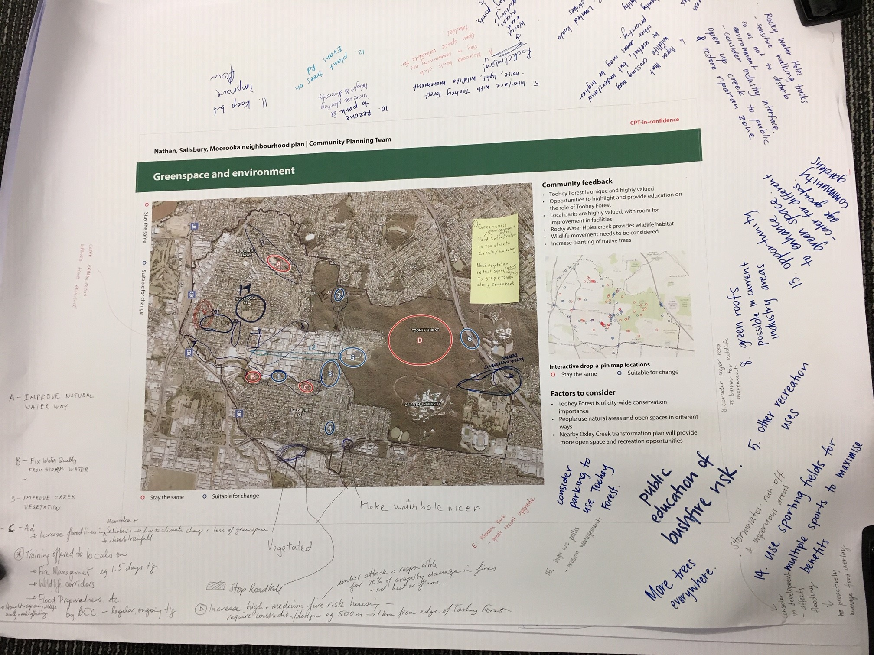
Figure 1: Greenspace and environment Activity 2 sheet

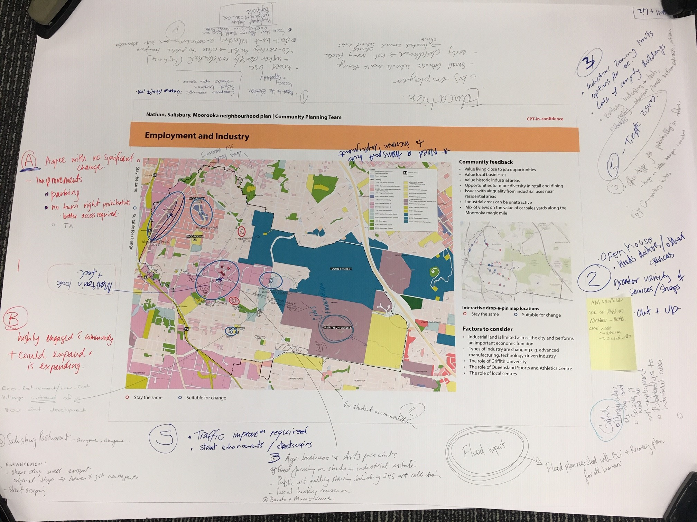
Figure 2: Employment and industry Activity 2 sheet.

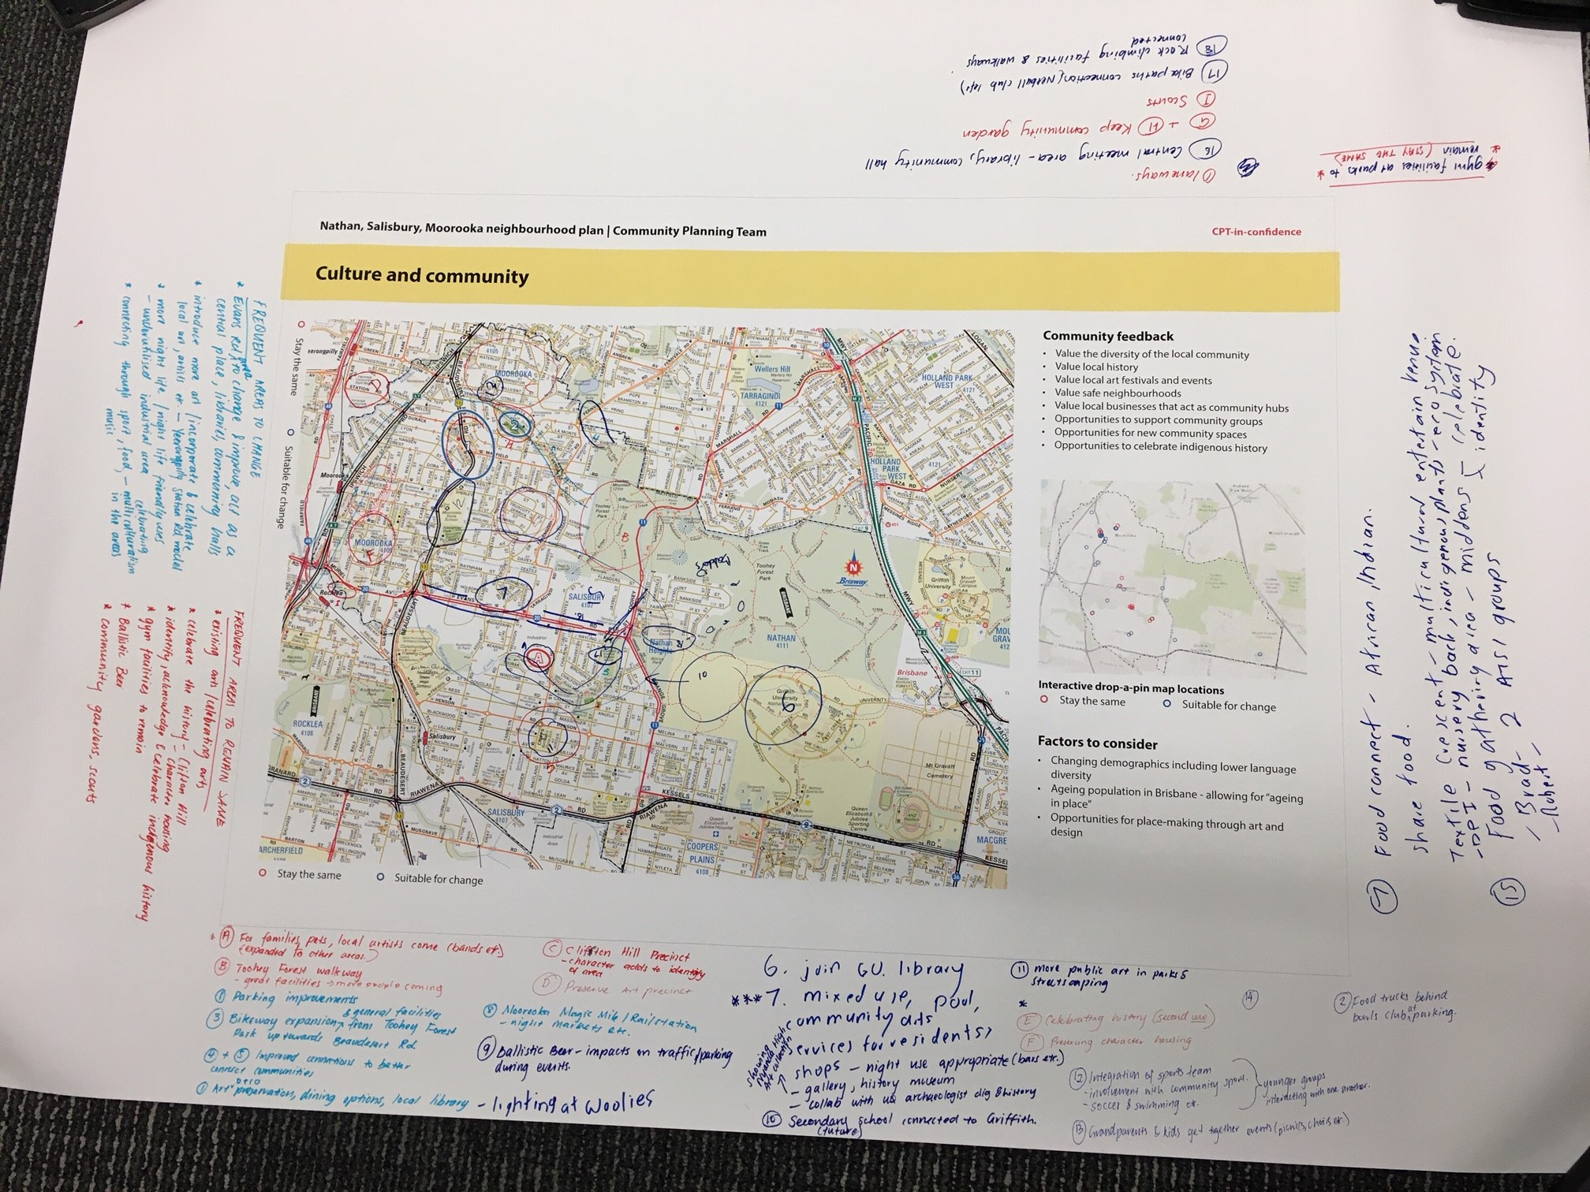
Figure 3: Culture and community Activity 2 sheet.

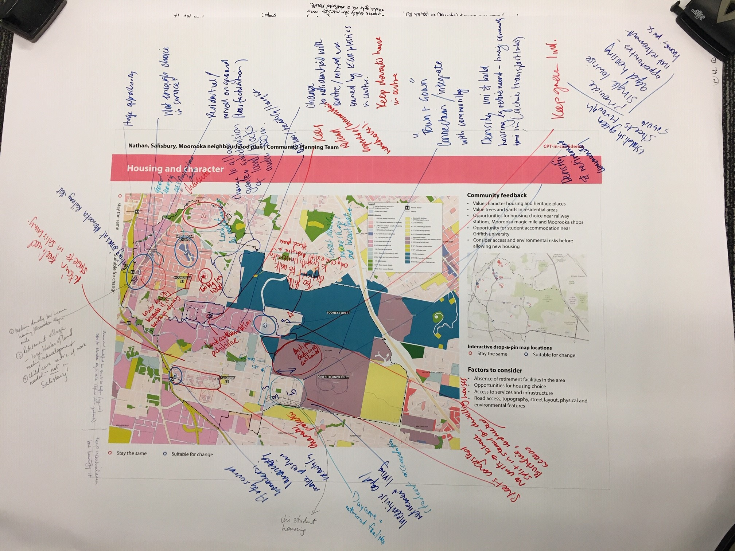
Figure 4: Housing and character Activity 2 sheet.

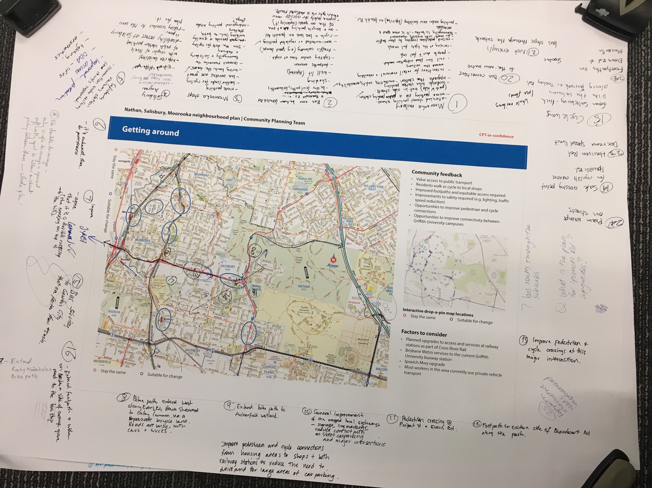
Figure 5: Getting around Activity 2 sheet.

