Brisbane City Plan 2014

Amendment - Infrastructure amendment 1a - Local Government Infrastructure Plan
1. Guide to this document

- In this document, amendments to Brisbane City Plan 2014 (v.22) are detailed as follows:
  - in the Schedule of text amendments:
  - text identified in strikethrough and red highlight (e.g. example) represents text to be omitted;
  - text identified in underlining and green highlight (e.g. example) represents text to be inserted; and
  - in the Schedule of SOW amendments, insertions or omissions are as detailed in the tables; and
  - in the Schedule of mapping amendments, insertions or omissions are as detailed in the tables.
- Text that is preceded by the heading “Reason for change” does not form part of the amendments, and is included as explanatory information about the reason for the proposed amendment only.

SCHEDULE OF TEXT AMENDMENTS

Part 4 Local government infrastructure plan \ 4.5 Plans for trunk infrastructure \ 4.5.3 Editor's note—Extrinsic material
Reason for change: These documents have been updated to reflect the amendment

Column 1  Title of document | Column 2  Date | Column 3  Author
Brisbane City Plan 2014  Local Government Infrastructure Plan Extrinsic Material  Stormwater network | June 2018 December 2021 | Brisbane City Council
Brisbane City Plan 2014  Local Government Infrastructure Plan Extrinsic Material  Transport network | June 2018 December 2021 | Brisbane City Council
Brisbane City Plan 2014  Local Government Infrastructure Plan Extrinsic Material  Public parks and land for community facilities network | June 2018 December 2021 | Brisbane City Council
Brisbane City Plan 2014  Local Government Infrastructure Plan Extrinsic Material  Planning Assumptions | June 2018 | Brisbane City Council
Brisbane City Plan 2014  Local Government Infrastructure Plan Extrinsic Material  Schedule of works model | June 2018 December 2021 | Brisbane City Council
Brisbane City Plan 2014  Local Government Infrastructure Plan Extrinsic Material  Interim amendment 1a | December 2021 | Brisbane City Council

Schedule 3 Local government infrastructure plan mapping and tables \ SC3.1 Planning assumption tables

Table SC3.1.7—Existing and project demand for the transport network (road network)

Reason for change: These figures have been updated to reflect minor changes to the road network SoW.

Column 1 | Column 2
Service catchment | Existing and projected demand (vehicle trips per day)
 | 2016 (base date) | 2021 | 2026 | 2031 | Ultimate development
1 | 400,068 | 409,109401,627 | 418,151403,185 | 437,191421,544 | 580,600
2 | 76,888 | 78,81678,191 | 80,74579,494 | 83,99982,698 | 84,242
3 | 296,785 | 324,696341,299 | 352,607385,812 | 379,712415,469 | 581,695
4 | 268,520 | 270,447284,483 | 272,374300,446 | 283,918313,179 | 395,728
5 | 239,216 | 254,968260,042 | 270,720280,868 | 285,807296,520 | 394,952
6 | 428,682 | 445,138430,241 | 461,595431,799 | 489,577457,975 | 655,490
7 | 560,299 | 581,921581,874 | 603,542603,448 | 638,914638,814 | 767,913
8 | 1,111,403 | 1,193,8371,258,047 | 1,276,2711404,691 | 1,368,8471506,582 | 1,738,143
9 | 214,720 | 230,101249,795 | 245,481284,870 | 268,846311,984 | 367,118
10 | 430,033 | 462,255466,530 | 494,477503,026 | 535,463544,721 | 775,461
11 | 209,368 | 214,625224,590 | 219,882239,811 | 226,302246,813 | 293,326
12 | 132,327 | 133,465138,503 | 134,602144,679 | 141,271151,847 | 162,920
13 | 204,861 | 213,075212,207 | 221,289219,553 | 244,454242,537 | 386,383
14 | 381,068 | 396,446420,789 | 411,824460,510 | 433,715484,989 | 708,025
15 | 526,197 | 534,455548,044 | 542,712569,892 | 573,005601,701 | 827,583
16 | 701,732 | 768,000798,826 | 834,269895,920 | 879,144944,112 | 1,280,345
17 | 71,445 | 71,59772,565 | 71,74873,686 | 73,41275,394 | 97,725
Citywide | 6,253,612 | 6,582,9516,767,651 | 6,912,2907,281,691 | 7,343,5777,736,881 | 10,097,649

Appendix 2 Table of amendments

Table AP2.1—Table of amendments

Reason for change: This section has been updated to reflect the amendment.

23 November 2023 (adoption) and 10 December 2021 (effective) | 23.00/2021 | Interim local government infrastructure plan amendment | Interim amendment to Brisbane City Plan 2014: Local government infrastructure plan (LGIP) (Section 17 of the Planning Act 2016).  Refer to Amendment 23.00/2021 for further detail.

Schedule of SOW amendments

Part 4 Local government infrastructure plan \ 4.5 Plans for trunk infrastructure \ 4.5.2 Schedule of works \ Table 4.5.2.1—Schedules of works for future trunk infrastructure

and

Schedule 3 Local government infrastructure plan mapping and tables \ SC3.2 Schedules of works \ Table SC3.2.1—Schedules of works for future trunk infrastructure
Excel tables linked in Column 2

Table 1: Insert the following rows into Table SW1 – Stormwater network schedule of works for future trunk infrastructure in alphabetical order of the LGIP ID
LGIP ID ⁽¹⁾ | Map reference | Suburb | Project description | Service catchment | Estimated year of completion ⁽²⁾ | Diameter (mm) | Height (mm) | Length (m) | Area (m²) | Establishment cost ($) ⁽³⁾ | Reason for change
BNE-PR-008 | SW192 | Brisbane City | Pipe - Relief | Citywide | 2021 - 2026 | 1,500 | - | 124 | - | 469,686 | Refer to note 3
BNE-PR-009 | SW192 | Brisbane City | Pipe - Relief | Citywide | 2021 - 2026 | 1,350 | - | 108 | - | 652,465 | Refer to note 3
BNE-PR-010 | SW192, SW193 | Brisbane City | Pipe - Relief | Citywide | 2021 - 2026 | 1,500 | - | 303 | - | 2,180,631 | Refer to note 3
GAP-PN-001 | SW170 | The Gap | Pipe - New | Breakfast Creek | 2021 - 2026 | 1,800 | 1,500 | 56 | - | 270,079 | Refer to note 3
GAP-PN-002 | SW170 | The Gap | Pipe - New | Breakfast Creek | 2021 - 2026 | 1,500 | - | 31 | - | 223,100 | Refer to note 3
GAP-PN-003 | SW170 | The Gap | Pipe - New | Breakfast Creek | 2021 - 2026 | 1,500 | - | 10 | - | 80,862 | Refer to note 3
GAP-PN-004 | SW170 | The Gap | Pipe - New | Breakfast Creek | 2021 - 2026 | 1,050 | - | 10 | - | 50,641 | Refer to note 3
GAP-PN-005 | SW170 | The Gap | Pipe - New | Breakfast Creek | 2021 - 2026 | 1,200 | - | 55 | - | 285,559 | Refer to note 3
GAP-PN-006 | SW170 | The Gap | Pipe - New | Breakfast Creek | 2021 - 2026 | 1,200 | - | 17 | - | 93,221 | Refer to note 3
GAP-PN-007 | SW170 | The Gap | Pipe - New | Breakfast Creek | 2021 - 2026 | 1,200 | - | 13 | - | 71,289 | Refer to note 3
GAP-PN-008 | SW170 | The Gap | Pipe - New | Breakfast Creek | 2021 - 2026 | 1,050 | - | 16 | - | 76,163 | Refer to note 3
GAP-PN-009 | SW170 | The Gap | Pipe - New | Breakfast Creek | 2021 - 2026 | 1,050 | - | 40 | - | 180,282 | Refer to note 3
GAP-PN-010 | SW170 | The Gap | Pipe - New | Breakfast Creek | 2021 - 2026 | 1,800 | - | 9 | - | 92,662 | Refer to note 3
GAP-PN-011 | SW170 | The Gap | Pipe - New | Breakfast Creek | 2021 - 2026 | 1,050 | - | 38 | - | 171,268 | Refer to note 3
GAP-PN-012 | SW170 | The Gap | Pipe - New | Breakfast Creek | 2021 - 2026 | 1,050 | - | 12 | - | 57,125 | Refer to note 3
GAP-PN-013 | SW170 | The Gap | Pipe - New | Breakfast Creek | 2021 - 2026 | 1,050 | - | 18 | - | 85,687 | Refer to note 3
GAP-PN-014 | SW170 | The Gap | Pipe - New | Breakfast Creek | 2021 - 2026 | 1,050 | - | 11 | - | 52,363 | Refer to note 3
GAP-PN-015 | SW170 | The Gap | Pipe - New | Breakfast Creek | 2021 - 2026 | 1,050 | - | 38 | - | 171,268 | Refer to note 3
GAP-PN-016 | SW170 | The Gap | Pipe - New | Breakfast Creek | 2021 - 2026 | 1,500 | 1,200 | 25 | - | 100,013 | Refer to note 3
GAP-PN-017 | SW170 | The Gap | Pipe - New | Breakfast Creek | 2021 - 2026 | 1,500 | 1,200 | 26 | - | 104,016 | Refer to note 3
GAP-PN-018 | SW170 | The Gap | Pipe - New | Breakfast Creek | 2021 - 2026 | 1,650 | - | 23 | - | 201,406 | Refer to note 3
NUN-PN-001 | SW134 | Nundah | Pipe - New | Kedron Brook | 2021 - 2026 | 1,200 | - | 13 | - | 37,520 | Refer to note 3
NUN-PN-002 | SW134 | Nundah | Pipe - New | Kedron Brook | 2021 - 2026 | 1,200 | - | 57 | - | 155,759 | Refer to note 3
NUN-PN-003 | SW134 | Nundah | Pipe - New | Kedron Brook | 2021 - 2026 | 1,200 | - | 26 | - | 75,040 | Refer to note 3
NUN-PN-004 | SW134 | Nundah | Pipe - New | Kedron Brook | 2021 - 2026 | 1,200 | - | 18 | - | 51,950 | Refer to note 3
NUN-PN-005 | SW134 | Nundah | Pipe - New | Kedron Brook | 2021 - 2026 | 1,200 | - | 162 | - | 442,682 | Refer to note 3
NUN-PN-006 | SW134 | Nundah | Pipe - New | Kedron Brook | 2021 - 2026 | 1,200 | - | 8 | - | 24,562 | Refer to note 3
NUN-PN-007 | SW134 | Nundah | Pipe - New | Kedron Brook | 2021 - 2026 | 1,200 | - | 19 | - | 54,835 | Refer to note 3
NUN-PN-008 | SW134 | Nundah | Pipe - New | Kedron Brook | 2021 - 2026 | 1,200 | - | 155 | - | 423,554 | Refer to note 3
NUN-PN-009 | SW134 | Nundah | Pipe - New | Kedron Brook | 2021 - 2026 | 1,050 | - | 31 | - | 73,536 | Refer to note 3
NUN-PN-010 | SW134 | Nundah | Pipe - New | Kedron Brook | 2021 - 2026 | 1,800 | 600 | 17 | - | 86,594 | Refer to note 3
NUN-PN-011 | SW134 | Nundah | Pipe - New | Kedron Brook | 2021 - 2026 | 1,050 | - | 45 | - | 106,748 | Refer to note 3
PAL-CU-005 | SW312 | Pallara | Culvert | Oxley Creek | 2021 - 2026 | 2,700 | - | 20 | - | 462,974 | Refer to note 3
PAL-CU-008 | SW312 | Pallara | Culvert | Oxley Creek | 2021 - 2026 | 2,700 | - | 20 | - | 567,354 | Refer to note 3
PAL-CU-010 | SW312 | Pallara | Culvert | Oxley Creek | 2021 - 2026 | 1,500 | 900 | 17 | - | 252,732 | Refer to note 3
PAL-CU-011 | SW312 | Pallara | Culvert | Oxley Creek | 2021 - 2026 | 1,800 | 600 | 20 | - | 332,862 | Refer to note 3
PAL-NC-001 | SW312 | Pallara | Natural channel | Oxley Creek | 2021 - 2026 | - | - | 400 | 11,885 | 2,845,312 | Refer to note 3
PAL-NC-002 | SW312 | Pallara | Natural channel | Oxley Creek | 2021 - 2026 | - | - | 475 | 26,500 | 2,474,422 | Refer to note 3
PAL-NC-003 | SW312 | Pallara | Natural channel | Oxley Creek | 2021 - 2026 | - | - | 423 | 25,100 | 2,116,448 | Refer to note 3
PAL-PN-001 | SW312 | Pallara | Pipe - New | Oxley Creek | 2021 - 2026 | 1,050 | - | 200 | - | 474,430 | Refer to note 3
PAL-PN-002 | SW312 | Pallara | Pipe - New | Oxley Creek | 2021 - 2026 | 1,350 | - | 200 | - | 635,929 | Refer to note 3
PAL-PN-003 | SW312 | Pallara | Pipe - New | Oxley Creek | 2021 - 2026 | 1,350 | - | 200 | - | 1,208,266 | Refer to note 3
PAL-PN-004 | SW312 | Pallara | Pipe - New | Oxley Creek | 2021 - 2026 | 1,350 | - | 15 | - | 141,049 | Refer to note 3
PAL-PN-005 | SW312 | Pallara | Pipe - New | Oxley Creek | 2021 - 2026 | 1,350 | - | 104 | - | 925,914 | Refer to note 3
PAL-PN-006 | SW312 | Pallara | Pipe - New | Oxley Creek | 2021 - 2026 | 1,350 | - | 110 | - | 979,333 | Refer to note 3
PAL-PN-007 | SW312 | Pallara | Pipe - New | Oxley Creek | 2021 - 2026 | 1,500 | 900 | 60 | - | 636,349 | Refer to note 3
PAL-PN-008 | SW312 | Pallara | Pipe - New | Oxley Creek | 2021 - 2026 | 1,350 | - | 20 | - | 127,614 | Refer to note 3
PAL-PN-009 | SW312 | Pallara | Pipe - New | Oxley Creek | 2021 - 2026 | 1,350 | - | 195 | - | 1,178,060 | Refer to note 3
PAL-PN-010 | SW312, SW332 | Pallara | Pipe - New | Oxley Creek | 2021 - 2026 | 1,350 | - | 111 | - | 352,941 | Refer to note 3
PAL-PN-011 | SW312, SW332 | Pallara | Pipe - New | Oxley Creek | 2021 - 2026 | 1,350 | - | 340 | - | 1,081,081 | Refer to note 3
PAL-PN-012 | SW312,SW332 | Pallara | Pipe - New | Oxley Creek | 2021 - 2026 | 1,350 | - | 120 | - | 381,560 | Refer to note 3
PAL-PN-013 | SW312, SW332 | Pallara | Pipe - New | Oxley Creek | 2021 - 2026 | 1,350 | - | 25 | - | 159,519 | Refer to note 3
PAL-PN-014 | SW312,SW332 | Pallara | Pipe - New | Oxley Creek | 2021 - 2026 | 1,350 | - | 80 | - | 483,306 | Refer to note 3
PAL-PN-015 | SW312, SW332 | Pallara | Pipe - New | Oxley Creek | 2021 - 2026 | 1,350 | - | 45 | - | 271,859 | Refer to note 3
PAL-WL-001 | SW312 | Pallara | Wetland | Oxley Creek | 2021 - 2026 | - | - | - | 16,800 | 1,835,392 | Refer to note 3
RHI-PN-001 | SW172 | Red Hill | Pipe - New | Breakfast Creek | 2021 - 2026 | 1,500 | - | 85 | - | 321,962 | Refer to note 3
RHI-PN-002 | SW172 | Red Hill | Pipe - New | Breakfast Creek | 2021 - 2026 | 1,500 | - | 76 | - | 287,871 | Refer to note 3
RHI-PN-003 | SW172, SW171 | Red Hill | Pipe - New | Breakfast Creek | 2021 - 2026 | 1,500 | - | 44 | - | 166,664 | Refer to note 3
RHI-PN-004 | SW171 | Red Hill | Pipe - New | Breakfast Creek | 2021 - 2026 | 1,500 | - | 69 | - | 261,358 | Refer to note 3
RHI-PN-005 | SW171 | Red Hill | Pipe - New | Breakfast Creek | 2021 - 2026 | 1,500 | - | 7 | - | 29,791 | Refer to note 3
RHI-PN-006 | SW172 | Red Hill | Pipe - New | Breakfast Creek | 2021 - 2026 | 1,500 | - | 53 | - | 200,752 | Refer to note 3
VIR-PN-001 | SW114 | Virginia | Pipe - New | Kedron Brook | 2021 - 2026 | 1,500 | 900 | 24 | - | 96,015 | Refer to note 3
VIR-PN-002 | SW114 | Virginia | Pipe - New | Kedron Brook | 2021 - 2026 | 1,500 | 1,200 | 33 | - | 124,996 | Refer to note 3
VIR-PN-003 | SW114 | Virginia | Pipe - New | Kedron Brook | 2021 - 2026 | 1,500 | 1,200 | 10 | - | 42,560 | Refer to note 3
VIR-PN-004 | SW114 | Virginia | Pipe - New | Kedron Brook | 2021 - 2026 | 2,100 | 1,300 | 33 | - | 385,471 | Refer to note 3
VIR-PN-005 | SW114 | Virginia | Pipe - New | Kedron Brook | 2021 - 2026 | 1,800 | 1,800 | 19 | - | 96,782 | Refer to note 3
VIR-PN-006 | SW114 | Virginia | Pipe - New | Kedron Brook | 2021 - 2026 | 1,650 | - | 10 | - | 49,030 | Refer to note 3

Table 2: Amend the following rows in Table SW1 – Stormwater network schedule of works for future trunk infrastructure, as detailed below
LGIP ID ⁽¹⁾ | Map reference | Suburb | Project description | Service catchment | Estimated year of completion ⁽²⁾ | Diameter (mm) | Height (mm) | Length (m) | Area (m²) | Establishment cost ($) ⁽³⁾ | Reason for change
ACR-PN-001 | SW271 | Acacia Ridge | Pipe - New | Oxley Creek | 2016 - 2021 | 1,350 | - | 53 | - | 156,725  156,724 | Refer to note 6
ACR-PN-002 | SW271 | Acacia Ridge | Pipe - New | Oxley Creek | 2016 - 2021 | 1,350 | - | 208 | - | 618,729  618,730 | Refer to note 6
ACR-PN-005 | SW292 | Acacia Ridge | Pipe - New | Oxley Creek | 2016 - 2021 | 1,350 | - | 56 | - | 166,580  166,579 | Refer to note 6
ACR-PN-008 | SW292 | Acacia Ridge | Pipe - New | Oxley Creek | 2016 - 2021 | 1,050 | - | 51 | - | 113,705  113,706 | Refer to note 6
ALB-PR-084 | SW153 | Albion | Pipe - Relief | Albion | 2016 - 2021 | 1,050 | - | 25 | - | 58,143  58,144 | Refer to note 6
ALB-PR-085 | SW153 | Albion | Pipe - Relief | Albion | 2016 - 2021 | 1,050 | - | 66 | - | 146,121  146,122 | Refer to note 6
ALB-PR-093 | SW153 | Albion | Pipe - Relief | Albion | 2016 - 2021 | 1,650 | - | 81 | - | 1,227,644  1,227,646 | Refer to note 6
ALB-PR-094 | SW153 | Albion | Pipe - Relief | Albion | 2016 - 2021 | 1,650 | - | 73 | - | 1,097,847  1,097,846 | Refer to note 6
ALB-PR-095 | SW153 | Albion | Pipe - Relief | Albion | 2016 - 2021 | 1,650 | - | 12 | - | 53,026  53,027 | Refer to note 6
ALB-PR-096 | SW153 | Albion | Pipe - Relief | Albion | 2016 - 2021 | 1,650 | - | 35 | - | 529,635  529,636 | Refer to note 6
ALB-PR-102 | SW153 | Albion | Pipe - Relief | Albion | 2016 - 2021 | 1,800 | - | 34 | - | 424,078  424,079 | Refer to note 6
ALB-PR-104 | SW153 | Albion | Pipe - Relief | Albion | 2016 - 2021 | 1,800 | - | 20 | - | 273,075  273,076 | Refer to note 6
ALB-PR-109 | SW153 | Albion | Pipe - Relief | Albion | 2016 - 2021 | 1,650 | - | 80 | - | 618,410  618,411 | Refer to note 6
ALB-PR-125 | SW153 | Albion | Pipe - Relief | Albion | 2021 - 2026 | 825 | - | 59 | - | 203,110  203,111 | Refer to note 6
BUL-PR-007 | SW173 | Bulimba | Pipe - Relief | Pashen Creek LSMP | 2016 - 2021 | 1,800 | - | 19 | - | 169,414  169,412 | Refer to note 6
BUL-PR-008 | SW173 | Bulimba | Pipe - Relief | Pashen Creek LSMP | 2016 - 2021 | 1,800 | - | 134 | - | 1,146,872  1,146,873 | Refer to note 6
BUL-PR-010 | SW173 | Bulimba | Pipe - Relief | Pashen Creek LSMP | 2016 - 2021 | 1,800 | - | 62 | - | 528,466  528,465 | Refer to note 6
BUL-PR-024 | SW173 | Bulimba | Pipe - Relief | Pashen Creek LSMP | 2016 - 2021 | 1,500 | - | 115 | - | 1,144,765  1,144,764 | Refer to note 6
BUL-PR-025 | SW174 | Bulimba | Pipe - Relief | Pashen Creek LSMP | 2016 - 2021 | 1,500 | - | 84 | - | 834,254  834,255 | Refer to note 6
BUL-PR-028 | SW173 | Bulimba | Pipe - Relief | Pashen Creek LSMP | 2016 - 2021 | 1,500 | - | 41 | - | 408,928  408,930 | Refer to note 6
CHE-PR-047 | SW112 | Chermside | Pipe - Relief | Nundah Downfall Creek | 2021 - 2026 | 1,350 | - | 55 | - | 175,196  175,197 | Refer to note 6
COO-PR-122 | SW213 | Coorparoo | Pipe - Relief | Norman Creek | 2021 - 2026 | 1,800 | - | 63 | - | 302,156  302,154 | Refer to note 6
DOO-PR-009 | SW311 | Doolandella | Pipe - Relief | Doolandella | 2016 - 2021 | 1,500 | - | 76 | - | 268,280  268,281 | Refer to note 6
DOO-PR-030 | SW311 | Doolandella | Pipe - Relief | Doolandella | 2016 - 2021 | 1,200 | - | 24 | - | 63,648  63,646 | Refer to note 6
DOO-PR-036 | SW311 | Doolandella | Pipe - Relief | Doolandella | 2016 - 2021 | 1,200 | - | 177 | - | 452,411  452,412 | Refer to note 6
DOO-PR-037 | SW311 | Doolandella | Pipe - Relief | Doolandella | 2016 - 2021 | 1,650 | - | 101 | - | 413,627  413,626 | Refer to note 6
EVP-PR-025 | SW111 | Everton Park | Pipe - Relief | Nundah Downfall Creek | 2021 - 2026 | 1,650 | - | 33 | - | 142,994  142,996 | Refer to note 6
FVA-PR-005 | SW173 | Fortitude Valley, Bowen Hills | Pipe - Relief | INES | 2021 - 2026 | 2,100 | - | 93 | - | 573,626  573,627 | Refer to note 6
FVA-PR-015 | SW173 | Fortitude Valley | Pipe - Relief | INES | 2021 - 2026 | 1,050 | - | 36 | - | 85,132  85,133 | Refer to note 6
FVA-PR-018 | SW173 | Fortitude Valley | Pipe - Relief | INES | 2021 - 2026 | 1,200 | - | 39 | - | 106,659  106,660 | Refer to note 6
FVA-PR-019 | SW173 | Fortitude Valley | Pipe - Relief | INES | 2021 - 2026 | 1,350 | - | 150 | - | 476,092  476,094 | Refer to note 6
FVA-PR-022 | SW173 | Fortitude Valley | Pipe - Relief | INES | 2021 - 2026 | 1,800 | - | 51 | - | 244,976  244,975 | Refer to note 6
FVA-PR-023 | SW173 | Fortitude Valley, Newstead | Pipe - Relief | INES | 2021 - 2026 | 1,800 | - | 89 | - | 427,376  427,375 | Refer to note 6
FVA-PR-024 | SW173 | Fortitude Valley, Newstead | Pipe - Relief | INES | 2021 - 2026 | 2,100 | - | 142 | - | 875,799  875,801 | Refer to note 6
FVA-PR-025 | SW173 | Fortitude Valley | Pipe - Relief | INES | 2021 - 2026 | 1,800 | - | 16 | - | 79,942  79,941 | Refer to note 6
FVA-PR-026 | SW173 | Fortitude Valley | Pipe - Relief | INES | 2021 - 2026 | 2,100 | - | 109 | - | 672,262  672,264 | Refer to note 6
FVA-PR-027 | SW173 | Fortitude Valley | Pipe - Relief | INES | 2021 - 2026 | 1,050 | - | 105 | - | 250,011  250,010 | Refer to note 6
FVA-PR-028 | SW173 | Fortitude Valley | Pipe - Relief | INES | 2021 - 2026 | 2,400 | - | 119 | - | 803,669  803,668 | Refer to note 6
FVA-PR-029 | SW173 | Fortitude Valley | Pipe - Relief | INES | 2021 - 2026 | 3,000 | - | 76 | - | 707,432  707,431 | Refer to note 6
FVA-PR-032 | SW173 | Fortitude Valley | Pipe - Relief | INES | 2021 - 2026 | 1,800 | - | 32 | - | 155,059  155,058 | Refer to note 6
FVA-PR-034 | SW173 | Fortitude Valley | Pipe - Relief | INES | 2021 - 2026 | 1,050 | - | 32 | - | 75,458  75,460 | Refer to note 6
FVA-PR-035 | SW173 | Fortitude Valley | Pipe - Relief | INES | 2021 - 2026 | 1,050 | - | 175 | - | 415,259  415,260 | Refer to note 6
FVA-PR-038 | SW173 | Fortitude Valley | Pipe - Relief | INES | 2016 - 2021 | 1,200 | - | 41 | - | 200,293  200,294 | Refer to note 6
FVA-PR-041 | SW173 | Fortitude Valley | Pipe - Relief | INES | 2021 - 2026 | 2,100 | - | 133 | - | 818,575  818,576 | Refer to note 6
FVA-PR-042 | SW173 | Fortitude Valley | Pipe - Relief | INES | 2021 - 2026 | 1,800 | - | 10 | - | 51,804  51,803 | Refer to note 6
FVA-PR-051 | SW173 | Fortitude Valley | Pipe - Relief | INES | 2021 - 2026 | 1,050 | - | 3 | - | 9,012  9,013 | Refer to note 6
HEM-CU-005 | SW176 | Hemmant | Culvert | ATC South (a) | 2016 - 2021 | 1,700 | 3,000 | 25 | - | 1,224,869  1,224,868 | Refer to note 6
HEM-CU-008 | SW176 | Hemmant | Culvert | Bulimba Creek | 2021 - 2026 | 1,200 | - | 29 | - | 233,847  233,849 | Refer to note 6
INA-CU-001 | SW290 | Inala, Richlands | Culvert | Richlands (b) | 2021 - 2026 | 1,350 | - | 15 | - | 141,048  141,049 | Refer to note 6
MGE-PR-002 | SW254 | Mount Gravatt East | Pipe - Relief | Norman Creek | 2016 - 2021 | 1,050 | - | 49 | - | 108,497  108,498 | Refer to note 6
MGE-PR-006 | SW254 | Mount Gravatt East | Pipe - Relief | Bulimba Creek | 2016 - 2021 | 1,500 | - | 35 | - | 122,156  122,155 | Refer to note 6
NUN-PR-021 | SW134 | Nundah | Pipe - Relief | Kedron Brook | 2021 - 2026 | 1,500 | - | 93 | - | 352,204  352,205 | Refer to note 6
NUN-PR-029 | SW134 | Nundah | Pipe - Relief | Kedron Brook | 2021 - 2026 | 1,800 | - | 58 | - | 279,966  279,965 | Refer to note 6
NUN-PR-047 | SW134 | Nundah | Pipe - Relief | Kedron Brook | 2021 - 2026 | 1,500 | - | 4 | - | 17,675  17,676 | Refer to note 6
NUN-PR-127 | SW134 | Nundah | Pipe - Relief | Kedron Brook | 2021 - 2026 | 1,800 | - | 41 | - | 197,013  197,012 | Refer to note 6
NUN-PR-128 | SW134 | Nundah | Pipe - Relief | Kedron Brook | 2021 - 2026 | 1,800 | - | 36 | - | 174,587  174,586 | Refer to note 6
NUN-PR-129 | SW134 | Nundah | Pipe - Relief | Kedron Brook | 2021 - 2026 | 1,800 | - | 56 | - | 271,526  271,527 | Refer to note 6
NWS-PR-004 | SW173 | Newstead | Pipe - Relief | INES | 2016 - 2021 | 2,100 | - | 145 | - | 833,015  833,016 | Refer to note 6
NWS-PR-005 | SW173 | Newstead | Pipe - Relief | INES | 2016 - 2021 | 2,700 | - | 6 | - | 47,109  47,110 | Refer to note 6
NWS-PR-008 | SW173 | Newstead | Pipe - Relief | INES | 2021 - 2026 | 2,100 | - | 58 | - | 354,670  354,669 | Refer to note 6
NWS-PR-009 | SW173 | Newstead | Pipe - Relief | INES | 2016 - 2021 | 2,700 | - | 241 | - | 3,415,420  3,415,419 | Refer to note 6
NWS-PR-010 | SW173 | Newstead | Pipe - Relief | INES | 2021 - 2026 | 2,700 | - | 170 | - | 1,355,748  1,355,749 | Refer to note 6
NWS-PR-011 | SW173 | Newstead | Pipe - Relief | INES | 2021 - 2026 | 2,100 | - | 53 | - | 614,254  614,253 | Refer to note 6
NWS-PR-013 | SW173 | Newstead, Fortitude Valley | Pipe - Relief | INES | 2021 - 2026 | 2,400 | - | 81 | - | 1,039,039  1,039,040 | Refer to note 6
NWS-PR-017 | SW173 | Newstead | Pipe - Relief | INES | 2016 - 2021 | 1,950 | - | 26 | - | 141,863  141,865 | Refer to note 6
NWS-PR-018 | SW173 | Newstead | Pipe - Relief | INES | 2016 - 2021 | 1,950 | - | 15 | - | 83,465  83,464 | Refer to note 6
NWS-PR-019 | SW173 | Newstead | Pipe - Relief | INES | 2016 - 2021 | 1,950 | - | 73 | - | 370,367  370,369 | Refer to note 6
NWS-PR-022 | SW173 | Newstead | Pipe - Relief | INES | 2016 - 2021 | 1,950 | - | 47 | - | 238,105  238,104 | Refer to note 6
NWS-PR-023 | SW173 | Newstead | Pipe - Relief | INES | 2016 - 2021 | 1,950 | - | 11 | - | 58,727  58,728 | Refer to note 6
NWS-PR-025 | SW173 | Newstead | Pipe - Relief | INES | 2016 - 2021 | 1,950 | - | 7 | - | 42,600  42,599 | Refer to note 6
NWS-PR-026 | SW173 | Newstead | Pipe - Relief | INES | 2021 - 2026 | 1,200 | - | 72 | - | 195,452  195,453 | Refer to note 6
NWS-PR-027 | SW173 | Newstead | Pipe - Relief | INES | 2021 - 2026 | 1,350 | - | 61 | - | 194,315  194,316 | Refer to note 6
NWS-PR-033 | SW173 | Newstead | Pipe - Relief | INES | 2016 - 2021 | 1,500 | - | 35 | - | 124,787  124,786 | Refer to note 6
NWS-PR-037 | SW173 | Newstead | Pipe - Relief | INES | 2016 - 2021 | 1,500 | - | 27 | - | 100,268  100,266 | Refer to note 6
OXY-PR-046 | SW271 | Oxley | Pipe - Relief | Oxley Creek | 2021 - 2026 | 1,650 | - | 86 | - | 373,132  373,130 | Refer to note 6
OXY-PR-053 | SW271 | Oxley | Pipe - Relief | Oxley Creek | 2021 - 2026 | 2,100 | - | 61 | - | 373,187  373,188 | Refer to note 6
PIN-CC-002 | SW116 | Pinkenba | Concrete Lined Channel | ATCN | 2021 - 2026 | - | - | 231 | - | 224,875  224,876 | Refer to note 6
PIN-CC-009 | SW116 | Pinkenba | Concrete Lined Channel | ATCN | 2021 - 2026 | - | - | 157 | - | 355,409  355,410 | Refer to note 6
PIN-NC-002 | SW116 | Pinkenba | Natural Channel | ATCN | 2021 - 2026 | - | - | 71 | - | 53,156  53,155 | Refer to note 6
PIN-NC-003 | SW116 | Pinkenba | Natural Channel | ATCN | 2021 - 2026 | - | - | 92 | - | 68,168  68,167 | Refer to note 6
RIC-CU-002 | SW290 | Richlands | Culvert | Richlands (a) | 2021 - 2026 | 1,050 | - | 35 | - | 83,486  83,488 | Refer to note 6
RIC-PR-007 | SW290 | Richlands | Pipe - Relief | Richlands (a) | 2021 - 2026 | 1,050 | - | 53 | - | 125,377  125,379 | Refer to note 6
RIC-PR-009 | SW290 | Richlands | Pipe - Relief | Richlands (a) | 2021 - 2026 | 1,350 | - | 48 | - | 152,285  152,284 | Refer to note 6
RIC-PR-129 | SW290 | Richlands | Pipe - Relief | Richlands (a) | 2016 - 2021 | 1,200 | - | 41 | - | 103,902  103,901 | Refer to note 6
RIC-PR-148 | SW290 | Richlands | Pipe - Relief | Richlands (a) | 2021 - 2026 | 1,050 | - | 49 | - | 116,235  116,236 | Refer to note 6
RIC-PR-149 | SW290 | Richlands | Pipe - Relief | Richlands (a) | 2021 - 2026 | 1,500 | - | 49 | - | 185,602  185,604 | Refer to note 6
RIC-PR-150 | SW290 | Richlands | Pipe - Relief | Richlands (a) | 2021 - 2026 | 1,950 | - | 317 | - | 1,729,280  1,729,278 | Refer to note 6
RIC-PR-176 | SW290 | Richlands | Pipe - Relief | Richlands (a) | 2021 - 2026 | 1,200 | - | 46 | - | 124,334  124,333 | Refer to note 6
ROC-BS-002 | SW276, SW275 | Rochedale | Bioretention Swale | Rochedale (d) | 2016 - 2021 | - | - | 854 | - | 280,640  280,641 | Refer to note 6
ROC-PR-144 | SW276 | Rochedale | Pipe - Relief | Rochedale (d) | 2021 - 2026 | 1,050 | - | 28 | - | 71,269  71,270 | Refer to note 6
ROC-PR-154 | SW276 | Rochedale | Pipe - Relief | Rochedale (d) | 2021 - 2026 | 2,400 | - | 92 | - | 1,174,242  1,174,241 | Refer to note 6
ROC-PR-157 | SW276 | Rochedale | Pipe - Relief | Rochedale (d) | 2021 - 2026 | 2,400 | - | 158 | - | 2,014,535  2,014,536 | Refer to note 6
ROC-PR-175 | SW275 | Rochedale | Pipe - Relief | Rochedale (d) | 2021 - 2026 | 1,200 | - | 24 | - | 134,212  134,214 | Refer to note 6
SBR-PR-045 | SW192 | South Brisbane | Pipe - Relief | BBnePrec3 | 2021 - 2026 | 1,200 | - | 33 | - | 169,621  169,622 | Refer to note 6
SBR-PR-051 | SW192 | South Brisbane | Pipe - Relief | West End (b) | 2016 - 2021 | 1,200 | - | 64 | - | 163,486  163,487 | Refer to note 6
SBR-PR-055 | SW192 | South Brisbane | Pipe - Relief | BBnePrec3 | 2016 - 2021 | 2,400 | - | 71 | - | 850,256  850,254 | Refer to note 6
SBR-PR-057 | SW192 | South Brisbane | Pipe - Relief | West End (b) | 2016 - 2021 | 2,400 | - | 93 | - | 1,115,373  1,115,372 | Refer to note 6
SBR-PR-060 | SW192 | South Brisbane | Pipe - Relief | West End (b) | 2016 - 2021 | 2,400 | - | 66 | - | 783,268  783,269 | Refer to note 6
SBR-PR-068 | SW192 | South Brisbane | Pipe - Relief | West End (b) | 2021 - 2026 | 1,050 | - | 54 | - | 244,830  244,829 | Refer to note 6
SBR-PR-069 | SW192 | South Brisbane | Pipe - Relief | West End (b) | 2021 - 2026 | 1,200 | - | 21 | - | 116,860  116,858 | Refer to note 6
SBR-PR-070 | SW192 | South Brisbane | Pipe - Relief | West End (b) | 2021 - 2026 | 1,200 | - | 42 | - | 219,638  219,639 | Refer to note 6
SBR-PR-071 | SW192 | South Brisbane | Pipe - Relief | West End (b) | 2021 - 2026 | 1,200 | - | 67 | - | 348,361  348,360 | Refer to note 6
SBR-PR-074 | SW192 | South Brisbane | Pipe - Relief | BBnePrec3 | 2016 - 2021 | 2,400 | - | 42 | - | 498,372  498,373 | Refer to note 6
SBR-PR-075 | SW192 | South Brisbane | Pipe - Relief | West End (b) | 2016 - 2021 | 1,050 | - | 14 | - | 32,966  32,967 | Refer to note 6
TRF-PR-001 | SW173 | Teneriffe, Newstead | Pipe - Relief | INES | 2016 - 2021 | 1,950 | - | 152 | - | 774,319  774,318 | Refer to note 6
TRF-PR-003 | SW173 | Teneriffe | Pipe - Relief | INES | 2016 - 2021 | 1,050 | - | 7 | - | 18,255  18,257 | Refer to note 6
UMG-PR-023 | SW274 | Upper Mount Gravatt | Pipe - Relief | Bulimba Creek | 2021 - 2026 | 1,200 | - | 88 | - | 240,297  240,298 | Refer to note 6
UMG-PR-024 | SW274 | Upper Mount Gravatt | Pipe - Relief | Bulimba Creek | 2021 - 2026 | 2,100 | - | 6 | - | 43,249  43,250 | Refer to note 6
UMG-PR-033 | SW274 | Upper Mount Gravatt | Pipe - Relief | Bulimba Creek | 2021 - 2026 | 1,200 | - | 12 | - | 35,981  35,982 | Refer to note 6
WCL-PR-120 | SW289 | Wacol | Pipe - Relief | Richlands (c) | 2016 - 2021 | 1,800 | - | 76 | - | 342,631  342,633 | Refer to note 6
WES-PN-025 | SW192, SW191 | West End | Pipe - New | West End (a) | 2021 - 2026 | 1,500 | - | 24 | - | 96,014  96,015 | Refer to note 6
WES-PN-026 | SW192 | West End | Pipe - New | West End (a) | 2021 - 2026 | 1,500 | - | 26 | - | 104,015  104,016 | Refer to note 6
WES-PN-027 | SW192 | West End | Pipe - New | West End (a) | 2021 - 2026 | 1,200 | - | 56 | - | 153,026  153,025 | Refer to note 6
WES-PR-111 | SW192 | West End | Pipe - Relief | West End (a) | 2016 - 2021 | 1,050 | - | 12 | - | 52,710  52,712 | Refer to note 6
WES-PR-112 | SW192 | West End | Pipe - Relief | West End (a) | 2021 - 2026 | 1,050 | - | 37 | - | 167,851  167,852 | Refer to note 6
WES-PR-116 | SW192 | West End | Pipe - Relief | West End (a) | 2021 - 2026 | 1,050 | - | 18 | - | 85,685  85,687 | Refer to note 6
WES-PR-118 | SW192 | West End | Pipe - Relief | West End (a) | 2021 - 2026 | 1,050 | - | 8 | - | 39,136  39,137 | Refer to note 6
WES-PR-119 | SW192 | West End | Pipe - Relief | West End (a) | 2021 - 2026 | 1,050 | - | 33 | - | 147,211  147,212 | Refer to note 6
WES-PR-120 | SW191 | West End | Pipe - Relief | West End (a) | 2021 - 2026 | 1,500 | - | 93 | - | 668,040  668,041 | Refer to note 6
WES-PR-122 | SW192 | West End, South Brisbane | Pipe - Relief | West End (b) | 2021 - 2026 | 1,200 | - | 36 | - | 97,778  97,779 | Refer to note 6
WES-PR-162 | SW192 | West End | Pipe - Relief | West End (b) | 2016 - 2021 | 1,050 | - | 75 | - | 166,530  166,531 | Refer to note 6
WES-PR-164 | SW192 | West End | Pipe - Relief | West End (b) | 2016 - 2021 | 1,050 | - | 85 | - | 188,261  188,260 | Refer to note 6
WES-PR-166 | SW192 | West End | Pipe - Relief | West End (b) | 2016 - 2021 | 1,050 | - | 18 | - | 43,093  43,095 | Refer to note 6
WES-PR-167 | SW192 | West End | Pipe - Relief | West End (b) | 2016 - 2021 | 750 | - | 16 | - | 50,043  50,044 | Refer to note 6
WES-PR-168 | SW192 | West End | Pipe - Relief | West End (b) | 2016 - 2021 | 825 | - | 11 | - | 38,727  38,726 | Refer to note 6
WES-PR-170 | SW192 | West End | Pipe - Relief | West End (b) | 2016 - 2021 | 750 | - | 30 | - | 90,134  90,133 | Refer to note 6
WES-PR-171 | SW192 | West End | Pipe - Relief | West End (b) | 2016 - 2021 | 825 | - | 5 | - | 16,656  16,657 | Refer to note 6
WES-PR-172 | SW192 | West End | Pipe - Relief | West End (b) | 2016 - 2021 | 825 | - | 5 | - | 16,772  16,771 | Refer to note 6
WIL-NC-001 | SW291 | Willawong | Natural Channel | Oxley Creek | 2016 - 2021 | - | - | 192 | - | 122,524  122,523 | Refer to note 6
WIL-PN-016 | SW292 | Willawong | Pipe - New | Oxley Creek | 2021 - 2026 | 1,350 | - | 40 | - | 127,162  127,160 | Refer to note 6
WIL-PN-017 | SW292 | Willawong | Pipe - New | Oxley Creek | 2021 - 2026 | 1,350 | - | 39 | - | 124,671  124,669 | Refer to note 6
WIL-PN-018 | SW292 | Willawong | Pipe - New | Oxley Creek | 2021 - 2026 | 1,200 | - | 41 | - | 111,075  111,074 | Refer to note 6
WIL-PN-028 | SW292 | Willawong | Pipe - New | Oxley Creek | 2016 - 2021 | 1,350 | - | 64 | - | 189,958  189,960 | Refer to note 6
WIL-PN-029 | SW292 | Willawong | Pipe - New | Oxley Creek | 2016 - 2021 | 1,350 | - | 57 | - | 168,977  168,979 | Refer to note 6
WIL-PN-031 | SW292 | Willawong | Pipe - New | Oxley Creek | 2016 - 2021 | 1,050 | - | 57 | - | 125,485  125,486 | Refer to note 6
WIL-PR-026 | SW292 | Willawong | Pipe - Relief | Oxley Creek | 2021 - 2026 | 1,500 | - | 20 | - | 78,069  78,070 | Refer to note 6
WIL-PR-028 | SW292 | Willawong | Pipe - Relief | Oxley Creek | 2021 - 2026 | 1,350 | - | 83 | - | 263,193  263,192 | Refer to note 6
WIL-PR-029 | SW292 | Willawong | Pipe - Relief | Oxley Creek | 2021 - 2026 | 1,200 | - | 82 | - | 222,844  222,845 | Refer to note 6
WOO-PR-009 | SW213 | Woolloongabba | Pipe - Relief | Norman Creek | 2021 - 2026 | 1,050 | - | 31 | - | 73,821  73,822 | Refer to note 6
WOO-PR-010 | SW213 | Woolloongabba | Pipe - Relief | Norman Creek | 2021 - 2026 | 1,050 | - | 27 | - | 66,519  66,521 | Refer to note 6
WOO-PR-017 | SW213 | Woolloongabba | Pipe - Relief | Norman Creek | 2021 - 2026 | 1,200 | - | 80 | - | 217,351  217,350 | Refer to note 6
WOO-PR-018 | SW213 | Woolloongabba | Pipe - Relief | Norman Creek | 2021 - 2026 | 1,800 | - | 137 | - | 658,317  658,316 | Refer to note 6
WOO-PR-086 | SW213 | Woolloongabba | Pipe - Relief | Norman Creek | 2021 - 2026 | 2,100 | - | 53 | - | 323,746  323,747 | Refer to note 6
WOO-PR-087 | SW193 | Woolloongabba | Pipe - Relief | Norman Creek | 2021 - 2026 | 2,100 | - | 27 | - | 174,668  174,669 | Refer to note 6
WOO-PR-119 | SW213 | Woolloongabba, East Brisbane | Pipe - Relief | Norman Creek | 2021 - 2026 | 2,400 | - | 95 | - | 636,231  636,232 | Refer to note 6
WOO-PR-125 | SW193 | Woolloongabba | Pipe - Relief | Norman Creek | 2021 - 2026 | 2,100 | - | 21 | - | 137,007  137,008 | Refer to note 6
WOO-PR-126 | SW193 | Woolloongabba | Pipe - Relief | Norman Creek | 2021 - 2026 | 2,100 | - | 21 | - | 137,007  137,008 | Refer to note 6
WOO-PR-142 | SW213 | Woolloongabba | Pipe - Relief | Norman Creek | 2021 - 2026 | 2,100 | - | 40 | - | 246,529  246,528 | Refer to note 6
WOO-PR-143 | SW213 | Woolloongabba | Pipe - Relief | Norman Creek | 2021 - 2026 | 1,800 | - | 37 | - | 176,516  176,514 | Refer to note 6
WOO-PR-148 | SW213 | Woolloongabba | Pipe - Relief | Norman Creek | 2021 - 2026 | 1,800 | - | 34 | - | 164,459  164,458 | Refer to note 6
WOO-PR-151 | SW213 | Woolloongabba | Pipe - Relief | Norman Creek | 2021 - 2026 | 1,800 | - | 61 | - | 293,614  293,613 | Refer to note 6
WOO-PR-154 | SW213 | Woolloongabba | Pipe - Relief | Norman Creek | 2021 - 2026 | 2,100 | - | 22 | - | 140,968  140,969 | Refer to note 6
WOO-PR-155 | SW213 | Woolloongabba | Pipe - Relief | Norman Creek | 2021 - 2026 | 2,100 | - | 36 | - | 220,339  220,338 | Refer to note 6
WOO-PR-156 | SW213 | Woolloongabba | Pipe - Relief | Norman Creek | 2021 - 2026 | 2,100 | - | 10 | - | 66,621  66,622 | Refer to note 6
WOO-PR-159 | SW213 | Woolloongabba | Pipe - Relief | Norman Creek | 2021 - 2026 | 1,800 | - | 27 | - | 135,393  135,394 | Refer to note 6
WOO-PR-160 | SW213 | Woolloongabba | Pipe - Relief | Norman Creek | 2021 - 2026 | 1,800 | - | 26 | - | 131,980  131,981 | Refer to note 6
WOO-PR-161 | SW213 | Woolloongabba | Pipe - Relief | Norman Creek | 2021 - 2026 | 1,800 | - | 8 | - | 41,401  41,400 | Refer to note 6
WOO-PR-171 | SW213 | Woolloongabba | Pipe - Relief | Norman Creek | 2021 - 2026 | 2,100 | - | 64 | - | 391,188  391,187 | Refer to note 6
WYN-PR-001 | SW177 | Wynnum | Pipe - Relief | Wynnum | 2021 - 2026 | 1,950 | - | 157 | - | 858,618  858,616 | Refer to note 6

Table 3: Delete the following rows of Table SW1 – Stormwater network schedule of works for future trunk infrastructure
LGIP ID ⁽¹⁾ | Map reference | Suburb | Project description | Service catchment | Estimated year of completion ⁽²⁾ | Diameter (mm) | Height (mm) | Length (m) | Area (m²) | Establishment cost ($) ⁽³⁾ | Reason for change
ALB-SQ-002 | SW153 | Albion | SQID | Albion | 2016 - 2021 | - | - | - | - | 106,534 | Refer to note 1
ALB-SQ-003 | SW153 | Albion | SQID | Albion | 2016 - 2021 | - | - | - | - | 1,134,411 | Refer to note 1
ALB-SQ-005 | SW153 | Albion | SQID | Albion | 2016 - 2021 | - | - | - | - | 106,351 | Refer to note 1
ALB-SQ-008 | SW153 | Albion | SQID | Albion | 2021 - 2026 | - | - | - | - | 214,900 | Refer to note 1
HAM-SQ-001 | SW153 | Hamilton | SQID | Albion | 2021 - 2026 | - | - | - | - | 404,518 | Refer to note 1
ROC-CU-003 | SW275 | Rochedale | Culvert | Rochedale (c) | 2016 - 2021 | 2,100 | 3,300 | 21 | - | 610,795 | Refer to note 1
ROC-PR-149 | SW276 | Rochedale | Pipe - Relief | Rochedale (d) | 2021 - 2026 | 1,050 | - | 55 | - | 131,408 | Refer to note 1
ROC-PR-187 | SW275 | Rochedale | Pipe - Relief | Rochedale (c) | 2016 - 2021 | 1,200 | - | 58 | - | 148,162 | Refer to note 1
ROC-PR-190 | SW275 | Rochedale | Pipe - Relief | Rochedale (c) | 2016 - 2021 | 1,500 | - | 24 | - | 91,114 | Refer to note 1
ROC-SQ-008 | SW275 | Rochedale | SQID | Rochedale (c) | 2021 - 2026 | - | - | - | - | 85,974 | Refer to note 1
YER-PR-029 | SW232 | Yeronga | Pipe - Relief | BBnePrec3 | 2016 - 2021 | 1,500 | - | 44 | - | 155,294 | Refer to note 1
YER-PR-030 | SW232 | Yeronga | Pipe - Relief | BBnePrec3 | 2016 - 2021 | 1,500 | - | 47 | - | 165,428 | Refer to note 1
YER-PR-031 | SW232 | Yeronga | Pipe - Relief | BBnePrec3 | 2016 - 2021 | 1,500 | - | 7 | - | 29,619 | Refer to note 1
YER-PR-032 | SW232 | Yeronga | Pipe - Relief | BBnePrec3 | 2016 - 2021 | 1,500 | - | 80 | - | 282,149 | Refer to note 1
YER-PR-034 | SW232 | Yeronga | Pipe - Relief | BBnePrec3 | 2016 - 2021 | 1,650 | - | 9 | - | 42,038 | Refer to note 1
YER-PR-035 | SW232 | Yeronga | Pipe - Relief | BBnePrec3 | 2016 - 2021 | 1,650 | - | 47 | - | 190,809 | Refer to note 1
YER-PR-036 | SW232 | Yeronga | Pipe - Relief | BBnePrec3 | 2016 - 2021 | 1,650 | - | 10 | - | 43,830 | Refer to note 1
YER-PR-037 | SW232 | Yeronga | Pipe - Relief | BBnePrec3 | 2016 - 2021 | 1,650 | - | 7 | - | 33,843 | Refer to note 1
YER-PR-047 | SW232 | Yeronga | Pipe - Relief | BBnePrec3 | 2016 - 2021 | 1,800 | - | 11 | - | 53,301 | Refer to note 1
YER-PR-048 | SW232 | Yeronga | Pipe - Relief | BBnePrec3 | 2016 - 2021 | 1,800 | - | 7 | - | 34,243 | Refer to note 1
YER-PR-049 | SW232 | Yeronga | Pipe - Relief | BBnePrec3 | 2016 - 2021 | 1,800 | - | 20 | - | 95,155 | Refer to note 1
YER-PR-050 | SW232 | Yeronga | Pipe - Relief | BBnePrec3 | 2016 - 2021 | 1,800 | - | 25 | - | 119,273 | Refer to note 1
YER-PR-051 | SW232 | Yeronga | Pipe - Relief | BBnePrec3 | 2016 - 2021 | 1,800 | - | 64 | - | 287,427 | Refer to note 1
YER-PR-052 | SW232 | Yeronga | Pipe - Relief | BBnePrec3 | 2016 - 2021 | 1,800 | - | 14 | - | 67,853 | Refer to note 1
YER-PR-053 | SW232 | Yeronga | Pipe - Relief | BBnePrec3 | 2016 - 2021 | 1,800 | - | 66 | - | 299,189 | Refer to note 1
YER-PR-056 | SW232 | Yeronga | Pipe - Relief | BBnePrec3 | 2016 - 2021 | 1,800 | - | 14 | - | 64,996 | Refer to note 1
YER-PR-057 | SW232 | Yeronga | Pipe - Relief | BBnePrec3 | 2016 - 2021 | 1,800 | - | 59 | - | 264,750 | Refer to note 1
YER-PR-058 | SW232 | Yeronga | Pipe - Relief | BBnePrec3 | 2016 - 2021 | 1,800 | - | 8 | - | 38,878 | Refer to note 1
YER-PR-059 | SW232 | Yeronga | Pipe - Relief | BBnePrec3 | 2016 - 2021 | 1,800 | - | 43 | - | 193,082 | Refer to note 1
YER-PR-060 | SW232 | Yeronga | Pipe - Relief | BBnePrec3 | 2016 - 2021 | 1,800 | - | 33 | - | 150,469 | Refer to note 1
YER-PR-061 | SW232 | Yeronga | Pipe - Relief | BBnePrec3 | 2016 - 2021 | 1,800 | - | 72 | - | 324,747 | Refer to note 1
YER-PR-062 | SW232 | Yeronga | Pipe - Relief | BBnePrec3 | 2016 - 2021 | 1,800 | - | 10 | - | 49,649 | Refer to note 1

Table SW1 Stormwater network schedule of works for future trunk infrastructure

Reason for Change – Inserting relevant effective date
Table SW1 – Stormwater network schedule of works for future trunk infrastructure
Effective 29 June 2018 10 December 2021

Table 4: Insert the following rows into Table R1 – Transport network (road network) schedule of works for future trunk infrastructure in alphabetical order of the LGIP ID
LGIP ID ⁽¹⁾ | Map reference | Suburb | Project description | Project type | Estimated year of completion ⁽²⁾ | Service Catchment | Establishment cost ($) ⁽³⁾ | Reason for change
BOH-RI-002 | R172 | Bowen Hills | Bowen Bridge Road/O'Connell Terrace Intersection | Road intersection project | 2021 - 2026 | 8 | 1,002,466 | Refer to note 3
BOH-RI-003 | R173 | Bowen Hills | St Pauls Terrace/Brookes Street Intersection | Road intersection project | 2021 - 2026 | 8 | 1,008,819 | Refer to note 3
BRG-RC-006 | R52 | Bracken Ridge | Hoyland Street (Kluver Street to Bracken Ridge Road) | Road corridor project | 2021 - 2026 | 15 | 4,348,657 | Refer to note 3
BRG-RI-004 | R52 | Bracken Ridge | Norris Road/Pritchard Place Intersection | Road intersection project | 2021 - 2026 | 15 | 723,662 | Refer to note 3
BRG-RI-005 | R52 | Bracken Ridge | Norris Road/Barbour Road Intersection | Road intersection project | 2021 - 2026 | 15 | 1,487,614 | Refer to note 3
HER-RI-001 | R172 | Herston | Bowen Bridge Road/Gilchrist Avenue/Herston Road Intersection | Road intersection project | 2021 - 2026 | 8 | 1,208,888 | Refer to note 3
IND-RI-004 | R211 | Indooroopilly | Clarence Road/Lambert Road Intersection | Road intersection project | 2021 - 2026 | 11 | 953,290 | Refer to note 3
IND-RI-005 | R211 | Indooroopilly | Clarence Road/Westminster Road Intersection | Road intersection project | 2021 - 2026 | 11 | 681,341 | Refer to note 3
MGE-RI-002 | R235 | Mount Gravatt East | Newnham Road/Wecker Road Intersection | Road intersection project | 2021 - 2026 | 3 | 990,125 | Refer to note 3
PAL-RC-005 | R311 | Pallara | Ritchie Road (129 Ritchie Road to 139 Ritchie Road) | Road corridor project | 2021 - 2026 | 9 | 568,716 | Refer to note 3
PAL-RI-002 | R331 | Pallara | Ritchie Road/Wadeville Street Intersection | Road intersection project | 2021 - 2026 | 9 | 2,429,044 | Refer to note 3
ROC-RB-001 | R295 | Rochedale | Gardner Road Bridge (between Priestdale Road and Underwood Road) | Road bridge | 2021 - 2026 | 3 | 6,679,700 | Refer to note 3
ROC-RC-040 | R295 | Rochedale | Gardner Road (Underwood Road to bridge over waterway) | Road corridor project | 2021 - 2026 | 3 | 1,449,435 | Refer to note 3
ROC-RC-041 | R295 | Rochedale | Gardner Road (Priestdale Road to bridge over waterway) | Road corridor project | 2021 - 2026 | 3 | 5,937,241 | Refer to note 3
ROC-RC-042 | R295 | Rochedale | Gardner Road (Miles Platting Road to Priestdale Road) | Road corridor project | 2021 - 2026 | 3 | 8,753,057 | Refer to note 3
ROC-RI-010 | R295 | Rochedale | School Road/Gardner Road Extension Intersection | Road intersection project | 2021 - 2026 | 3 | 2,160,078 | Refer to note 3
WOO-RI-003 | R213 | Woolloongabba | Ipswich Road/O'Keefe Street Intersection | Road intersection project | 2021 - 2026 | 8 | 1,648,397 | Refer to note 3

Table 5: Amend the Establishment Cost ($) column in the following rows in Table R1 – Transport network (road network) schedule of works for future trunk infrastructure, as detailed below
LGIP ID ⁽¹⁾ | Map reference | Suburb | Project description | Project type | Estimated year of completion ⁽²⁾ | Service Catchment | Establishment cost ($) ⁽³⁾ | Reason for change
ACR-RI-001 | R293 | Acacia Ridge | Learoyd Road/Bradman Street Intersection | Road Intersection Project | 2021 - 2026 | 7 | 1,875,738  1,875,739 | Refer to note 6
ACR-RI-002 | R292 | Acacia Ridge | Learoyd Road/Paradise Road Intersection | Road Intersection Project | 2021 - 2026 | 7 | 1,177,191  1,177,192 | Refer to note 6
AFD-RC-004 | R272 | Archerfield | Beatty Road (Mortimer Road to Kerry Road) | Road Corridor Project | 2021 - 2026 | 7 | 4,914,746  4,914,747 | Refer to note 6
AFD-RC-005 | R272 | Archerfield | Beatty Road (Kerry Road to Boundary Road) | Road Corridor Project | 2021 - 2026 | 7 | 3,162,730  3,162,731 | Refer to note 6
AFD-RI-001 | R272 | Archerfield | Beatty Road/Boundary Road Intersection | Road Intersection Project | 2016 - 2021 | 7 | 954,008  954,007 | Refer to note 6
AGR-RC-004 | R293 | Algester, Acacia Ridge | Delathin Road (Learoyd Road to Range Drive) | Road Corridor Project | 2021 - 2026 | 7 | 1,086,477  1,086,478 | Refer to note 6
ALB-RC-001 | R153 | Albion, Hamilton | Kingsford Smith Drive (Amy Street to Hunt Street) | Road Corridor Project | 2016 - 2021 | 16 | 973,012  973,013 | Refer to note 6
ALB-RC-007 | R153 | Albion | Hudson Road (Bimbil Street to Albion Overpass) | Road Corridor Project | 2016 - 2021 | 16 | 2,182,359  2,182,358 | Refer to note 6
ALB-RC-011 | R153 | Albion | Sandgate Road (Albion Overpass to Anstey Street) | Road Corridor Project | 2016 - 2021 | 16 | 1,671,335  1,671,334 | Refer to note 6
ALB-RC-012 | R153 | Albion | Sandgate Road Anstey Street to Abbotsford Road/Frodsham Street/Crosby Road) | Road Corridor Project | 2016 - 2021 | 16 | 1,995,143  1,995,142 | Refer to note 6
ALB-RI-005 | R153 | Albion | Sandgate Road/Frodsham Street Intersection | Road Intersection Project | 2016 - 2021 | 16 | 1,270,906  1,270,907 | Refer to note 6
ALB-RI-006 | R153 | Albion | Sandgate Road/Albion Overpass | Road Intersection Project | 2016 - 2021 | 16 | 1,562,691  1,562,692 | Refer to note 6
ALB-RI-007 | R153 | Albion | Sandgate Road/Collingwood Street Intersection | Road Intersection Project | 2016 - 2021 | 16 | 1,033,969  1,033,970 | Refer to note 6
ANN-RI-002 | R232 | Annerley | Ipswich Road/Cracknell Road/Villa Street Intersection | Road Intersection Project | 2016 - 2021 | 7 | 1,568,576  1,568,578 | Refer to note 6
ASH-RI-002 | R171 | Ashgrove | Waterworks Road/Ashgrove Avenue Intersection | Road Intersection Project | 2016 - 2021 | 12 | 1,768,341  1,768,342 | Refer to note 6
ASH-RI-003 | R171 | Ashgrove | Waterworks Road/Jubilee Terrace Intersection | Road Intersection Project | 2016 - 2021 | 12 | 1,796,139  1,796,138 | Refer to note 6
BEL-RI-002 | R216 | Belmont | Meadowlands Road/Wright Street Intersection | Road Intersection Project | 2016 - 2021 | 2 | 841,358  841,357 | Refer to note 6
BOH-RI-001 | R173 | Bowen Hills | Gregory Terrace/Costin Street Intersection | Road Intersection Project | 2016 - 2021 | 8 | 1,438,757  1,438,756 | Refer to note 6
BRG-RI-001 | R73 | Bracken Ridge | Telegraph Road/Denham Street Intersection | Road Intersection Project | 2016 - 2021 | 15 | 1,075,006  1,075,007 | Refer to note 6
BRG-RI-002 | R53 | Bracken Ridge | Robinson Road West/Kirby Road Intersection | Road Intersection Project | 2021 - 2026 | 15 | 1,940,366  1,940,365 | Refer to note 6
BRG-RI-003 | R53 | Bracken Ridge | Bracken Ridge Road/Barfoot Road Intersection | Road Intersection Project | 2021 - 2026 | 15 | 1,487,615  1,487,614 | Refer to note 6
CDE-RC-004 | R72 | Carseldine | Beams Road (Gympie Road to Lacey Road) | Road Corridor Project | 2021 - 2026 | 15 | 749,986  749,987 | Refer to note 6
CDE-RC-005 | R72 | Carseldine | Beams Road (Lacey Road to Cowie Road) | Road Corridor Project | 2021 - 2026 | 15 | 2,841,523  2,841,522 | Refer to note 6
CDE-RI-002 | R72 | Carseldine | Beams Road/Dorville Road Intersection | Road Intersection Project | 2021 - 2026 | 15 | 1,442,596  1,442,597 | Refer to note 6
CDE-RI-003 | R72 | Carseldine | Beams Road/Cowie Road Intersection | Road Intersection Project | 2021 - 2026 | 15 | 1,014,035  1,014,036 | Refer to note 6
CDL-RC-002 | R215 | Carindale, Carina | Meadowlands Road (Preston Road to bridge over Bulimba Creek) | Road Corridor Project | 2016 - 2021 | 4 | 2,864,874  2,864,875 | Refer to note 6
CHE-RC-007 | R113, R93 | Aspley, Chermside | Murphy Road (Kittyhawk Drive to Ellison Road) | Road Corridor Project | 2016 - 2021 | 15 | 2,719,501  2,719,502 | Refer to note 6
CHE-RC-008 | R113, R112 | Chermside, Aspley | Murphy Road (Gympie Road to Kittyhawk Drive) | Road Corridor Project | 2016 - 2021 | 15 | 1,303,911  1,303,913 | Refer to note 6
CHE-RC-009 | R113 | Chermside | Hamilton Road (Kittyhawk Drive to Pfingst Road) | Road Corridor Project | 2016 - 2021 | 14 | 6,960,671  6,960,669 | Refer to note 6
CHE-RC-010 | R113 | Chermside | Hamilton Road (Gympie Road to Kingsmill Street) | Road Corridor Project | 2016 - 2021 | 14 | 1,776,426  1,776,425 | Refer to note 6
CHE-RI-001 | R113 | Chermside | Murphy Road/Kittyhawk Drive Intersection | Road Intersection Project | 2016 - 2021 | 15 | 714,847  714,848 | Refer to note 6
CHE-RI-007 | R113 | Chermside | Hamilton Road/Pfingst Road Intersection | Road Intersection Project | 2016 - 2021 | 14 | 983,347  983,348 | Refer to note 6
CLL-RC-004 | R195 | Cannon Hill, Murarrie | Wynnum Road (Southgate Avenue to Creek Road) | Road Corridor Project | 2021 - 2026 | 5 | 2,075,610  2,075,609 | Refer to note 6
CLL-RI-003 | R195 | Cannon Hill | Wynnum Road/Creek Road Intersection | Road Intersection Project | 2021 - 2026 | 5 | 1,508,722  1,508,721 | Refer to note 6
CLL-RI-004 | R195 | Cannon Hill | Wynnum Road/Southgate Avenue/Cannondale Street Intersection | Road Intersection Project | 2021 - 2026 | 5 | 1,815,492  1,815,493 | Refer to note 6
COO-RC-005 | R213 | Coorparoo | Cavendish Road (Holdsworth Street to Wakefield Street) | Road Corridor Project | 2016 - 2021 | 4 | 1,780,461  1,780,462 | Refer to note 6
COO-RC-007 | R193 | Coorparoo, East Brisbane | Stanley Street East (Cavendish Road to bridge over Norman Creek) | Road Corridor Project | 2021 - 2026 | 8, 4 | 1,640,616  1,640,617 | Refer to note 6
COO-RI-004 | R214 | Coorparoo | Old Cleveland Road/Leicester Street Intersection | Road Intersection Project | 2021 - 2026 | 4 | 1,566,275  1,566,276 | Refer to note 6
CVE-RC-002 | R313 | Calamvale | Ormskirk Street (Benhiam Street to Hamish Street) | Road Corridor Project | 2021 - 2026 | 6 | 1,856,341  1,856,340 | Refer to note 6
CVE-RC-007 | R313 | Calamvale | Benhiam Street (Benhiam Street to Highlands Drive) | Road Corridor Project | 2021 - 2026 | 6 | 2,255,807  2,255,806 | Refer to note 6
CVE-RC-010 | R333 | Calamvale | Nottingham Road (Benthiam Street to Appleby Street) | Road Corridor Project | 2021 - 2026 | 6 | 2,206,732  2,206,731 | Refer to note 6
CVE-RC-011 | R333 | Calamvale | Nottingham Road (Menser to Behiam Street) | Road Corridor Project | 2021 - 2026 | 6 | 2,404,528  2,404,529 | Refer to note 6
CVE-RI-001 | R333 | Calamvale | Nottingham Road/Benhiam Street Intersection | Road Intersection Project | 2021 - 2026 | 6 | 923,427  923,428 | Refer to note 6
DAR-RB-002 | R270 | Darra | Harcourt Road Bridge (between Railway Parade and Manburgh Terrace) | Road Bridge | 2021 - 2026 | 10 | 4,965,893  4,965,894 | Refer to note 6
DAR-RC-009 | R270 | Darra, Richlands | Boundary Road (Archerfield Road to Acanthus Street) | Road Corridor Project | 2021 - 2026 | 10 | 3,214,866  3,214,865 | Refer to note 6
DAR-RC-010 | R270 | Darra, Oxley | Dowding Street (Englefield Road to Valance Street) | Road Corridor Project | 2021 - 2026 | 10 | 2,226,421  2,226,422 | Refer to note 6
DEA-RC-002 | R53 | Deagon | Depot Road (Gateway Motorway Ramp to Deagon Deviation) | Road Corridor Project | 2016 - 2021 | 15 | 3,514,249  3,514,248 | Refer to note 6
DEA-RC-003 | R73, R53 | Deagon | Depot Road (Quinlan Street to Gateway Motorway Ramp) | Road Corridor Project | 2016 - 2021 | 15 | 1,456,064  1,456,065 | Refer to note 6
DUR-RC-002 | R291 | Durack, Willawong | King Avenue (Inala Avenue to bridge over Bullockhead Creek) | Road Corridor Project | 2021 - 2026 | 9 | 1,480,177  1,480,178 | Refer to note 6
DUR-RI-001 | R291 | Durack | King Avenue/Inala Avenue Intersection | Road Intersection Project | 2021 - 2026 | 9 | 1,078,475  1,078,476 | Refer to note 6
EAB-RC-007 | R193 | East Brisbane | Stanley Street East (Lisburn Street to Wellington Road) | Road Corridor Project | 2021 - 2026 | 8 | 5,611,464  5,611,462 | Refer to note 6
EAB-RC-011 | R193 | East Brisbane | Stanley Street East (Vulture Street East to bridge over Norman Creek) | Road Corridor Project | 2021 - 2026 | 8 | 669,670  669,671 | Refer to note 6
EAB-RI-004 | R193 | East Brisbane | Stanley Street East/Lisburn Street Intersection | Road Intersection Project | 2021 - 2026 | 8 | 2,061,125  2,061,124 | Refer to note 6
FGR-RC-003 | R129 | Ferny Grove | Upper Kedron Road (Nelson Place to (bridge over Cedar Creek) | Road Corridor Project | 2021 - 2026 | 13 | 619,037  619,035 | Refer to note 6
FLK-RI-001 | R330 | Forest Lake | Johnson Road/Woogaroo Street Intersection | Road Intersection Project | 2021 - 2026 | 10 | 1,623,515  1,623,514 | Refer to note 6
FTZ-RB-002 | R73 | Fitzgibbon, Taigum | Lemke Road Bridge (between Bluegum Place and Telegraph Road) | Road Bridge | 2016 - 2021 | 15 | 6,151,886  6,151,887 | Refer to note 6
FTZ-RC-003 | R73, R72 | Fitzgibbon, Bracken Ridge | Telegraph Road (Norris Road to Mustang Street) | Road Corridor Project | 2016 - 2021 | 15 | 3,836,498  3,836,500 | Refer to note 6
FTZ-RC-004 | R72 | Fitzgibbon, Bracken Ridge | Telegraph Road (Norris Road to Mustang Street) | Road Corridor Project | 2016 - 2021 | 15 | 1,866,480  1,866,482 | Refer to note 6
FTZ-RC-005 | R73 | Fitzgibbon, Taigum, Zillmere | Beams Road (Carselgrove Avenue to Handford Road) | Road Corridor Project | 2021 - 2026 | 15 | 3,742,270  3,742,269 | Refer to note 6
FTZ-RC-006 | R73 | Fitzgibbon | Lemke Road (bridge over Cabbage Tree Creek to Telegraph Road) | Road Corridor Project | 2016 - 2021 | 15 | 755,127  755,126 | Refer to note 6
FTZ-RI-002 | R73 | Fitzgibbon | Telegraph Road/Mustang Street Intersection | Road Intersection Project | 2016 - 2021 | 15 | 1,270,847  1,270,848 | Refer to note 6
FVA-RI-001 | R173 | Fortitude Valley | Warner Street/Wickham Street Intersection | Road Intersection Project | 2016 - 2021 | 8 | 3,477,380  3,477,379 | Refer to note 6
GAP-RI-002 | R170 | The Gap | Waterworks Road/Settlement Road Intersection | Road Intersection Project | 2021 - 2026 | 12 | 1,369,191  1,369,192 | Refer to note 6
GEE-RC-002 | R93 | Geebung | Murphy Road (Ellison Street to Queens Circuit) | Road Corridor Project | 2021 - 2026 | 15 | 4,837,127  4,837,126 | Refer to note 6
GEE-RI-002 | R93 | Geebung | Robinson Road West/Murphy Road Intersection | Road Intersection Project | 2016 - 2021 | 15 | 1,406,206  1,406,207 | Refer to note 6
GEE-RI-003 | R93 | Geebung | Robinson Road East/Bilsen Road Intersection | Road Intersection Project | 2016 - 2021 | 15 | 1,560,712  1,560,711 | Refer to note 6
GNG-RI-001 | R152 | Grange | Grange Road/Raymont Road Intersection | Road Intersection Project | 2016 - 2021 | 14 | 1,244,108  1,244,107 | Refer to note 6
GNG-RI-002 | R152 | Grange | Days Road/Kedron Brook Road Intersection | Road Intersection Project | 2016 - 2021 | 14 | 1,266,739  1,266,740 | Refer to note 6
GRE-RI-002 | R213 | Greenslopes | Juliette Street/Earl Street Intersection | Road Intersection Project | 2021 - 2026 | 4 | 1,330,191  1,330,192 | Refer to note 6
GUM-RI-001 | R217 | Gumdale | Green Camp Road/New Cleveland Road Intersection | Road Intersection Project | 2021 - 2026 | 1 | 1,484,216  1,484,215 | Refer to note 6
HAM-RC-004 | R153 | Hamilton | Kingsford Smith Drive (Hunt Street to Cooksley Street) | Road Corridor Project | 2016 - 2021 | 16 | 1,252,936  1,252,937 | Refer to note 6
HAM-RC-005 | R154 | Hamilton | Kingsford Smith Drive (Flexington Terrace to Racecourse Road) | Road Corridor Project | 2016 - 2021 | 16 | 586,586  586,587 | Refer to note 6
HAM-RC-009 | R154 | Hamilton | Kingsford Smith Drive (Racecourse Road to Harbour Road) | Road Corridor Project | 2016 - 2021 | 16 | 1,265,628  1,265,629 | Refer to note 6
HAM-RC-010 | R154 | Hamilton | Kingsford Smith Drive (Harbour Road to Nudgee Road) | Road Corridor Project | 2016 - 2021 | 16 | 4,523,471  4,523,473 | Refer to note 6
HAM-RI-001 | R153 | Hamilton | Kingsford Smith Drive/Cooksley Intersection | Road Intersection Project | 2016 - 2021 | 16 | 1,060,053  1,060,052 | Refer to note 6
HAM-RI-002 | R154 | Hamilton | Kingsford Smith Drive/Nudgee Road Intersection | Road Intersection Project | 2016 - 2021 | 16 | 1,194,106  1,194,107 | Refer to note 6
HAM-RI-006 | R153 | Hamilton | Kingsford Smith Drive/Crescent Road Intersection | Road Intersection Project | 2016 - 2021 | 16 | 1,145,652  1,145,654 | Refer to note 6
HEA-RC-002 | R331 | Heathwood | Wadeville Street (Blunder Road to Stapylton Road) | Road Corridor Project | 2021 - 2026 | 9 | 4,138,138  4,138,137 | Refer to note 6
HEA-RC-004 | R331 | Heathwood, Forest Lake | Stapylton Road (Logan Motorway Ramp to Ritchie Road) | Road Corridor Project | 2016 - 2021 | 9 | 6,210,367  6,210,365 | Refer to note 6
HEA-RI-001 | R351 | Heathwood | Johnson Road/Stapylton Road Intersection | Road Intersection Project | 2016 - 2021 | 9 | 1,406,585  1,406,584 | Refer to note 6
KRR-RC-002 | R150 | Keperra, The Gap, Enoggera | Settlement Road (Kilbowie Street to Mungarie Street) | Road Corridor Project | 2021 - 2026 | 13, 12 | 7,779,688  7,779,689 | Refer to note 6
KRR-RI-001 | R130 | Keperra | Dawson Road/Madsen Street Intersection | Road Intersection Project | 2016 - 2021 | 13 | 1,059,489  1,059,490 | Refer to note 6
LPA-RC-002 | R332 | Larapinta, Pallara | Paradise Road (Radius Drive to Adjacent Kulcha Street) | Road Corridor Project | 2016 - 2021 | 6, 9 | 6,781,149  6,781,148 | Refer to note 6
LUT-RI-001 | R153 | Lutwyche | Lutwyche Road/Chalk Street Intersection | Road Intersection Project | 2021 - 2026 | 14 | 1,791,942  1,791,943 | Refer to note 6
MDW-RC-001 | R111 | McDowall | Rode Road (Brynner Street to Ifield Street) | Road Corridor Project | 2016 - 2021 | 14 | 3,215,769  3,215,770 | Refer to note 6
MDW-RC-002 | R111 | McDowall | Rode Road (Pleshette Place to Foambark Street) | Road Corridor Project | 2016 - 2021 | 14 | 2,031,995  2,031,994 | Refer to note 6
MDW-RI-003 | R111 | McDowall | Beckett Road/Hamilton Road Intersection | Road Intersection Project | 2016 - 2021 | 15 | 1,154,806  1,154,807 | Refer to note 6
MGE-RI-001 | R235 | Mount Gravatt East | Newnham Road/Creek Road Intersection | Road Intersection Project | 2016 - 2021 | 3 | 1,154,806  1,154,807 | Refer to note 6
MGR-RI-002 | R254 | Mt Gravatt | Logan Road/Broadwater Road Intersection | Road Intersection Project | 2021 - 2026 | 3 | 1,301,243  1,301,244 | Refer to note 6
MNW-RI-001 | R196 | Manly West | Wondall Road/Bognor Street Intersection | Road Intersection Project | 2016 - 2021 | 1 | 809,944  809,945 | Refer to note 6
MOM-RI-001 | R249 | Mount Ommaney | Dandenong Road/Sirocco Street/Central Avenue Intersection | Road Intersection Project | 2016 - 2021 | 10 | 1,329,713  1,329,714 | Refer to note 6
MOR-RI-001 | R174 | Morningside | Lytton Road/Junction Road Intersection | Road Intersection Project | 2021 - 2026 | 5 | 1,738,938  1,738,939 | Refer to note 6
MUR-RC-001 | R175, R174 | Murarrie, Cannon Hill | Lytton Road (Junction Road to Creek Road) | Road Corridor Project | 2021 - 2026 | 5 | 6,018,140  6,018,141 | Refer to note 6
NRP-RI-001 | R194 | Norman Park | Wynnum Road/Bennets Road Intersection | Road Intersection Project | 2021 - 2026 | 5 | 1,165,643  1,165,644 | Refer to note 6
NRP-RI-002 | R193 | Norman Park | Wynnum Road/Hawthorne Road Intersection | Road Intersection Project | 2021 - 2026 | 5 | 1,523,693  1,523,694 | Refer to note 6
NUN-RC-002 | R134 | Nundah | Melton Road (Masefield Street to Buckland Road) | Road Corridor Project | 2021 - 2026 | 16 | 2,706,263  2,706,262 | Refer to note 6
NUN-RI-001 | R134 | Nundah | Melton Street/Buckland Road Intersection | Road Intersection Project | 2021 - 2026 | 16 | 1,440,831  1,440,832 | Refer to note 6
NWM-RI-001 | R152 | Newmarket | Newmarket Road/Wilston Road Intersection | Road Intersection Project | 2016 - 2021 | 13 | 1,032,308  1,032,307 | Refer to note 6
OXY-RC-008 | R270 | Oxley | Dowding Street (Englefield Road to Ipswich Road) | Road Corridor Project | 2021 - 2026 | 10, 9 | 1,563,940  1,563,939 | Refer to note 6
PIN-RC-007 | R155 | Pinkenba, Eagle Farm | Kingsford Smith Drive (Gateway Motorway Bridge to Sugarmill Road) | Road Corridor Project | 2021 - 2026 | 16 | 6,949,879  6,949,880 | Refer to note 6
PIN-RC-008 | R155 | Pinkenba, Eagle Farm | Kingsford Smith Drive (Sugarmill Road to Curtin Avenue East) | Road Corridor Project | 2021 - 2026 | 16 | 5,684,601  5,684,602 | Refer to note 6
PIN-RI-004 | R155 | Pinkenba | Kingsford Smith Drive/Sugarmill Road Intersection | Road Intersection Project | 2021 - 2026 | 16 | 952,343  952,344 | Refer to note 6
RAN-RB-001 | R197 | Ransome | Rickertt Road Bridge (between Green Camp Road and Chelsea Road) | Road Bridge | 2021 - 2026 | 1 | 3,652,476  3,652,475 | Refer to note 6
RAN-RC-002 | R197 | Ransome | Rickertt Road (bridge over Lota Creek to Chelsea Road) | Road Corridor Project | 2021 - 2026 | 1 | 3,738,479  3,738,480 | Refer to note 6
RAN-RC-003 | R198, R197 | Ransome | Rickertt Road (Chelsea Road to bridge over Tingalpa Creek) | Road Corridor Project | 2021 - 2026 | 1 | 2,290,001  2,290,000 | Refer to note 6
RAN-RC-004 | R197 | Ransome, Wakerley | Rickertt Road (Green Camp Road to bridge over Lota Creek) | Road Corridor Project | 2021 - 2026 | 1 | 2,195,059  2,195,058 | Refer to note 6
RAN-RI-001 | R197 | Ransome | Rickertt Road/Chelsea Road Intersection | Road Intersection Project | 2021 - 2026 | 1 | 1,315,096  1,315,097 | Refer to note 6
RIC-RC-005 | R290 | Richlands, Inala | Pine Road (Archerfield Road to Garden Road) | Road Corridor Project | 2021 - 2026 | 10 | 1,713,485  1,713,484 | Refer to note 6
ROC-RC-003 | R295, R296 | Rochedale | Miles Platting Road (Gardner to Rochedale Road) | Road Corridor Project | 2016 - 2021 | 3 | 6,160,363  6,160,362 | Refer to note 6
ROC-RC-010 | R276, R275 | Rochedale | Ford Road (Gardner Road to Rochedale Road) | Road Corridor Project | 2016 - 2021 | 3 | 6,881,941  6,881,942 | Refer to note 6
ROC-RC-012 | R275 | Rochedale | Gardner Road (Ford Road to Prebble Street) | Road Corridor Project | 2016 - 2021 | 3 | 3,136,721  3,136,722 | Refer to note 6
ROC-RC-019 | R256 | Rochedale, MacKenzie | Grieve Road (Mount Gravatt Capalaba Road to Grieve Road) | Road Corridor Project | 2021 - 2026 | 3 | 4,515,156  4,515,157 | Refer to note 6
ROC-RC-025 | R275 | Rochedale | Miles Platting Road (Pacific Motorway to School Road) | Road Corridor Project | 2016 - 2021 | 3 | 1,022,662  1,022,663 | Refer to note 6
ROC-RC-026 | R295, R275 | Rochedale | Miles Platting Road (School Road to School Road) | Road Corridor Project | 2016 - 2021 | 3 | 1,942,131  1,942,130 | Refer to note 6
ROC-RC-029 | R296, R276 | Rochedale | Rochedale Road (Miles Platting Road to School Road) | Road Corridor Project | 2016 - 2021 | 3 | 2,714,537  2,714,539 | Refer to note 6
ROC-RC-031 | R276 | Rochedale | Rochedale Road (Ford Road to School Road) | Road Corridor Project | 2016 - 2021 | 3 | 3,259,594  3,259,595 | Refer to note 6
ROC-RC-032 | R295, R275 | Rochedale | School Road (Miles Platting Road to Priestdale Road) | Road Corridor Project | 2016 - 2021 | 3 | 1,813,973  1,813,974 | Refer to note 6
ROC-RC-034 | R275 | Rochedale | School Road (Gardner Road to Miles Platting Road) | Road Corridor Project | 2016 - 2021 | 3 | 1,318,779  1,318,778 | Refer to note 6
ROC-RC-036 | R275, R295 | Rochedale | Gardner Road (Miles Plating Road to School Road) | Road Corridor Project | 2016 - 2021 | 3 | 2,538,581  2,538,580 | Refer to note 6
ROC-RC-038 | R295 | Rochedale | Priestdale Road (School Road to Gardner Road) | Road Corridor Project | 2016 - 2021 | 3 | 1,475,849  1,475,850 | Refer to note 6
ROC-RC-039 | R255, R275 | Rochedale | Gardner Road (Prebble Street to Mount Gravatt Capalaba Road) | Road Corridor Project | 2021 - 2026 | 3 | 9,310,648  9,310,649 | Refer to note 6
ROC-RI-001 | R275 | Rochedale | Miles Platting Road/School Road Intersection | Road Intersection Project | 2016 - 2021 | 3 | 1,077,039  1,077,040 | Refer to note 6
ROC-RI-002 | R295 | Rochedale | Miles Platting Road/Gardner Road Intersection | Road Intersection Project | 2016 - 2021 | 3 | 841,358  841,357 | Refer to note 6
ROC-RI-003 | R296 | Rochedale | Rochedale Road/Miles Plating Road Intersection | Road Intersection Project | 2016 - 2021 | 3 | 841,358  841,357 | Refer to note 6
ROC-RI-004 | R275 | Rochedale | Gardner Road/Prebble Street Intersection | Road Intersection Project | 2016 - 2021 | 3 | 924,489  924,490 | Refer to note 6
ROC-RI-007 | R276 | Rochedale | Rochedale Road/School Road Intersection | Road Intersection Project | 2016 - 2021 | 3 | 939,939  939,940 | Refer to note 6
ROC-RI-009 | R295 | Rochedale | School Road/Priestdale Road Intersection | Road Intersection Project | 2016 - 2021 | 3 | 1,023,174  1,023,175 | Refer to note 6
ROC-RI-011 | R276 | Rochedale | Rochedale Road/Ford Road Intersection | Road Intersection Project | 2016 - 2021 | 3 | 1,234,989  1,234,990 | Refer to note 6
ROC-RI-012 | R275 | Rochedale | Gardner Road/School Road Intersection | Road Intersection Project | 2016 - 2021 | 3 | 735,697  735,698 | Refer to note 6
ROC-RI-013 | R275 | Rochedale | Gardner Road/Ford Road Intersection | Road Intersection Project | 2016 - 2021 | 3 | 735,697  735,698 | Refer to note 6
ROC-RI-016 | R256 | Rochedale | Grieve Road/Rochedale Road Intersection | Road Intersection Project | 2021 - 2026 | 3 | 1,066,085  1,066,086 | Refer to note 6
ROC-RI-018 | R275 | Rochedale | School Road/School Road Intersection | Road Intersection Project | 2016 - 2021 | 3 | 1,276,374  1,276,375 | Refer to note 6
SBR-RC-001 | R192 | South Brisbane, West End | Montague Road (Mollison Street to Merivale Street) | Road Corridor Project | 2016 - 2021 | 8 | 25,754,509  25,754,510 | Refer to note 6
SBR-RI-001 | R192 | South Brisbane | Melbourne Street/Grey Street Intersection | Road Intersection Project | 2016 - 2021 | 8 | 2,932,966  2,932,968 | Refer to note 6
SBR-RI-002 | R192 | South Brisbane | Mollison Street/Montague Road Intersection | Road Intersection Project | 2016 - 2021 | 8 | 2,595,166  2,595,168 | Refer to note 6
SNH-RI-001 | R293 | Sunnybank Hills | Hellawell Road/Jackson Road Intersection | Road Intersection Project | 2016 - 2021 | 6 | 1,555,535  1,555,534 | Refer to note 6
SUN-RI-001 | R274 | Sunnybank | Mains Road/Elva Street Intersection | Road Intersection Project | 2016 - 2021 | 6 | 1,464,337  1,464,336 | Refer to note 6
TAI-RC-002 | R73 | Taigum | Lemke Road (Handford Road to Deport Road) | Road Corridor Project | 2016 - 2021 | 15 | 2,356,034  2,356,035 | Refer to note 6
TAI-RI-001 | R73 | Taigum | Roghan Road/Muller Road Intersection | Road Intersection Project | 2016 - 2021 | 15 | 985,317  985,318 | Refer to note 6
TIN-RC-008 | R176, R196, R197 | Tingalpa, Wynnum West | Kianawah Road (Wynnum Road to Wondall Road) | Road Corridor Project | 2021 - 2026 | 1 | 6,931,628  6,931,629 | Refer to note 6
TIN-RC-010 | R196 | Tingalpa | Manly Road (Wynnum Road to Castlerea Street) | Road Corridor Project | 2021 - 2026 | 1 | 2,686,105  2,686,106 | Refer to note 6
TIN-RI-001 | R197 | Tingalpa | Kianawah Road/Wondall Road Intersection | Road Intersection Project | 2021 - 2026 | 1 | 880,580  880,579 | Refer to note 6
TIN-RI-002 | R196 | Tingalpa | Manly Road/Belmont Road Intersection | Road Intersection Project | 2021 - 2026 | 1 | 1,231,341  1,231,342 | Refer to note 6
TIN-RI-004 | R196 | Tingalpa | Hemmant and Tingalpa Road/Wynnum Road Intersection | Road Intersection Project | 2016 - 2021 | 1 | 1,145,147  1,145,148 | Refer to note 6
TOO-RC-002 | R191 | Toowong | High Street (Jephson Street to Sherwood Road)) | Road Corridor Project | 2021 - 2026 | 8 | 6,255,614  6,255,615 | Refer to note 6
TOO-RC-003 | R191 | Toowong | High Street (Sherwood Road to Benson Street) | Road Corridor Project | 2021 - 2026 | 8 | 3,095,978  3,095,977 | Refer to note 6
TOO-RI-001 | R191 | Toowong | Milton Road/Croydon Street Intersection | Road Intersection Project | 2021 - 2026 | 8 | 1,612,025  1,612,024 | Refer to note 6
TOO-RI-004 | R191 | Toowong | Benson Street/High Street Intersection | Road Intersection Project | 2021 - 2026 | 8 | 2,722,144  2,722,145 | Refer to note 6
TOO-RI-005 | R191 | Toowong | Sherwood Road/High Street Intersection | Road Intersection Project | 2021 - 2026 | 8 | 2,344,280  2,344,279 | Refer to note 6
TRF-RI-001 | R173 | Teneriffe | Skyring Terrace/Vernon Terrace/Commercial Road Intersection | Road Intersection Project | 2016 - 2021 | 8 | 2,835,466  2,835,468 | Refer to note 6
UMG-RI-003 | R254 | Upper Mount Gravatt | Newnham Road/Dawson Road Intersection | Road Intersection Project | 2016 - 2021 | 3 | 1,326,406  1,326,407 | Refer to note 6
WAK-RC-009 | R197 | Wakerley | Green Camp Road (Tilley Road to Manly Road) | Road Corridor Project | 2016 - 2021 | 1 | 3,561,350  3,561,352 | Refer to note 6
WAK-RC-010 | R197 | Wakerley | Green Camp Road (Rickertt Road to Tilley Road) | Road Corridor Project | 2016 - 2021 | 1 | 1,661,302  1,661,301 | Refer to note 6
WAK-RI-003 | R197 | Wakerley | Green Camp Road/Manly Road Intersection | Road Intersection Project | 2016 - 2021 | 1 | 900,469  900,470 | Refer to note 6
WAK-RI-004 | R197 | Wakerley | Green Camp Road/Tilley Road Intersection | Road Intersection Project | 2016 - 2021 | 1 | 1,040,297  1,040,298 | Refer to note 6
WAK-RI-005 | R197 | Wakerley | Green Camp Road/Rickertt Road Intersection | Road Intersection Project | 2016 - 2021 | 1 | 903,319  903,320 | Refer to note 6
WCL-RC-009 | R289 | Wacol | Wacol Station Road (Wacol Station Road Rail Crossing to Ipswich Motorway) | Road Corridor Project | 2021 - 2026 | 10 | 1,515,904  1,515,902 | Refer to note 6
WCL-RC-011 | R289, R309 | Wacol | Boundary Road (Tile Street to McRoyle Street) | Road Corridor Project | 2021 - 2026 | 10 | 5,036,450  5,036,452 | Refer to note 6
WCL-RC-012 | R289 | Wacol | Boundary Road (McRoyle Street to Progress Road) | Road Corridor Project | 2021 - 2026 | 10 | 3,151,399  3,151,400 | Refer to note 6
WCL-RC-013 | R290, R289 | Wacol, Darra | Boundary Road (Anderson Drive to Boundary Road Bridge) | Road Corridor Project | 2016 - 2021 | 10 | 2,496,451  2,496,452 | Refer to note 6
WCL-RC-015 | R289 | Wacol | Progress Road (Industrial Avenue to Boundary Road) | Road Corridor Project | 2016 - 2021 | 10 | 2,401,515  2,401,516 | Refer to note 6
WCL-RC-016 | R289 | Wacol | Progress Road (Production Street to Ipswich Motorway) | Road Corridor Project | 2016 - 2021 | 10 | 1,880,456  1,880,455 | Refer to note 6
WCL-RC-018 | R289 | Wacol | Boundary Road Bridge (between Bukulla Street to Boundary Road) | Road Corridor Project | 2016 - 2021 | 10 | 291,093  291,092 | Refer to note 6
WCL-RC-019 | R269 | Wacol, Sumner | Wacol Station Road (Wolston Road to bridge over Wolston Creek) | Road Corridor Project | 2016 - 2021 | 10 | 1,964,102  1,964,101 | Refer to note 6
WCL-RI-003 | R289 | Wacol | Progress Road/Boundary Road Intersection | Road Intersection Project | 2016 - 2021 | 10 | 1,050,406  1,050,407 | Refer to note 6
WCL-RI-004 | R289 | Wacol | Progress Road/Industrial Avenue Intersection | Road Intersection Project | 2016 - 2021 | 10 | 977,426  977,428 | Refer to note 6
WCL-RI-005 | R309 | Wacol | Boundary Road/Tile Street Intersection | Road Intersection Project | 2021 - 2026 | 10 | 1,555,565  1,555,564 | Refer to note 6
WES-RI-003 | R192 | West End | Montague Road/Jane Street Intersection | Road Intersection Project | 2016 - 2021 | 8 | 2,862,056  2,862,055 | Refer to note 6
WES-RI-004 | R192 | West End | Vulture Street/Montague Street Intersection | Road Intersection Project | 2016 - 2021 | 8 | 2,098,212  2,098,213 | Refer to note 6
WIL-RC-018 | R292, R291 | Willawong | King Avenue (Bridge over Bullockhead Creek to Sherbrooke Road) | Road Corridor Project | 2021 - 2026 | 9 | 3,936,588  3,936,589 | Refer to note 6
WIL-RC-019 | R292 | Willawong | Learoyd Road (Sherbrooke Road to Gooderham Road) | Road Corridor Project | 2021 - 2026 | 9 | 3,913,928  3,913,927 | Refer to note 6
WIL-RI-001 | R292 | Willawong | Learoyd Road/Watson Road Intersection | Road Intersection Project | 2021 - 2026 | 7 | 1,134,125  1,134,126 | Refer to note 6
WIL-RI-006 | R292 | Willawong | Learoyd Road/Gooderham Road Intersection | Road Intersection Project | 2021 - 2026 | 9 | 957,743  957,744 | Refer to note 6
WOO-RI-001 | R213 | Woolloongabba | Logan Road/Old Cleveland Road Intersection | Road Intersection Project | 2021 - 2026 | 8 | 1,788,999  1,788,998 | Refer to note 6
WSR-RC-002 | R153 | Windsor, Lutwyche | Lutwyche Road (Fuller street to Chalk Street) | Road Corridor Project | 2021 - 2026 | 14 | 7,207,242  7,207,241 | Refer to note 6
WSR-RI-002 | R153 | Windsor | Lutwyche Road/Maygar Street Intersection | Road Intersection Project | 2021 - 2026 | 14 | 1,435,943  1,435,944 | Refer to note 6
WVH-RC-002 | R113 | Wavell Heights | Hamilton Road (Newman Road to Spence Road) | Road Corridor Project | 2016 - 2021 | 14 | 2,992,071  2,992,072 | Refer to note 6
WVH-RI-001 | R113 | Wavell Heights | Hamilton Road/Spence Road Intersection | Road Intersection Project | 2016 - 2021 | 14 | 1,335,739  1,335,740 | Refer to note 6
WVH-RI-002 | R113 | Wavell Heights | Hamilton Road/Newman Road Intersection | Road Intersection Project | 2016 - 2021 | 14 | 960,908  960,907 | Refer to note 6
ZIL-RC-003 | R93 | Zillmere | Handford Road (Pretoria Street to Coxen Street) | Road Corridor Project | 2021 - 2026 | 15 | 1,773,351  1,773,352 | Refer to note 6

Table 6: Amend the Estimated year of completion column and Establishment cost ($) column in the following rows in Table R1 – Transport network (road network) schedule of works for future trunk infrastructure, as detailed below
LGIP ID ⁽¹⁾ | Map reference | Suburb | Project description | Project type | Estimated year of completion ⁽²⁾ | Service Catchment | Establishment cost ($) ⁽³⁾ | Reason for change
BYO-RC-001 | R114 | Banyo | Nudgee Road (Raubers Road to Tufnell Road) | Road Corridor Project | 2016 - 2021  2021 - 2026 | 16 | 3,341,837  3,492,256 | Refer to note 4
BYO-RI-001 | R114 | Banyo | Nudgee Road/Tufnell Street Intersection | Road Intersection Project | 2016 - 2021  2021 - 2026 | 16 | 954,008  1,001,275 | Refer to note 4
COO-LC-001 | R213 | Coorparoo | Cavendish Road Open Level Crossing | Open Level Crossing | 2016 - 2021  2021 - 2026 | 4 | 82,250,000 | Refer to note 4
COP-LC-001 | R273 | Coopers Plains | Boundary Road Open Level Crossing | Open Level Crossing | 2016 - 2021  2021 - 2026 | 7 | 54,050,000 | Refer to note 4
DAR-RI-005 | R270 | Darra | Monier Road/Bellwood Street Intersection | Road Intersection Project | 2016 - 2021  2021 - 2026 | 10 | 1,498,151  1,568,747 | Refer to note 4
IND-RI-003 | R211 | Indooroopilly | Moggill Road/Coonan Street/Keating Street Intersection | Road Intersection Project | 2016 - 2021  2021 - 2026 | 11 | 1,478,809  1,563,998 | Refer to note 4
NUD-RI-001 | R94 | Nudgee | St Vincents Road/Childs Road Intersection | Road Intersection Project | 2016 - 2021  2021 - 2026 | 16 | 884,944  924,362 | Refer to note 4
PAD-RI-001 | R172 | Paddington | Caxton Street/Dowse Street Intersection | Road Intersection Project | 2016 - 2021  2021 - 2026 | 8 | 1,593,016  1,642,558 | Refer to note 4
ROC-RI-006 | R296 | Rochedale | Rochedale Road/Priestdale Road Intersection | Road Intersection Project | 2016 - 2021  2021 - 2026 | 3 | 1,272,851  1,343,447 | Refer to note 4
ROC-RI-014 | R295 | Rochedale | Gardner Road/Priestdale Road Intersection | Road Intersection Project | 2016 - 2021  2021 - 2026 | 3 | 946,239  999,186 | Refer to note 4
SHI-RI-001 | R172 | Spring Hill | Brunswick Street/Gregory Terrace Intersection | Road Intersection Project | 2016 - 2021  2021 - 2026 | 8 | 1,672,369  1,727,319 | Refer to note 4

Table 7: Amend the Estimated year of completion column in the following rows in Table R1 – Transport network (road network) schedule of works for future trunk infrastructure
LGIP ID ⁽¹⁾ | Map reference | Suburb | Project description | Project type | Estimated year of completion ⁽²⁾ | Service Catchment | Establishment cost ($) ⁽³⁾ | Reason for change
COO-LC-001 | R213 | Coorparoo | Cavendish Road Open Level Crossing | Open Level Crossing | 2016 - 2021  2021 - 2026 | 4 | 82,250,000 | Refer to note 4
COP-LC-001 | R273 | Coopers Plains | Boundary Road Open Level Crossing | Open Level Crossing | 2016 - 2021  2021 - 2026 | 7 | 54,050,000 | Refer to note 4

Table 8: Amend the Project description column in the following rows in Table R1 – Transport network (road network) schedule of works for future trunk infrastructure
LGIP ID ⁽¹⁾ | Map reference | Suburb | Project description | Project type | Estimated year of completion ⁽²⁾ | Service Catchment | Establishment cost ($) ⁽³⁾ | Reason for change
BRG-RI-003 | R53 | Bracken Ridge | Bracken Ridge Road/Barfoot RoadStreet Intersection | Road Intersection Project | 2021 - 2026 | 15 | 1,487,614 | Refer to note 5
BYO-RI-001 | R114 | Banyo | Nudgee Road/Tufnell StreetRoad Intersection | Road Intersection Project | 2021 - 2026 | 16 | 1,001,275 | Refer to note 5
CVE-RC-010 | R333 | Calamvale | Nottingham Road (BenthiamBenhiam Street to Appleby Street) | Road Corridor Project | 2021 - 2026 | 6 | 2,206,731 | Refer to note 5
CVE-RC-011 | R333 | Calamvale | Nottingham Road (Menser to BehiamBenhiam Street) | Road Corridor Project | 2021 - 2026 | 6 | 2,404,529 | Refer to note 5
HAM-RC-005 | R154 | Hamilton | Kingsford Smith Drive (FlexingtonLexington Terrace to Racecourse Road) | Road Corridor Project | 2016 - 2021 | 16 | 586,587 | Refer to note 5
NRP-RI-001 | R194 | Norman Park | Wynnum Road/BennetsBennetts Road Intersection | Road Intersection Project | 2021 - 2026 | 5 | 1,165,644 | Refer to note 5
SGT-RI-001 | R53 | Sandgate | Bracken RIdgeRidge Road/Deagon Deviation Intersection | Road Intersection Project | 2021 - 2026 | 15 | 1,115,712 | Refer to note 5

Table 9: Delete the following rows of Table R1 – Transport network (road network) schedule of works for future trunk infrastructure
LGIP ID ⁽¹⁾ | Map reference | Suburb | Project description | Project type | Estimated year of completion ⁽²⁾ | Service Catchment | Establishment cost ($) ⁽³⁾ | Reason for change
AGR-RI-001 | R293 | Algester | Learoyd Road/McCotter Street Intersection | Road Intersection Project | 2021 - 2026 | 7 | 1,413,760 | Refer to note 3
HAW-RC-001 | R194, R193 | Hawthorne, Norman Park | Balmoral Street (Hawthorne Road to Riding Road) | Road Corridor Project | 2021 - 2026 | 5 | 10,829,030 | Refer to note 1
HAW-RI-001 | R194 | Hawthorne | Wynnum Road/Balmoral Street Intersection | Road Intersection Project | 2021 - 2026 | 5 | 1,301,691 | Refer to note 1
HEA-RC-007 | R330, R331, R351 | Heathwood, Forest Lake | Johnson Road (Woogaroo Street to Stapylton Road) | Road Corridor Project | 2021 - 2026 | 9, 10 | 16,753,360 | Refer to note 1
HEA-RC-008 | R351, R352 | Heathwood, Larapinta | Johnson Road (Stapylton Road to Paradise Road) | Road Corridor Project | 2021 - 2026 | 9, 6 | 10,083,004 | Refer to note 1
LPA-RC-003 | R352, R353 | Larapinta, Parkinson | Johnson Road (Paradise Road to Southlink Street) | Road Corridor Project | 2021 - 2026 | 6 | 12,637,884 | Refer to note 1
LPA-RI-001 | R352 | Larapinta | Johnson Road/Paradise Road Intersection | Road Intersection Project | 2021 - 2026 | 6 | 991,744 | Refer to note 1
MGE-RC-001 | R254, R255 | Mt Gravatt East, Mt Gravatt | Broadwater Road (Logan Road to Newnham Street) | Road Corridor Project | 2021 - 2026 | 3 | 10,947,020 | Refer to note 1
NRP-RB-001 | R193 | Norman Park | Wynnum Road Bridge (between Laidlaw Parade and Gillan Street) | Road Bridge | 2021 - 2026 | 5, 8 | 5,521,208 | Refer to note 1
NRP-RC-003 | R194, R193 | Norman Park, Morningside, Hawthorne, Norman Park | Wynnum Road (Hawthorne Road to Bennetts Road) | Road Corridor Project | 2021 - 2026 | 5 | 8,772,020 | Refer to note 1
NRP-RC-004 | R193 | Norman Park | Balmoral Road (Overend Street to Hawthorne Road) | Road Corridor Project | 2021 - 2026 | 5 | 2,767,314 | Refer to note 1
NRP-RC-005 | R194 | Norman Park, Morningside | Bennetts Road (Wynnum Road to Balmoral Street) | Road Corridor Project | 2021 - 2026 | 5 | 1,864,792 | Refer to note 1
NRP-RC-006 | R193 | Norman Park, East Brisbane | Wynnum Road (Gillan Street to Norman Avenue) | Road Corridor Project | 2021 - 2026 | 5 | 16,455,861 | Refer to note 1
NRP-RC-007 | R193 | Norman Park | Wynnum Road (Norman Avenue to Overend Street) | Road Corridor Project | 2021 - 2026 | 5 | 6,067,129 | Refer to note 1
NRP-RI-004 | R193 | Norman Park | Wynnum Road/Norman Avenue Intersection | Road Intersection Project | 2021 - 2026 | 5 | 1,080,380 | Refer to note 1
OXY-RC-007 | R271 | Oxley, Rocklea | New Road (Blunder Road to Boundary Road) | Road Corridor Project | 2021 - 2026 | 9, 7 | 10,201,104 | Refer to note 3
OXY-RC-009 | R271, R270 | Inala, Oxley | Boundary Road (Kimberley Street to Blunder Road) | Road Corridor Project | 2021 - 2026 | 9 | 8,933,030 | Refer to note 1
OXY-RI-005 | R271 | Oxley | Blunder Road/Boundary Road Intersection | Road Intersection Project | 2021 - 2026 | 9 | 1,183,493 | Refer to note 3
ROC-RI-008 | R276 | Rochedale | Rochedale Road/Prebble Street Intersection | Road Intersection Project | 2021 - 2026 | 3 | 1,337,746 | Refer to note 1
WAK-RC-001 | R217, R197 | Wakerley, Gumdale | Green Camp Road (Rickertt Road to Molle Road) | Road Corridor Project | 2021 - 2026 | 1 | 7,540,702 | Refer to note 3
WCL-LC-001 | R289 | Wacol | Wacol Station Road Open Level Crossing | Open Level Crossing | 2021 - 2026 | 10 | 54,050,000 | Refer to note 3

Table R1 Transport network (road network) schedule of works for future trunk infrastructure

Reason for Change – Inserting relevant effective date
Table R1 – Transport network (road network) schedule of works for future trunk infrastructure
Effective 29 June 2018 10 December 2021

Table 10: Insert the following rows into Table APT1 – Transport network (pathway network) schedule of works for future trunk infrastructure in alphabetical order of the LGIP ID
LGIP ID ⁽¹⁾ | Map reference | Suburb | Project description | Project type | Estimated year of completion ⁽²⁾ | Service catchment | Establishment cost ($)  ⁽³⁾ | Reason for change
IND-RW-001 | APT211, APT210 | Indooroopilly | Indooroopilly Riverwalk (Witton Road to Witton Barracks) | RiverWalk | 2021 - 2026 | Citywide | 44,556,534 | Refer to note 3
KAN-GB-001 | APT193 | Kangaroo Point | Kangaroo Point Green Bridge | Cycle Route (Primary) | 2021 - 2026 | Citywide | 140,438,437 | Refer to note 3
NWS-GB-001 | APT153 | Newstead | Breakfast Creek Green Bridge | Cycle Route (Primary) | 2021 - 2026 | Citywide | 24,993,278 | Refer to note 3
PAL-SP-001 | APT312 | Pallara | Pallara Bikeway (Sweets Road to Vied Road) | Cycle Route (Secondary) | 2021 - 2026 | Citywide | 455,272 | Refer to note 3
PAL-SP-002 | APT312 | Pallara | Pallara Bikeway (Kraft Road to Sweets Road) | Cycle Route (Secondary) | 2021 - 2026 | Citywide | 545,540 | Refer to note 3

Table 11 Amend the Establishment Cost ($) column in the following rows in Table APT1 – Transport network (pathway network) schedule of works for future trunk infrastructure, as detailed below
LGIP ID (1) | Map reference | Suburb | Project description | Project type | Estimated year of completion (2) | Service catchment | Establishment cost ($)  (3) | Reason for change
ALB-SP-002 | APT153 | Albion | Albion Bikeway (Bogan Street to Yulestar Street) | Cycle Route (Secondary) | 2021 - 2026 | Citywide | 1,908,326  1,908,325 | Refer to note 6
BRD-SP-002 | APT91, APT92 | Bridgeman Downs | Cabbage Tree Creek Bikeway (Albany Creek Road to Coolabah Crescent Park) | Cycle Route (Primary) | 2021 - 2026 | Citywide | 306,890 306,888 | Refer to note 6
BUL-RW-003 | APT173 | Bulimba | Bulimba (Bulimba Riverside Park) | RiverWalk | 2021 - 2026 | Citywide | 631,513  631,514 | Refer to note 6
CHW-SP-002 | APT112 | Chermside West | Chermside West Bikeway (Maundrell Terrace to Chital Place) | Cycle Route (Secondary) | 2016 - 2021 | Citywide | 354,303  354,305 | Refer to note 6
CVE-SP-002 | APT313 | Calamvale | Calamvale Bikeway (Ormskirk Street to Highlands Drive Park) | Cycle Route (Secondary) | 2021 - 2026 | Citywide | 1,191,014  1,191,016 | Refer to note 6
CVE-SP-003 | APT313 | Calamvale | Calamvale Bikeway (Bundabah Drive to Benhiam Street) | Cycle Route (Secondary) | 2021 - 2026 | Citywide | 480,904  480,903 | Refer to note 6
DUR-SP-002 | APT291 | Durack | Blunder Creek Bikeway (Adeline Street to Messara Circuit) | Cycle Route (Secondary) | 2021 - 2026 | Citywide | 2,024,708  2,024,707 | Refer to note 6
EAF-SP-001 | APT134, APT154 | Eagle Farm | Moreton Bay Cycleway (The Boulevard to Trade Coast Drive) | Cycle Route (Primary) | 2016 - 2021 | Citywide | 1,551,875  1,551,876 | Refer to note 6
EMP-SP-001 | APT275, APT274 | Eight Mile Plains | Bulimba Creek Bikeway (Maisie Dixon Park to Holmead Road) | Cycle Route (Secondary) | 2016 - 2021 | Citywide | 1,784,243  1,784,242 | Refer to note 6
EMP-SP-004 | APT295 | Eight Mile Plains | Bulimba Creek Bikeway (Underwood Road to Logan Road (western side of Gateway Motorway)) | Cycle Route (Primary) | 2021 - 2026 | Citywide | 1,374,372  1,374,371 | Refer to note 6
ENG-SB-001 | APT131 | Enoggera, Everton Park | Kedron Brook Bikeway (Enoggera Memorial Park to northern side of creek) | Cycle Route (Secondary) | 2021 - 2026 | Citywide | 1,444,625  1,444,626 | Refer to note 6
FGR-SP-003 | APT129 | Ferny Grove | Cedar Creek Bikeway (Keperra Picnic Ground Park to Nelson Place Park - Ferny Grove) | Cycle Route (Secondary) | 2021 - 2026 | Citywide | 1,814,307  1,814,306 | Refer to note 6
HEA-SP-001 | APT331 | Heathwood, Forest Lake | Heathwood Bikeway (Stapylton Road to Euengella Terrace Park) | Cycle Route (Secondary) | 2016 - 2021 | Citywide | 2,519,313  2,519,314 | Refer to note 6
HER-SP-001 | APT152 | Herston | Enoggera Creek Bikeway (Clyde Road to Gould Road Park) | Cycle Route (Secondary) | 2021 - 2026 | Citywide | 659,323  659,322 | Refer to note 6
HPW-SP-003 | APT233 | Holland Park West | Mott Creek Bikeway (Mananda Street to Woodford Street) | Cycle Route (Secondary) | 2021 - 2026 | Citywide | 211,277  211,276 | Refer to note 6
HPW-SP-004 | APT233 | Holland Park West | Glindemann Creek Bikeway (Birdwood Road Park to Joachim Street Park) | Cycle Route (Secondary) | 2021 - 2026 | Citywide | 675,618  675,617 | Refer to note 6
MDW-SP-002 | APT111 | McDowall | Cabbage Tree Creek Bikeway (Hamilton Road to Old Northern Road) | Cycle Route (Secondary) | 2021 - 2026 | Citywide | 463,120  463,119 | Refer to note 6
MGE-SP-001 | APT235 | Mount Gravatt East, Carina Heights | Salvin Creek Bikeway (Creek Road to Pine Mountain Road) | Cycle Route (Secondary) | 2021 - 2026 | Citywide | 328,185  328,186 | Refer to note 6
MIT-SP-003 | APT130 | Mitchelton | Kedron Brook Bikeway (Cribb Avenue to Oxford Grove Park) | Cycle Route (Secondary) | 2016 - 2021 | Citywide | 194,508  194,509 | Refer to note 6
MKA-SP-005 | APT252 | Moorooka | Rocky Water Holes Creek Bikeway (Gladstone Street to Beaudesert Road) | Cycle Route (Secondary) | 2021 - 2026 | Citywide | 132,253  132,254 | Refer to note 6
MOR-SP-001 | APT174 | Morningside | Perrin Creek Bikeway (Algoori Street to Beelarong Street) | Cycle Route (Secondary) | 2021 - 2026 | Citywide | 351,749  351,748 | Refer to note 6
MOR-SP-004 | APT174 | Morningside | Perrin Creek Bikeway (Algoori Street to Baringa Street) | Cycle Route (Secondary) | 2021 - 2026 | Citywide | 273,344  273,343 | Refer to note 6
OXY-SP-001 | APT270 | Oxley | Oxley Bikeway (Englefield Road to Douglas Street - southern side of railway line) | Cycle Route (Secondary) | 2021 - 2026 | Citywide | 995,243  995,244 | Refer to note 6
OXY-SP-005 | APT251, APT271 | Oxley | Oxley Creek Bikeway (Cliveden Avenue to Lawson Street Park) | Cycle Route (Secondary) | 2021 - 2026 | Citywide | 1,385,199  1,385,198 | Refer to note 6
OXY-SP-006 | APT271 | Oxley | Oxley Creek Bikeway (Lawson Street Park to Ipswich Motorway) | Cycle Route (Secondary) | 2021 - 2026 | Citywide | 1,126,875  1,126,874 | Refer to note 6
RIC-SP-003 | APT290 | Richlands | Richlands Bikeway (Natalie Street to Eugenia Street) | Cycle Route (Secondary) | 2016 - 2021 | Citywide | 687,509  687,508 | Refer to note 6
RIC-SP-005 | APT290 | Richlands | Bullockhead Creek Bikeway (eastern side of creek along proposed park boundary) | Cycle Route (Secondary) | 2016 - 2021 | Citywide | 634,036  634,037 | Refer to note 6
ROC-SP-002 | APT275 | Rochedale | Rochedale Bikeway (Cooper Crescent to Prebble Street plus link to Gardner Road) | Cycle Route (Primary) | 2021 - 2026 | Citywide | 973,922  973,920 | Refer to note 6
ROC-SP-005 | APT276 | Rochedale | Rochedale Bikeway (future road to Rochedale Road ) | Cycle Route (Secondary) | 2021 - 2026 | Citywide | 2,063,867  2,063,868 | Refer to note 6
ROC-SP-012 | APT295 | Rochedale | Rochedale Bikeway (future road to Priestdale Road) | Cycle Route (Secondary) | 2021 - 2026 | Citywide | 2,290,038  2,290,039 | Refer to note 6
RUN-SP-002 | APT294 | Runcorn | Runcorn Bikeway (Glenefer Street to Beenleigh Road) | Cycle Route (Primary) | 2016 - 2021 | Citywide | 788,782  788,781 | Refer to note 6
RUN-SP-004 | APT294, APT295 | Runcorn | Bulimba Creek Bikeway (Warrigal Road to Bulimba Creek Bikeway) | Cycle Route (Primary) | 2021 - 2026 | Citywide | 2,026,729  2,026,728 | Refer to note 6
SAL-SP-002 | APT253, APT252 | Salisbury | Rocky Water Holes Creek Bikeway (McCarthy Road to Precision Street) | Cycle Route (Secondary) | 2021 - 2026 | Citywide | 485,141  485,140 | Refer to note 6
SAL-SP-003 | APT252 | Salisbury | Rocky Water Holes Creek Bikeway (Precision Street to Assembly Street) | Cycle Route (Secondary) | 2021 - 2026 | Citywide | 522,845  522,844 | Refer to note 6
SIP-SP-002 | APT250 | Sinnamon Park | Jindalee Creek Bikeway (Oldfield Road (west) to Jindalee Creek) | Cycle Route (Secondary) | 2016 - 2021 | Citywide | 405,424  405,423 | Refer to note 6
SIP-SP-004 | APT250 | Sinnamon Park, Seventeen Mile Rocks | Jindalee Creek Bikeway (McPherson Road Park to Oldfield Road Park) | Cycle Route (Secondary) | 2021 - 2026 | Citywide | 862,476  862,477 | Refer to note 6
SLU-SP-001 | APT211 | St Lucia | Gailey Road Bikeway (Sandford Street to Gailey Road) | Cycle Route (Primary) | 2016 - 2021 | Citywide | 230,490  230,491 | Refer to note 6
SVH-SP-001 | APT194 | Seven Hills | Perrin Creek Bikeway (Darcy Road to Foxton Street) | Cycle Route (Secondary) | 2021 - 2026 | Citywide | 788,996  788,997 | Refer to note 6
UMG-SP-002 | APT254 | Upper Mount Gravatt | Mimosa Creek Bikeway (Hibiscus Sports Centre to Klumpp Road/Mains Road intersection) | Cycle Route (Secondary) | 2021 - 2026 | Citywide | 648,697  648,696 | Refer to note 6
WCL-SP-004 | APT289 | Wacol | Bullockhead Creek Bikeway (Ipswich Motorway ramp to Boundary Road) | Cycle Route (Secondary) | 2021 - 2026 | Citywide | 1,329,131  1,329,130 | Refer to note 6
WSR-SP-001 | APT173 | Windsor | Enoggera Creek Bikeway (Under ICB Bridge to Lutwyche Road) | Cycle Route (Primary) | 2016 - 2021 | Citywide | 220,903  220,904 | Refer to note 6

Table 12: Delete the following rows of Table APT1 – Transport network (pathway network) schedule of works for future trunk infrastructure
LGIP ID (1) | Map reference | Suburb | Project description | Project type | Estimated year of completion (2) | Service catchment | Establishment cost ($)  (3) | Reason for change
KUR-SP-001 | APT314 | Kuraby, Runcorn | Bulimba Creek Bikeway (Persse Road to Beenleigh Road) | Cycle Route (Primary) | 2021 - 2026 | Citywide | 1,341,020 | Refer to note 1

Table APT1 – Transport network (pathway network) schedule of works for future trunk infrastructure

Reason for Change – Inserting relevant effective date
Table APT1 – Transport network (pathway network) schedule of works for future trunk infrastructure
Effective 29 June 2018 10 December 2021

Table 13: Insert the following rows into Table APT2 – Transport network (ferry terminals network) schedule of works for future trunk infrastructure in alphabetical order of the LGIP ID
LGIP ID ⁽¹⁾ | Map reference | Suburb | Project description | Project type | Estimated year of completion ⁽²⁾ | Service catchment | Establishment cost ($)  ⁽³⁾ | Reason for change
FVA-FT-001 | APT173 | Fortitude Valley | Howard Smith Wharves Ferry Terminal | New Ferry terminal | 2021 - 2026 | Citywide | 18,388,591 | Refer to note 3

Table 14: Amend the Estimated year of completion column and Establishment cost ($) column in the following rows in Table APT2 – Transport network (ferry terminals network) schedule of works for future trunk infrastructure, as detailed below
LGIP ID ⁽¹⁾ | Map reference | Suburb | Project description | Project type | Estimated year of completion ⁽²⁾ | Service catchment | Establishment cost ($)  ⁽³⁾ | Reason for change
BNE-FT-004 | APT193 | Brisbane City | Eagle Street Pier Ferry Terminal | DDA compliance, flood resilience | 2016 – 2021  2021 - 2026 | Citywide | 11,398,485  12,193,728 | Refer to note 4
KAN-FT-003 | APT193 | Kangaroo Point | Dockside Ferry Terminal | DDA compliance, flood resilience | 2016 – 2021  2021 - 2026 | Citywide | 11,476,654  12,277,352 | Refer to note 4
NWF-FT-002 | APT193 | New Farm | New Farm Park Ferry Terminal | DDA compliance, flood resilience | 2016 - 2021  2021 - 2026 | Citywide | 11,311,888  10,574,156 | Refer to note 4
SBR-FT-002 | APT192 | South Brisbane | South Bank 1 and 2 Ferry Terminal | DDA compliance, flood resilience | 2016 – 2021  2021 - 2026 | Citywide | 13,644,072  14,595,984 | Refer to note 4
SLU-FT-002 | APT212 | St Lucia | Guyatt Park Ferry Terminal | DDA compliance, flood resilience | 2016 - 2021  2021 - 2026 | Citywide | 11,973,268  11,192,403 | Refer to note 4

Table 15: Amend the Establishment Cost ($) column in the following rows in Table APT2 – Transport network (ferry terminals network) schedule of works for future trunk infrastructure, as detailed below
LGIP ID ⁽¹⁾ | Map reference | Suburb | Project description | Project type | Estimated year of completion ⁽²⁾ | Service catchment | Establishment cost ($)  ⁽³⁾ | Reason for change
NRP-FT-001 | APT193 | Norman Park | Norman Park Ferry Terminal | DDA compliance, flood resilience | 2016 - 2021 | Citywide | 11,178,190  11,178,191 | Refer to note 6

Table APT2 – Transport network (ferry terminals network) schedule of works for future trunk infrastructure

Reason for Change – Inserting relevant effective date
Table APT2 – Transport network (ferry terminals network) schedule of works for future trunk infrastructure
Effective 29 June 2018 10 December 2021

Table 16: Insert the following rows into Table PCF1 – Public parks and land for community facilities network (public parks network) schedule of works for future trunk infrastructure, in alphabetical order of the LGIP ID
LGIP ID ⁽¹⁾ | Map reference | Suburb | Project description | Project type | Estimated year of completion ⁽²⁾ | Service catchment | Area of land (hectares) | Establishment cost ($) ⁽³⁾ | Reason for change
ALD-U1-001 | PCF132 | Alderley | Upgrade existing park infrastructure to the value of $1m+ (District) | Embellishment - Upgrade | 2021 - 2026 | West | 5.55 | 1,520,415 | Refer to note 3
BAN-A1-001 | PCF114 | Banyo | Acquire and embellish land to provide LOCAL RECREATION infrastructure | Land Acquisition and Embellishment | 2021 - 2026 | North | 0.80 | 1,613,875 | Refer to note 3
BNE-U1-001 | PCF193 | Brisbane City | Upgrade existing park infrastructure to value of $1m+ (Metropolitan) | Embellishment - Upgrade | 2021 - 2026 | West | 16.69 | 1,520,415 | Refer to note 3
COO-U3-001 | PCF213 | Coorparoo | Upgrade existing park infrastructure of up to the value of $500k (District) | Embellishment - Upgrade | 2021 - 2026 | East | 1.70 | 760,208 | Refer to note 3
ELG-A1-001 | PCF310 | Ellen Grove | Acquire and embellish land to provide LOCAL RECREATION infrastructure | Land Acquisition and Embellishment | 2021 - 2026 | South | 1.00 | 1,506,807 | Refer to note 2
GRE-A4-001 | PCF233 | Greenslopes | Acquire and embellish land to provide URBAN COMMON infrastructure | Land Acquisition and Embellishment | 2021 - 2026 | East | 0.13 | 1,059,912 | Refer to note 3
HER-E3-001 | PCF172 | Herston | Provide METROPOLITAN RECREATION infrastructure | Embellishment - New | 2021 - 2026 | West | 25.00 | 16,785,541 | Refer to note 3
INA-U1-001 | PCF291 | Inala | Upgrade existing park infrastructure to the value of $1m+ (District) | Embellishment - Upgrade | 2021 - 2026 | South | 5.31 | 1,520,415 | Refer to note 3
MCO-U1-011 | PCF191 | Mount Coot-Tha | Upgrade existing park infrastructure to the value of $1m+ (Metropolitan) | Embellishment - Upgrade | 2021 - 2026 | West | 44.83 | 1,520,415 | Refer to note 3
MUR-U1-011 | PCF175 | Murarrie | Upgrade existing park infrastructure to the value of $1m+ (District) | Embellishment - Upgrade | 2021 - 2026 | East | 8.99 | 1,520,415 | Refer to note 3
MUR-U1-012 | PCF195 | Murarrie | Upgrade existing park infrastructure to the value of $1m+ (District) | Embellishment - Upgrade | 2021 - 2026 | East | 10.03 | 1,520,415 | Refer to note 3
MUR-U1-013 | PCF195 | Murarrie | Upgrade existing park infrastructure to the value of $1m+ (District) | Embellishment - Upgrade | 2021 - 2026 | East | 18.84 | 1,520,415 | Refer to note 3
NUD-E5-001 | PCF94 | Nudgee | Provide DISTRICT SPORT Infrastructure | Embellishment - New | 2021 - 2026 | North | 6.31 | 10,549,067 | Refer to note 3
NUD-U3-010 | PCF95 | Nudgee | Upgrade existing park infrastructure to value of up to $500k (District) | Embellishment - Upgrade | 2021 - 2026 | North | 2.71 | 760,208 | Refer to note 3
PAL-A7-001 | PCF312 | Pallara | Acquire and embellish land to provide LOCAL ACCESS/RECREATION CORRIDOR PARK | Land Acquisition only | 2021 - 2026 | South | 1.70 | 4,110,847 | Refer to note 3
ROC-E6-002 | PCF296 | Rochedale | Provide metropolitan sports infrastructure | Embellishment - Upgrade | 2021 - 2026 | East | 14.33 | 16,472,600 | Refer to note 2
SHI-U1-001 | PCF172 | Spring Hill | Upgrade existing park infrastructure to the value of $1m+ (District) | Embellishment - Upgrade | 2021 - 2026 | West | 4.00 | 1,520,415 | Refer to note 3
SNH-E1-001 | PCF293 | Sunnybank Hills | Provide LOCAL RECREATION infrastructure | Embellishment - New | 2021 - 2026 | South | 0.48 | 604,438 | Refer to note 3
STC-U1-001 | PCF213 | Stones Corner | Upgrade existing park infrastructure to the value of $1m+ (District) | Embellishment - Upgrade | 2021 - 2026 | East | 5.04 | 1,520,415 | Refer to note 3
STF-U1-011 | PCF132 | Stafford | Upgrade existing park infrastructure to the value of $1m+ (District) | Embellishment - Upgrade | 2021 - 2026 | West | 2.79 | 1,520,415 | Refer to note 3
SVH-E1-001 | PCF194 | Seven Hills | Provide LOCAL RECREATION infrastructure | Embellishment - New | 2021 - 2026 | East | 0.10 | 567,909 | Refer to note 3
SWD-U2-001 | PCF231 | Sherwood | Upgrade existing park infrastructure to the value of $500k-$1m (District) | Embellishment - Upgrade | 2021 - 2026 | South | 15.84 | 1,140,311 | Refer to note 3
WSR-E1-001 | PCF152 | Windsor | Provide LOCAL RECREATION infrastructure | Embellishment - New | 2021 - 2026 | West | 1.80 | 731,329 | Refer to note 3
WSR-U3-011 | PCF152 | Windsor | Upgrade existing park infrastructure to value of up to $500k (District) | Embellishment - Upgrade | 2021 - 2026 | West | 0.28 | 760,208 | Refer to note 3

Table 17: Amend the Establishment Cost ($) column in the following rows in Table PCF1 – Public parks and land for community facilities network (public parks network) schedule of works for future trunk infrastructure, as detailed below
LGIP ID ⁽¹⁾ | Map reference | Suburb | Project description | Project type | Estimated year of completion ⁽²⁾ | Service catchment | Area of land (hectares) | Establishment cost ($) ⁽³⁾ | Reason for change
AGR-A1-002 | PCF313 | Algester | Acquire and embellish land to provide LOCAL RECREATION infrastructure | Land Acquisition and Embellishment | 2021 - 2026 | South | 0.66 | 1,338,822  1,338,823 | Refer to note 6
ALB-A1-002 | PCF153 | Albion | Acquire and embellish land to provide LOCAL RECREATION infrastructure | Land Acquisition and Embellishment | 2016 - 2021 | North | 0.26 | 2,752,330  2,752,331 | Refer to note 6
ASC-A1-001 | PCF154 | Ascot | Acquire and embellish land to provide LOCAL RECREATION infrastructure | Land Acquisition and Embellishment | 2016 - 2021 | North | 1.11 | 633,709  633,710 | Refer to note 6
BDL-E1-010 | PCF93 | Boondall | Provide LOCAL RECREATION infrastructure | Embellishment - New | 2016 - 2021 | North | 0.15 | 535,364  535,363 | Refer to note 6
BRD-A8-001 | PCF91 | Bridgeman Downs | Acquire and embellish land to provide DISTRICT OR METRO ACCESS/RECREATION CORRIDOR PARK | Land Acquisition and Embellishment | 2021 - 2026 | West | 2.00 | 854,794  854,795 | Refer to note 6
BUL-A8-001 | PCF173 | Bulimba | Acquire and embellish land to provide DISTRICT OR METRO ACCESS/RECREATION CORRIDOR PARK | Land Acquisition and Embellishment | 2016 - 2021 | East | 0.42 | 21,196,529  21,196,528 | Refer to note 6
COP-A1-001 | PCF273 | Coopers Plains | Acquire and embellish land to provide LOCAL RECREATION infrastructure | Land Acquisition and Embellishment | 2016 - 2021 | South | 0.42 | 2,741,827  2,741,826 | Refer to note 6
CVE-A1-001 | PCF313 | Calamvale | Acquire and embellish land to provide LOCAL RECREATION infrastructure | Land Acquisition and Embellishment | 2021 - 2026 | South | 0.40 | 928,010  928,011 | Refer to note 6
CVE-E2-002 | PCF333 | Calamvale | Provide DISTRICT RECREATION infrastructure | Embellishment - New | 2021 - 2026 | South | 3.00 | 10,611,872  10,611,871 | Refer to note 6
DOO-A1-004 | PCF311 | Doolandella | Acquire and embellish land to provide LOCAL RECREATION infrastructure | Land Acquisition and Embellishment | 2016 - 2021 | South | 1.52 | 1,674,505  1,674,504 | Refer to note 6
EAB-E8-001 | PCF213 | East Brisbane | Provide DISTRICT OR METRO ACCESS/RECREATION CORRIDOR PARK infrastructure | Land Acquisition and Embellishment | 2016 - 2021 | East | 0.10 | 1,334,732  1,334,731 | Refer to note 6
ELG-A8-001 | PCF310 | Ellen Grove | Acquire and embellish land to provide DISTRICT OR METRO ACCESS/RECREATION CORRIDOR PARK | Land Acquisition and Embellishment | 2021 - 2026 | South | 19.03 | 3,683,247  3,683,246 | Refer to note 6
ELG-E2-001 | PCF310 | Ellen Grove | Provide DISTRICT RECREATION infrastructure | Embellishment - New | 2021 - 2026 | South | 2.50 | 10,407,312  10,407,313 | Refer to note 6
ELG-E5-001 | PCF310 | Ellen Grove | Provide DISTRICT SPORT infrastructure | Embellishment - New | 2016 - 2021 | South | 5.48 | 9,643,295  9,643,294 | Refer to note 6
FLK-E1-001 | PCF310 | Forest Lake | Provide LOCAL RECREATION infrastructure | Embellishment - New | 2016 - 2021 | South | 0.20 | 539,857  539,855 | Refer to note 6
FTZ-E2-001 | PCF73 | Fitzgibbon | Provide DISTRICT RECREATION infrastructure | Embellishment - New | 2016 - 2021 | North | 14.00 | 10,378,718  10,378,719 | Refer to note 6
FTZ-E5-001 | PCF73 | Fitzgibbon | Provide DISTRICT SPORT infrastructure | Embellishment - New | 2016 - 2021 | North | 6.00 | 9,779,741  9,779,740 | Refer to note 6
HEM-A2-001 | PCF156 | Hemmant | Acquire and embellish land to provide DISTRICT RECREATION infrastructure | Land Acquisition and Embellishment | 2021 - 2026 | East | 0.20 | 1,646,436  1,646,437 | Refer to note 6
MCG-E1-001 | PCF274 | Macgregor | Provide LOCAL RECREATION infrastructure | Embellishment - New | 2016 - 2021 | South | 0.20 | 539,857  539,855 | Refer to note 6
MIL-E4-001 | PCF192 | Milton | Provide URBAN COMMON infrastructure | Embellishment - New | 2016 - 2021 | West | 0.15 | 733,081  733,080 | Refer to note 6
MNW-A7-002 | PCF177 | Manly West | Acquire and embellish land to provide LOCAL ACCESS/RECREATION corridor park | Land Acquisition and Embellishment | 2016 - 2021 | East | 0.30 | 197,317  197,316 | Refer to note 6
MNW-A7-003 | PCF197, PCF196 | Manly West | Acquire and embellish land to provide LOCAL ACCESS/RECREATION corridor park | Land Acquisition and Embellishment | 2021 - 2026 | East | 0.30 | 636,490  636,489 | Refer to note 6
RIC-A1-005 | PCF290 | Richlands | Acquire and embellish land to provide LOCAL RECREATION infrastructure | Land Acquisition and Embellishment | 2016 - 2021 | South | 0.92 | 1,719,668  1,719,669 | Refer to note 6
ROC-A1-032 | PCF295 | Rochedale | Acquire and embellish land to provide LOCAL RECREATION infrastructure | Land Acquisition and Embellishment | 2021 - 2026 | East | 0.59 | 1,359,714  1,359,715 | Refer to note 6
ROC-A2-010 | PCF295 | Rochedale | Acquire and embellish land to provide DISTRICT RECREATION infrastructure | Land Acquisition and Embellishment | 2021 - 2026 | East | 1.70 | 3,715,329  3,715,328 | Refer to note 6
RUN-A1-001 | PCF314 | Runcorn | Acquire and embellish land to provide LOCAL RECREATION infrastructure | Land Acquisition and Embellishment | 2016 - 2021 | South | 0.64 | 727,383  727,382 | Refer to note 6
RUN-E5-001 | PCF295 | Runcorn | Provide DISTRICT SPORT infrastructure | Embellishment - New | 2016 - 2021 | South | 4.00 | 9,254,947  9,254,946 | Refer to note 6
TAI-E1-002 | PCF73 | Taigum | Provide LOCAL RECREATION infrastructure | Embellishment - New | 2016 - 2021 | North | 1.60 | 665,661  665,660 | Refer to note 6
UKE-E5-001 | PCF129 | Upper Kedron | Provide DISTRICT SPORT infrastructure | Embellishment - New | 2021 - 2026 | West | 8.81 | 11,251,894  11,251,893 | Refer to note 6
UMG-E1-001 | PCF274 | Upper Mount Gravatt | Provide LOCAL RECREATION infrastructure | Embellishment - New | 2016 - 2021 | East | 0.30 | 549,041  549,040 | Refer to note 6
WAK-A7-002 | PCF196 | Wakerley | Acquire and embellish land to provide LOCAL ACCESS/RECREATION corridor park | Land Acquisition and Embellishment | 2021 - 2026 | East | 0.20 | 161,000  160,999 | Refer to note 6
WAK-E5-001 | PCF196 | Wakerley | Provide DISTRICT SPORT infrastructure | Embellishment - New | 2016 - 2021 | East | 6.00 | 9,779,741  9,779,740 | Refer to note 6
WES-E4-001 | PCF192 | West End | Provide URBAN COMMON infrastructure | Embellishment - New | 2016 - 2021 | South | 0.10 | 650,969  650,968 | Refer to note 6

Table 18: Amend the Estimated year of completion column and Establishment cost ($) column in the following rows in Table PCF1 – Public parks and land for community facilities network (public parks network) schedule of works for future trunk infrastructure, as detailed below
LGIP ID ⁽¹⁾ | Map reference | Suburb | Project description | Project type | Estimated year of completion ⁽²⁾ | Service catchment | Area of land (hectares) | Establishment cost ($) ⁽³⁾ | Reason for change
BRD-A1-002 | PCF91 | Bridgeman Downs | Acquire and embellish land to provide LOCAL RECREATION infrastructure | Land Acquisition and Embellishment | 2016 - 2021  2021 - 2026 | West | 1.00 | 573,755  606,807 | Refer to note 4
BRG-A1-001 | PCF53 | Bracken Ridge | Acquire and embellish land to provide LOCAL RECREATION infrastructure | Land Acquisition and Embellishment | 2016 - 2021  2021 - 2026 | North | 1.00 | 1,673,755  1,706,807 | Refer to note 4
BUL-A1-001 | PCF174 | Bulimba | Acquire and embellish land to provide LOCAL RECREATION infrastructure | Land Acquisition and Embellishment | 2016 - 2021  2021 - 2026 | East | 0.80 | 3,106,883  3,133,875 | Refer to note 4
CHW-U3-010 | PCF112 | Chermside West | Upgrade existing park infrastructure to value of up to $500k (District) | Embellishment - Upgrade | 2021 - 2026  2016 - 2021 | West | 7.51 | 760,208  710,629 | Refer to note 4
HEN-A1-001 | PCF154 | Hendra | Acquire and embellish land to provide LOCAL RECREATION infrastructure | Land Acquisition and Embellishment | 2016 - 2021  2021 - 2026 | North | 1.00 | 2,223,755  2,256,807 | Refer to note 4
PAL-A1-001 | PCF332 | Pallara | Acquire and embellish land to provide LOCAL RECREATION infrastructure | Land Acquisition and Embellishment | 2016 - 2021  2021 - 2026 | South | 1.00 | 973,755  1,006,807 | Refer to note 4
ROC-A1-012 | PCF276 | Rochedale | Acquire and embellish land to provide LOCAL RECREATION infrastructure | Land Acquisition and Embellishment | 2016 - 2021  2021 - 2026 | East | 1.00 | 2,223,755  2,256,807 | Refer to note 4
ROC-A1-019 | PCF295 | Rochedale | Acquire and embellish land to provide LOCAL RECREATION infrastructure | Land Acquisition and Embellishment | 2016 - 2021  2021 - 2026 | East | 1.00 | 1,923,755  1,956,807 | Refer to note 4
ROC-A1-020 | PCF295 | Rochedale | Acquire and embellish land to provide LOCAL RECREATION infrastructure | Land Acquisition and Embellishment | 2016 - 2021  2021 - 2026 | East | 0.50 | 981,576  999,476 | Refer to note 4
SBR-A1-001 | PCF192 | South Brisbane | Acquire and embellish land to provide LOCAL RECREATION infrastructure | Land Acquisition and Embellishment | 2016 - 2021  2021 - 2026 | South | 0.30 | 10,669,704  10,681,544 | Refer to note 4
SMN-U3-010 | PCF269 | Sumner | Upgrade existing park infrastructure to value of up to $500k (District) | Embellishment - Upgrade | 2016 - 2021  2021 - 2026 | South | 4.31 | 710,629  760,208 | Refer to note 4
TRF-A8-001 | PCF173 | Teneriffe | Acquire and embellish land to provide DISTRICT OR METRO ACCESS/RECREATION CORRIDOR PARK | Land Acquisition and Embellishment | 2016 - 2021  2021 - 2026 | North | 0.13 | 4,711,056  4,722,292 | Refer to note 4
WES-A1-001 | PCF192 | West End | Acquire and embellish land to provide LOCAL RECREATION infrastructure | Land Acquisition and Embellishment | 2016 - 2021  2021 - 2026 | South | 0.50 | 10,256,576  10,274,476 | Refer to note 4
WST-E1-001 | PCF152 | Wilston | Provide LOCAL RECREATION infrastructure | Embellishment - New | 2016 - 2021  2021 - 2026 | West | 0.20 | 539,857  577,520 | Refer to note 4
WYN-U1-010 | PCF157 | Wynnum | Upgrade existing park infrastructure to the value of $1m+ (Metropolitan) | Embellishment - Upgrade | 2016 - 2021  2021 - 2026 | East | 10.65 | 1,421,258  1,520,415 | Refer to note 4

Table 19: Delete the following rows of Table PCF1 – Public parks and land for community facilities network (public parks network) schedule of works for future trunk infrastructure
LGIP ID ⁽¹⁾ | Map reference | Suburb | Project description | Project type | Estimated year of completion ⁽²⁾ | Service catchment | Area of land (hectares) | Establishment cost ($) ⁽³⁾ | Reason for change
BOH-E1-001 | PCF173 | Bowen Hills | Provide LOCAL RECREATION infrastructure | Embellishment - New | 2016 - 2021 | North | 0.25 | 544,350 | Refer to note 3
EMP-A8-001 | PCF295 | Eight Mile Plains | Acquire and embellish land to provide DISTRICT OR METRO ACCESS/RECREATION CORRIDOR PARK | Land Acquisition and Embellishment | 2021 - 2026 | South | 0.20 | 168,341 | Refer to note 3
FGR-A1-002 | PCF129 | Ferny Grove | Acquire and embellish land to provide LOCAL RECREATION infrastructure | Land Acquisition and Embellishment | 2016 - 2021 | West | 0.63 | 465,051 | Refer to note 3
HER-A8-001 | PCF172 | Herston | Acquire and embellish land to provide DISTRICT OR METRO ACCESS/RECREATION CORRIDOR PARK | Land Acquisition and Embellishment | 2021 - 2026 | West | 0.30 | 206,477 | Refer to note 3
MIT-A4-001 | PCF131 | Mitchelton | Acquire and embellish land to provide URBAN COMMON infrastructure | Land Acquisition and Embellishment | 2021 - 2026 | West | 0.32 | 5,668,559 | Refer to note 1
MOG-A1-001 | PCF267 | Moggill | Acquire and embellish land to provide LOCAL RECREATION infrastructure | Land Acquisition and Embellishment | 2016 - 2021 | West | 1.01 | 1,482,576 | Refer to note 3
MOG-E1-010 | PCF267 | Moggill | Provide LOCAL RECREATION infrastructure | Embellishment - New | 2016 - 2021 | West | 0.84 | 597,187 | Refer to note 3
NUD-U1-010 | PCF94 | Nudgee | Upgrade existing park infrastructure to the value of $1m+ (District) | Embellishment - Upgrade | 2021 - 2026 | North | 6.31 | 1,520,415 | Refer to note 3
PAR-A5-001 | PCF333 | Parkinson | Acquire and embellish land to provide DISTRICT SPORT infrastructure | Land Acquisition and Embellishment | 2016 - 2021 | South | 4.00 | 9,683,969 | Refer to note 3
ROC-A1-023 | PCF295 | Rochedale | Acquire and embellish land to provide LOCAL RECREATION infrastructure | Land Acquisition and Embellishment | 2021 - 2026 | East | 0.55 | 1,260,209 | Refer to note 1
SVH-E2-001 | PCF194 | Seven Hills | Provide DISTRICT RECREATION infrastructure | Embellishment - New | 2021 - 2026 | East | 0.10 | 9,425,427 | Refer to note 3

Table PCF1 – Public parks and land for community facilities network (public parks network) schedule of works for future trunk infrastructure

Reason for Change – Inserting relevant effective date
Table PCF1 – Public parks and land for community facilities network (public parks network) schedule of works for future trunk infrastructure
Effective 29 June 2018 10 December 2021

Table 20: Insert the following rows into Table PCF2 – Public parks and land for community facilities network (land for community facilities network) schedule of works for future trunk infrastructure, in alphabetical order of the LGIP ID
LGIP ID ⁽¹⁾ | Map reference | Suburb | Project description | Estimated year of completion ⁽²⁾ | Service catchment | Area of land (hectares) | Establishment cost ($)  ⁽³⁾ | Reason for change
IND-CF-001 | PCF211 | Indooroopilly | Basic site preparation and connection to services to provide DISTRICT COMMUNITY HUB | 2021 - 2026 | Urban West | 0.2 | 509,786 | Refer to note 3

Table 21: Amend the Estimated year of completion column and Establishment cost ($) column in the following rows in Table PCF2 – Public parks and land for community facilities network (land for community facilities network) schedule of works for future trunk infrastructure, as detailed below
LGIP ID ⁽¹⁾ | Map reference | Suburb | Project description | Estimated year of completion ⁽²⁾ | Service catchment | Area of land (hectares) | Establishment cost ($)  ⁽³⁾ | Reason for change
MIT-CF-001 | PCF131 | Mitchelton | Land acquisition, basic site preparation and connection to services to provide DISTRICT INTEGRATED FACILITY | 2016 – 2021  2021 - 2026 | Urban West | 1.18 | 16,197,401  16,244,047 | Refer to note 4
ROC-CF-001 | PCF275 | Rochedale | Land acquisition, basic site preparation and connection to services to provide DISTRICT COMMUNITY CENTRE | 2016 – 2021  2021 - 2026 | Urban East | 0.2 | 1,969,046  2,007,213 | Refer to note 4
WSR-CF-001 | PCF153 | Windsor | Land acquisition, basic site preparation and connection to services to provide LOCAL COMMUNITY CENTRE | 2016 – 2021  2021 - 2026 | Urban North | 0.18 | 4,484,050  4,512,950 | Refer to note 4

Table PCF2 – Public parks and land for community facilities network (land for community facilities network) schedule of works for future trunk infrastructure
Reason for Change – Inserting relevant effective date
Table PCF2 – Public parks and land for community facilities network (land for community facilities network) schedule of works for future trunk infrastructure Effective 29 June 2018 10 December 2021
Effective 29 June 2018 10 December 2021

Reason for change Notes:
- These items have a change in timing to move them outside the planning horizon of the LGIP.
- These items have a change in timing to move them inside the planning horizon of the LGIP.
- These items have a change in planning circumstances.
- These items have been modified (timing of delivery).
- These items have been modified (description).
- The establishment cost column has been updated to reflect the schedule of works model. This includes rounding changes which may result in minor differences for otherwise unchanged items and totals.

SCHEDULE OF MAPPING AMENDMENTS

Plans for trunk infrastructure maps

Part 4 Local government infrastructure plan \ 4.5 Plans for trunk infrastructure \ 4.5.1 Plans for trunk infrastructure maps \ Table 4.5.1.1— Plans for trunk infrastructure networks

and

Schedule 3 Local government infrastructure plan mapping and tables \ SC3.3 Local government infrastructure plan maps \ Table SC3.3.2— Plans for trunk infrastructure network maps
Maps link in Column 2

Table 22: Existing map tiles listed in Map tile numbers column below are deleted and replaced with the corresponding map tile inserted below.
Item no. | Map tile numbers | Reason for change
 | SW114, SW134, SW153, SW170, SW171, SW172, SW192, SW193, SW275, SW276, SW232, SW312, SW332 | These map tiles have been updated to reflect changes to the LGIP schedule of work for the stormwater network in Table 4.5.2.1—Schedules of works for future trunk infrastructure and Table SC3.2.1—Schedules of works for future trunk infrastructure.

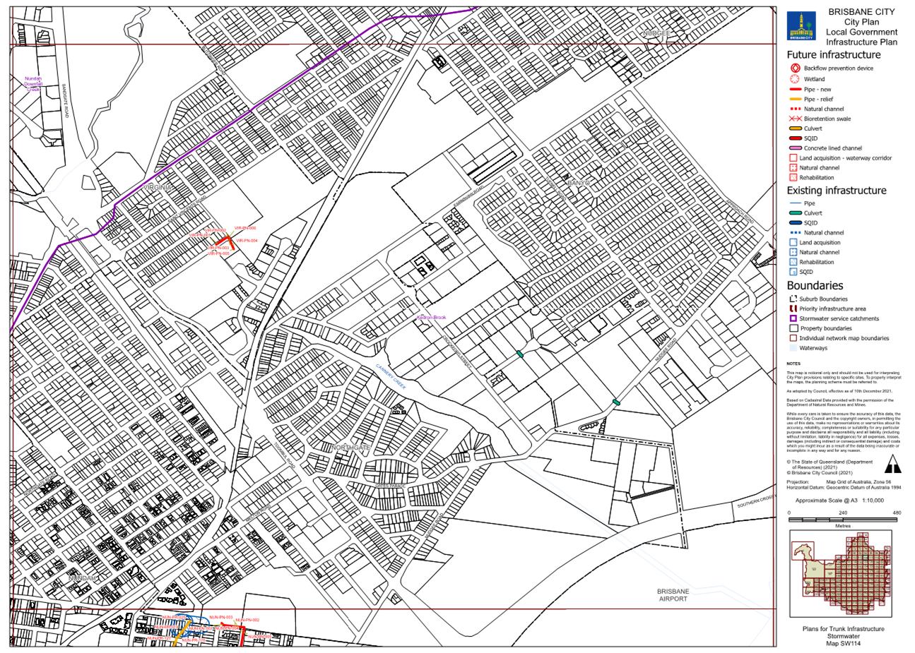

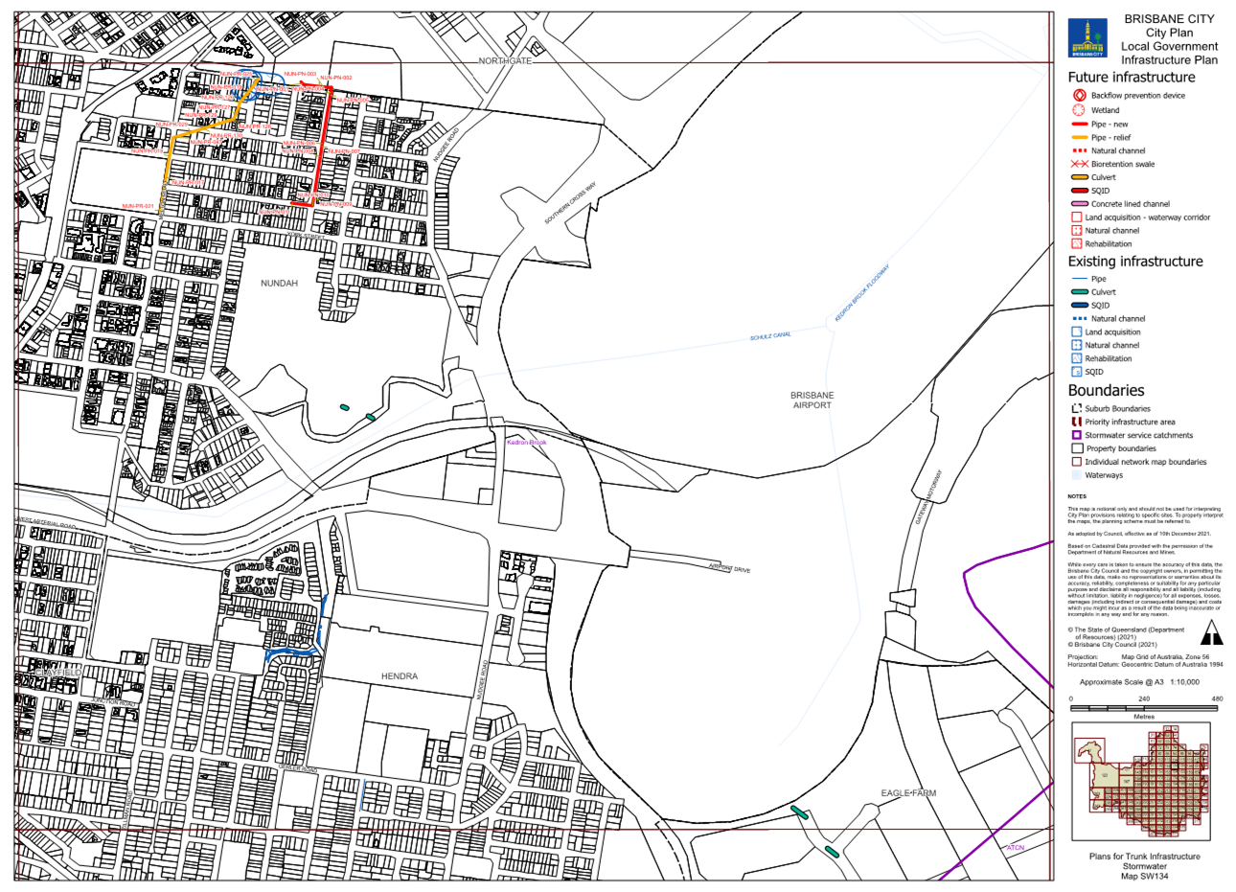

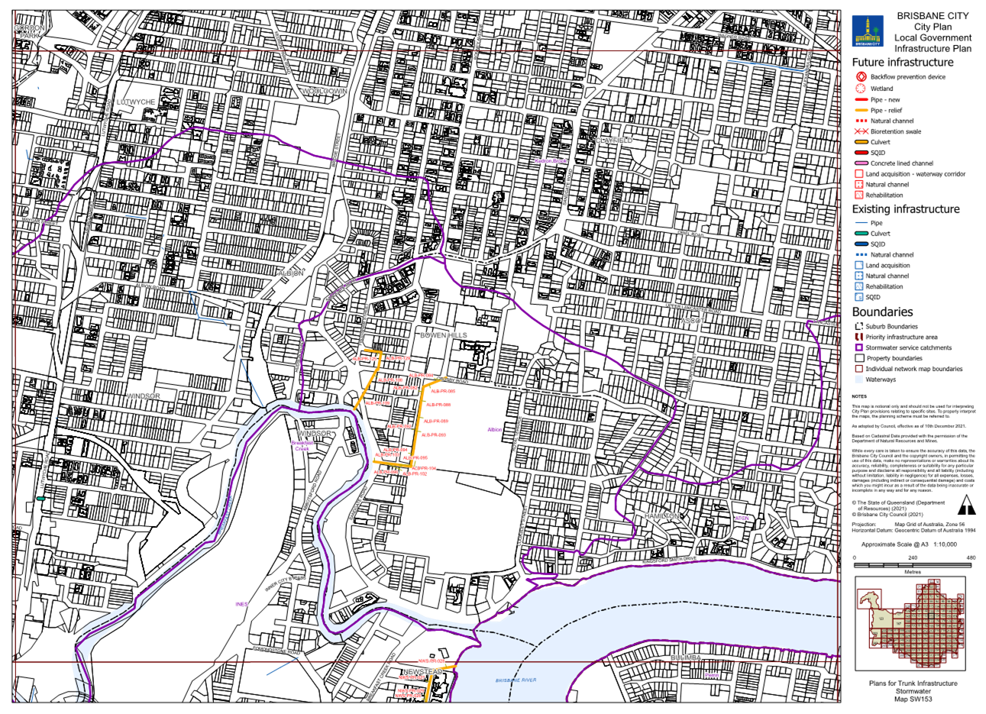

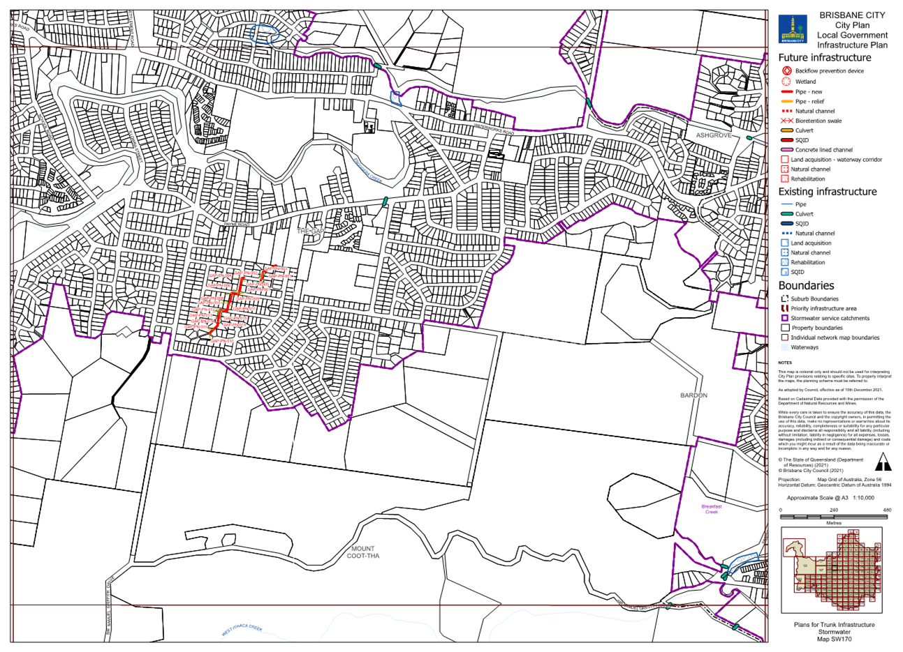

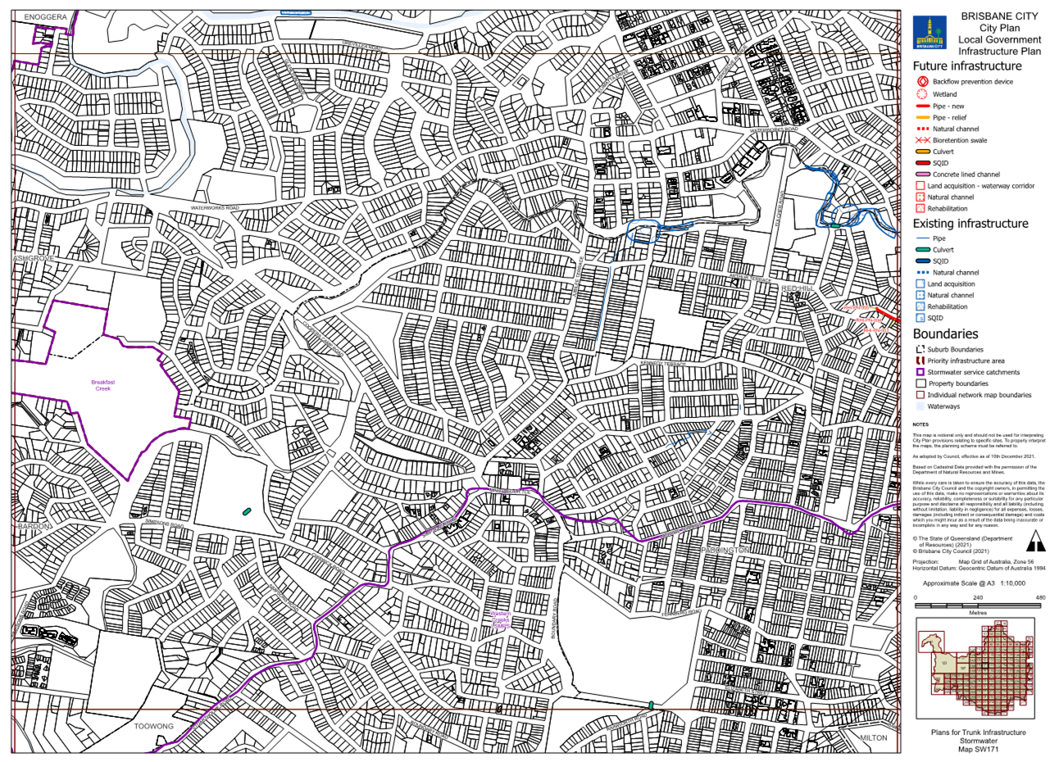

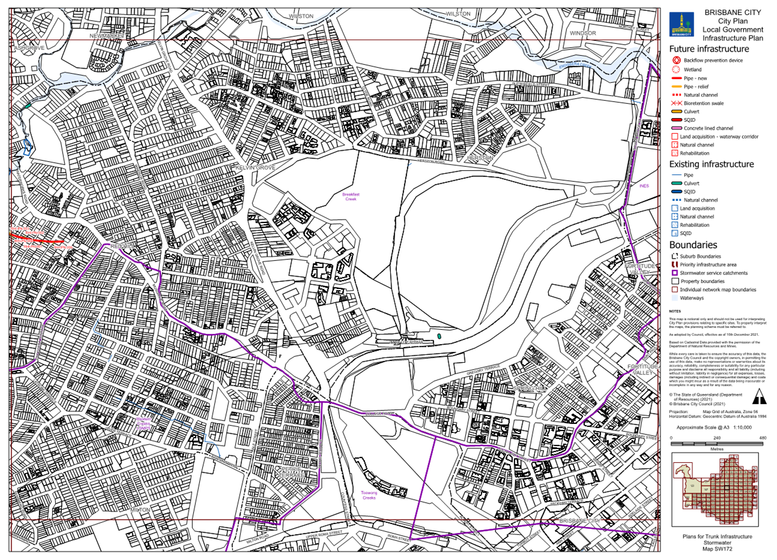

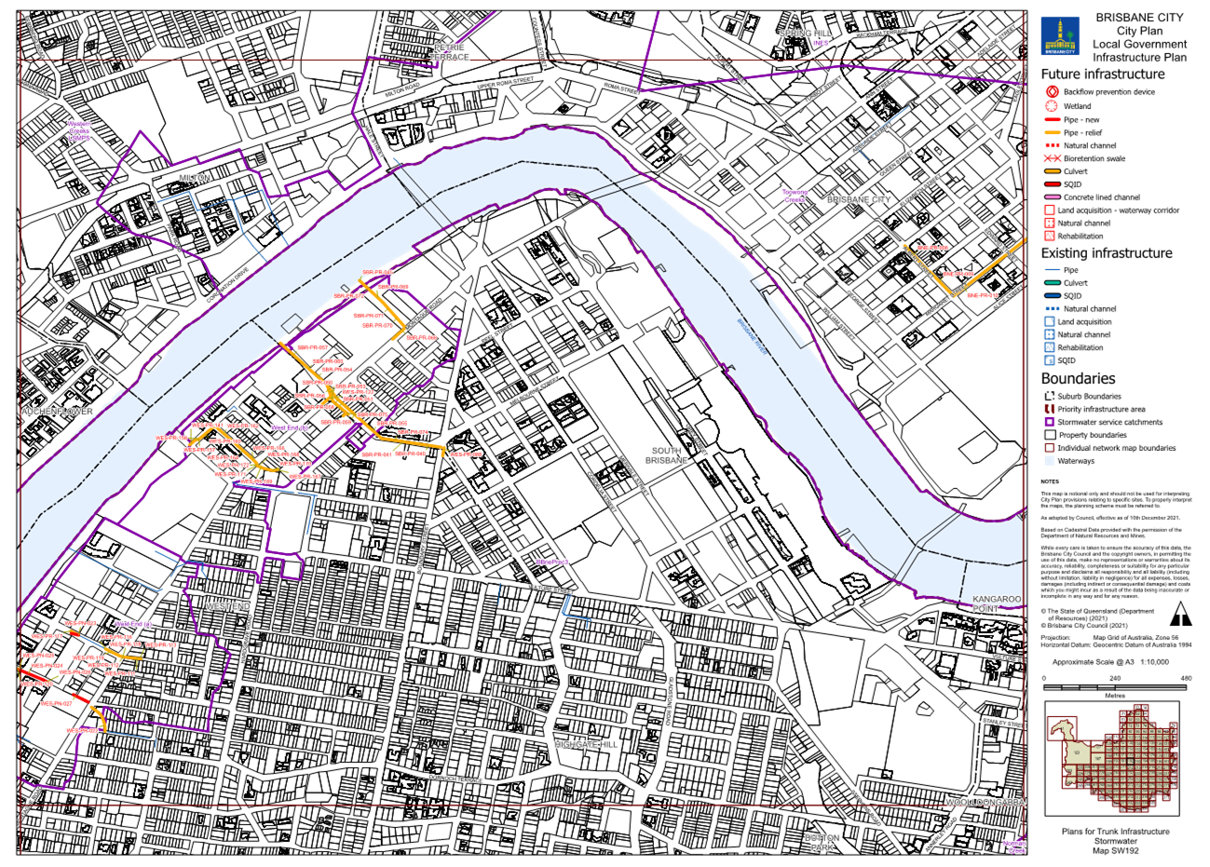

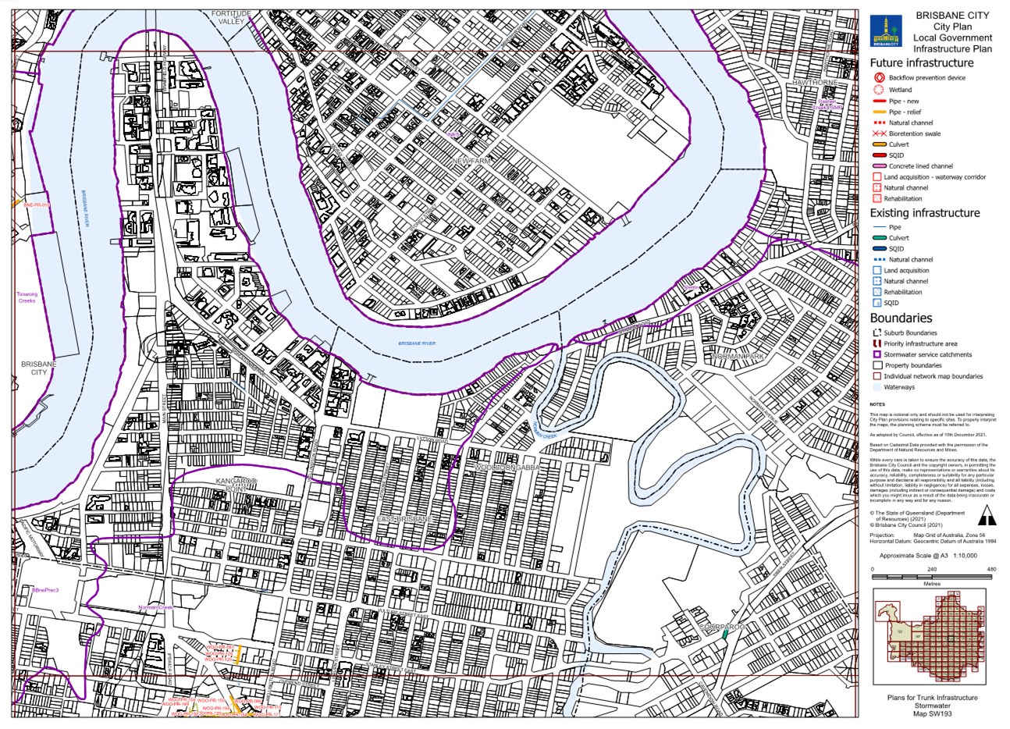

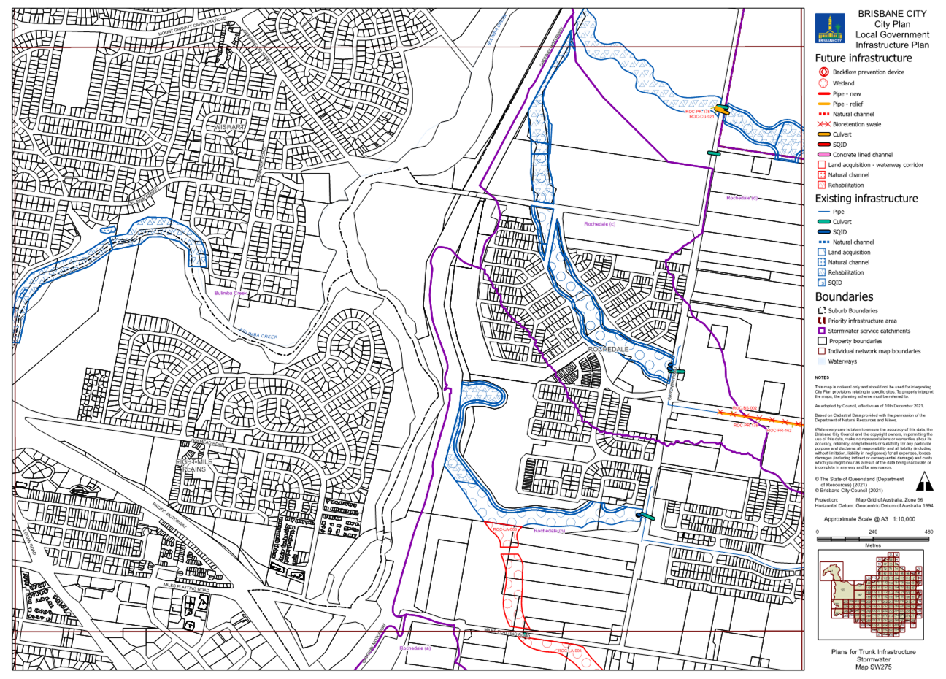

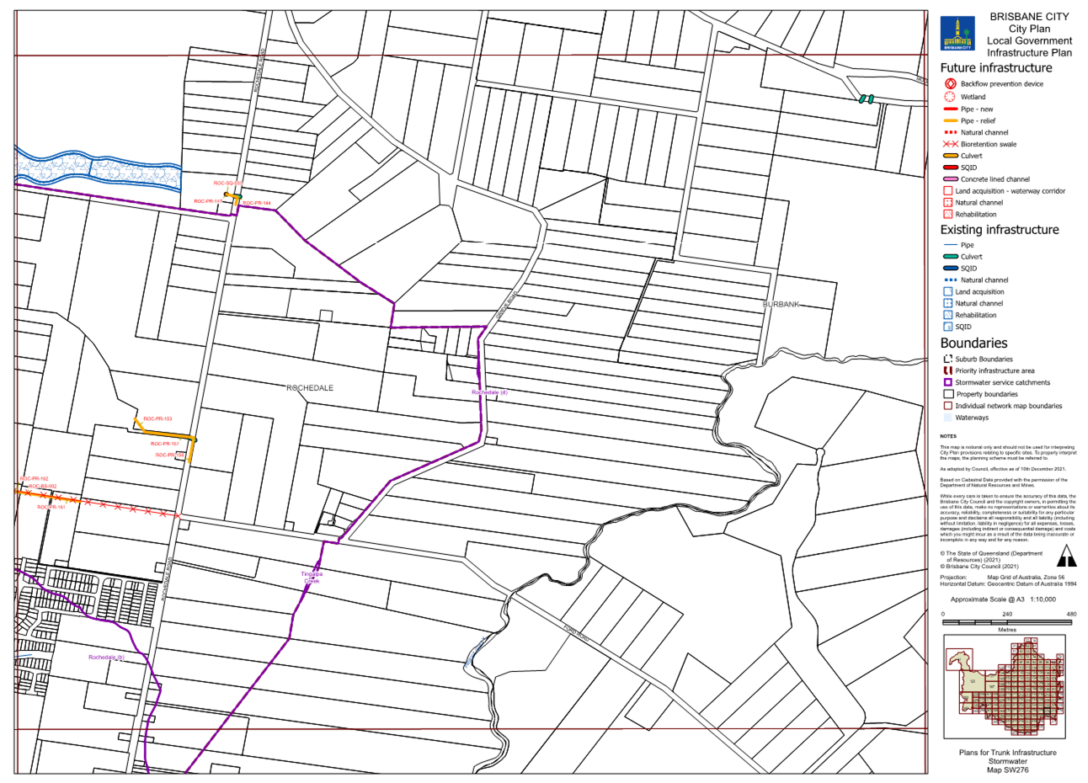

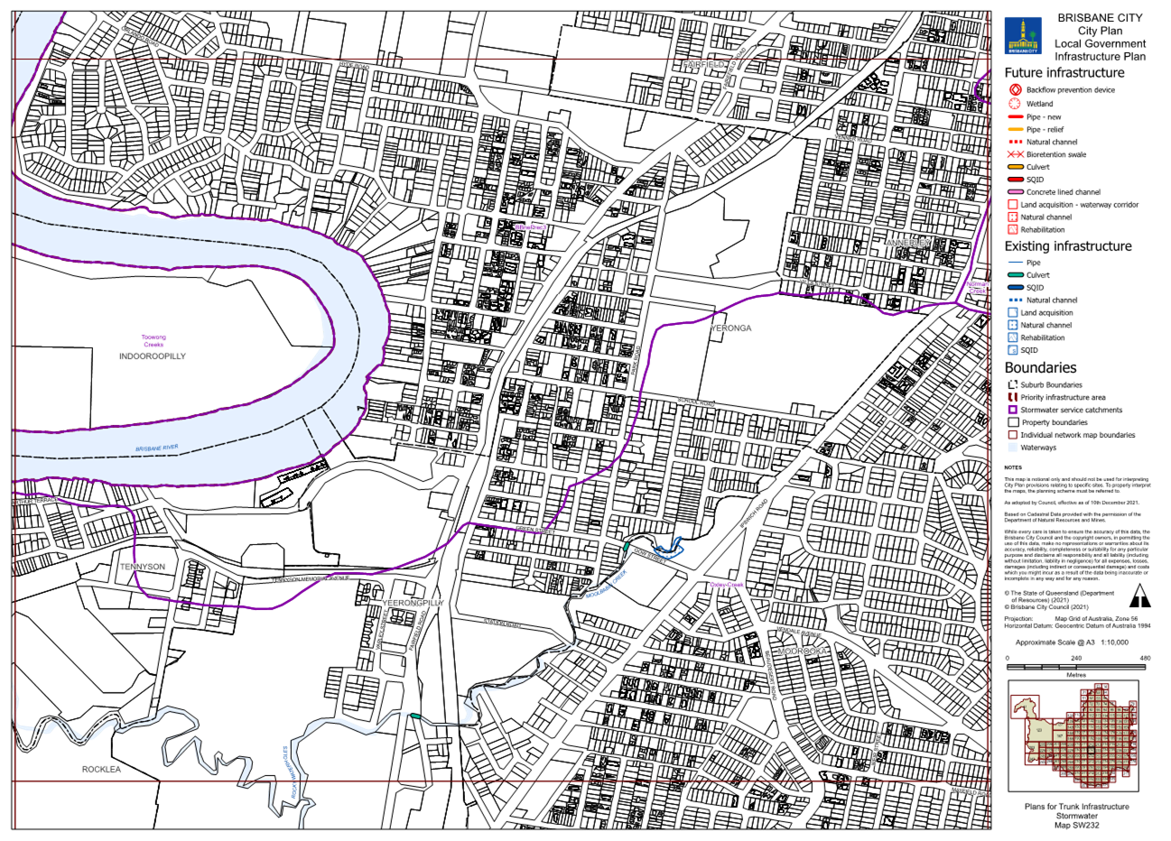

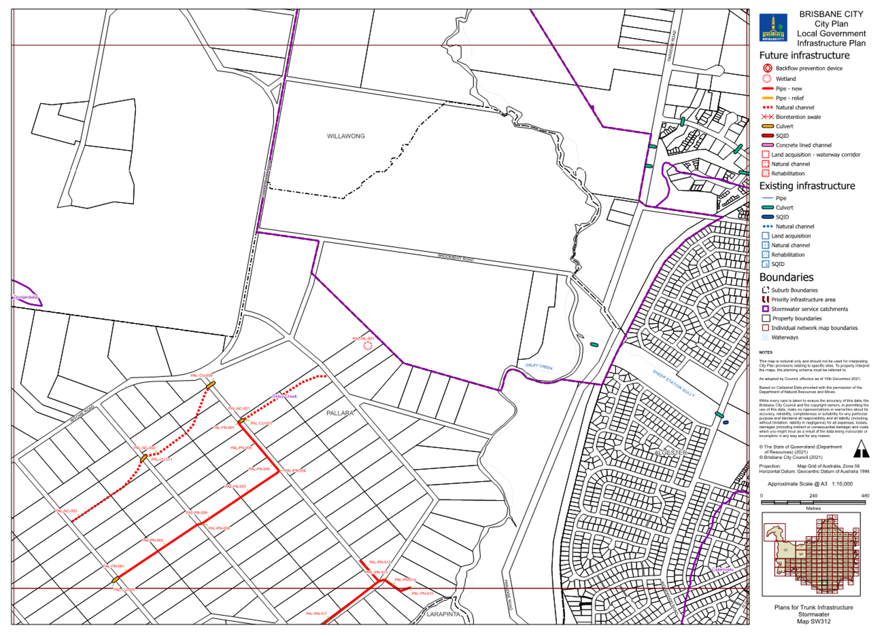

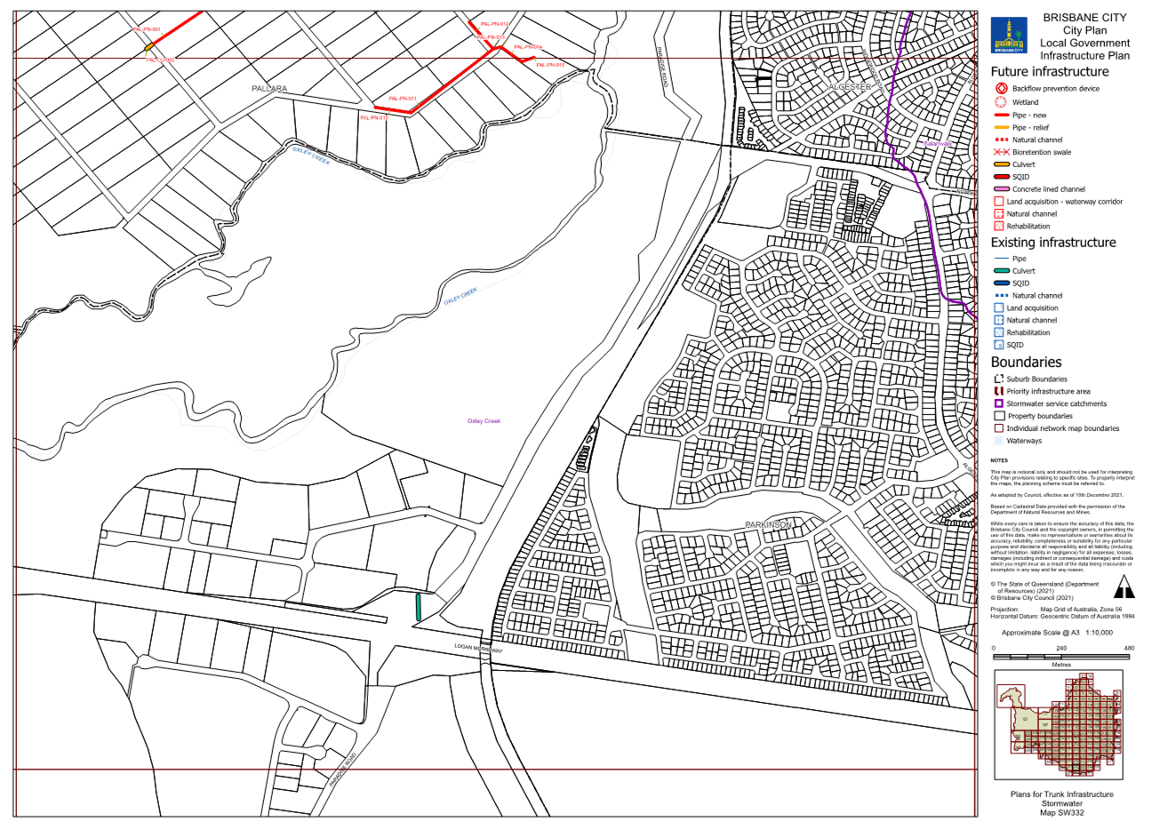

Table 23: Existing map tiles listed in Map tile numbers column below are deleted and replaced with the corresponding map tile inserted below.
Item no. | Map tile numbers | Reason for change
 | R52, R94, R114, R172, R173, R193, R194, R197, R211, R213, R217, R235, R254, R255, R270, R271, R273, R276, R289, R293, R295, R296, R311, R330, R331, R351, R352, R353 | These map tiles have been updated to reflect changes to the LGIP schedule of work for the road network in Table 4.5.2.1—Schedules of works for future trunk infrastructure and Table SC3.2.1—Schedules of works for future trunk infrastructure.

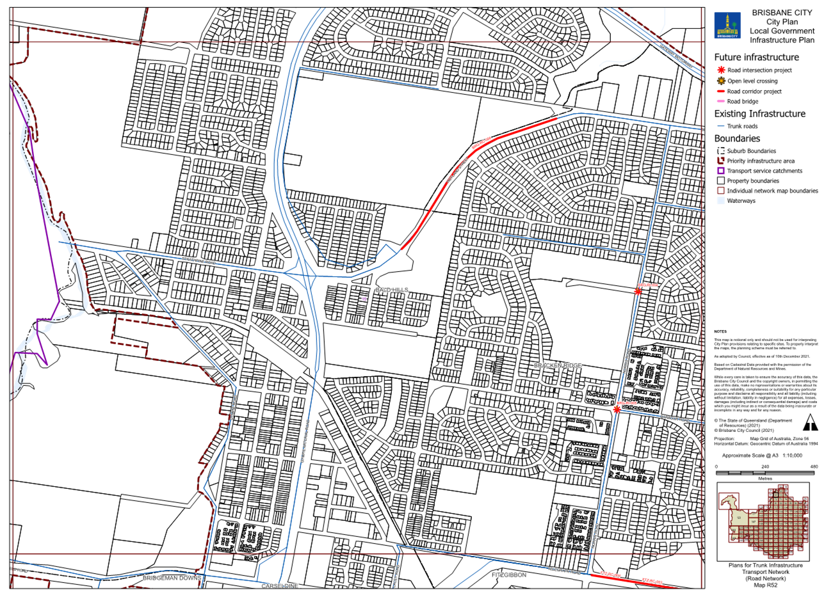

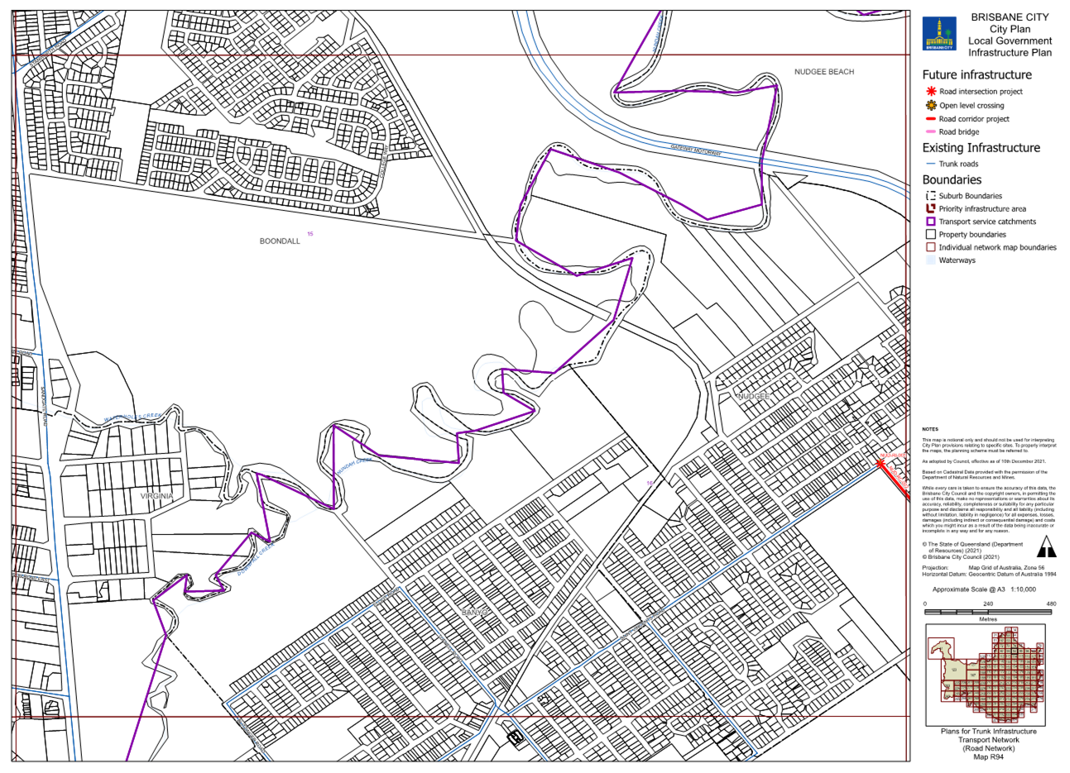

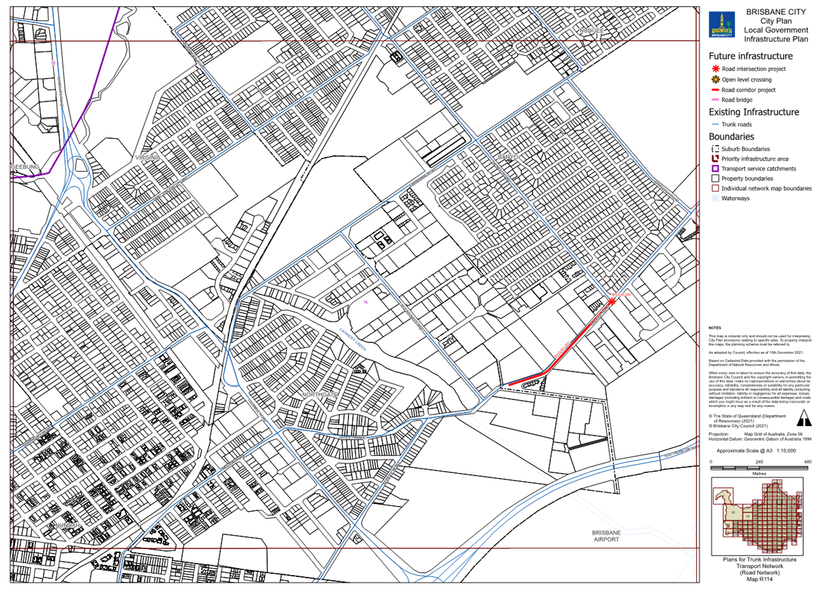

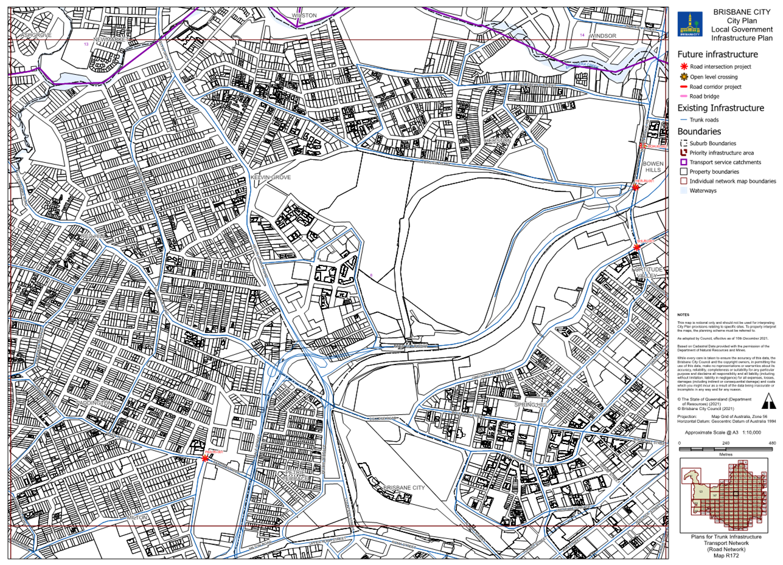

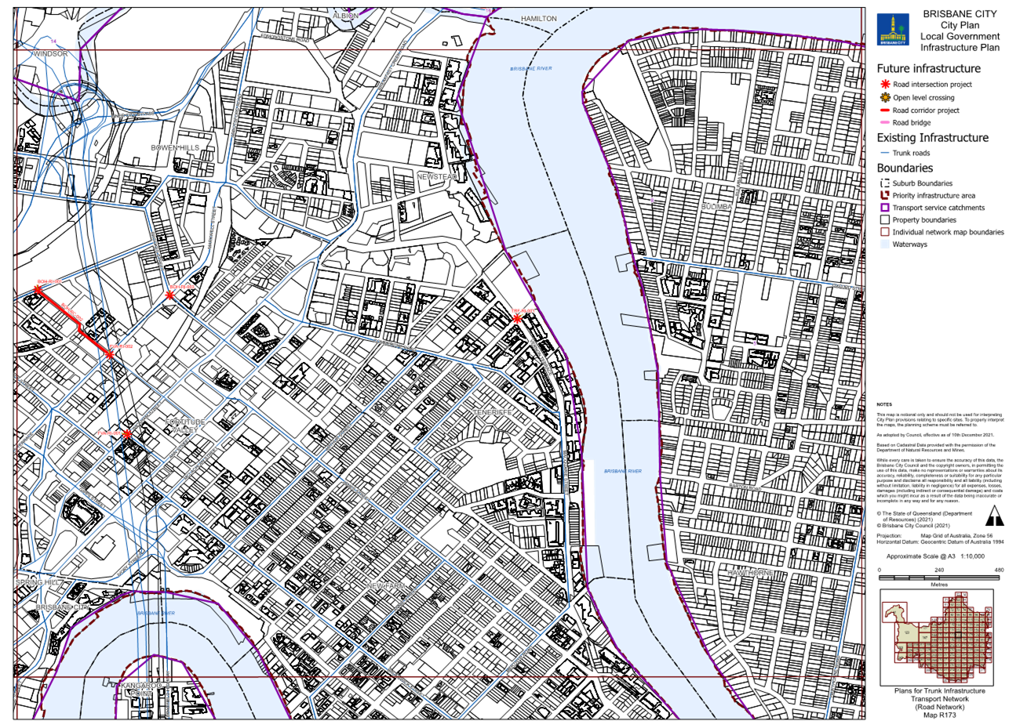

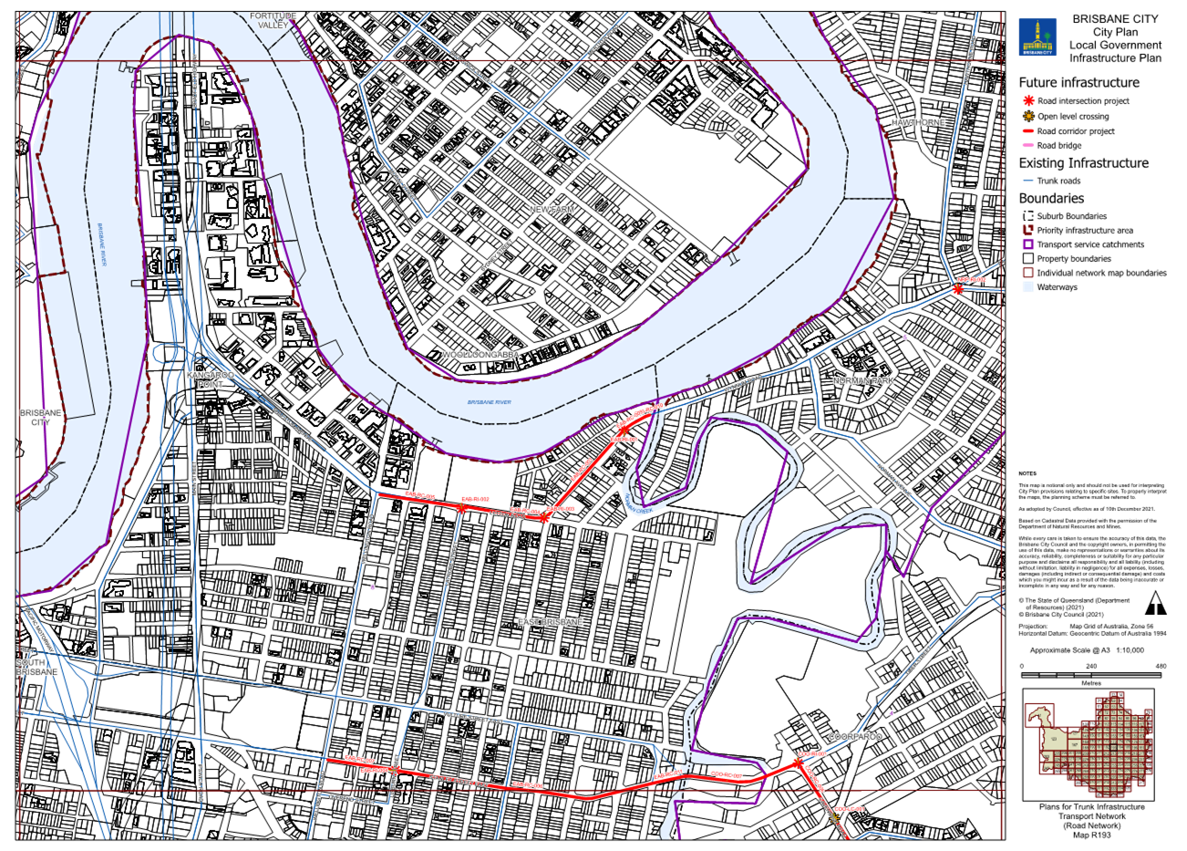

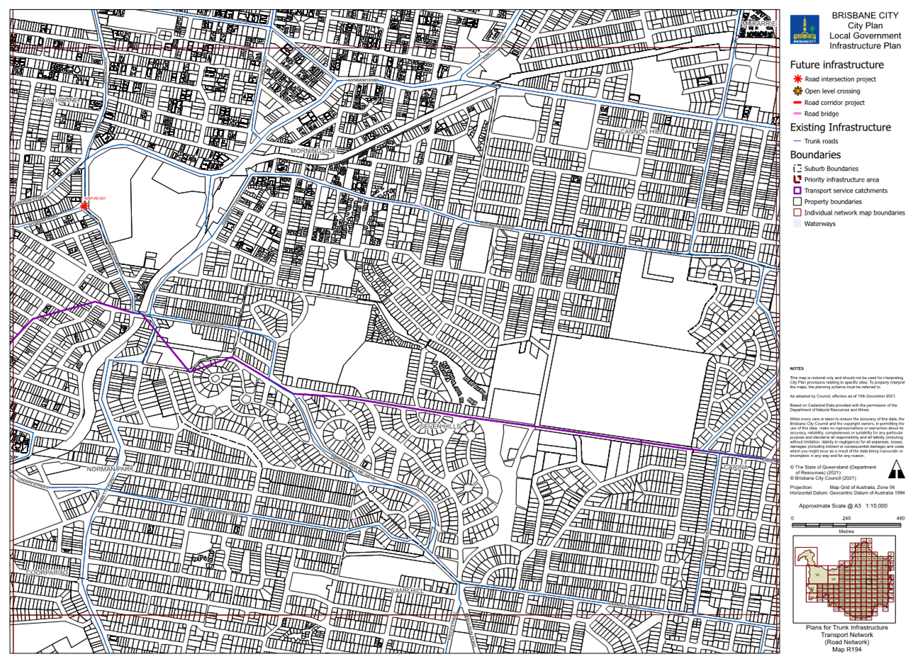

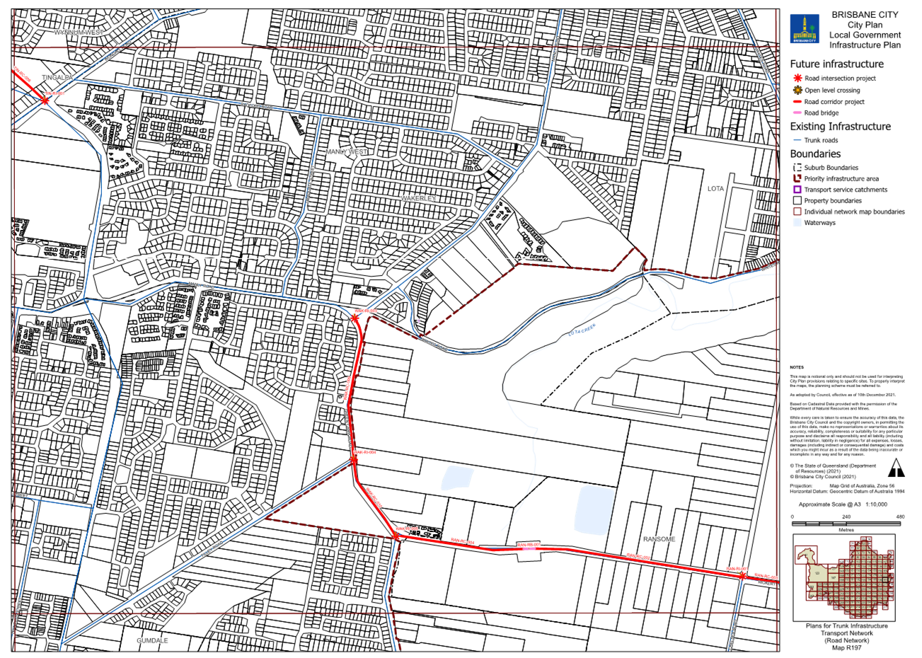

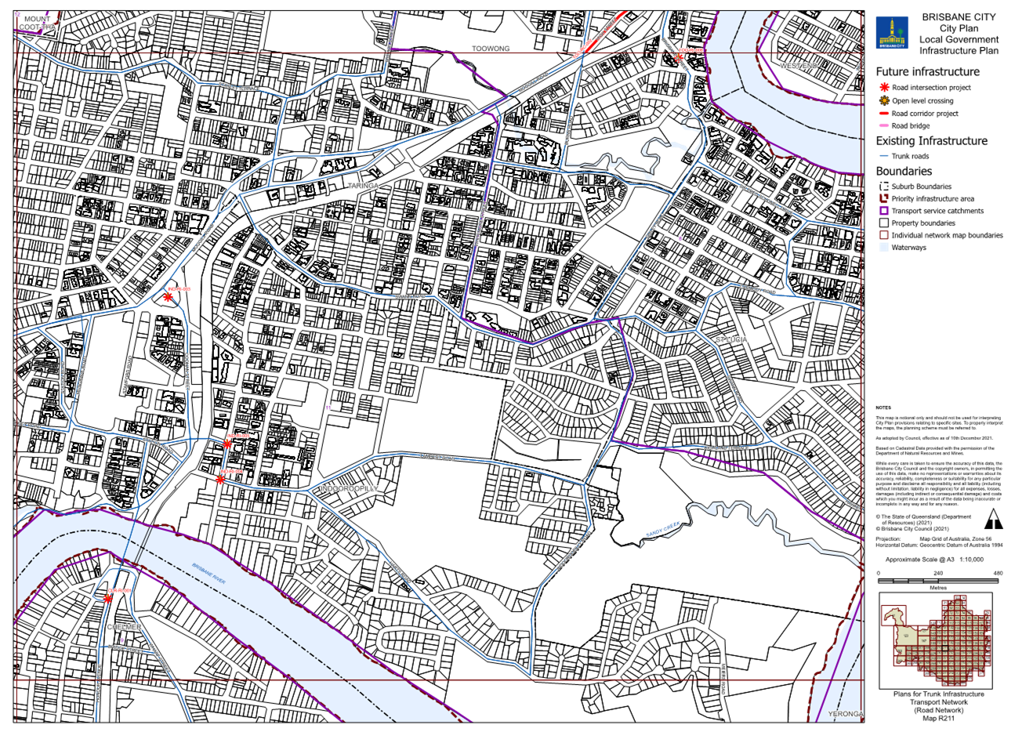

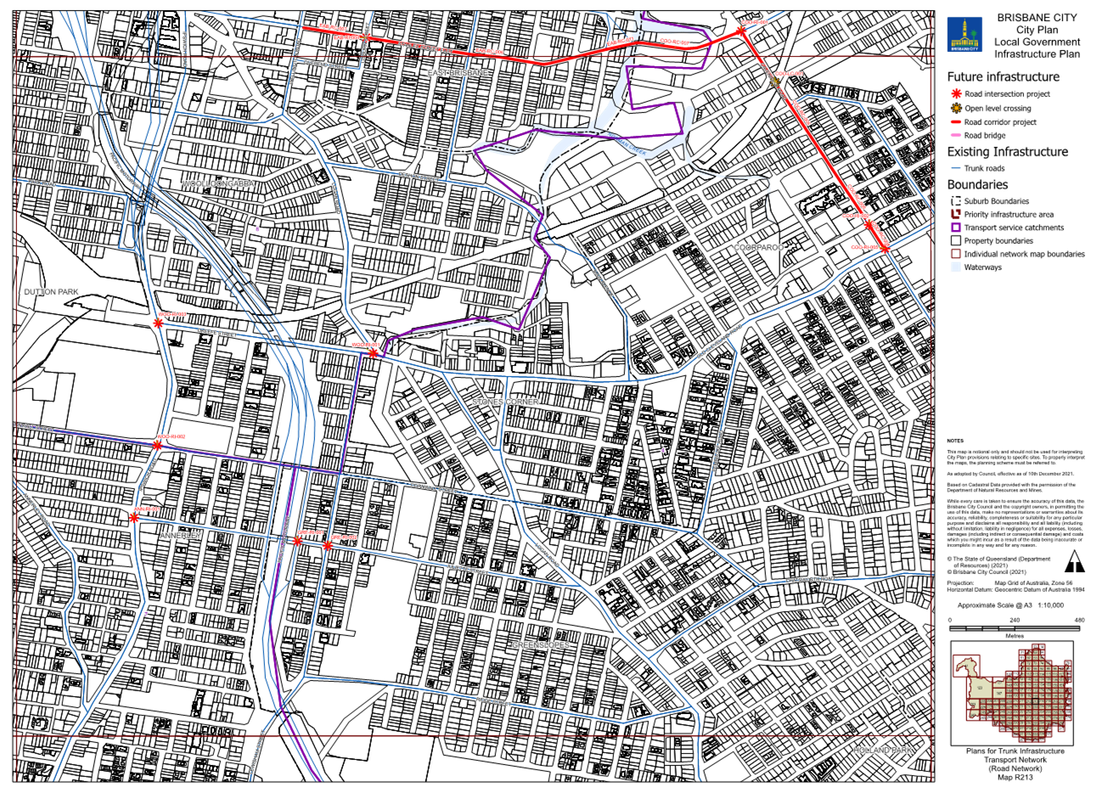

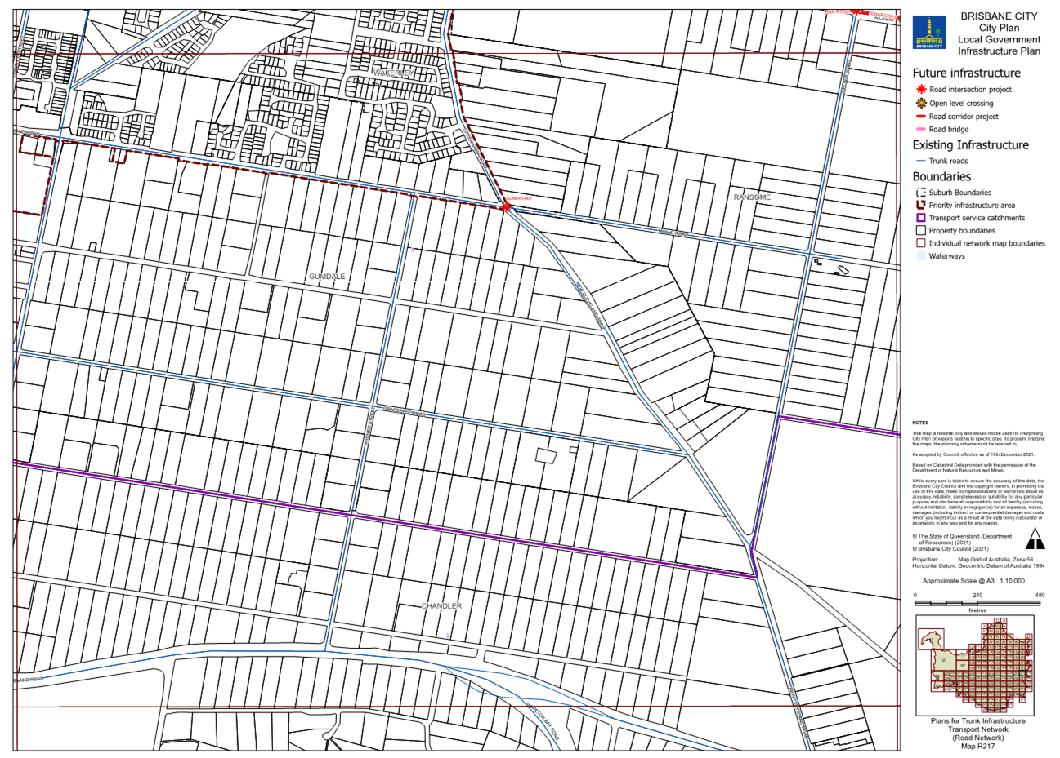

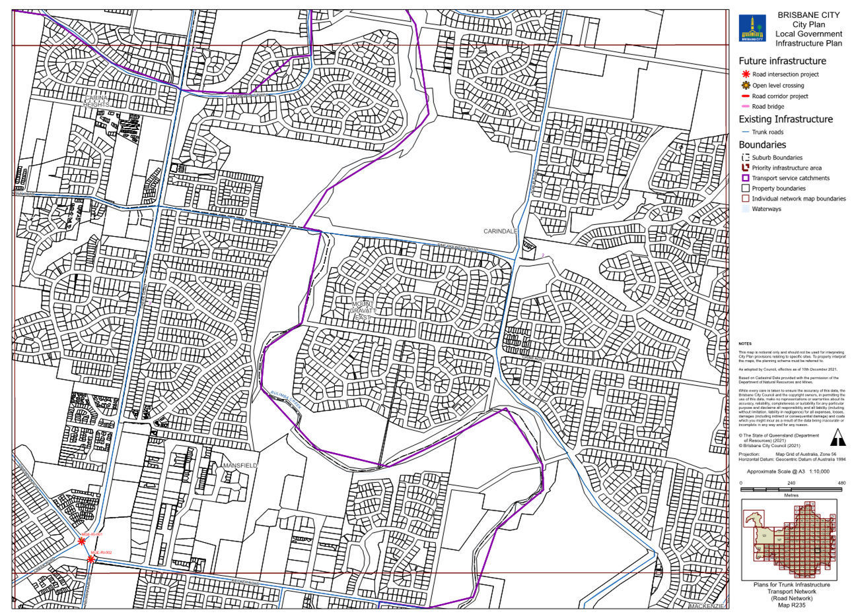

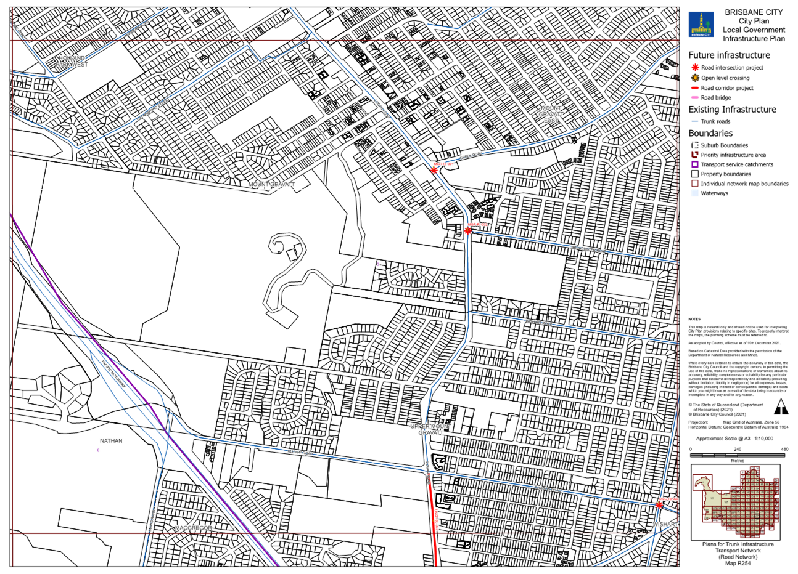

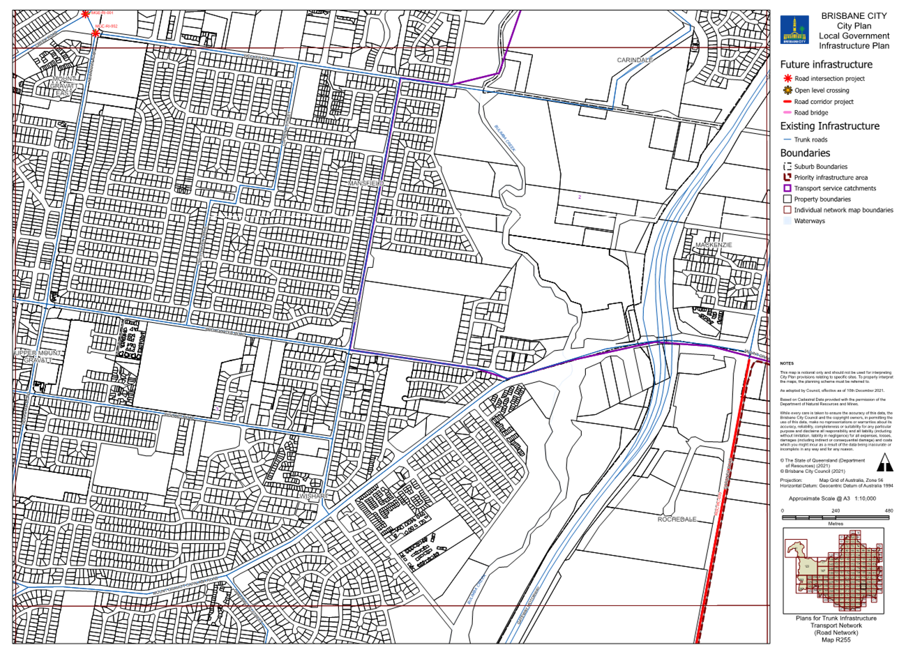

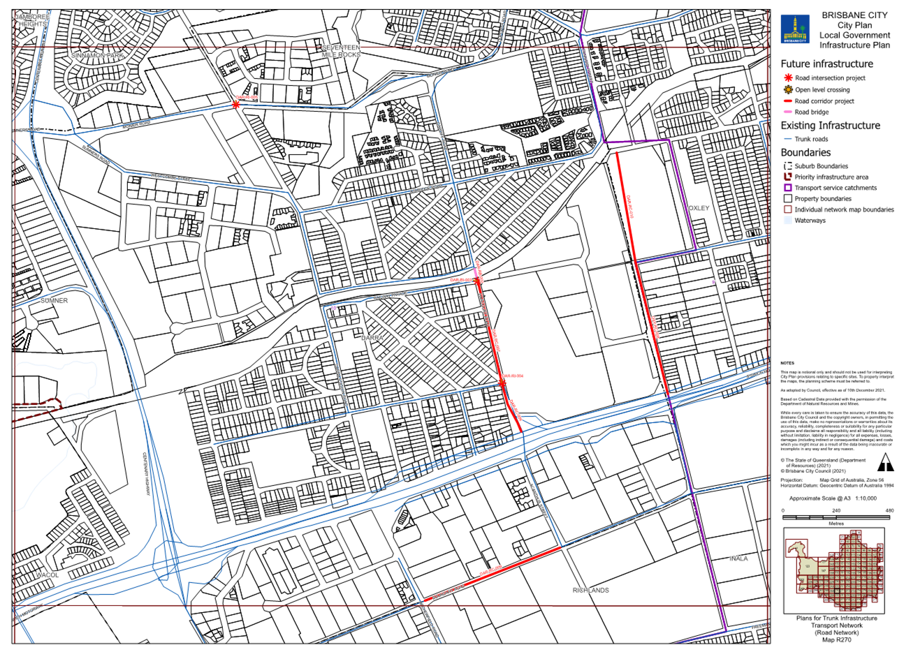

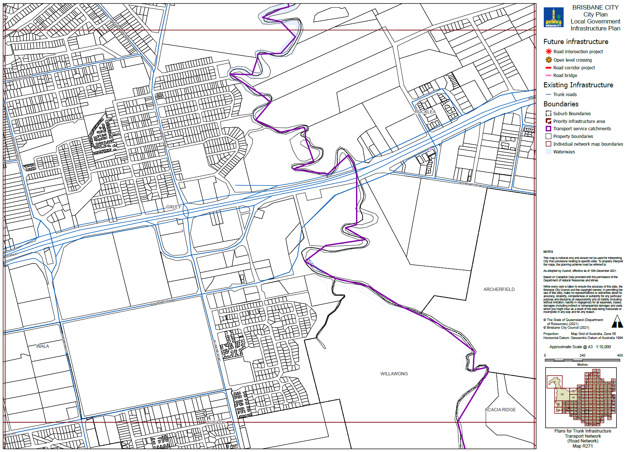

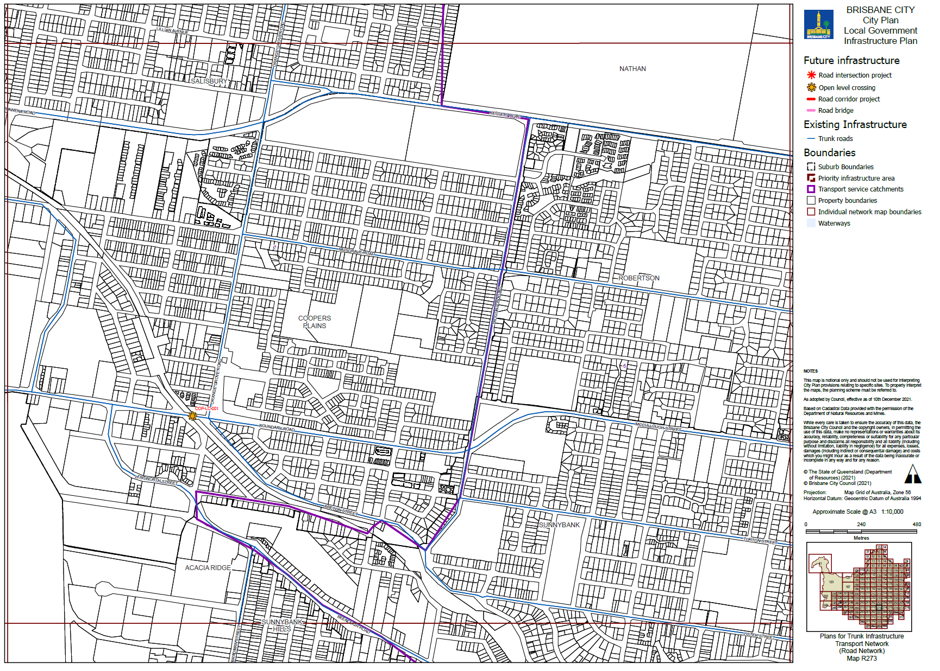

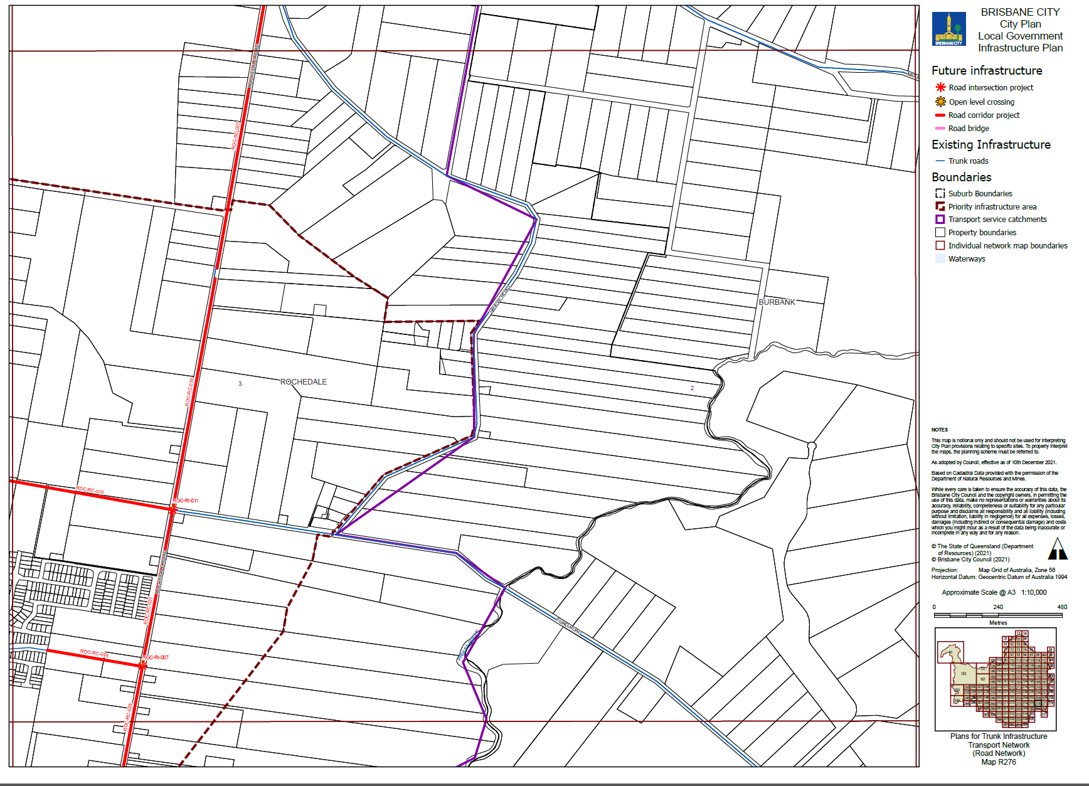

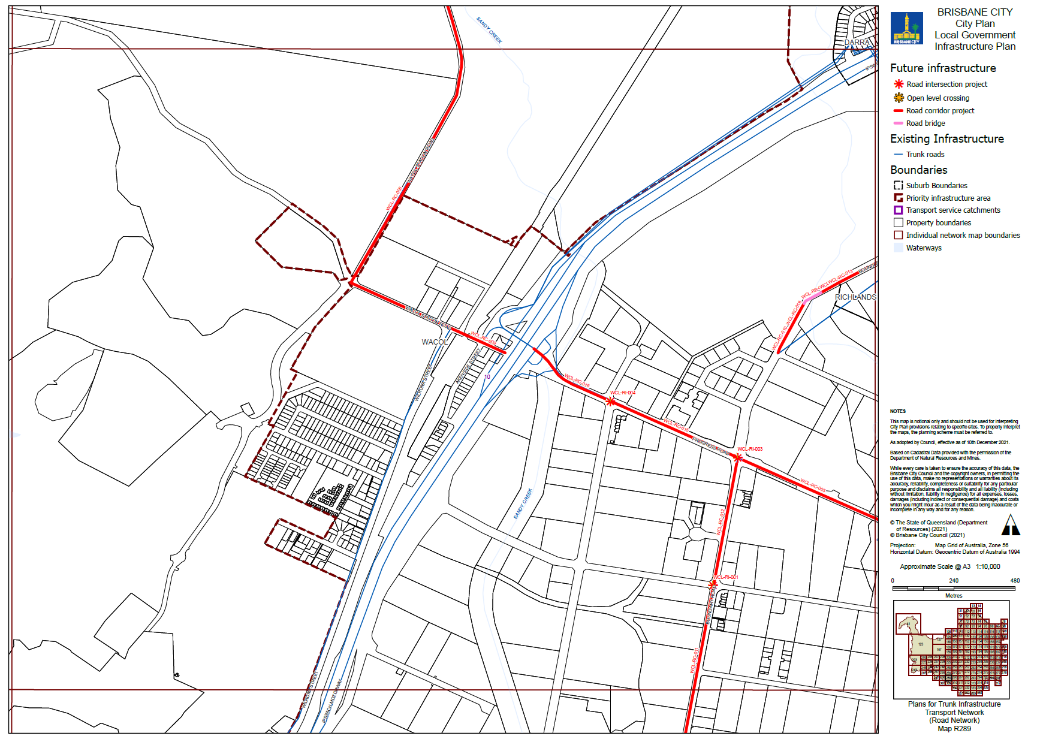

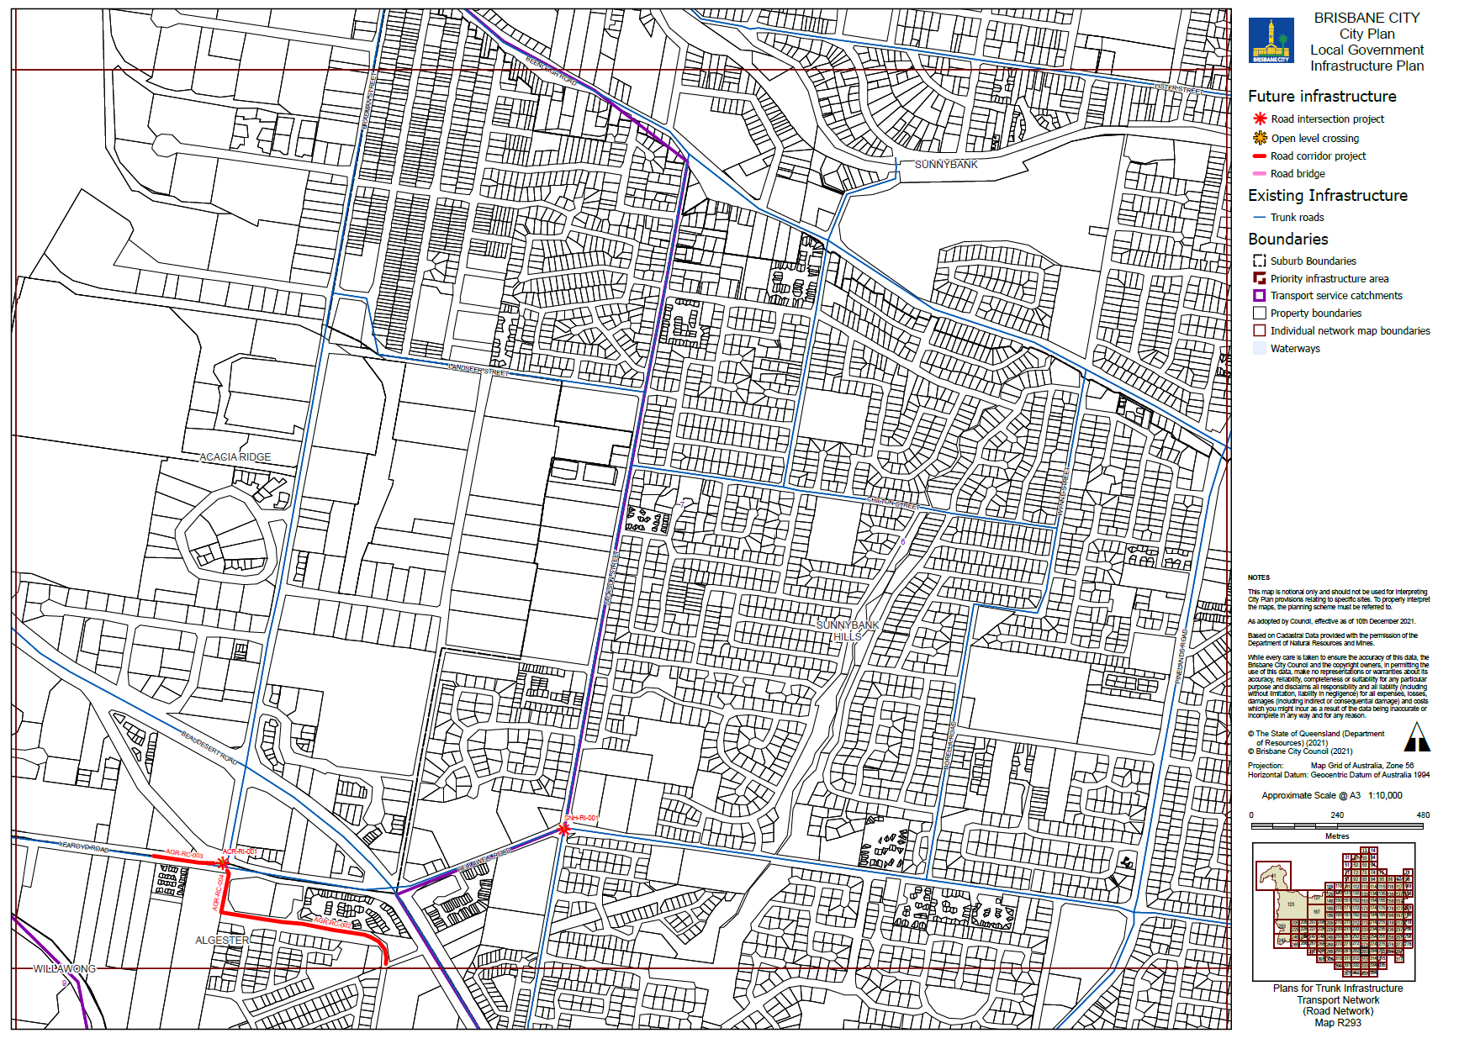

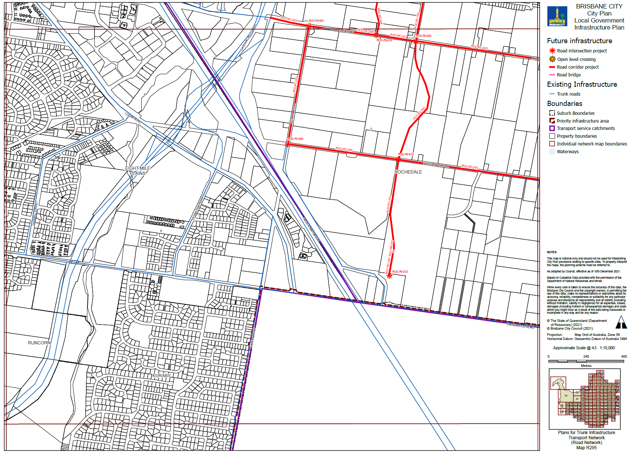

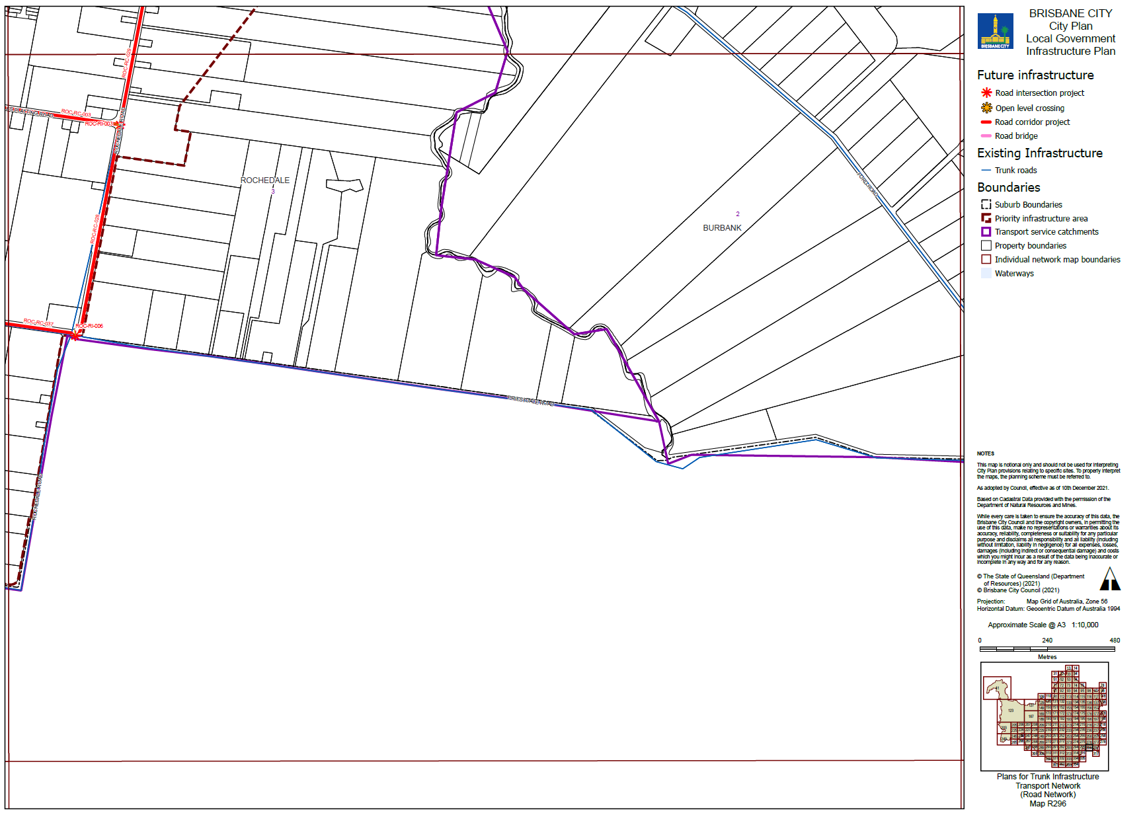

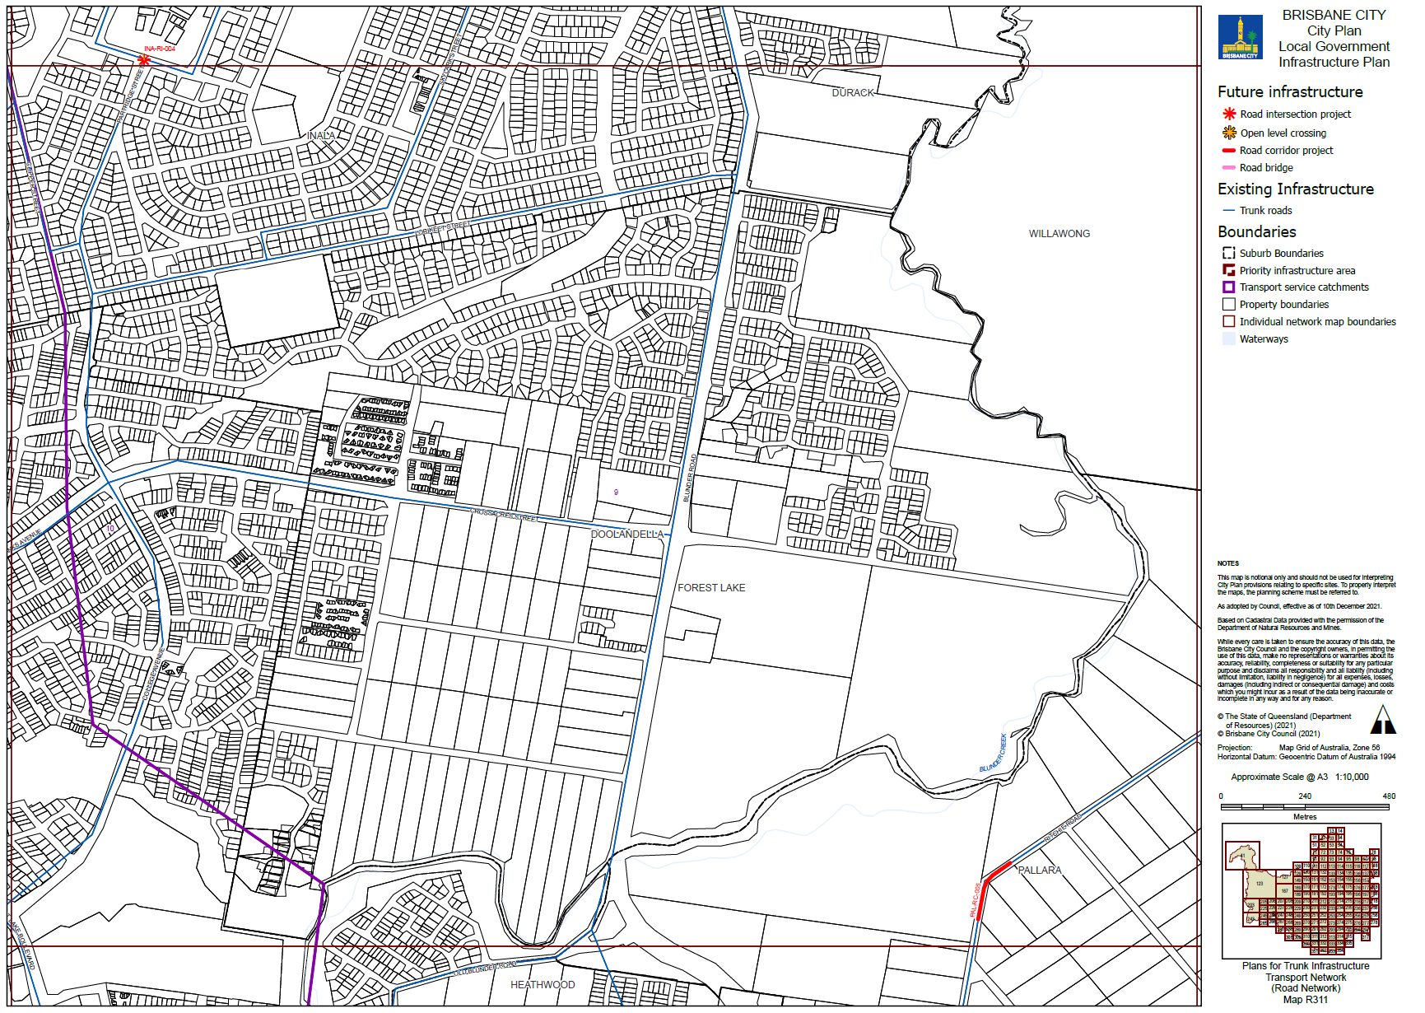

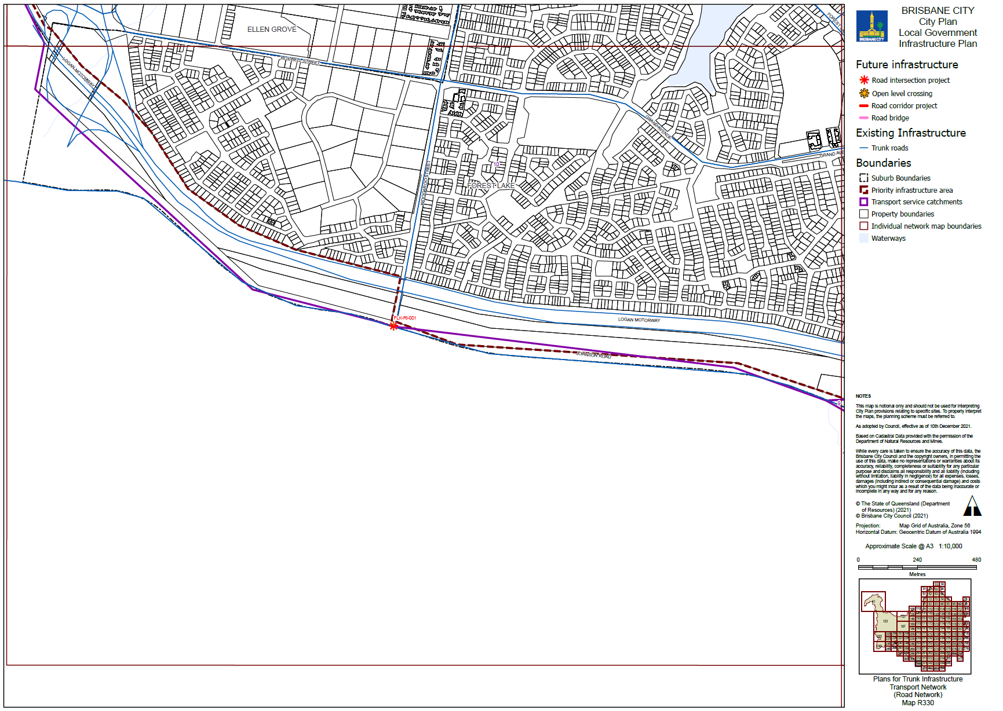

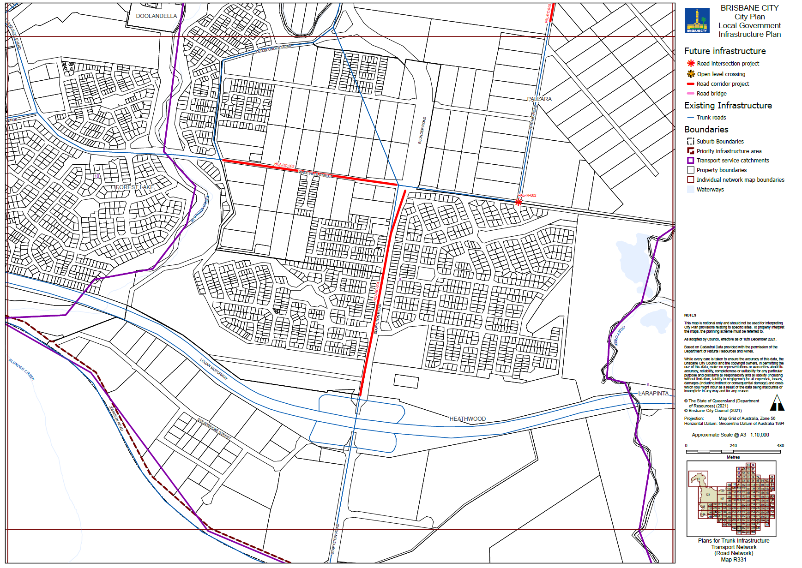

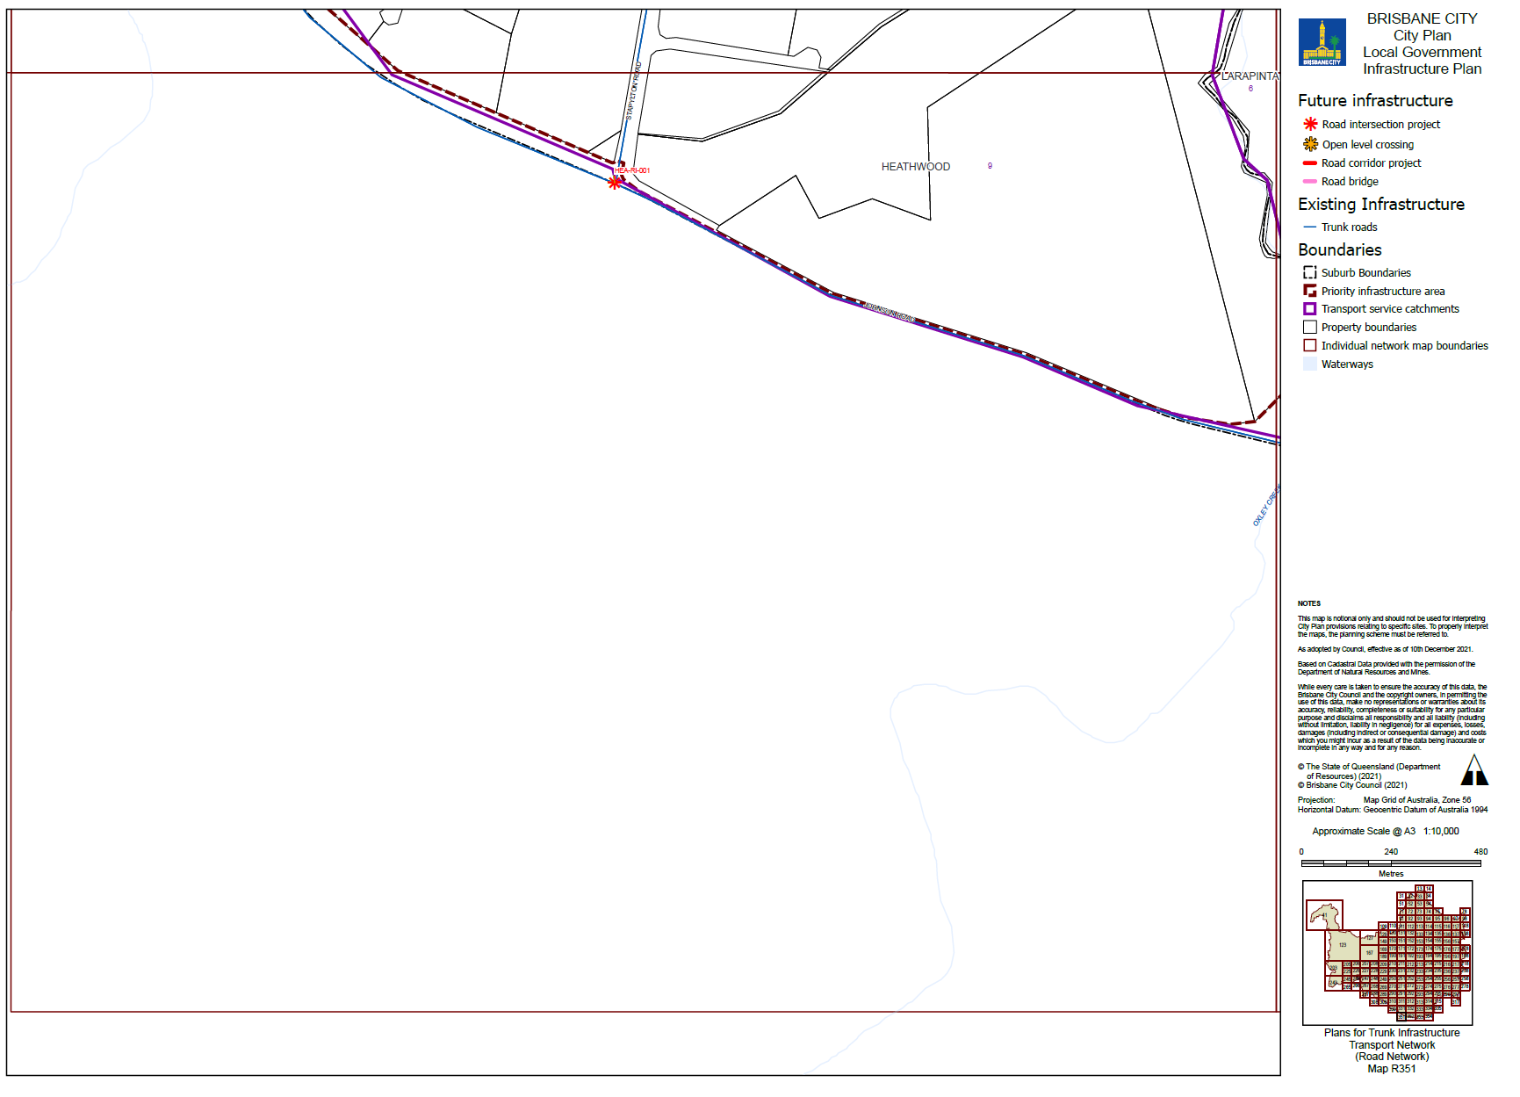

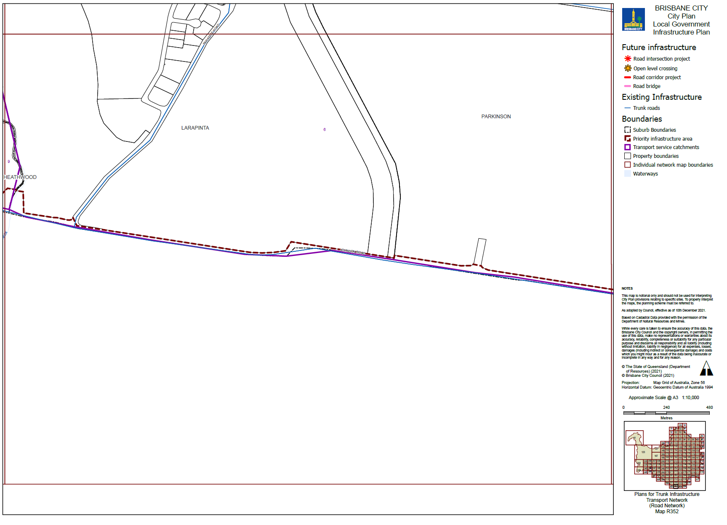

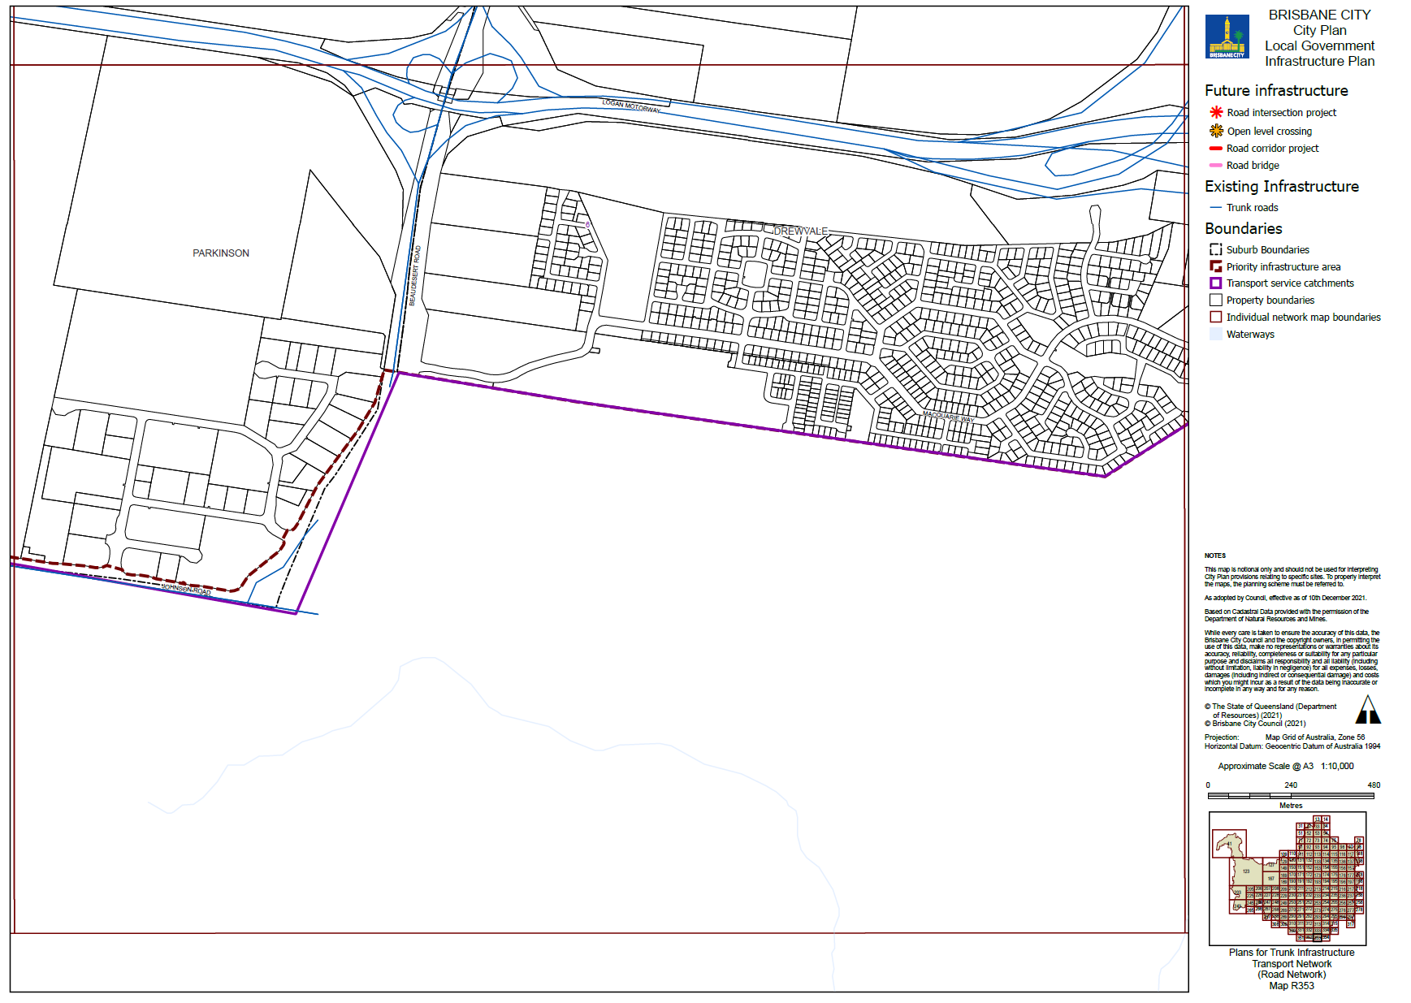

Table 24: Existing map tiles listed in Map tile numbers column below are deleted and replaced with the corresponding map tile inserted below.
Item no. | Map tile numbers | Reason for change
 | APT153, APT173, APT192, APT193, APT210, APT211, APT212, APT312, APT314 | These map tiles have been updated to reflect changes to the LGIP schedule of work for the pathway network in Table 4.5.2.1—Schedules of works for future trunk infrastructure and Table SC3.2.1—Schedules of works for future trunk infrastructure.

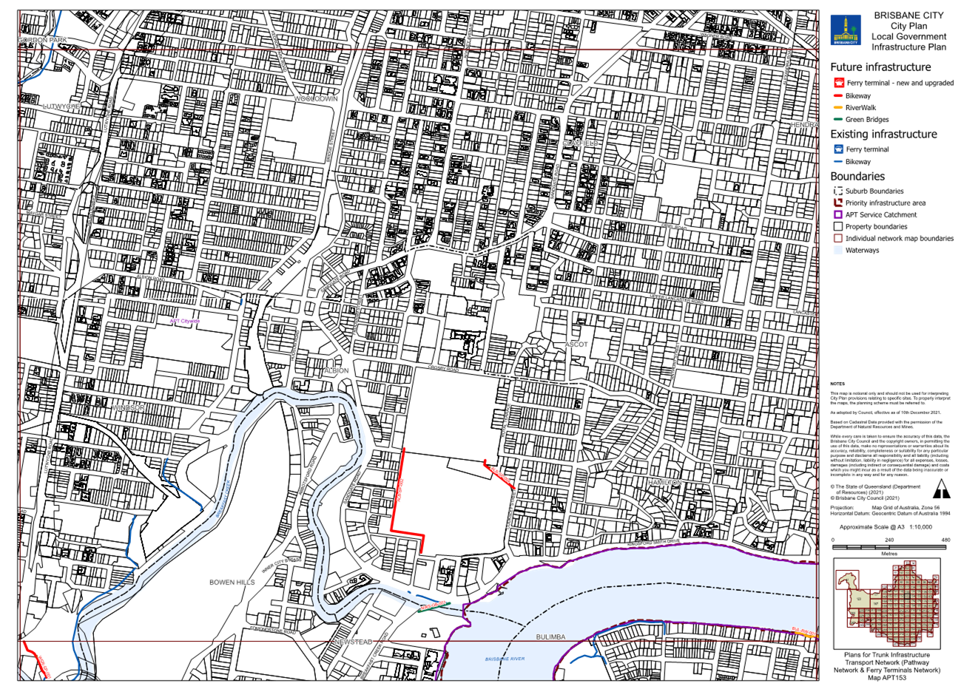

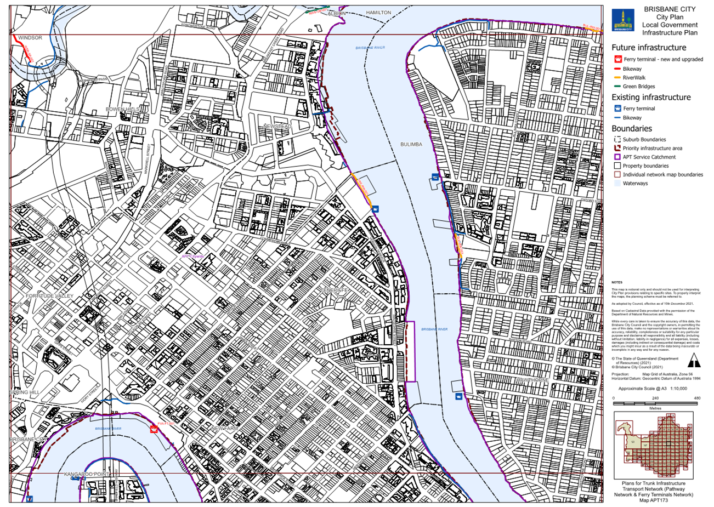

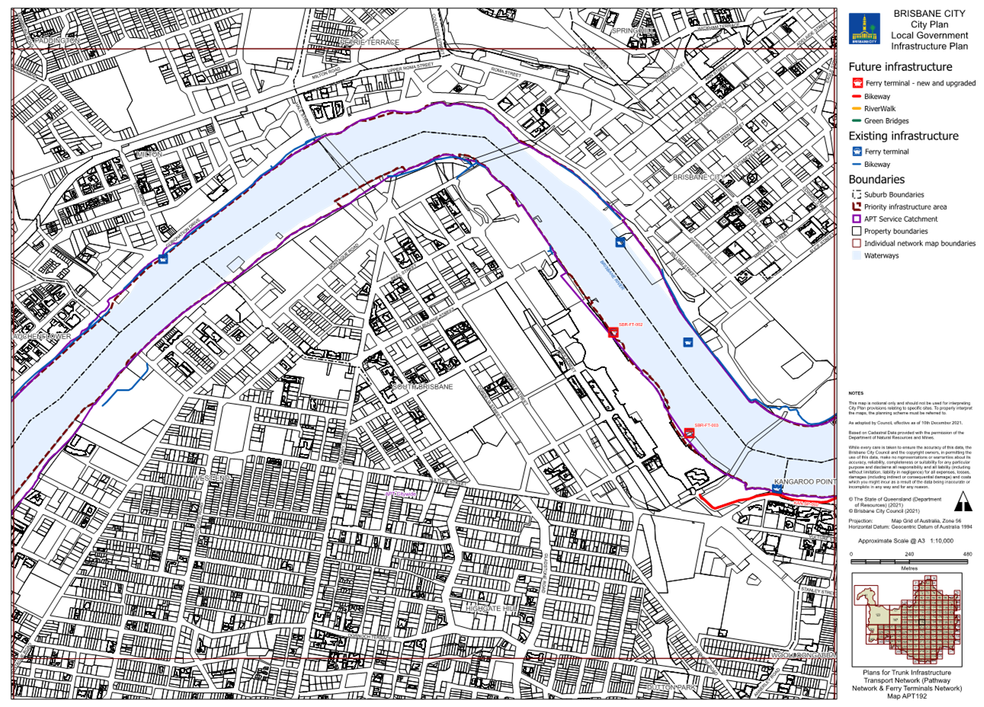

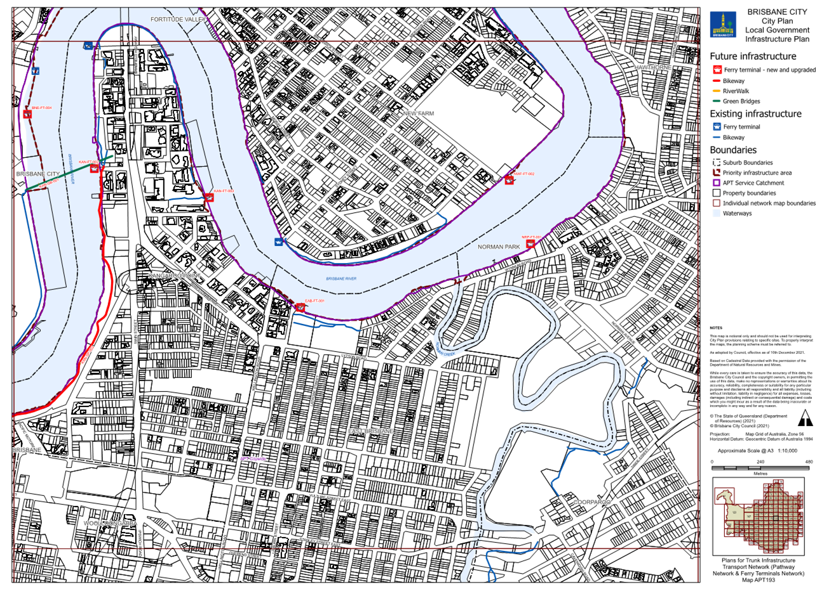

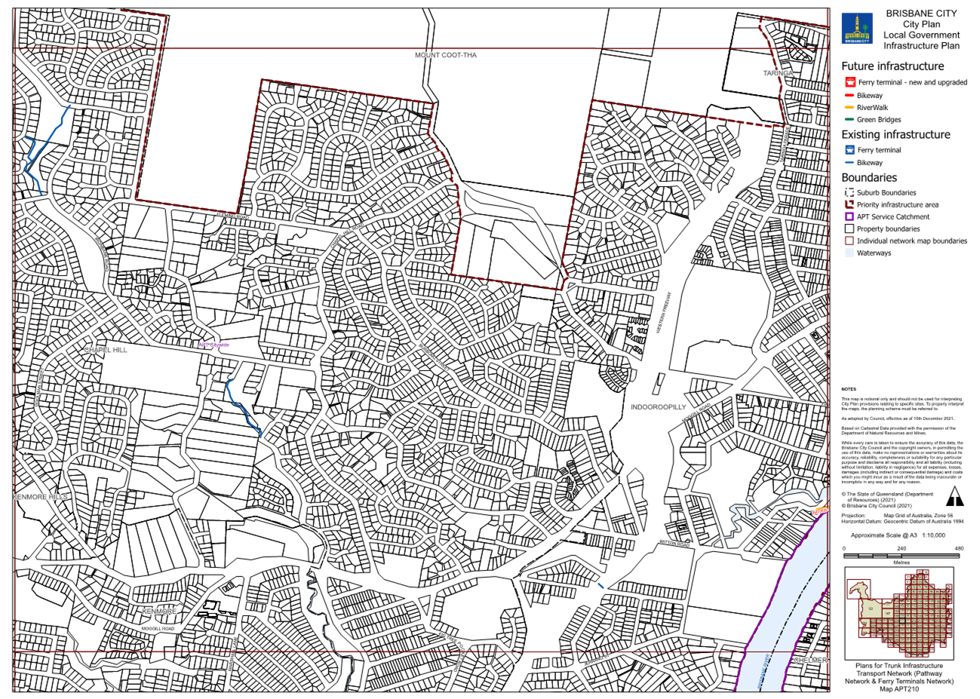

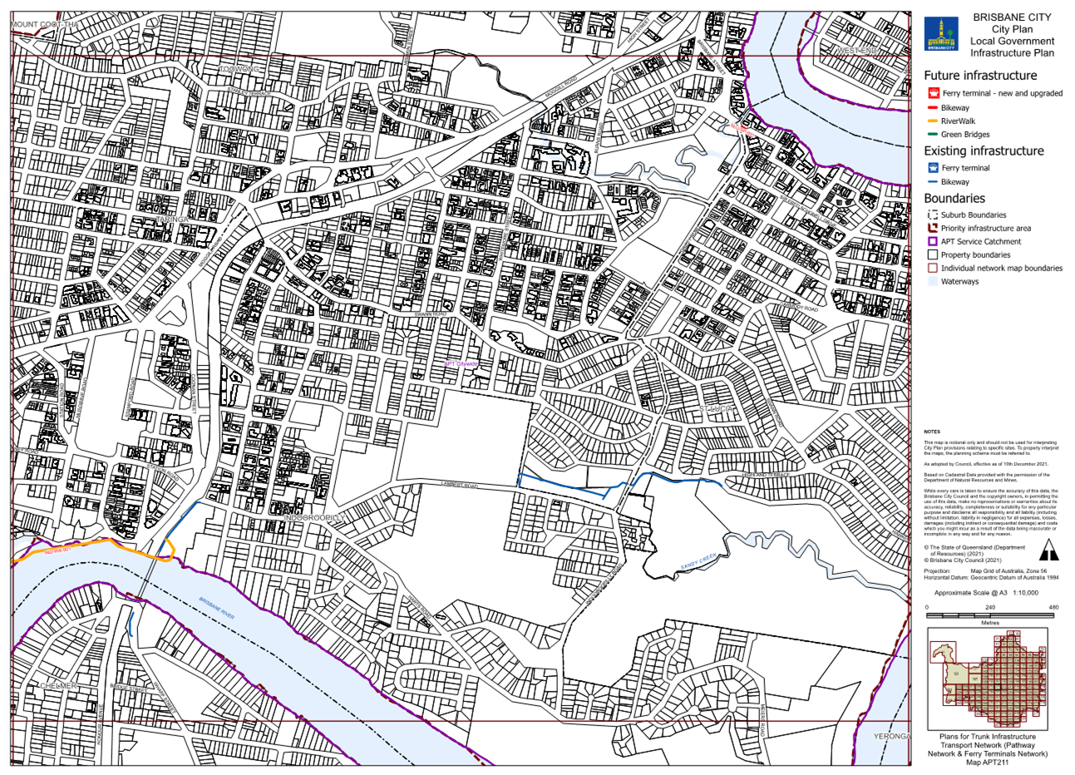

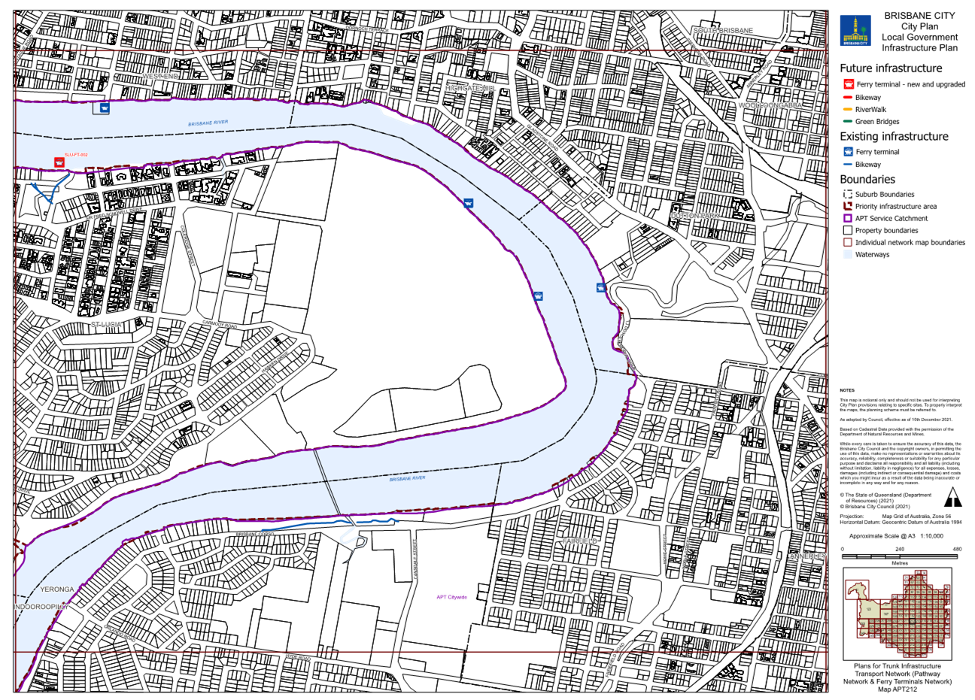

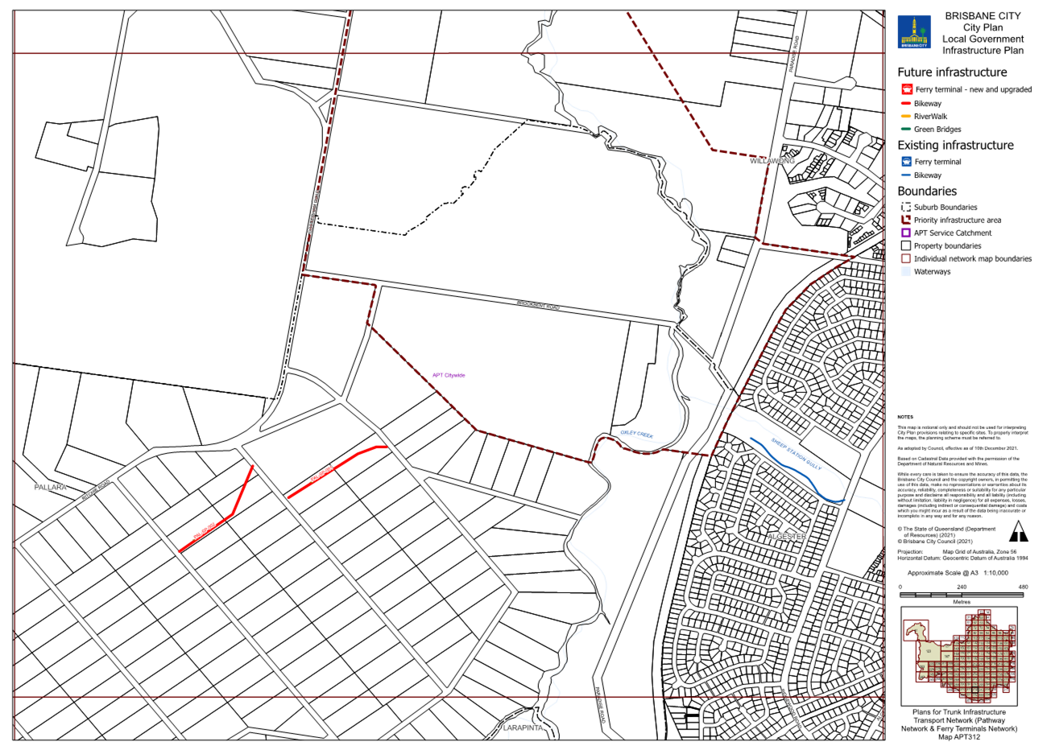

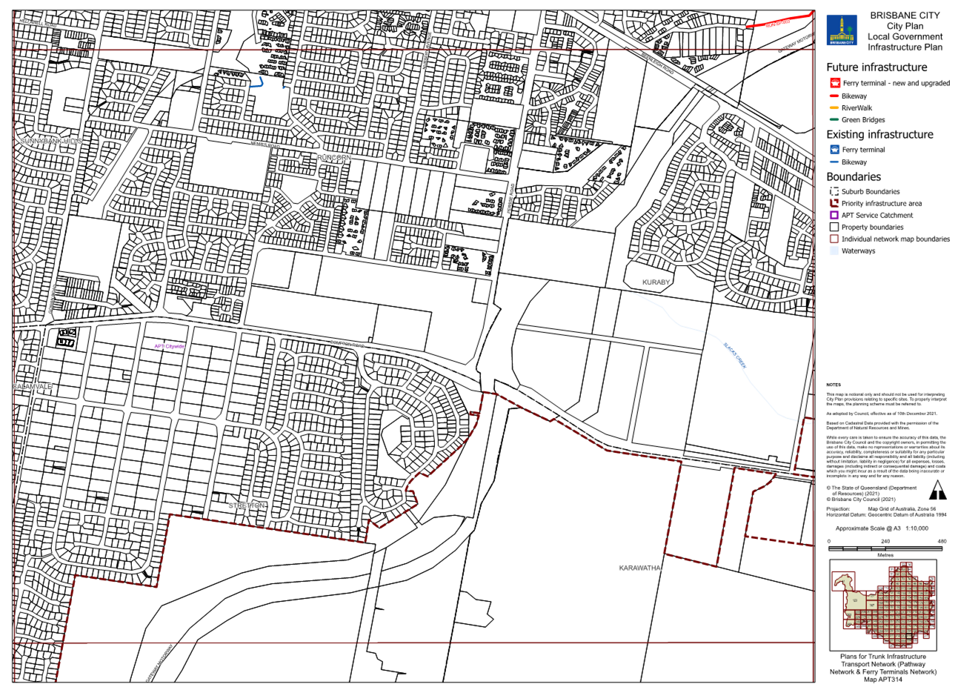

Table 25: Existing map tiles listed in Map tile numbers column below are deleted and replaced with the corresponding map tile inserted below.
Item no. | Map tile numbers | Reason for change
 | PCF94, PCF95, PCF114, PCF129, PCF131, PCF132, PCF152, PCF172, PCF173, PCF175, PCF191, PCF193, PCF194, PCF195, PCF211, PCF213, PCF231, PCF233, PCF267, PCF291, PCF293, PCF295, PCF296, PCF310, PCF312, PCF333 | These map tiles have been updated to reflect changes to the LGIP schedule of work for the public parks and land for community facilities network in Table 4.5.2.1—Schedules of works for future trunk infrastructure and Table SC3.2.1—Schedules of works for future trunk infrastructure.

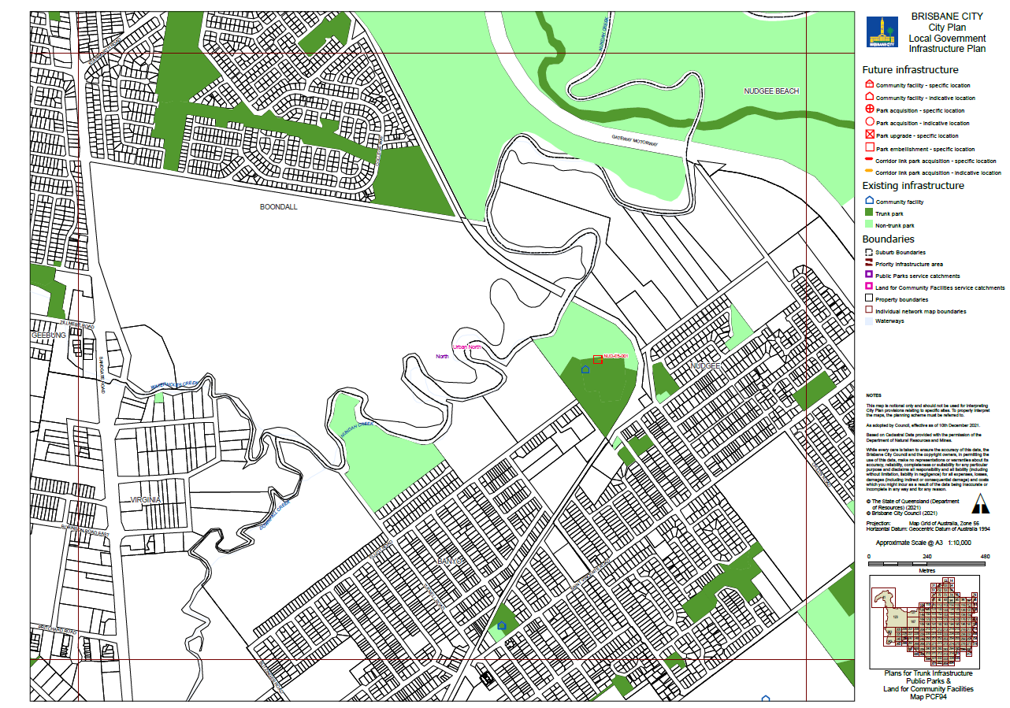

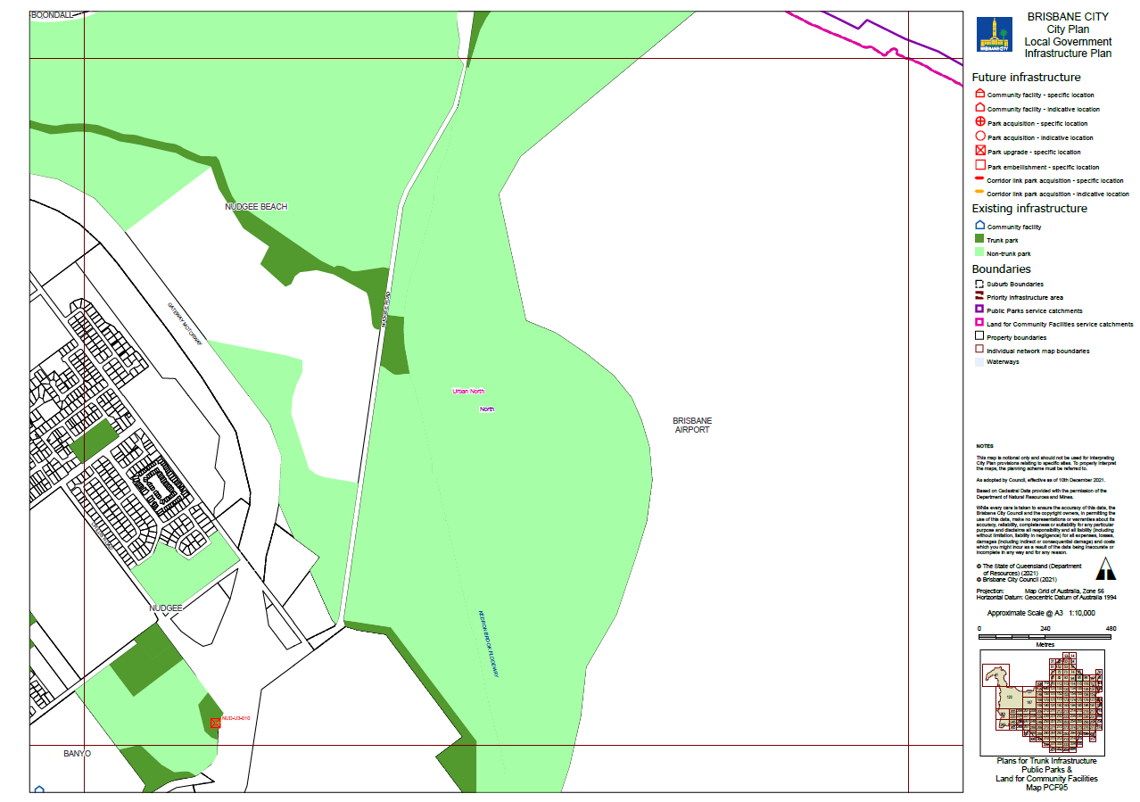
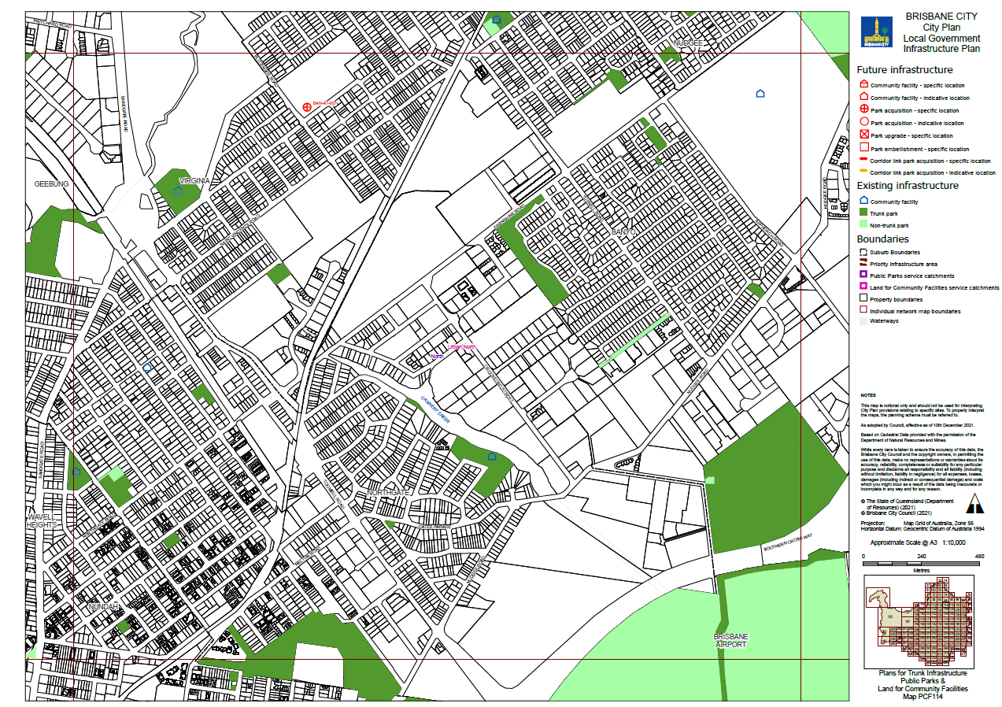

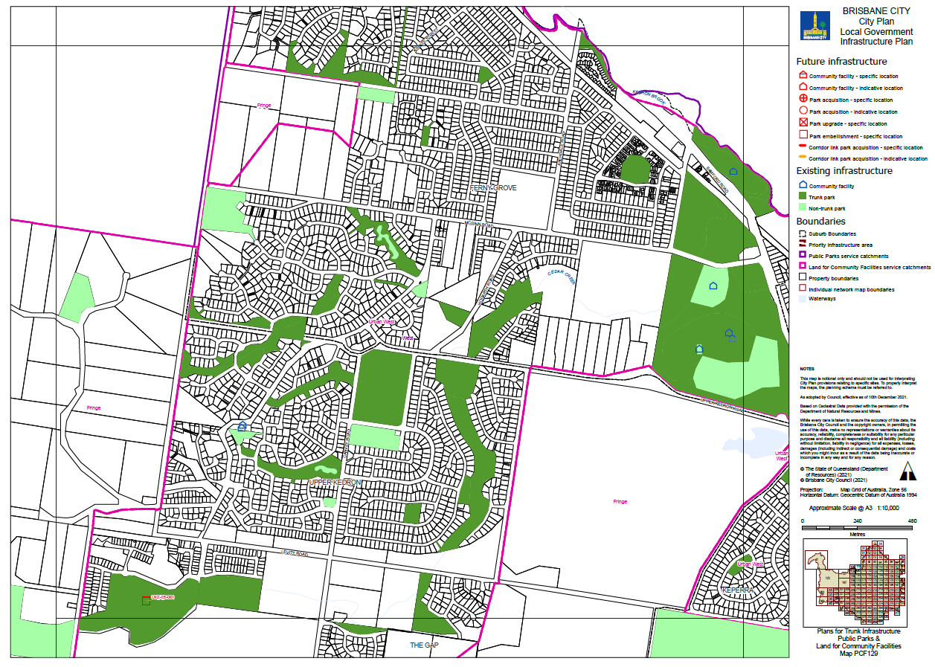

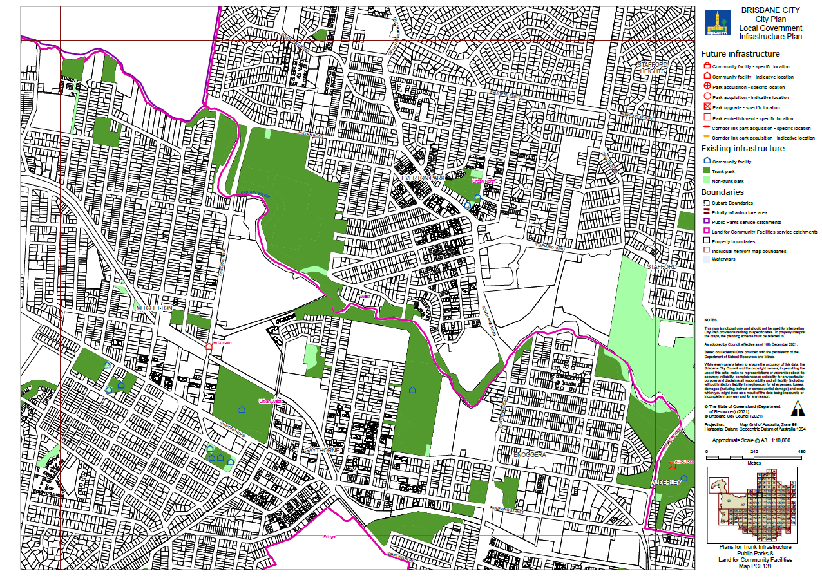

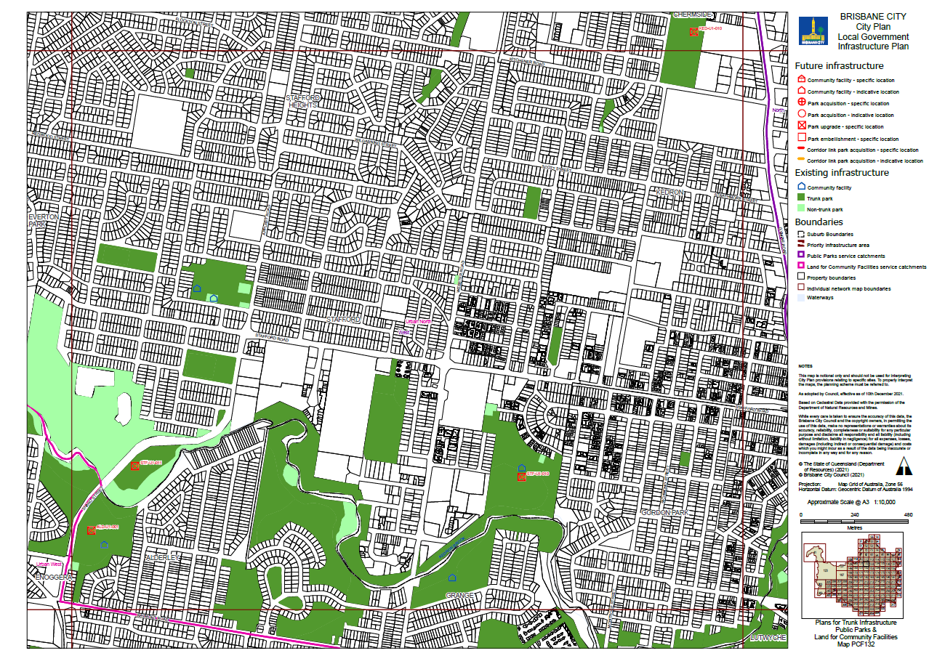

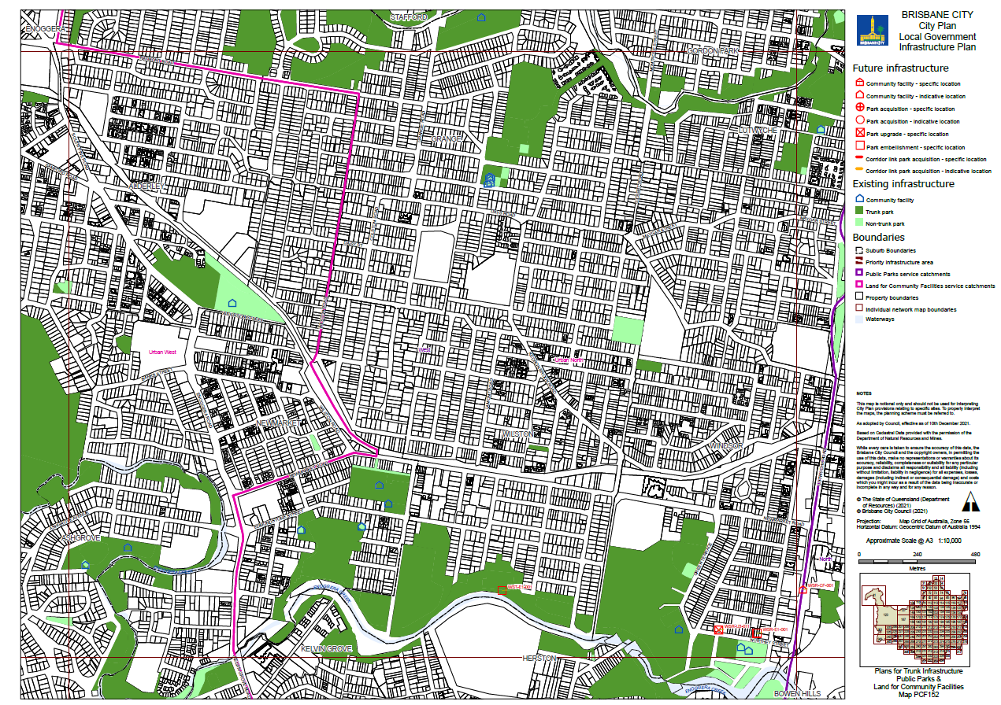

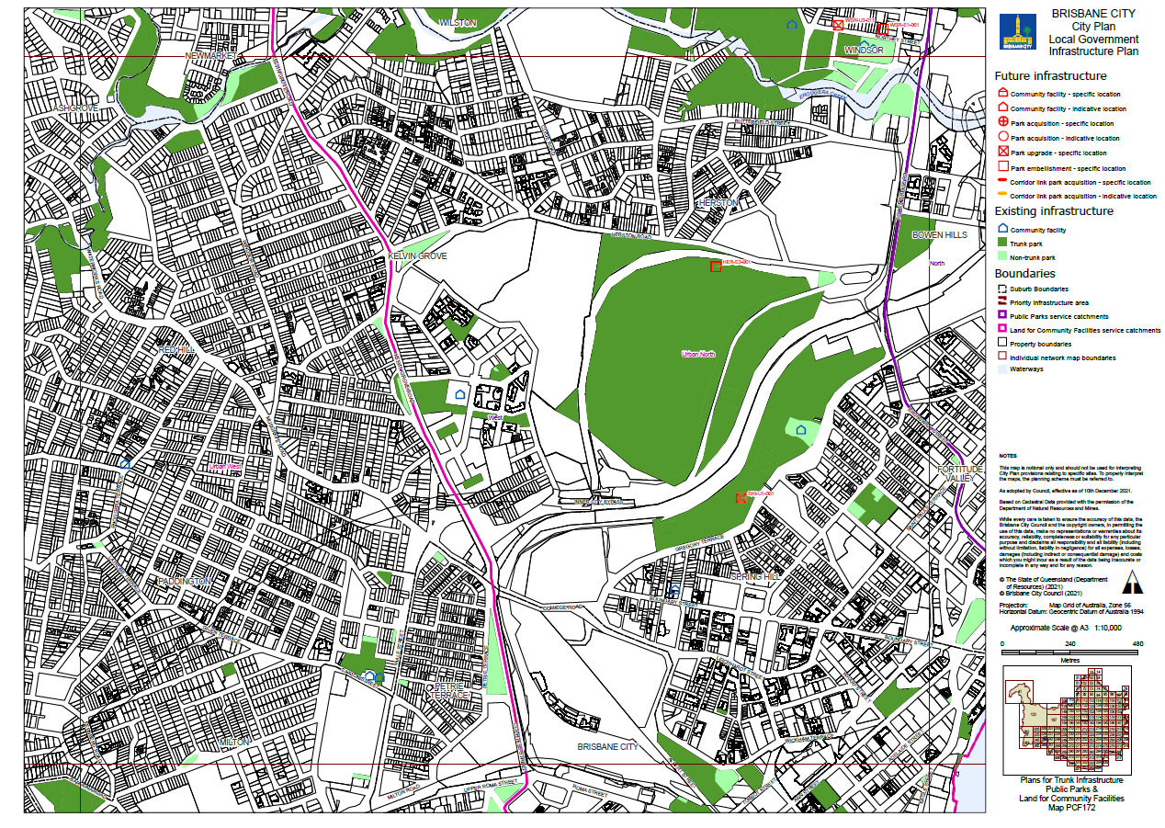

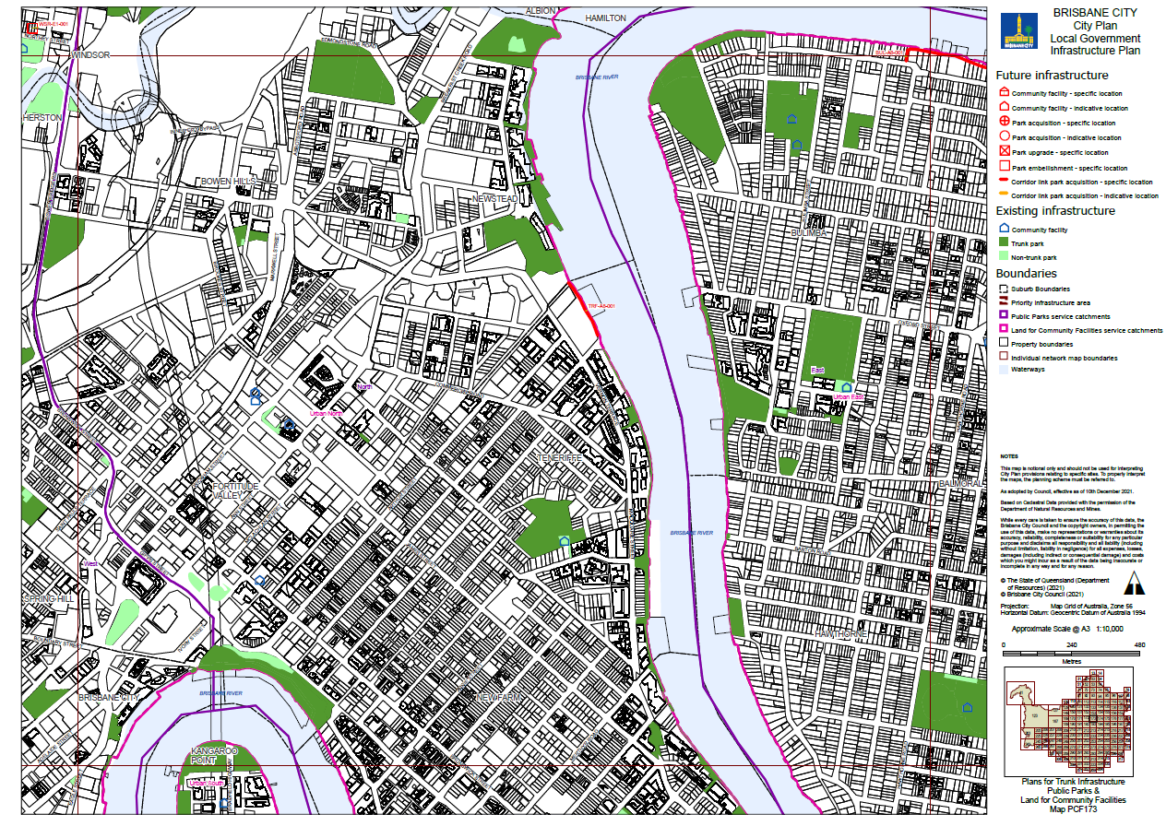

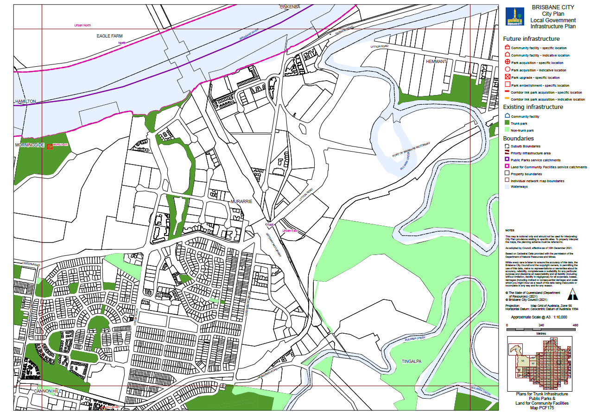

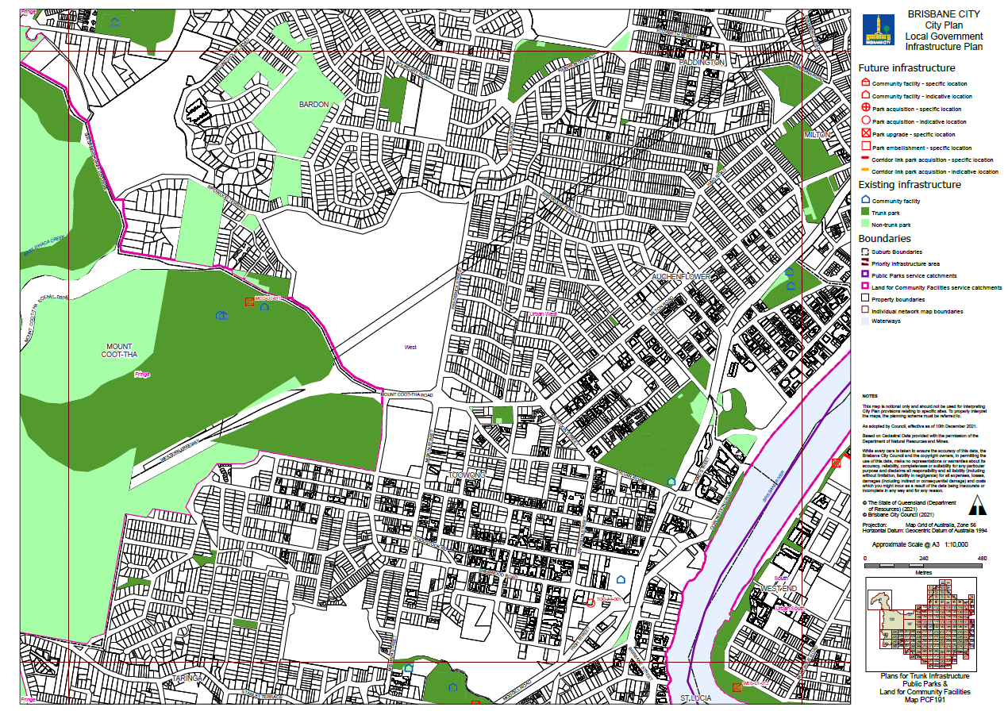

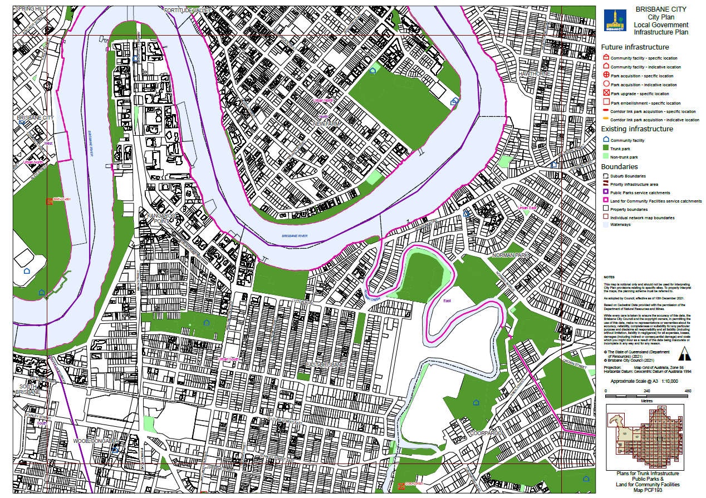

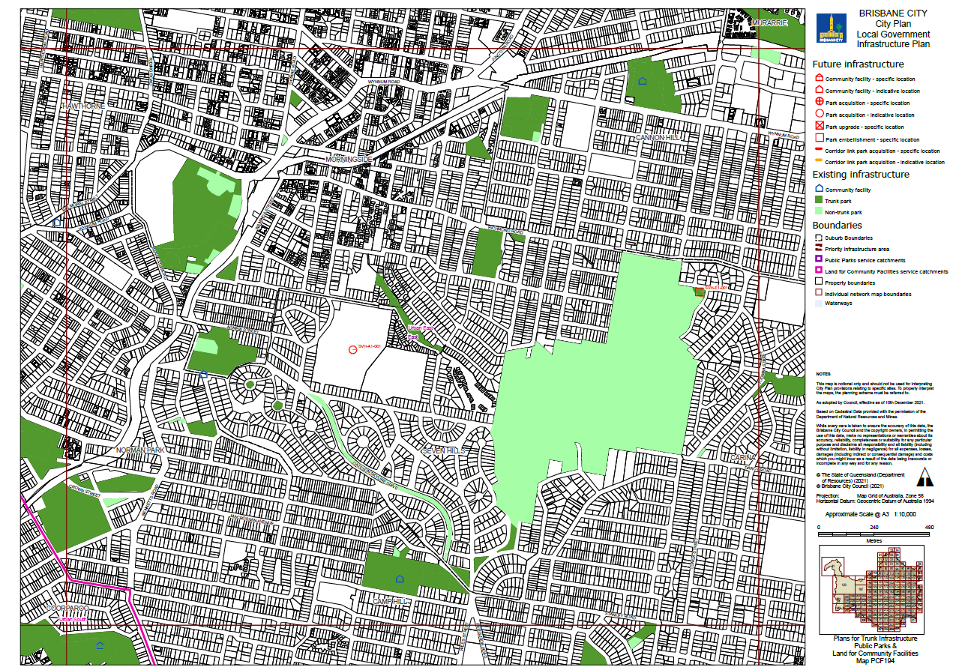

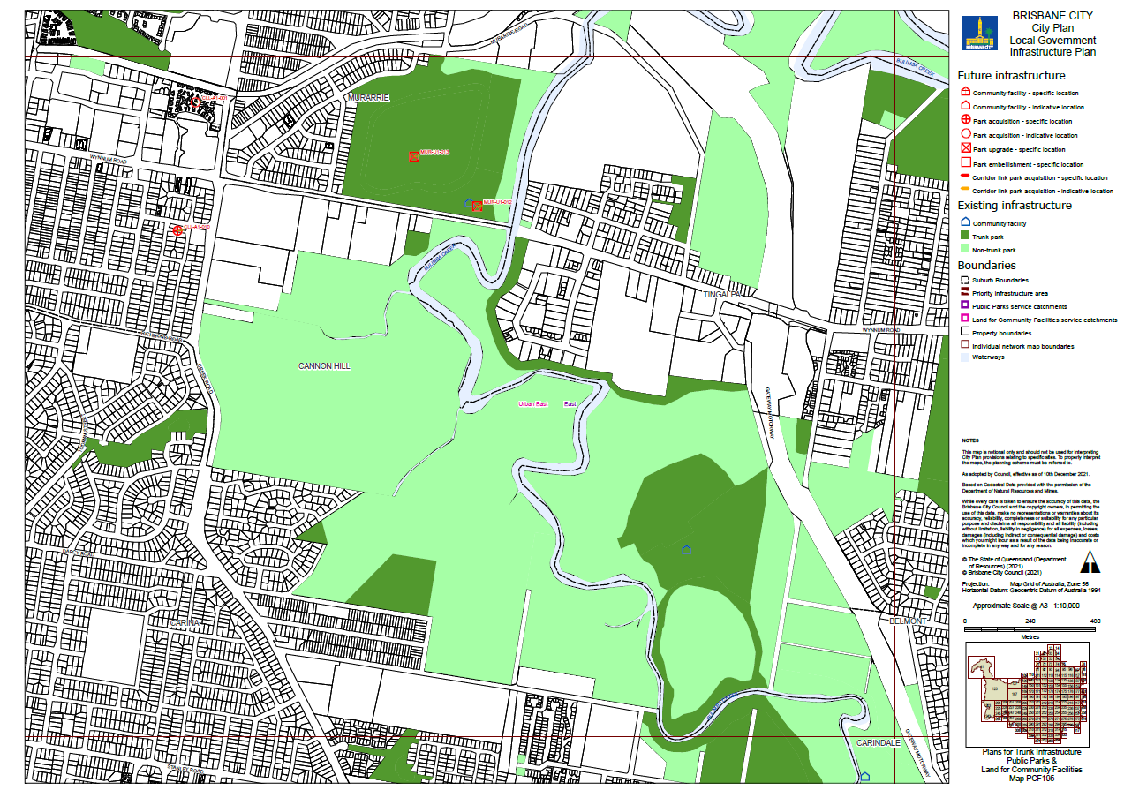

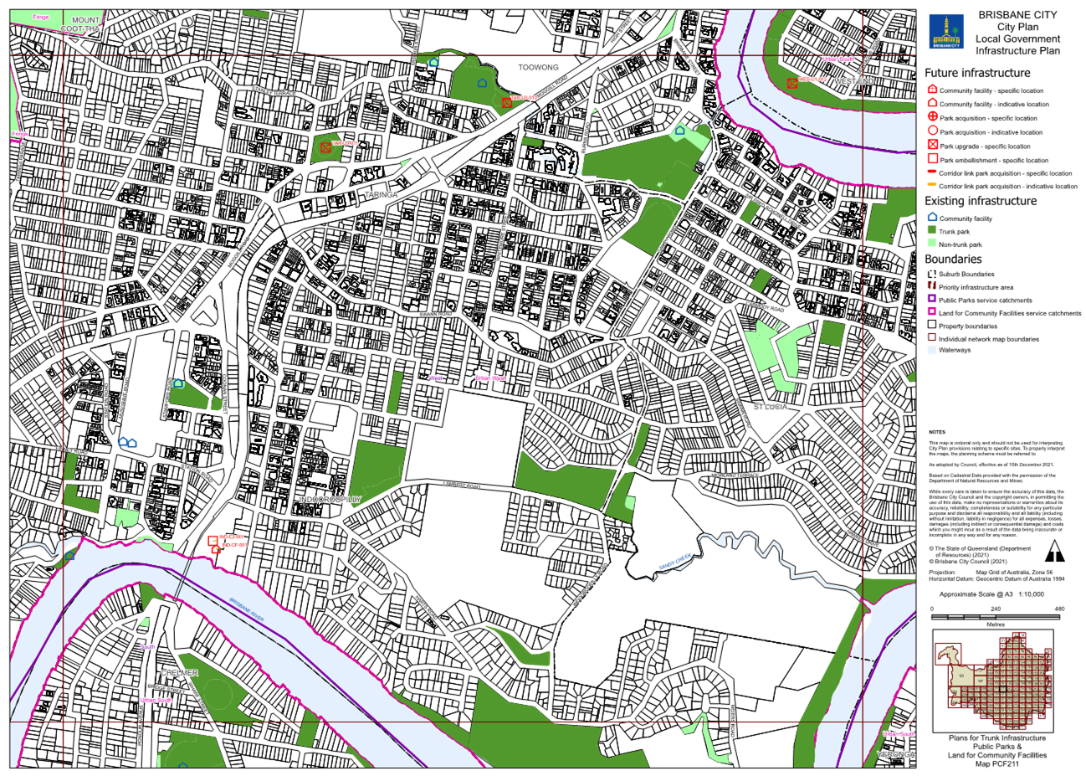

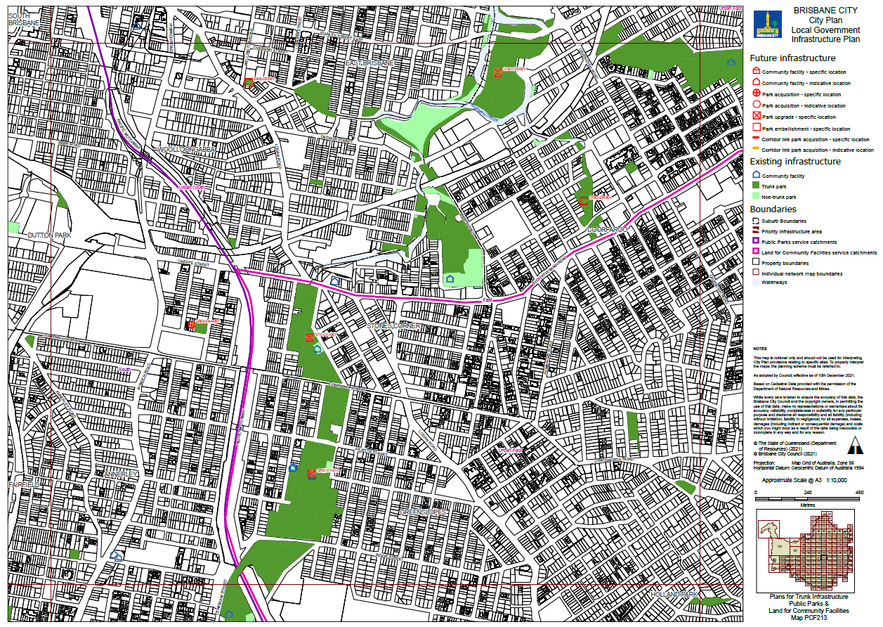

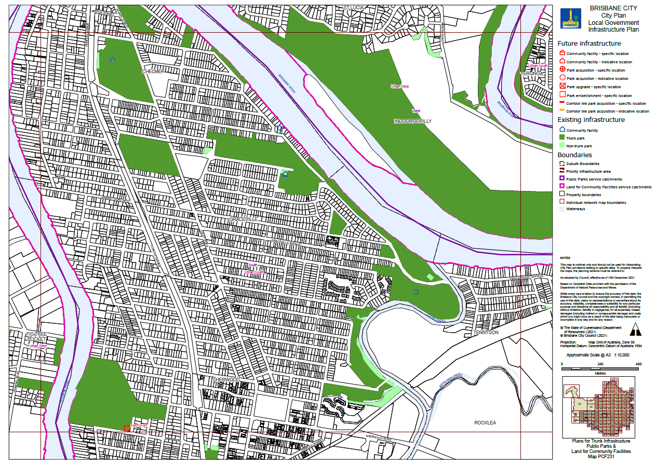
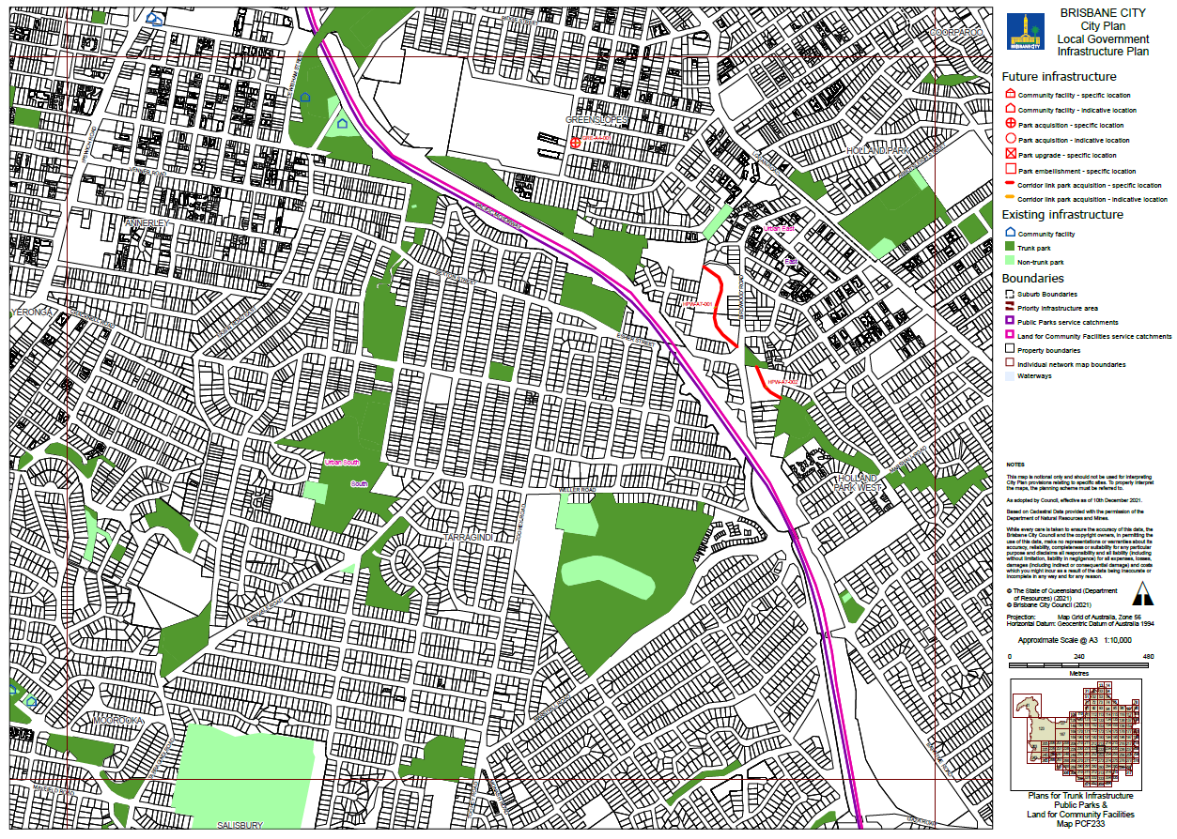

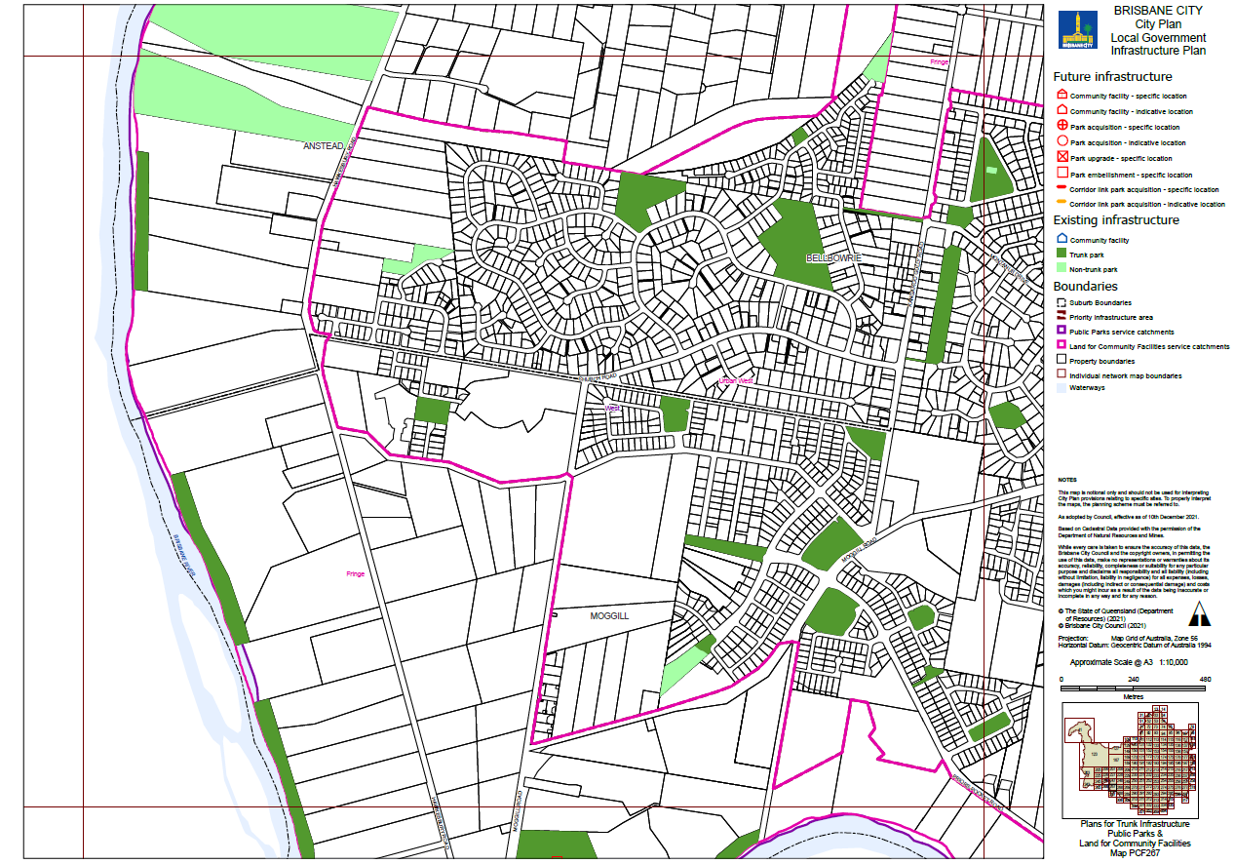

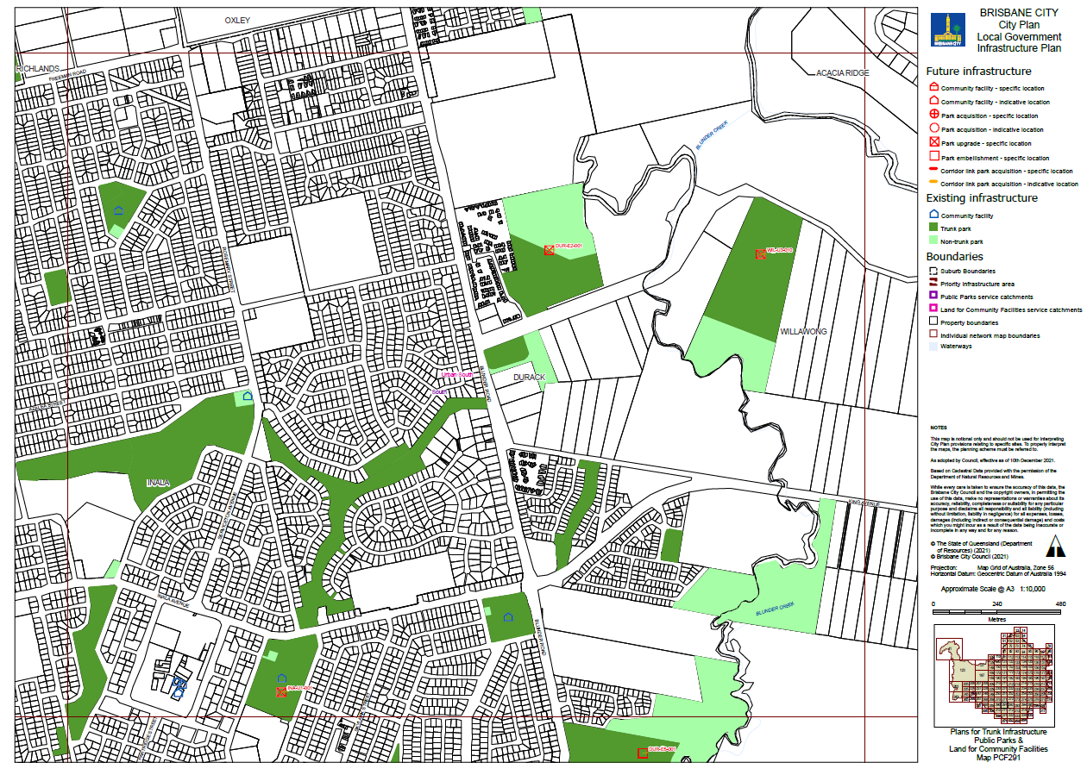

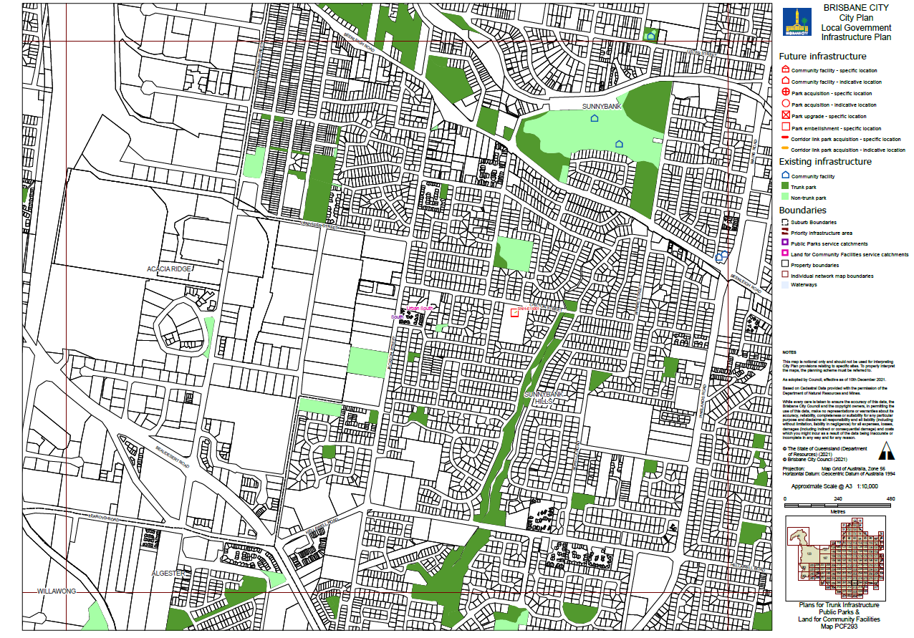

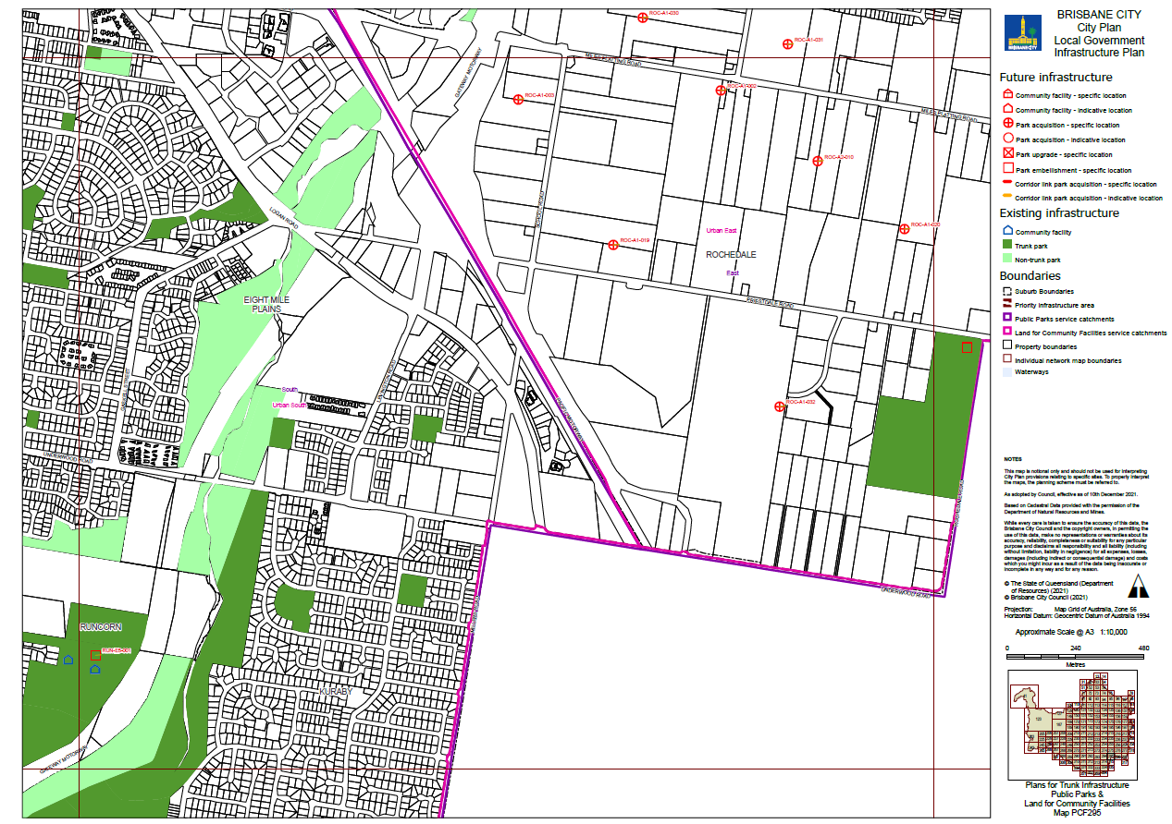

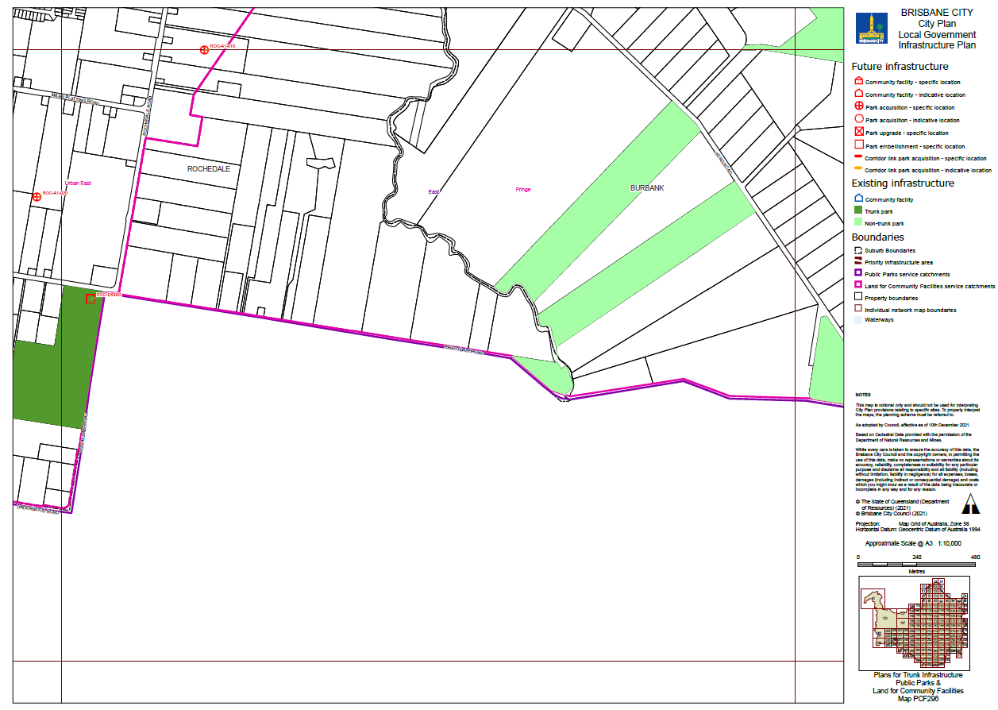

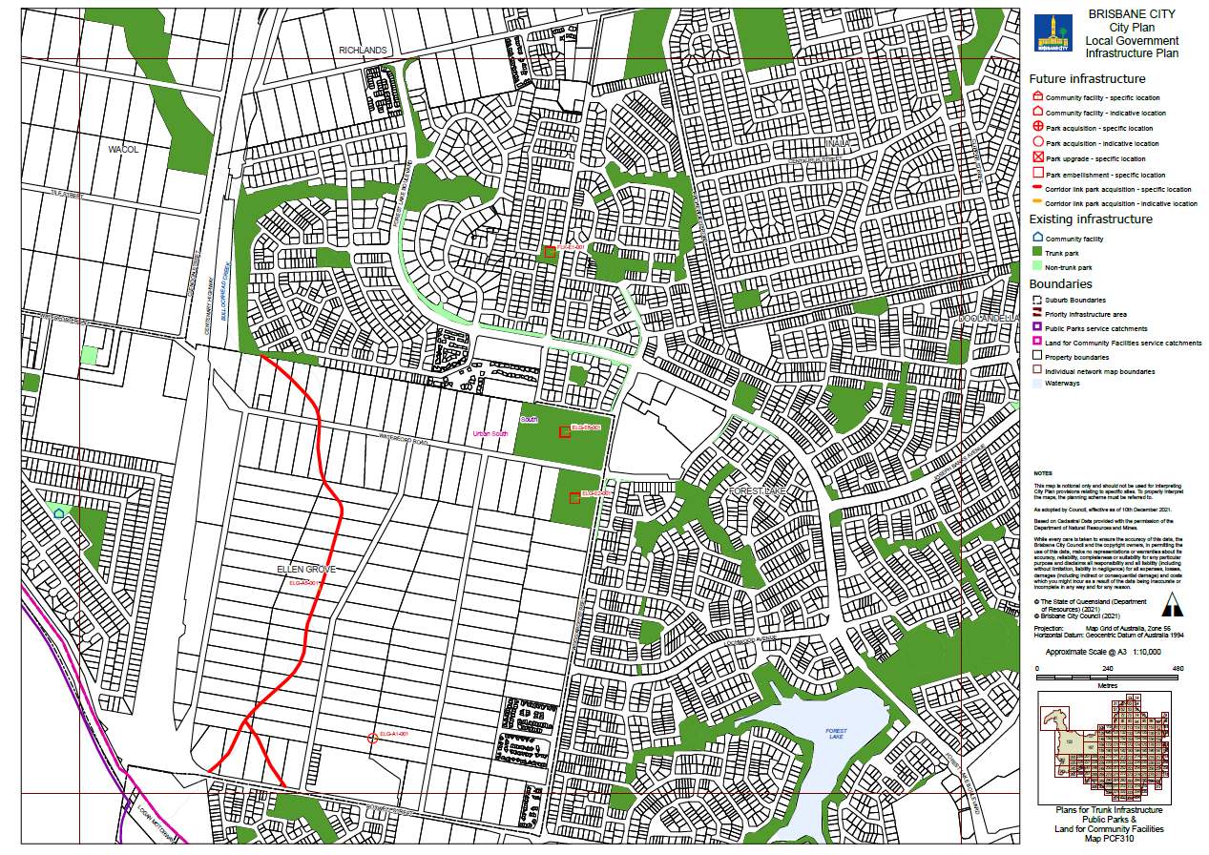

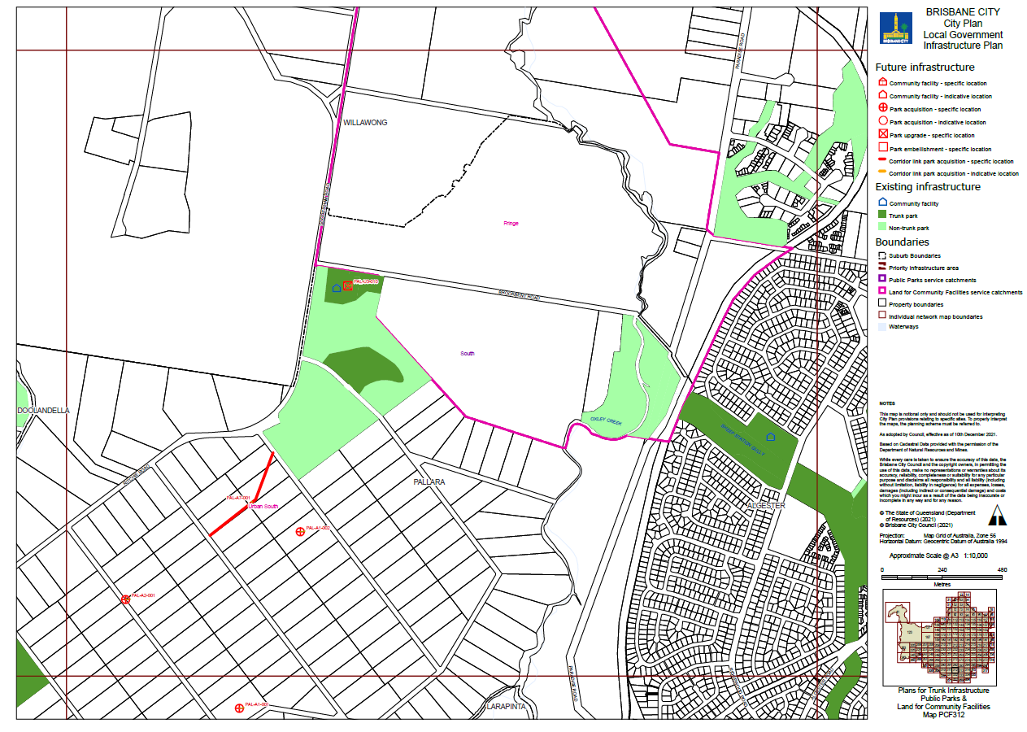

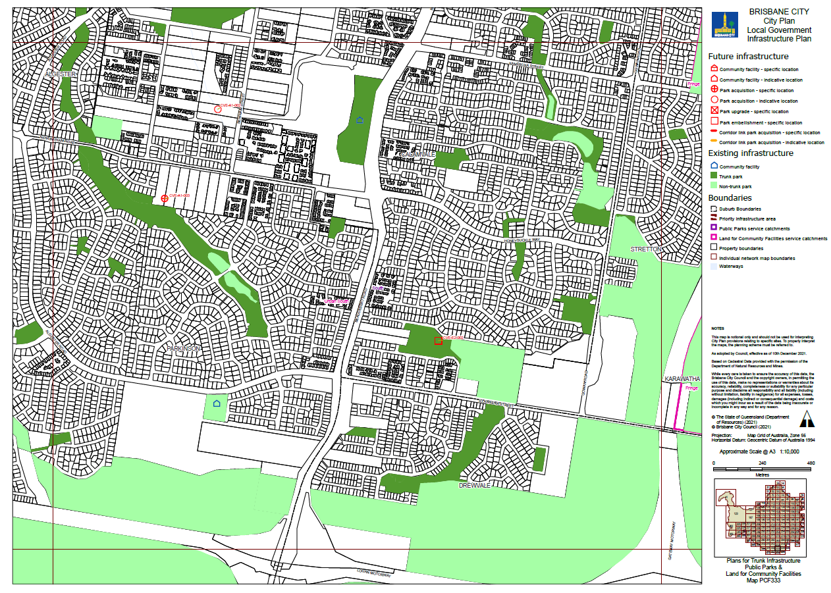

Table 26: Existing map tiles listed in Map tile numbers column below are updated to show the effective date as 10 December 2021.
Item no. | Map tile numbers | Reason for change
1. | All new map tiles | To update the maps to be consistent with the date of adoption of this amendment

