Sandgate district
neighbourhood plan

Brisbane City Plan 2014
Amendment Package – November 2022

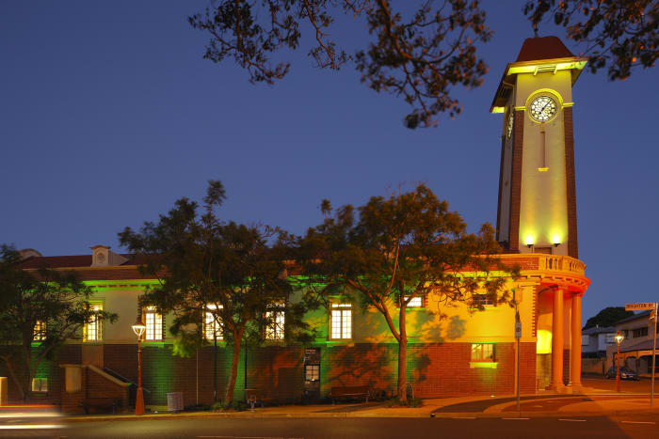

Table of Contents

Table of Contents 2
Part A: Explanatory Notes 4
Purpose 5
Introduction 5
Background 5
Community engagement 5
The neighbourhood plan boundary 7
Precincts 7
Key planning outcomes 8
Response to the planning scheme’s Strategic framework 8
Response to local planning outcomes 8
Amendment summary 9
Conclusion 12
Part B: Major Amendment v26.00/2023 13
Part 1 Amendment of Part 1 (About the planning scheme) 14
1.1 Amendment of section 1.2 (Planning scheme components) 14
Part 2 Amendment of Part 5 (Tables of assessment) 15
2.1 Amendment of section 5.9 (Categories of development and assessment—Neighbourhood plans) 15
Part 3 Amendment of Part 7 (Neighbourhood plans) 18
3.1 Amendment of section 7.2 (Neighbourhood plan codes) 18
7.2.19.1 Sandgate district neighbourhood plan code 18
7.2.19.1.1 Application 18
7.2.19.1.2 Purpose 18
7.2.19.1.3 Performance outcomes and acceptable outcomes 21
Part 4 Amendment of Part 8 (Overlays) 38
4.1 Amendment to section 8.2.19 (Significant landscape tree overlay code) 38
Part 5 Amendment of Schedule 2 (Mapping) 43
5.1 Amendment to SC2.2 (Zone maps) 43
5.2 Amendment to SC2.2 – Table SC2.2.1 (Zone maps) 43
5.3 Amendment to SC2.3 (Neighbourhood plan maps) 43
5.4 Amendment to SC2.3 – Table SC2.3.1 (Neighbourhood plan maps) 43
5.5 Amendment of Schedule 2.4 (Overlay maps) 44
5.6 Amendment of Table SC2.4.1 (Overlay maps) 45
Part 6 Amendment of Schedule 6 (Planning scheme policies) 47
6.1 Amendment to Schedule 6.16 (Infrastructure design planning scheme policy) – Table 5.1.2 47
6.2 Amendment to Schedule 6.16 (Infrastructure design planning scheme policy) – Section 5.2 47
5.2.19.1 Sandgate 47
5.2.19.1.1 Location and extent 47
5.2.19.1.2 Locality street specifications 49
5.2.19.1.3 Preferred plant species 50
6.3 Amendment to Schedule 6.16 (Infrastructure design planning scheme policy) – Section 5.3 50
5.3.19.3 Sandgate district 51
5.3.19.3.1 Location and extent 51
5.3.19.3.2 Locality street specifications 52
5.3.19.3.3 Standard footway elements and materials 52
5.3.19.3.4 Streetscape hierarchy 52
5.3.19.3.4.1 Streetscape types overview 52
6.4 Amendment to Schedule 6.29 Structure planning scheme policy 54
Part 7 Amendment of Appendix 2 (Table of amendments) 55
7.1 Amendment to Appendix 2 (Table of amendments) 55
Supplement 1—A3 Map Tiles 56

Part A: Explanatory Notes

Purpose

The purpose of these explanatory notes is to provide context to the Sandgate district neighbourhood plan amendment package (the amendment package) including the key outcomes sought and the process undertaken to develop the neighbourhood plan. The explanatory notes are for information only and do not form part of the amendment package.

Introduction

The amendment package sets out the statutory amendments required to amend Brisbane City Plan 2014 (the planning scheme) to incorporate proposed updates to the existing neighbourhood plan. It contains two parts: this explanatory statement (for information only) and the amendment package, which specifies the proposed statutory changes to the planning scheme.

Background

Brisbane City Council (Council) proposes to update the existing neighbourhood plan to guide future development and coordinate land use in the Sandgate district including the suburbs of Sandgate, Shorncliffe, Deagon and Brighton. Once adopted, the neighbourhood plan will become part of the planning scheme.

Council has developed the amendment package to amend the planning scheme. The amendment package forms a major amendment to the planning scheme as defined in the Planning Act 2016 and has been prepared in accordance with the Minister’s Guidelines and Rules.

Council commenced the neighbourhood planning process to focus on Sandgate, Shorncliffe and Deagon in early 2019. The Sandgate district neighbourhood plan draft strategy (the draft strategy) was released in October 2019 and was open for public consultation from 8 October 2019 to 4 November 2019. Feedback from the community, including the Community Planning Team (CPT) meetings, online survey and strategy responses, was used in the preparation of the neighbourhood plan. Internal Council stakeholders have also been involved in preparing the neighbourhood plan.

Council endorsed the amendment on 1 December 2020 and submitted the amendment to the Deputy Premier and Minister for State Development, Infrastructure, Local Government and Planning (the Minister) for State Interest Review. Prior to public consultation the neighbourhood plan was also amended to address conditions received from the Minister dated 25 March 2021.

The amendment package was released for public consultation from 10 May 2021 to 21 June 2021. Following a review and analysis of the submissions received, updates were made to the amendment package, and it was submitted to the Queensland Government on 14 June 2022 for consideration. The Minister advised on 13 October 2022 that the amendment was approved for adoption in the planning scheme.

Community engagement

The neighbourhood planning process involved a series of community engagement stages. A summary of the community engagement process is detailed in the following table.

Table 1 – Key community engagement summary
Engagement type | Date and location | Number
Online issues survey | March 2019 to April 2019 | 538 responses
Interactive mapping | March 2019 to April 2019 | 213 responses
CPT | Thursday 9 May 2019 – Sandgate RSL Memorial Hall | 21 attendees
 | Thursday 6 June 2019 – Sandgate RSL Memorial Hall | 24 attendees
 | Thursday 27 June 2019 – Sandgate RSL Memorial Hall | 15 attendees
Information kiosks | Thursday 24 October 2019 – Sandgate Town Hall | 250 attendees
 | Saturday 26 October 2019 – Sandgate Scouts Hall | 100 attendees
Draft amendment package consultation | 10 May 2021 to 21 June 2021 | Public consultation and feedback on the draft amendment package
Talk to a planner sessions (during consultation period) | Thursday 27 May 2021 –  Sandgate Bowls Club | 29 attendees
 | Saturday 29 May 2021 –  Sandgate Scout Hall | 35 attendees
 | Virtual meetings held from Monday 7 June 2021 to Friday 11 June 2021 | 7 attendees

The neighbourhood plan boundary

The Sandgate district neighbourhood plan includes the suburbs of Sandgate, Deagon, Shorncliffe and Brighton.

The neighbourhood plan boundary and precincts are outlined in Figure 1.

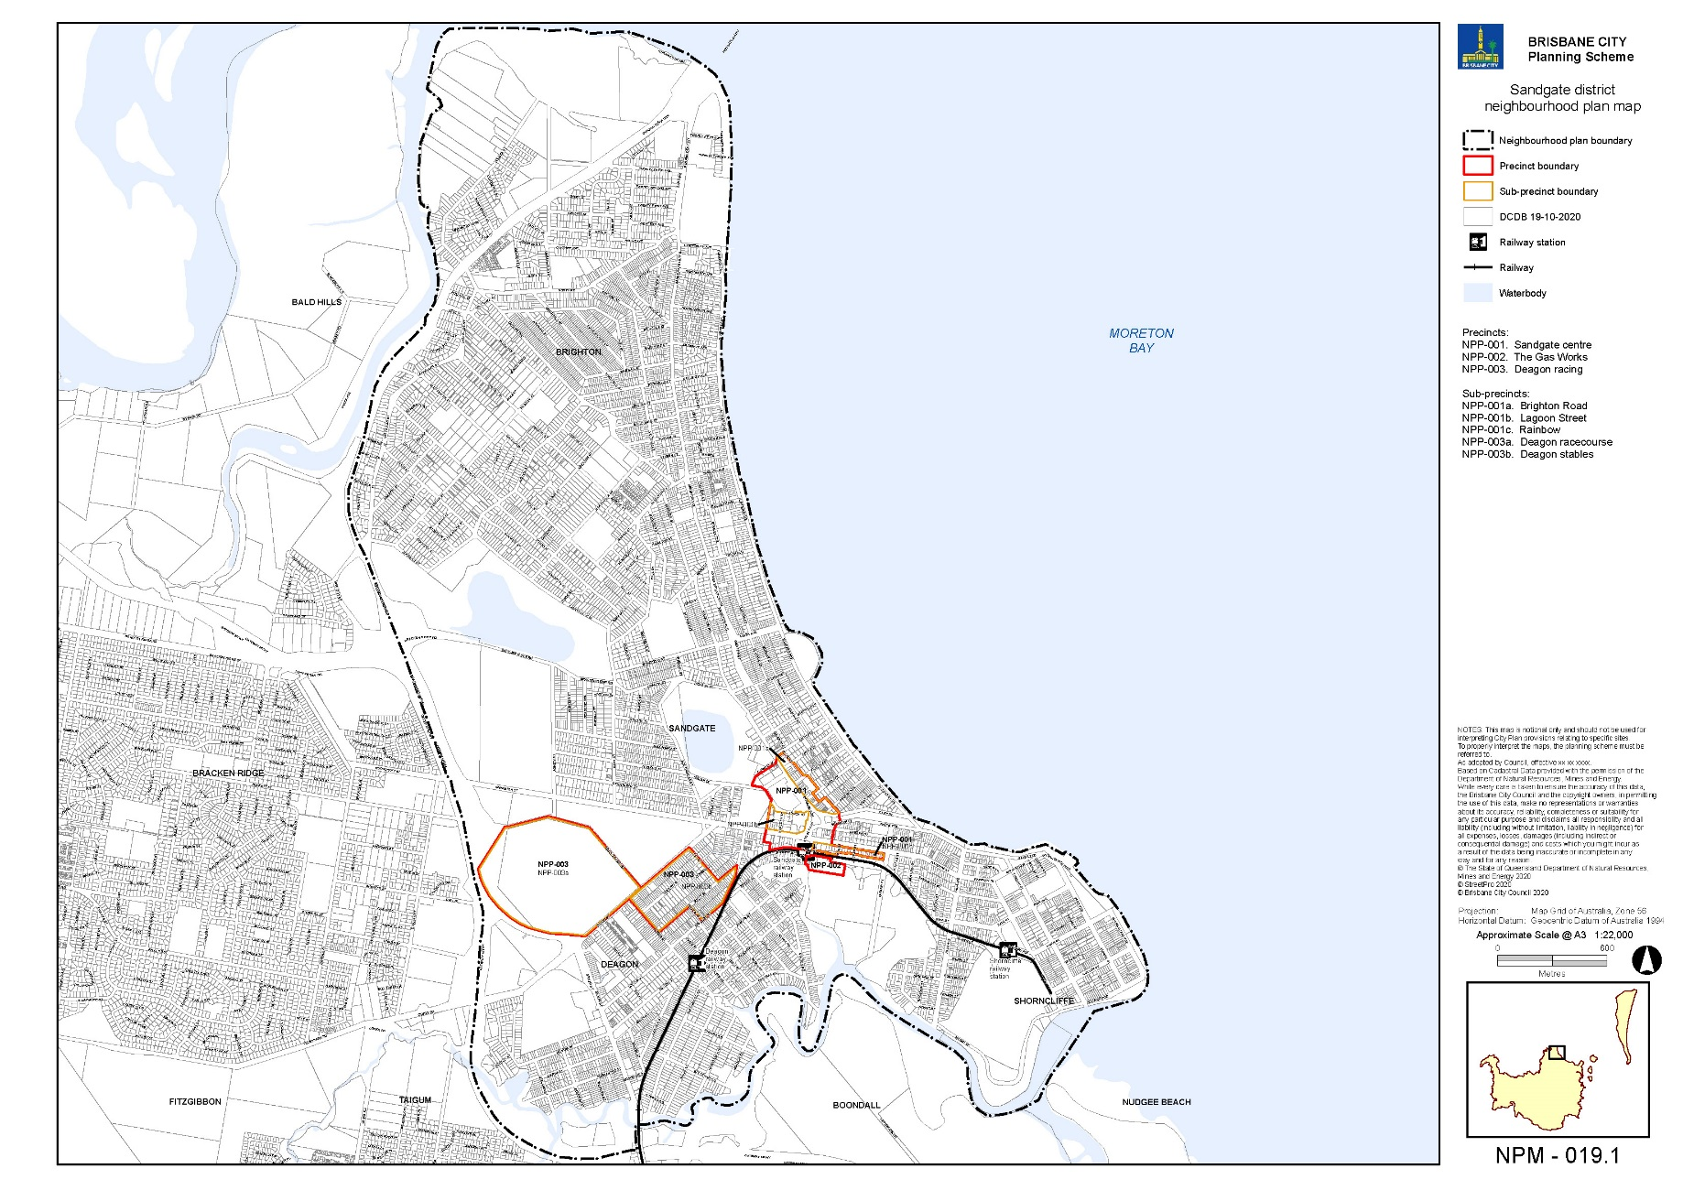
Figure 1 – Sandgate district neighbourhood plan boundary and precincts

Precincts

Neighbourhood plans include precincts and may also include sub-precincts. Precincts have been identified to address or provide for particular land uses, urban design, infrastructure or other site characteristics (e.g. environmental values), and have a specific set of provisions to achieve these outcomes. Located within a precinct, sub-precincts are smaller portions of the overall precinct, and include more detailed provisions to achieve the intended land use outcomes.

The amendment package proposes three precincts within the neighbourhood plan areas. Two of these precincts have sub-precincts. The proposed precincts are outlined in Figure 1 and also detailed in Part B of the amendment package. These precincts provide specific guidance on the types of uses and development outcomes supported in these locations and include:

- NPP-001: Sandgate centre precinct
  - NPP-001a: Brighton Road sub-precinct
  - NPP-001b: Lagoon Street sub-precinct
  - NPP-001c: Rainbow Street sub-precinct
- NPP-002: The Gas Works precinct
- NPP-003: Deagon racing
  - NPP-003a: Deagon racecourse
  - NPP-003b: Deagon stables

Key planning outcomes

The amendment package includes requirements to ensure that development responds to key State, regional and local planning outcomes.

Response to the planning scheme’s Strategic framework

The amendment package is aligned with the planning scheme’s Strategic framework. Under the Strategic framework, the neighbourhood plan area is identified as a suburban living area. The amendment package supports CityShape 2031 by delivering low density residential areas and character residential areas with a District centre on a public transport corridor.

Response to local planning outcomes

The neighbourhood plan area has frequent public transport access to the Brisbane CBD via the suburban railway network. It has a District centre at Sandgate and has a range of supporting service industry areas in Sandgate and Deagon. The Deagon racecourse is a major sport, recreation and entertainment facility located within the neighbourhood plan area providing stabling and training facilities for the racing industry.

The amendment package seeks to:
- Maintain and enhance the Sandgate centre as the primary centre for the area, providing a balance of commercial and residential development close to public transport.
- Balance the protection of the low density character of Sandgate, Shorncliffe and Deagon with providing housing choice close to the Sandgate railway station in the Gas Works precinct.
- Protect the character and heritage of properties in Sandgate, Shorncliffe and Deagon.
- Continue existing light industry uses in Sandgate around Connaught Street to support local businesses and employment.
- Provide for mixed industry and business uses on Rainbow Street to support a mix of employment generating uses including low impact industry, research and technology, advanced manufacturing, service industries and associated commercial uses including small scale offices, shops and food and drink outlets that complement the Sandgate centre.
- Provide for additional uses on Rainbow Street to meet the need of local residents, workers and businesses that include educational establishment (where technical institute or university, and where not including accommodation), function facility and health care service.
- Support the ongoing function of the Deagon racecourse and associated stabling and training facilities.

Amendment summary

Table 2 – Amendment summary

Part | Planning scheme reference | Proposed amendment | Part B amendment reference
Part 1 (About the planning scheme) | Table 1.2.2—Neighbourhood plans precincts and sub-precincts | Amend the row for the Sandgate district neighbourhood plan. Delete the existing precincts and replace with the following precincts:  - NPP-001: Sandgate centre  - NPP-001a: Brighton Road  - NPP-001b: Lagoon Street  - NPP-001c: Rainbow Street  - NPP-002: The Gas Works  - NPP-003: Deagon racing  - NPP-003a: Deagon racecourse  - NPP-003b: Deagon stables | Part 1.1 (1)
Part 5 (Tables of assessment) | Table 5.9.1—Categories of development and assessment changes—Neighbourhood plans | Amend the Sandgate district neighbourhood plan for the categories of development and assessment changes. Amend the MCU column from ‘No change’ to ‘Change’ to reflect development outcomes. | Part 2.1 (2)
 | Table 5.9.60.A—Sandgate district neighbourhood plan: material change of use | Amend and update the table of assessment to include:  - Rainbow Street sub-precinct (NPP-001c)  - The Gas Works precinct (NPP-002). | Part 2.1 (3)
Part 7 (Neighbourhood plans) | Section 7.2 Neighbourhood plan codes | Amend 7.2.19.1 Sandgate district neighbourhood plan code. | Part 3.1 (4)
Part 8 (Overlays) | Table 8.2.19.3.C —Significant landscape trees in specific locations | Amend the Significant landscape tree overlay code to include significant landscape trees in the suburbs of Deagon, Sandgate and Shorncliffe. | Part 4.1 (5, 6 and 7)
Schedule 2 (Mapping) | SC2.2 Zone Maps – ZM-001 (Map tile 6) | Amend map tile 6 to include changes in the Sandgate district neighbourhood plan area. | Part 5.1 (8)
 | SC2.2 Zone maps,  Table SC2.2.1—Zone maps | Amend Table SC2.2.1 to include new gazettal date for ZM-001 (Map tile 6). | Part 5.2 (9)
 | SC2.3 Neighbourhood plan maps, NPM-019.1 | Amend NPM-019.1 Sandgate district neighbourhood plan map. | Part 5.3 (10)
 | SC2.3 Neighbourhood plan maps,  Table SC2.3.1—Neighbourhood plan maps | Amend Table SC2.3.1 Neighbourhood plan maps to include new gazettal date for NPM-019.1. | Part 5.4 (11)
 | SC2.4 Overlay maps | Amend OM-003.2 Commercial character building overlay map (Map tile 6). | Part 5.5 (12)
 |  | Amend OM-004.1 Dwelling house character overlay map (Map tile 6). | Part 5.5 (13)
 |  | Amend OM-008.1 Heritage overlay map (Map tile 6). | Part 5.5 (14)
 |  | Amend OM-016.2 Pre-1911 building overlay map (Map tile 6). | Part 5.5 (15)
 |  | Amend OM-019.1 Significant landscape tree overlay map (Map tile 6). | Part 5.5 (16)
 |  | Amend OM-019.2 Streetscape hierarchy overlay map (Map tile 6). | Part 5.5 (17)
 |  | Amend OM-020.1 Traditional building character overlay map (Map tile 6). | Part 5.5 (18)
 | SC2.4 Overlay maps,  Table SC2.4.1 | Amend Table SC2.4.1 to include new gazettal date for OM-003.2 Commercial character building overlay map (Map tile 6). | Part 5.6 (19)
 |  | Amend Table SC2.4.1 to include new gazettal date for OM-004.1 Dwelling house character overlay map (Map tile 6). | Part 5.6 (20)
 |  | Amend Table SC2.4.1 to include new gazettal date for OM-008.1 Heritage overlay map (Map tile 6). | Part 5.6 (21)
 |  | Amend Table SC2.4.1 to include new gazettal date for OM-016.2 Pre-1911 building overlay map (Map tile 6). | Part 5.6 (22)
 |  | Amend Table SC2.4.1 to include new gazettal date for OM-019.1 Significant landscape tree overlay map (Map tile 6). | Part 5.6 (23)
 |  | Amend Table SC2.4.1 to include new gazettal date for OM-019.2 Streetscape hierarchy overlay map (Map tile 6). | Part 5.6 (24)
 |  | Amend Table SC2.4.1 to include new gazettal date for OM-020.1 Traditional building character overlay map (Map tile 6). | Part 5.6 (25)
Schedule 6 Planning scheme policies | SC6.16 Infrastructure design planning scheme policy, Chapter 5 Streetscape locality advice | Amend Table 5.1.2—Locality streets within Neighbourhood plan areas and other locations to include reference to Sandgate district neighbourhood plan. | Part 6.1 (26)
 | SC6.16 Infrastructure design planning scheme policy, Chapter 5 Streetscape locality advice, Section 5.2 Locality streets in Suburban Centre Improvement Projects, 5.2.19.1 Sandgate | Amend 5.2.19.1.1 Location and extent (detailing the location and extent of the Suburban Centre Improvement Project within Sandgate), 5.2.19.1.2 Locality street specifications and 5.2.19.1.3 Preferred plant species. | Part 6.2 (27)
 | SC6.16 Infrastructure design planning scheme policy, Chapter 5 Streetscape locality advice, Section 5.3 Neighbourhood plans and other locations | Insert 5.3.19.3 Sandgate district – Section detailing location and extent of locality streets including specifications and preferred plant species. | Part 6.3 (28)
 | SC6.29 Structure planning planning scheme policy, 1 Introduction | Amend table in 1.1 Relationship planning scheme to include Sandgate district neighbourhood plan. | Part 6.4 (29)
Appendix 2 (Table of Amendments) | Table AP2.1—Table of amendments | Insert date of adoption and effective date, planning scheme version number, amendment type and summary of amendments as a result of the neighbourhood plan. | Part 7.1 (30)

Conclusion

The neighbourhood planning process commenced in early 2019. The amendment package is a product of a range of technical studies and feedback from the community and stakeholders. The amendment package proposes a range of changes to the planning scheme including a new Sandgate district neighbourhood plan code, changes to zones, overlays and planning scheme policies.

Part B: Major Amendment v26.00/2023

It is hereby certified that this is a true and correct copy of Brisbane City Plan 2014 Major Amendment v26.00/2023 made, in accordance with the Planning Act 2016, by Brisbane City Council.

John Cowie
Manager
City Planning and Economic Development
City Planning and Sustainability
Brisbane City Council

Part 1 Amendment of Part 1 (About the planning scheme)

1.1 Amendment of section 1.2 (Planning scheme components)
- Section 1.2 Planning scheme components, Table 1.2.2—Neighbourhood plans precincts and sub-precincts–
‘
Sandgate district neighbourhood plan | NPP-001: Sandgate town centre  NPP-002: The Gas Works  NPP-003: Deagon stables
’–
omit, insert:
‘
Sandgate district neighbourhood plan | NPP-001: Sandgate centre  NPP-001a: Brighton Road  NPP-001b: Lagoon Street  NPP-001c: Rainbow Street  NPP-002: The Gas Works  NPP-003: Deagon racing  NPP-003a: Deagon racecourse  NPP-003b: Deagon stables
’.

Part 2 Amendment of Part 5 (Tables of assessment)

2.1 Amendment of section 5.9 (Categories of development and assessment—Neighbourhood plans)
- Section 5.9 Categories of development and assessment—Neighbourhood plans, Table 5.9.1—Neighbourhood plan categories of development and assessment changes–
‘
Sandgate district neighbourhood plan | No change | No change | No change | No change
’–
omit, insert:
‘
Sandgate district neighbourhood plan | Change | No change | No change | No change
’.
- Section 5.9 Categories of development and assessment—Neighbourhood plans, Table 5.9.60.A—Sandgate district neighbourhood plan: material change of use–
‘
Use | Categories of development and assessment | Assessment benchmarks
MCU, if assessable development | No change | Sandgate district neighbourhood plan code
’
omit and insert:
‘
Table 5.9.60.A—Sandgate district neighbourhood plan: material change of use
Use | Categories of development and assessment | Assessment benchmarks
If in the neighbourhood plan area
MCU, if assessable development where not listed in this table | No change | Sandgate district neighbourhood plan code
If in the Rainbow Street sub-precinct (NPP-001c)
Educational establishment where technical institute or university, and where not including accommodation | Acceptable development, subject to compliance with identified requirements
 | If involving an existing premises with no increase in gross floor area, where complying with all acceptable outcomes in section A of the Specialised centre code | Not applicable
 | Assessable development—Code assessment
 | If involving an existing premises with no increase in gross floor area, where not complying with all acceptable outcomes in section A of the Specialised centre code | Sandgate district neighbourhood plan code  Specialised centre code—purpose, overall outcomes and section A outcomes only
 | If involving a new premises or an existing premises with an increase in gross floor area | Sandgate district neighbourhood plan code  Community facilities code  Specialised centre code  Specialised centre zone code  Prescribed secondary code
Function facility | Accepted development, subject to compliance with identified requirements
 | If involving an existing premises with no increase in gross floor area, where complying with all acceptable outcomes in section A of the Specialised centre code | Not applicable
 | Assessable development—Code assessment
 | If involving an existing premises with no increase in gross floor area, where not complying with all acceptable outcomes in section A of the Specialised centre code | Sandgate district neighbourhood plan code  Specialised centre code—purpose, overall outcomes and section A outcomes only
 | If involving a new premises or an existing premises with an increase in gross floor area | Sandgate district neighbourhood plan code  Specialised centre code  Specialised centre zone code  Prescribed secondary code
Health care service | Accepted development, subject to compliance with identified requirements
 | If involving an existing premises with no increase in gross floor area, where complying with all acceptable outcomes in section A of the Specialised centre code | Not applicable
 | Assessable development—Code assessment
 | If involving an existing premises with no increase in gross floor area, where not complying with all acceptable outcomes in section A of the Specialised centre code | Sandgate district neighbourhood plan code  Specialised centre code—purpose, overall outcomes and section A outcomes only
 | If involving a new premises or an existing premises with an increase in gross floor area | Sandgate district neighbourhood plan code  Community facilities code  Specialised centre code  Specialised centre zone code  Prescribed secondary code
If in The Gas Works precinct (NPP-002)
Care co-located uses (activity group), excluding Food and drink outlet and Shop | Assessable development—Impact assessment
The planning scheme including:
Sandgate district neighbourhood plan code
Retirement and residential care facility code
Low-medium density residential zone code
Prescribed secondary code
Residential care facility | Assessable development—Impact assessment
The planning scheme including:
Sandgate district neighbourhood plan code
Retirement and residential care facility code
Low-medium density residential zone code
Prescribed secondary code
Short-term accommodation | Assessable development—Impact assessment
The planning scheme including:
Sandgate district neighbourhood plan code
Multiple dwelling code
Short-term accommodation code
Low-medium density residential zone code
Prescribed secondary code
Tourist park | Assessable development—Impact assessment
The planning scheme including:
Sandgate district neighbourhood plan code
Tourist park and relocatable home park code
Low-medium density residential zone code
Prescribed secondary code
’.

Part 3 Amendment of Part 7 (Neighbourhood plans)

3.1 Amendment of section 7.2 (Neighbourhood plan codes)
- Section 7.2 Neighbourhood plans, 7.2.19.1. Sandgate district neighbourhood plan code–
omit, insert:
‘

7.2.19.1 Sandgate district neighbourhood plan code

7.2.19.1.1 Application
      - This code applies to assessing a material change of use, reconfiguring a lot, operational work or building work in the Sandgate district neighbourhood plan area if:
        - assessable development where this code is an applicable code identified in the assessment benchmarks column of a table of assessment for a neighbourhood plan (section 5.9); or
        - impact assessable development.
      - Land in the Sandgate district neighbourhood plan area is identified on the NPM-019.1 Sandgate district neighbourhood plan map and includes the following precincts:
        - Sandgate centre precinct (Sandgate district neighbourhood plan/NPP-001):
          - Brighton Road sub-precinct (Sandgate district neighbourhood plan/NPP-001a);
          - Lagoon Street sub-precinct (Sandgate district neighbourhood plan/NPP-001b);
          - Rainbow Street sub-precinct (Sandgate district neighbourhood plan/NPP-001c).
        - The Gas Works precinct (Sandgate district neighbourhood plan/NPP-002);
        - Deagon racing precinct (Sandgate district neighbourhood plan/NPP-003):
          - Deagon racecourse sub-precinct (Sandgate district neighbourhood plan/NPP-003a);
          - Deagon stables sub-precinct (Sandgate district neighbourhood plan/NPP-003b).
      - When using this code, reference should be made to section 1.5, section 5.3.2 and section 5.3.3.

Note—The following purpose, overall outcomes, performance outcomes and acceptable outcomes comprise the assessment benchmarks of this code.
Note—This neighbourhood plan includes a table of assessment. Refer to Table 5.9.60.A, Table 5.9.60.B, Table 5.9.60.C and Table 5.9.60.D.

7.2.19.1.2 Purpose
      - The purpose of the Sandgate district neighbourhood plan code is to provide finer grained planning at a local level for the Sandgate district neighbourhood plan area.
      - The purpose of the Sandgate district neighbourhood plan code will be achieved through overall outcomes including overall outcomes for each precinct of the neighbourhood plan area.
      - The overall outcomes for the neighbourhood plan area are:
        - Heritage places that contribute to the history and identity of Sandgate district are conserved, whilst allowing for adaptive reuse where appropriate.
        - Residential development will be predominantly low density with the character of the district continuing to reflect traditional architectural features such as ‘timber and tin’ housing.
        - Sandgate centre is the primary centre for the district, providing employment opportunities and services for the local community, and is supported by an existing District centre in Deagon.
        - Low impact industry uses are protected around Connaught Street contributing to the local economy and jobs.
        - The environmental and Aboriginal cultural heritage values of Moreton Bay, Boondall and Tinchi Tamba Wetlands, Cabbage Tree Creek and Third, Dowse and Einbunpin lagoons are protected.
        - Sandgate foreshore and Shorncliffe Pier continue to provide recreational uses that attract tourism to the Sandgate district.
        - Deagon racecourse provides for a limited range of non-residential uses to support the function of the racecourse as a Major sport, recreation and entertainment facility, while maintaining the primacy of the Sandgate centre.
        - Development does not exceed building heights specified in the neighbourhood plan, to maintain the prevailing character of the area.
      - Sandgate centre precinct (Sandgate district neighbourhood plan/NPP-001) overall outcomes are:
        - Sandgate centre continues to be the primary centre for the district and provides a mix of dwelling types within an employment centre close to public transport, providing housing choice for residents.
        - The cultural heritage significance and setting of the Sandgate Town Hall, Sandgate War Memorial Park and Sandgate Post Office are conserved as important historical landmarks and celebrated as a gateway into the Sandgate centre.
        - Development protects the recreation, scenic and landscape values of Einbunpin Lagoon Park and facilitates opportunities for physical connections and integration between the Lagoon and other public spaces.
        - Development maintains and enhances pedestrian connections within the centre and between the centre and key destinations including Sandgate railway station and the foreshore.
        - Development in Brighton Road sub-precinct (Sandgate district neighbourhood plan/NPP-001a):
          - contributes to the function of this area as the primary commercial street and community hub of the centre;
          - protects and complements the traditional elements of the streetscape along Brighton Road and contributes to pedestrian amenity;
          - comprises a built form that provides a transition between the centre and adjoining residential areas to protect residential amenity.
        - Development in Lagoon Street sub-precinct (Sandgate district neighbourhood plan/NPP-001b):
          - includes a mix of compatible residential and non-residential uses, ensuring that commercial activity does not result in adverse noise, light or odour impacts on residents;
          - supports the commercial function of the centre by accommodating a mix of centre activities and residential uses on the ground floor and provides for pedestrian activity around Einbunpin Lagoon Park and street corners;
          - has a built form that is cohesive with the existing centre, presents a human scale to the street, and provides an appropriate interface with heritage places.
        - Development in the Rainbow Street sub-precinct (Sandgate district neighbourhood plan/NPP-001c):
          - provides a mix of low impact industry uses, research and technology, advanced manufacturing, offices, service industry and including small-scale food and drink outlets and shops that complement the Sandgate centre;
Note—The term ‘advanced manufacturing’ is defined as a manufacturing process that takes advantage of high-technology or knowledge-intensive inputs including chemical and medicinal manufacturing, vehicle and transport manufacturing, professional and scientific equipment manufacturing, computer and electronic manufacturing, specialised machinery and equipment manufacturing.
          - provides for a range of supporting uses including educational establishment (including technical institute and university and not accommodation), function facility and health care service that meet the needs of local residents and businesses;
          - has a high quality built form that complements the amenity of the Sandgate centre;
          - creates strong pedestrian links between the Sandgate centre and railway station.
      - The Gas Works precinct (Sandgate district neighbourhood plan/NPP-002) overall outcomes are:
        - Development of residential uses such as multiple dwellings provide housing choice close to Sandgate railway station and centre.
        - Development ensures people and property are protected from risks associated with flooding and coastal hazards as shown in Figure f.
        - Development ensures that sensitive uses are located outside the odour area shown in Figure g while emission sources continue to operate in the surrounding area.
        - Development ensures that residential amenity and environmental values are protected by addressing site contamination, biodiversity, wetlands and waterway corridors.
        - Development integrates with existing infrastructure, including road, public transport, pedestrian, cycling and park networks.
        - Development provides for a pedestrian link to facilitate access to Sandgate railway station, connecting between Towner Street and Curlew Street.
      - Deagon racing precinct (Sandgate district neighbourhood plan/NPP-003) overall outcomes are:
        - The history of horse racing in Sandgate district is acknowledged in this precinct by the continuation of uses related to horse racing and stabling and the protection of character and heritage values.
        - Development in Deagon racecourse sub-precinct (Sandgate district neighbourhood plan/NPP-003a):
          - supports the function of the racecourse as a major sport, recreation and entertainment facility including associated equine industry uses and non-residential uses that do not adversely affect the primacy of the existing Sandgate centre;
          - conserves the cultural heritage significance of the racecourse and enhances public understanding and appreciation of its heritage values;
          - reinforces the racecourse sub-precinct as a gateway into Sandgate;
          - protects and enhances significant vegetation and wetlands to ensure long-term ecological functionality;
          - provides new infrastructure to support any additional demand placed on infrastructure networks as a result of development;
          - provides connected pedestrian and bicycle paths, consistent with existing networks, to maximise use of active and public transport;
          - incorporates a built form that addresses the street and complements the established character of the surrounding area;
          - provides large shade trees and landscaping to improve the sub-tropical character, amenity and microclimate of the sub-precinct.
        - Development in Deagon stables sub-precinct (Sandgate district neighbourhood plan/NPP-003b):
          - is predominantly for low density dwellings consistent with the zone;
          - may include a stable where odour and noise impacts on residential uses are mitigated.

Note—A stable is an example of animal keeping as defined in Table SC1.1.1.B.

7.2.19.1.3 Performance outcomes and acceptable outcomes
Table 7.2.19.1.3.A—Performance outcomes and acceptable outcomes
Performance outcomes | Acceptable outcomes
If in the Sandgate centre precinct (Sandgate district neighbourhood plan/NPP-001)
Development is of a height, scale and form that achieves the intended outcome for the neighbourhood plan, improves the amenity of the neighbourhood plan area, contributes to a cohesive streetscape and built form character and is:  - consistent with anticipated density and assumed infrastructure demand;  - proportionate to and commensurate with the site area and frontage width;  - designed to avoid adverse impacts to adjoining development;  - sited with appropriate setbacks to enable existing and future buildings to be well separated from each other and to avoid affecting the potential development of an adjoining site.  Note—Development that exceeds the intended number of storeys or building height can place disproportionate pressure on the transport network, public space or community facilities in particular.  Note—Development that is over-scaled for its site can result in an undesirable dominance of vehicle access, parking and manoeuvring areas that significantly reduce streetscape character and amenity. | AO1  Development complies with:  - building heights in Table 7.2.19.1.3.B;  - front, side and rear setback requirements in Table 7.2.19.1.3.C.  Note—Neighbourhood plans will mostly specify a maximum number of storeys where zone outcomes have been varied in relation to building height. Some neighbourhood plans may also specify height in metres. Development must comply with both parameters where maximum number of storeys and height in metres are specified.
Development provides for pedestrian activity, safety and interaction with active ground floor uses between the railway station and centre, along Brighton Road and around Einbunpin Lagoon Park. | AO2  Development provides active frontages in accordance with Figure a.
If in the Brighton Road sub-precinct (Sandgate district neighbourhood plan/NPP-001a)
Development provides a building bulk and scale consistent with the intended form and character of the Brighton Road sub-precinct through:  - building frontages that provide a consistent edge with the street aligning with the built form of adjoining commercial buildings;  - ensuring the upper levels above the podium are set back to reduce the bulk and scale visible from the opposite side of street frontage.  Note—Refer to Figure b for guidance in achieving this performance outcome. | AO3  Development is contained within the building envelope for the site by applying:  - the maximum building height in Table 7.2.19.1.3.B;  - front, side and rear setbacks requirements in Table 7.2.19.1.3.C.  Note—The building envelope must include all requirements from any applicable overlay codes.  Note—This can be demonstrated by a building envelope plan, elevations and sections.
Development protects the character, privacy and amenity of adjoining land in the Residential zones category through:  - stepping down in height and scale towards the residential site boundary;  - a sympathetic built form along an interface that does not create an overbearing appearance or significantly impact on the privacy and amenity of adjoining buildings;  - landscaped buffers and screens to provide visual privacy, shading and amenity;  - boundary treatments that mitigate noise impacts from vehicle entries, loading areas, services and equipment areas. | AO4.1  Development where adjoining a zone in the Residential zones category provides a building height transition through setbacks that comply with Table 7.2.19.1.3.C.
AO4.2
Development where adjoining a zone in the Residential zones category provides a 2m wide landscaping strip along the adjoining boundary which:
  - retains and includes new mature trees;
  - incorporates additional landscaping planted at regular intervals to ensure a significant level of screening is provided.
AO4.3
Development where adjoining a zone in the Residential zones category provides that noise generating impacts are mitigated with sympathetic acoustic and landscape boundary treatments or site design, in accordance with a noise impact assessment report prepared in accordance with the Noise impact assessment planning scheme policy.
Development provides building frontages that:  - protect and complement the character of the existing commercial development along Brighton Road;  - contribute to a fine grain urban form and maintain low-scale footpath awnings to the street, similar to traditional buildings in the street;  - create a strong visual interest that is complementary to the level of detail and articulation of the existing streetscape. | AO5  Development:  - provides building frontages in accordance with Figure b;  - is clearly expressed as individual shop fronts of 5m to 10m width to complement the existing fine grain nature of the street;  - incorporates a continuous awning at a height, and constructed of materials, consistent with the existing streetscape;  - has building facades that are articulated with frequent recesses and projections and elements of a finer scale than the main structural framing of the building;  - is built to the front alignment of Brighton Road at the ground floor.
Development reinforces the role of Brighton Road as a pedestrian-oriented shopping street by:  - ensuring all sites in this sub-precinct have appropriate rear access so that no vehicle crossovers are created to Brighton Road;  - maintaining or enhancing existing pedestrian connections. | AO6.1  Development maintains or provides the shared service lane shown in Figure c that:  - contributes to pedestrian permeability in the centre;  - facilitates vehicle access to the rear;  - provides opportunities for dual frontage tenancies or rear tenancies;  - integrates the shared service lane with any adjoining pedestrian links and crossings.
AO6.2
Development provides that:
  - no vehicle crossovers are created to Brighton Road;
  - rear access is provided to surrounding sites with a frontage to Brighton Road.
If in the Lagoon Street sub-precinct (Sandgate district neighbourhood plan/NPP-001b)
Development is of a bulk, scale and form that contributes to a cohesive streetscape and built form character through siting and design that:  - avoids adverse amenity impacts on adjoining development;  - enables existing and future buildings to be well separated from each other to allow for light penetration, air circulation between buildings, and the preservation of views, vistas and residential privacy;  - respects the existing built form and setting of properties in the Heritage overlay;  - provides subtropical planting that contributes to the landscape character of the neighbourhood plan area;  - results in a sensitive massing and articulation that ensures the building does not dominate the street or other pedestrian spaces.  Note—Development that is over-scaled for its site can result in an undesirable built form that significantly reduces amenity and streetscape character. | AO7  Development:  - has a maximum podium height of 2 storeys;  - complies with the setbacks in Table 7.2.19.1.3.C;  - applies rear boundary setback requirements to boundaries identified in Figure d.
Development of the podium levels of the building exhibit a human-scale, fine grain and architectural interest having regard to the characteristics of adjoining development and supporting an attractive, safe and comfortable pedestrian environment. | AO8  Development is designed so that the ground floor and first storeys incorporate:  - individual shop fronts of 10m to 20m in width;  - awnings and sun protection devices;  - balconies oriented to the street;  - elements of a finer scale than the main structural framing;  - display windows, showcases or public art.
Development is designed to promote a strong visual and pedestrian connection to Einbunpin Lagoon Park, as shown in Figure e, by:  - providing articulated facades above 2 storeys with a high proportion of transparent openings to enable casual surveillance;  - maintaining the amenity of adjacent parks and open space;  - reducing vehicle movement over footpaths to ensure pedestrian safety and continuity of movement. | AO9  No acceptable outcome is prescribed.
Development for residential uses at the ground floor where not an active frontage shown on Figure a:  - maintains the ability for commercial uses to be developed adjoining or adjacent to the dwelling;  - can be adapted for conversion to and between non-residential and residential uses;  - provides a consistent, high amenity streetscape combining a mix of residential and commercial uses;  - provides open spaces that provide amenity for residents to the rear and side of a building. | AO10  No acceptable outcome is prescribed.
If in the Rainbow Street sub-precinct (Sandgate district neighbourhood plan/NPP-001c)
Development has a building footprint or site cover which:  - is of an appropriate form and intensity for the location;  - balances built form with open space, parking and landscaping at ground level;  - limits areas of external surface car parking. | AO11  Development provides a maximum building footprint or site cover of 75%.  Note—The building footprint or site cover includes at-grade car parking areas that are covered with shelter. Enclosed car parking areas are included if they protrude more than 1m above ground level.
Buildings define the street edge and reinforce the desired character of the precinct through:  - orientation to the street;  - providing overlooking and casual surveillance from upper level balconies and windows;  - clearly defined building entrances;  - high quality finishes at the ground storey pedestrian level. | AO12  No acceptable outcome is prescribed.
Development provides site entrances which:  - are clearly visible from the street, and are not obstructed by fencing, walls, advertising or car parking;  - define the threshold between public and private space;  - provide safe, secure and convenient access to the site for building occupants and visitors;  - provide a sufficiently scaled and sheltered entry and meeting space;  - provide lighting. | AO13  No acceptable outcome is prescribed.
Development provides car parking which:  - minimises the impact on the quality of adjoining streetscapes or public spaces in terms of location, bulk, form and amenity impacts including noise, light or odours;  - includes:  - setback distances to mitigate impacts;  - scale and detail of any parking structure walls that minimise visual impacts from the street and adjoining properties;  - measures to minimise the visual impacts of open car parking and vehicle movement areas on the street and adjoining properties;  - convenient, safe and legible vehicle access and car parking for users. | AO14.1  Development provides car parking which is:  - located underground; or  - has limited visibility from the street, other public spaces or adjoining properties; or  - is set back from front, rear and side boundaries in compliance with the requirements in Table 7.2.19.1.3.C.  Note—Car parking which extends 1m above ground level will be counted in the maximum height and will be subject to the relevant boundary setback requirements.
AO14.2
Development does not provide a basement parking structure which:
  - extends above ground level forward of the main building line;
  - impacts on connections between the public footpath or space and the development.
AO14.3
Development only provides car parking located above ground if:
- it is fully integrated within the building design and is sleeved by development; or
- it offers short-term car parking for customer, visitors or service providers, that is a portion of the total required car parking; or
- it is located to the side or rear of the site away from the primary street.
If in The Gas Works precinct (Sandgate district neighbourhood plan/NPP-002)
Development is undertaken in accordance with a structure plan that demonstrates it is well integrated with:  - adjoining residential development on Towner Street;  - the existing road network with access from Towner Street;  - Sandgate railway station (including car parking) and other public transport;  - the local pedestrian network. | AO15  Development is undertaken in accordance with an approved structure plan prepared in accordance with Structure planning planning scheme policy.  Note—A structure plan prepared in accordance with the Structure planning planning scheme policy can assist in demonstrating achievement of this outcome and is a useful tool to integrate development layout with all relevant spatial attributes as addressed in overlays and neighbourhood plans.
Development avoids unacceptable exposure of property, infrastructure and residents to environmental constraints. | AO16  Development is not located within the environmental constraints area indicated in Figure f.  Note: Figure f reflects extent of the Biodiversity areas overlay, Coastal hazard overlay high storm-tide inundation area sub-category, Flood overlay Creek/waterway flood planning area sub-category and Waterway corridors overlay.
Development is located, designed and constructed to achieve the air quality (planning) criteria in Table 8.2.13.3.B, odour criteria in Table 8.2.13.3.C and health risk criteria in Table 8.2.13.3.D.  Note—An air quality impact report prepared in accordance with the Air quality planning scheme policy can assist in demonstrating achievement of this performance outcome.  Note—The tables referenced in the performance outcome are contained within the Industrial amenity overlay code. | AO17  Development for sensitive uses is not located within the area indicated in Figure g.  Note—Sensitive uses may be accommodated in the area indicated in Figure g subject to further detailed assessment where air emission sources cease to lawfully operate in the Rainbow Street sub-precinct NPP-001c.
Development of difficult to evacuate uses is not located in the precinct. | AO18  No acceptable outcome is prescribed.
Development ensures that residential car parking is appropriately designed, located and enclosed to avoid potential impacts to people and property from coastal hazards. | AO19.1  Development of multiple dwellings in the Coastal hazard overlay (Medium storm-tide inundation area sub-category or Erosion prone area – permanent inundation due to sea level rise at 2100 sub-category), ensures that:  - car parking is provided in the basement;  - basement car parking entry is provided at 3.4m AHD;  - basement car parking is a waterproof structure with walls and floors impermeable to the passage of water with all entry points and services located at or above 3.4m AHD.
AO19.2
Development involving basement car parking that relies on a pumping solution to manage floodwater ingress or for dewatering after a flood provides a secondary pump system with a backup power source for the pump.
AO19.3
Development ensures that basement car parking that extends above ground level is screened and landscaped.
Development provides a pedestrian link between Curlew Park and Sandgate railway station along the northern boundary of the precinct. | AO20  Development provides the pedestrian connections identified in Figure h.
If in Deagon racecourse sub-precinct (Sandgate district neighbourhood plan/NPP-003a)
Development is undertaken in accordance with a structure plan that demonstrates an integrated long-term vision for the Deagon racecourse and provides that:  - the function of the racecourse as a Major sport, recreation and entertainment facility is maintained and supported by associated non-residential uses including animal keeping, training facilities, veterinary service, educational establishment, and low impact industry;  - the cultural heritage significance of the racecourse, its significant built elements and the relationship between built and open spaces is conserved and acknowledged;  - new infrastructure meets the needs of the community;  - footpaths, bicycle paths and roads integrate with and enhance existing networks;  - the precinct is well designed and is sympathetic to the local character and environment;  - new buildings are oriented toward adjoining streets and reinforce Board Street as a gateway into Sandgate.  Note—A structure plan prepared in accordance with the Structure planning planning scheme policy can assist in demonstrating achievement of this outcome and is a useful tool to integrate development layout with all relevant spatial attributes as addressed in overlays and neighbourhood plans. | AO21  No acceptable outcome is prescribed.
If in the Deagon stables sub-precinct (Sandgate district neighbourhood plan/NPP-003b)
Development for the purpose of a stable avoids or minimises adverse impacts on the amenity of land uses and residents of the subject site or adjoining sites, particularly in terms of noise and odour. | AO22.1  Development for a stable locates:  - stable buildings, waste storage bin areas and horse transport vehicle loading areas, a minimum of 10m from any residential building on an adjoining site without a stable;  - horse-training facilities, a minimum of 5m from any residential building on an adjoining site without a stable;  - stable buildings and horse-training facilities, a minimum of 1.5m from any residential building on an adjoining site that also includes a stable.
AO22.2
Development for a stable includes:
  - rubber mats (or similar) on concrete floors, pavements, loading ramps, transport vehicles and trailers, where horses are walked and loaded into vehicles;
  - stable doors and gates (including their component parts) that are made of non-metal materials, or include materials and components that prevent metal-on-metal contact;
  - stable feed or waste storage containers that are made of non-metal materials, or include materials and components that prevent metal-on-metal contact;
  - an acoustic fence that is 2m high along the boundary with a residential premises adjoining the site.

Table 7.2.19.1.3.B—Maximum building height
Development | Maximum building height (storeys or metres)
If in the Sandgate centre precinct (Sandgate district neighbourhood plan/NPP-001)
Development of a site where not in the Lagoon Street sub-precinct (Sandgate district neighbourhood plan/NPP-001b) and Rainbow Street sub-precinct (Sandgate district neighbourhood plan/NPP-001c) | 4 storeys
Development of a site in the Lagoon Street sub-precinct (Sandgate district neighbourhood plan/NPP-001b) | 5 storeys
Development of a site in the Rainbow Street sub-precinct (Sandgate district neighbourhood plan/NPP-001c) | 15 metres

Table 7.2.19.1.3.C—Minimum building setback
Level | Front setback (m) | Side setback (m) | Rear setback (m) | Where adjoining land in the Residential zones category (m)
If in the Brighton Road sub-precinct (Sandgate district neighbourhood plan/NPP-001a)
For the part of the building up to 2 storeys | 0 | 0 if blank wall  2 otherwise | 0 | 4 from adjoining boundary
For the part of the building above 2 storeys | 6 | 0 if blank wall  3 if non-habitable room  5 if habitable room or to balconies | 6 | 10 from adjoining boundary
If in the Lagoon Street sub-precinct (Sandgate district neighbourhood plan/NPP-001b)
For the part of the building up to 2 storeys | 0 | 0 if blank wall  3 if non-habitable room  5 if habitable room or to balconies | 0 if non-residential  6 if residential | Not specified
For the part of the building above 2 storeys | 6 |  | 6 | Not specified
If in the Rainbow Street sub-precinct (Sandgate district neighbourhood plan/NPP-001c)
For the part of the building up to 2 storeys | 0 | 0 | 0 | Not specified
For the part of the building above 2 storeys | 6 | 3 | 3 | Not specified

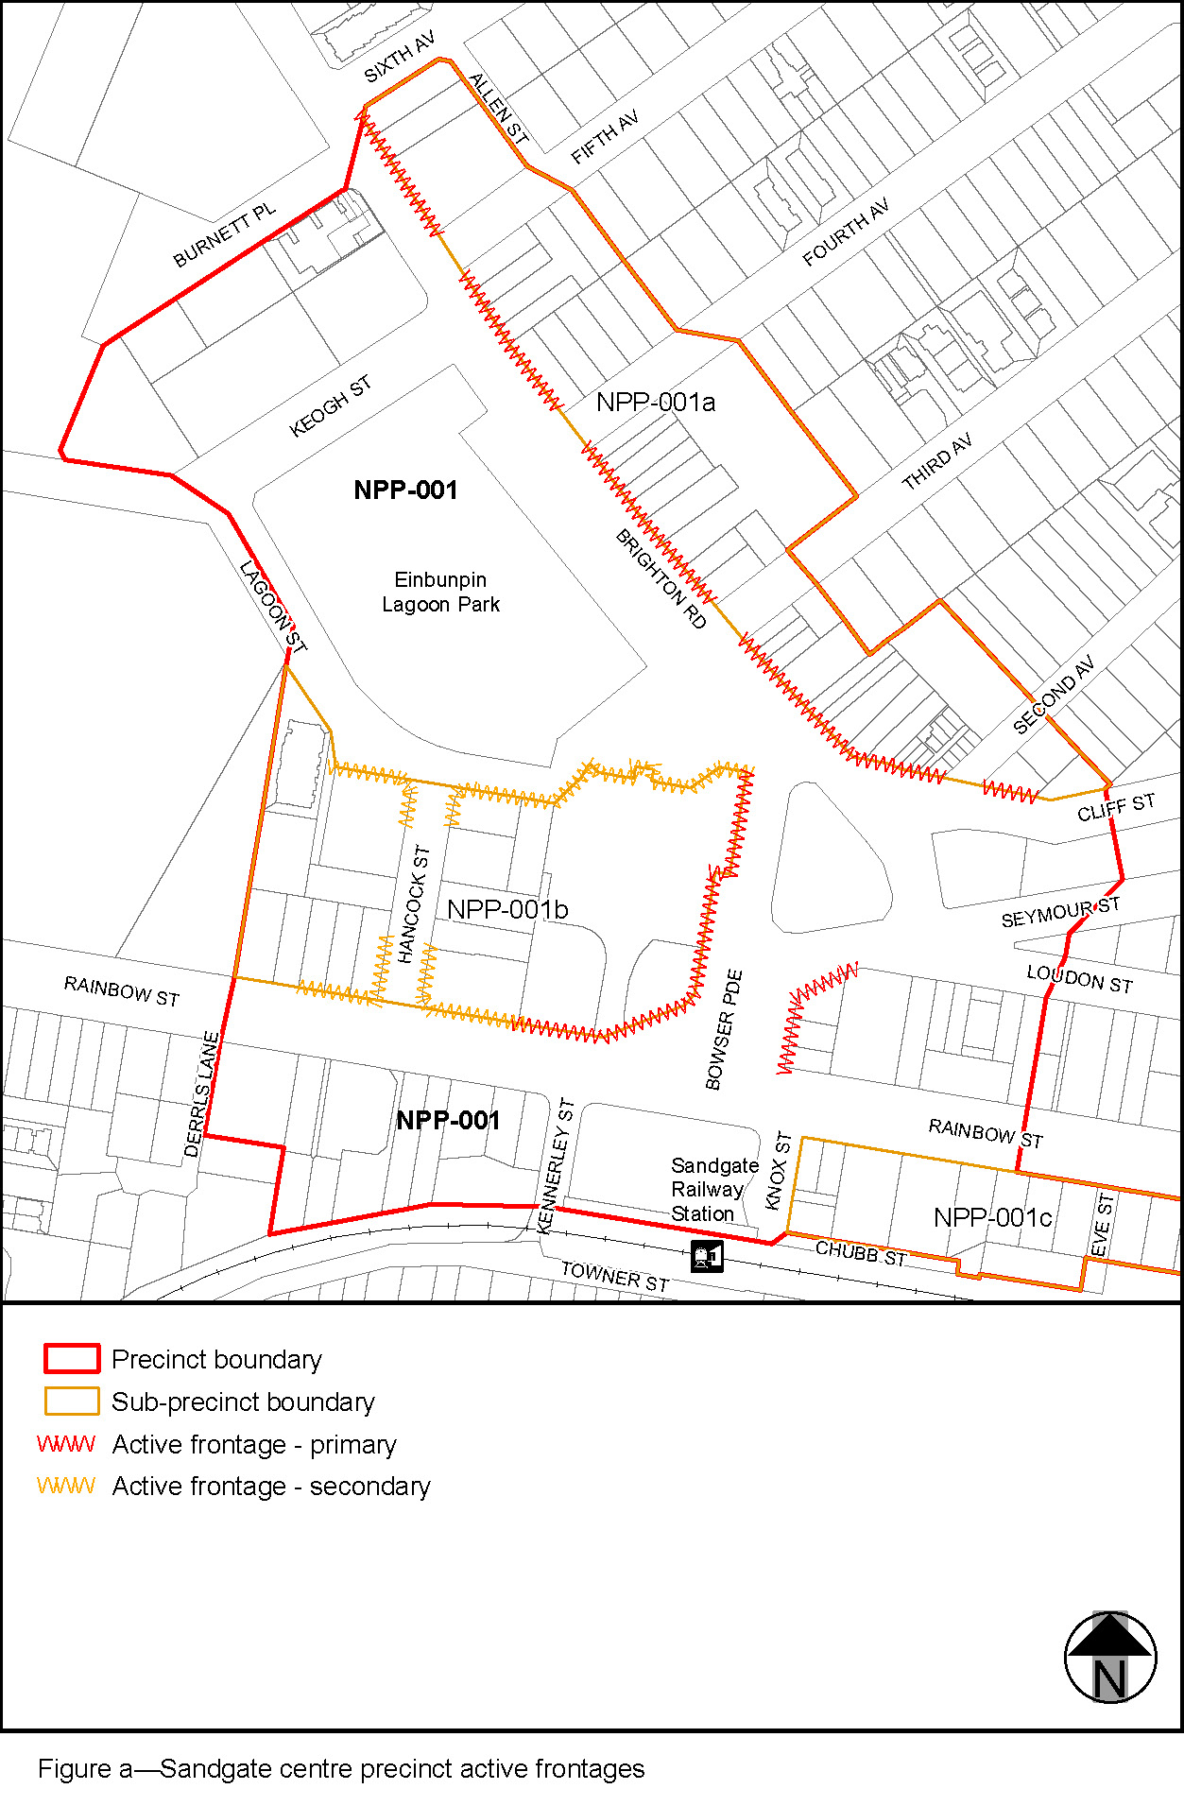

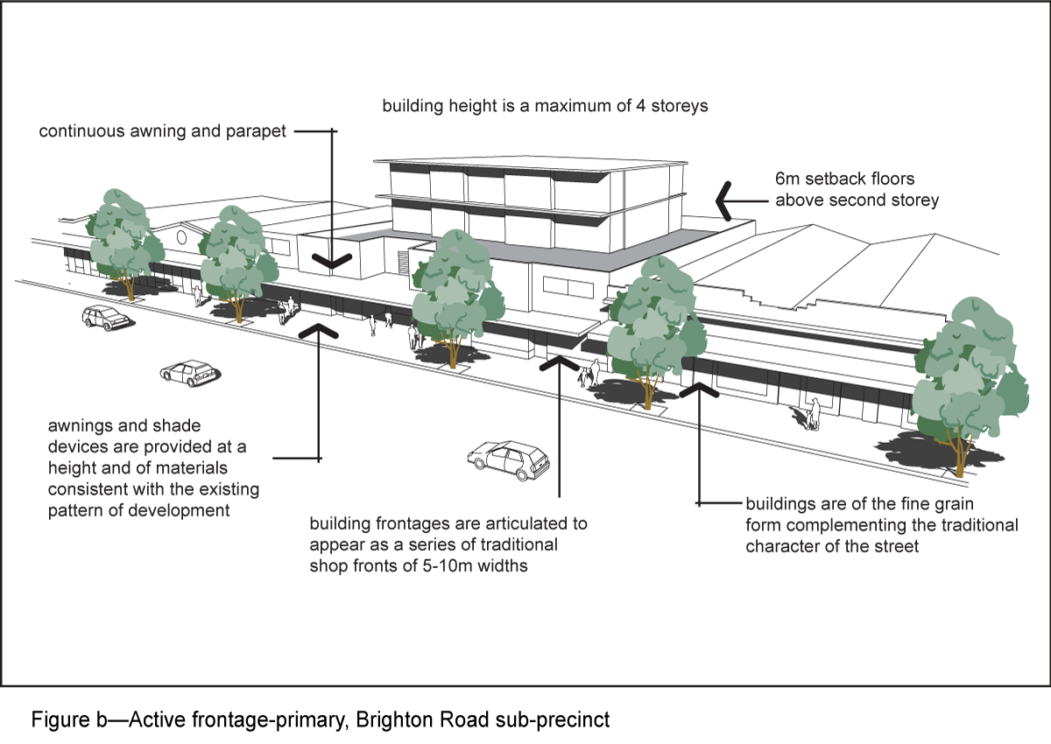
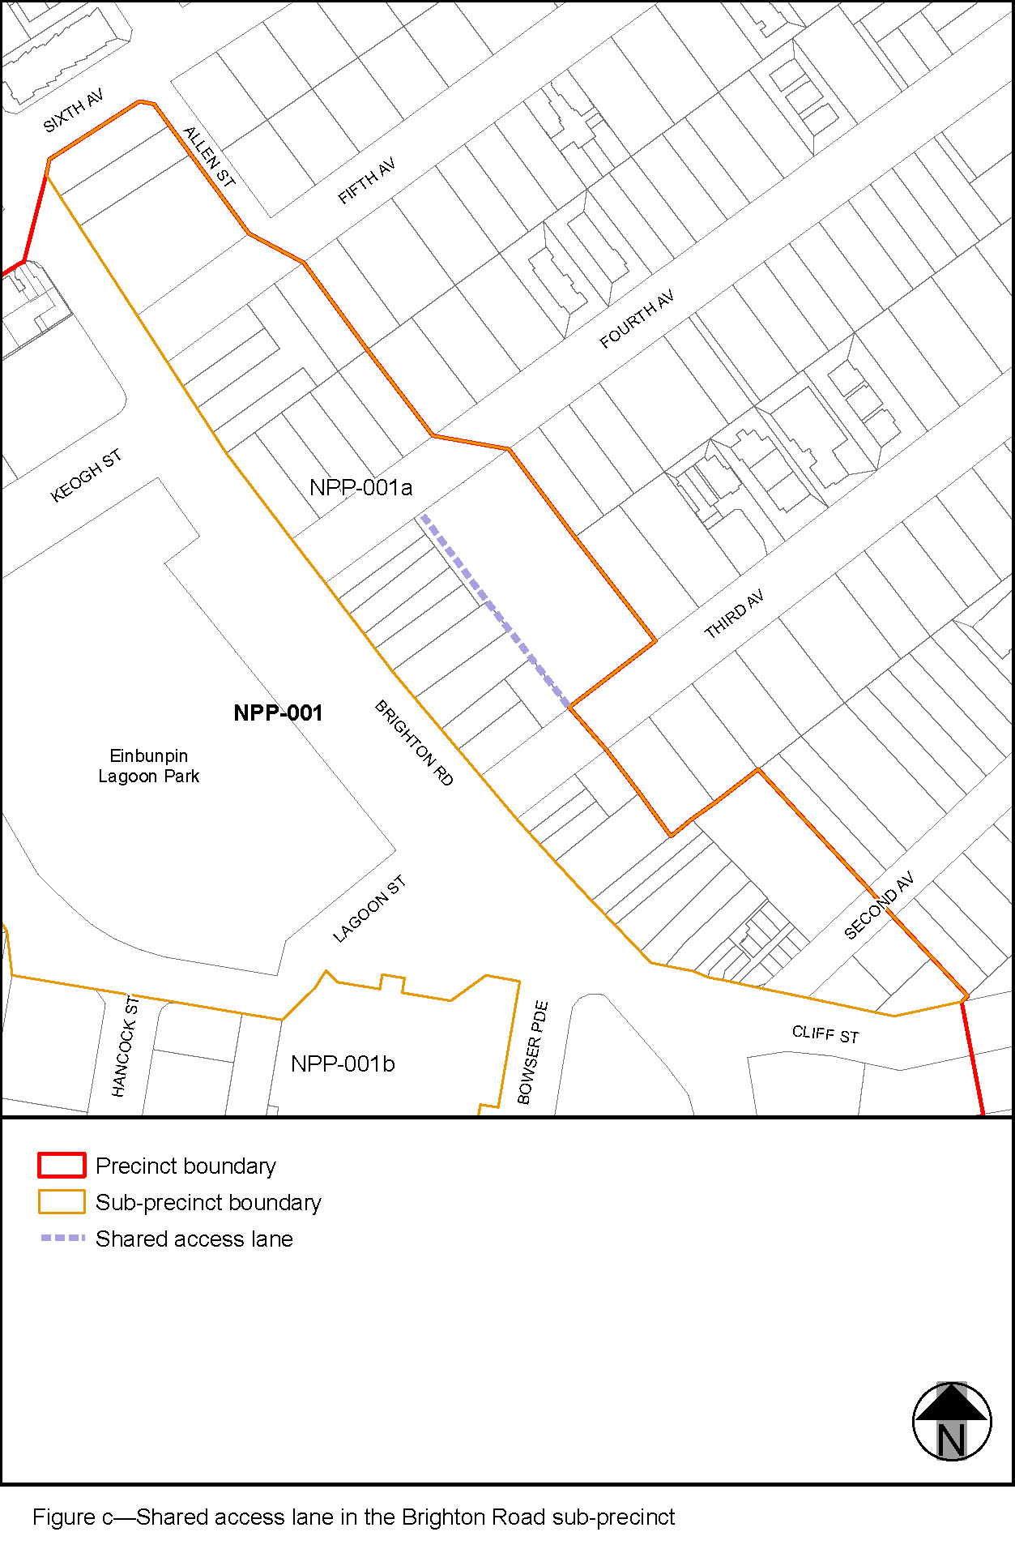
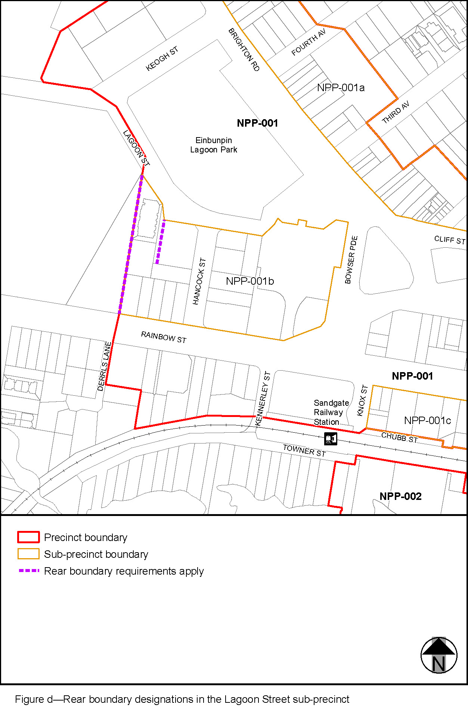
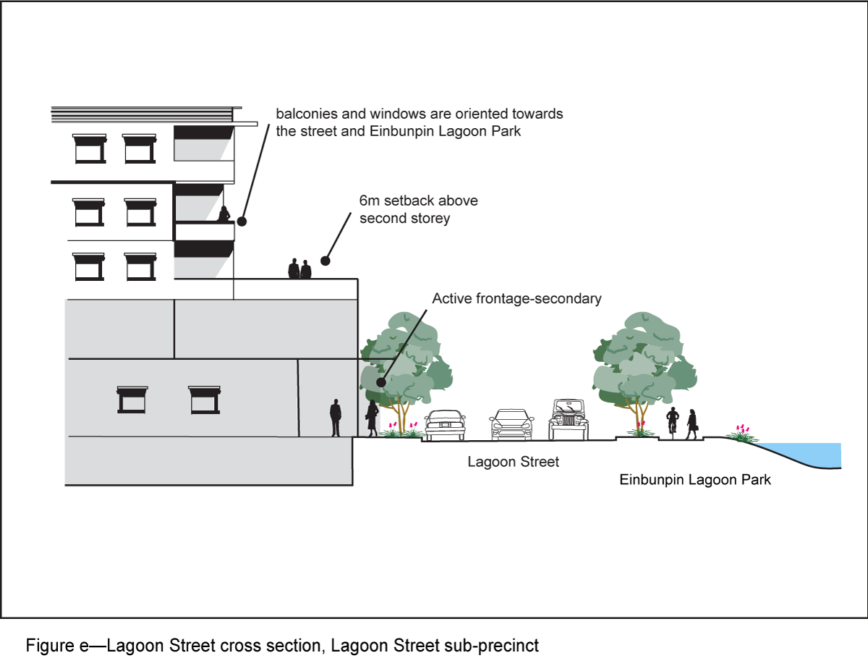
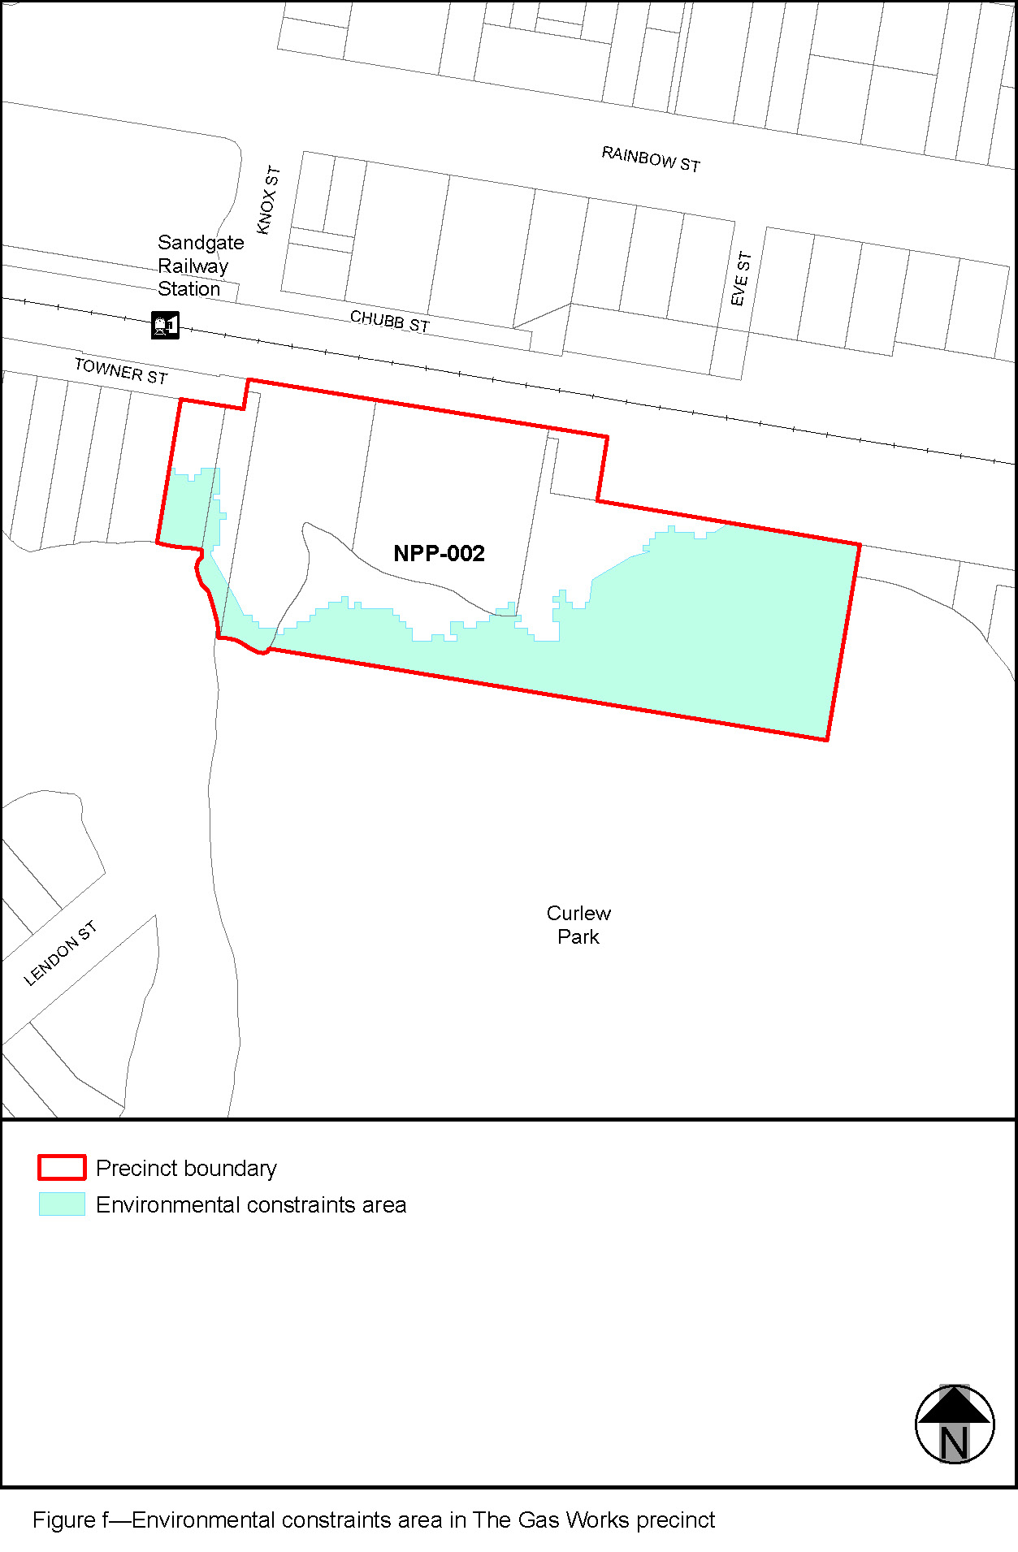
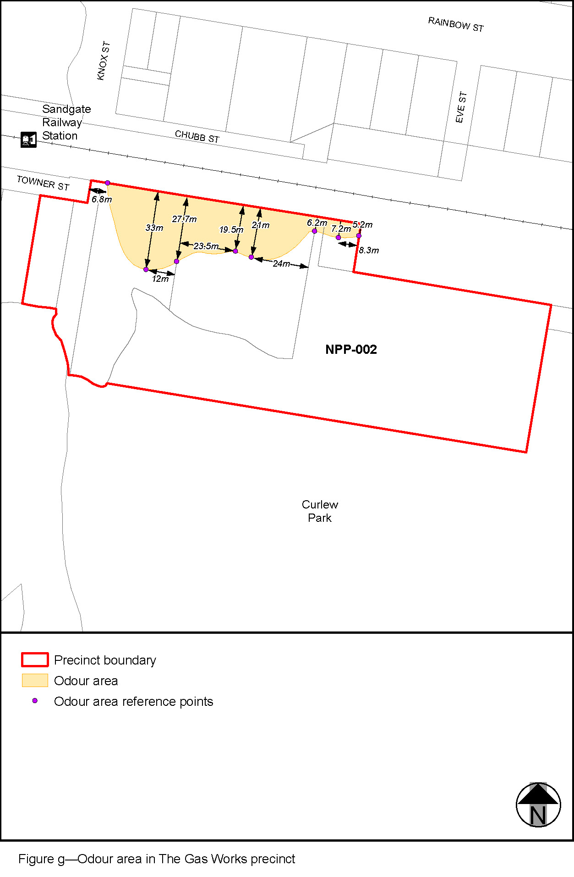
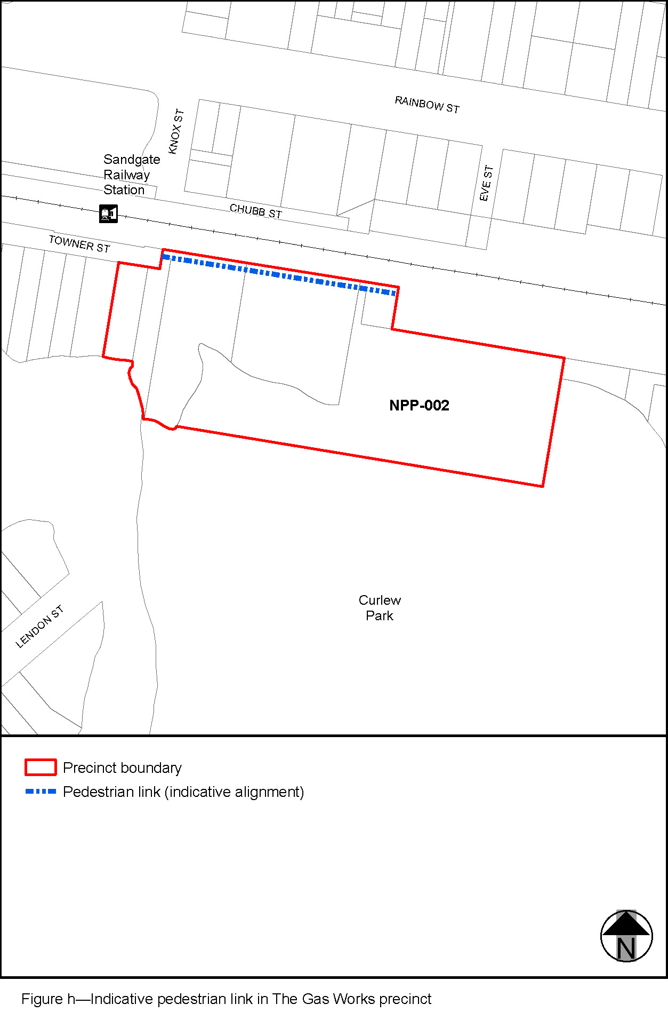
’–

Part 4 Amendment of Part 8 (Overlays)

4.1 Amendment to section 8.2.19 (Significant landscape tree overlay code)
- Section 8.2.19 Significant landscape tree overlay code, Table 8.2.19.3.C—Significant landscape trees in specific locations–
insert before Doolandella:
‘
Deagon
Grevillea robusta silky oak | 38 Albury Street (rear of) | L2 RP63001
Eucalyptus tereticornis forest red gum | 25 Blackwood Road (rear of) | L1 RP158781
Araucaria cunninghamii hoop pine | 54 Blackwood Road (back garden) | L68 RP29258
Eucalyptus tereticornis forest red gum | 65 Blackwood Road (northern corner) | L3 SP278308
Ficus benjamina weeping fig | 133 Board Street (racecourse complex Board Street frontage) | L2 RP159310
Delonix regia poinciana | 20 Braun Street (front garden) | L10-11 RP42455
Group of native trees | 41 Braun Street (Sandgate State High School, northern part of site adjacent to Depot Road and Braun Street) where native trees over 8m in height with a diameter at breast height greater than 450mm | L273 SL3223
Eucalyptus tereticornis forest red gum | 85 Braun Street (southern corner of carpark) | L1 RP179169
Group of Eucalyptus sp. gum trees | 147 Braun Street (rear of) | L163-164 RP29260
Delonix regia poinciana | 10 Burralong Street (front garden) | L156-157 RP29261
Eucalyptus tereticornis forest red gum | 69 Doris Street (rear of) | L3 RP73231
Eucalyptus tereticornis forest red gum | 8 Edith Street (Central Avenue frontage) | L128 RP29244
Corymbia tessellaris Moreton Bay ash | 82 Edith Street (rear of) | L34 RP29237
Eucalyptus tereticornis forest red gum | 9 Emily Street (back garden) | L18-19 RP29235
Grevillea robusta silky oak | 17 Eva Street (rear of) | L18 RP29254
Corymbia tessellaris Moreton Bay ash | 61 Henderson Road (rear of) | L173 RP29258
2 x Mangifera indica mango | 11 Hickson Road (southern boundary) | L228 RP29258
Mangifera indica mango | 14 Loftus Street (rear garden) | L41 RP818589
Grevillea robusta silky oak | 30 Nearra Street (rear garden) | L7-8 RP65830
Mangifera indica mango | 73a Nearra Street (rear garden) | L2 SP228946
Melaleuca leucadendra weeping paperbark | 78 Nearra Street (Utalong Street frontage) | L292 RP29261
Group of 3 Eucalyptus sp. gum trees | 97 Nearra Street (front garden) | L1 RP104737
Ficus benjamina weeping fig | 38 Scott Street (front of) | L94-95 RP29224
Mangifera indica mango | 21 Utalong Street (front garden) | L63 RP29261
Araucaria cunninghamii hoop pine | 41 Utalong Street (rear garden) | L83 RP29261
’.
- Section 8.2.19 Significant landscape tree overlay code,
Table 8.2.19.3.C—Significant landscape trees in specific locations–
insert before Sherwood (while retaining existing adopted sites):
‘
Sandgate
Araucaria cunninghamii hoop pine | 78 Alexandra Street (front garden) | L7 RP74442
Grevillea robusta silky oak | 112 Alexandra Street (rear garden) | L17 RP74973
Grevillea robusta silky oak | 10 Barton Street (rear garden) | L64 RP217315
Eucalyptus tereticornis forest red gum | 16 Barton Street (rear garden) | L61 RP4608
Araucaria cunninghamii hoop pine | 9 Beatham Street (rear garden) | L53 RP4601
Araucaria cunninghamii hoop pine | 20 Beatham Street (front garden) | L2 RP83784
2 x Araucaria cunninghamii hoop pine | 28 Borella Street (front garden) | L33 RP40928
Delonix regia poinciana | 48 Borella Street (front garden) | L21 RP66154
Jacaranda mimosifolia jacaranda | 44 Bracken Ridge Road (Wighton Street frontage) | L50 RP29211
Jacaranda mimosifolia jacaranda | 8 Connaught Street (rear garden) | L4 RP29199
Grevillea robusta silky oak | 10 Connaught Street (rear garden) | L62-63 RP29197
Eucalyptus tereticornis forest red gum | 69 Connaught Street (rear garden) | L102 RP29197
2 x Eucalyptus tereticornis forest red gum | 64 Eagle Terrace (Rainbow Street frontage) | L1 RP47157
Ficus racemosa Indian fig | 26 Flinders Parade (Cliff Street frontage) | L5 RP845608
Mangifera indica mango | 30 Griffith Street (rear garden) | L7-8 RP29146
Mangifera indica mango | 74 Hoskins Street (rear garden) | L2 RP62478
Melaleuca leucadendra weeping paperbark | 113 Hoskins Street (front garden) | L28 RP74973
Group of native trees and Delonix regia poinciana | 28A Lagoon Street (rear) | L10 S2782
Mangifera indica mango | 47 Loudon Street (front garden) | L4 RP4651
Delonix regia poinciana | 23 Lunn Street (rear of) | L1 RP4648
Araucaria columnaris Cook Island pine | 72 Nash Street (front corner) | L185 RP66490
2 x Mangifera indica mango | 86 Nash Street (rear garden) | L5 RP62478
Araucaria cunninghamii hoop pine | 94 Nash Street (rear garden) | L108 RP29197
Mangifera indica mango | 61 Palm Avenue (southern corner) | L2 RP44684
Araucaria cunninghamii hoop pine | 23 Paul Street (front garden) | L1 RP29133
Eucalyptus tereticornis forest red gum | 9 Perkins Street | L31 RP29154
2 x Mangifera indica mango | 47 Perkins Street (rear garden) | L2 RP50492
Ficus sp. fig | 17 Rainbow Street (rear garden) | L9-10 RP4623
Group of native trees | 54 Rainbow Street (Sandgate State School, northeast part of site adjacent to Keogh and Lagoon Streets) where native trees over 8m in height with a diameter at breast height greater than 450mm | L3 S2792
Group of Eucalypts and Corymbia, Lophostemon suaveolens swamp box, Ficus obliqua small leaf fig | 58 Rainbow Street (Anglican Church front and sides of site) | L2 C850
Mangifera indica mango | 170 Rainbow Street (rear garden) | L35 RP4649
Mangifera indica mango | 181 Rainbow Street (Beatham Street frontage) | L9 RP4601
Grevillea robusta silky oak | 234 Rainbow Street (rear garden) | L4 RP4480
Ficus benghalensis banyan | Corner of Palm Ave and Rainbow Street (adjacent to 235 Rainbow Street) | Adjacent to L36 RP892442
Mangifera indica mango | 33 Seasome Avenue (rear garden) | L1-2 GTP1263
Ficus macrophylla Moreton Bay fig | 30 Sixth Avenue (front corner) | L406 S277
Grevillea robusta silky oak | 129 Southerden Street (rear garden) | L5 RP29197
Grevillea robusta silky oak | 21 Verney Street (rear garden) | L53 RP60587
Mangifera indica mango | 1 Wakefield Street (front corner) | L1 RP46123
Ficus sp. fig | 81C Wakefield Street (front corner) | L4 RP154380
‘.
- Section 8.2.19 Significant landscape tree overlay code,
Table 8.2.19.3.C—Significant landscape trees in specific locations–
insert before South Brisbane (while retaining existing adopted sites):
‘
Shorncliffe
Ficus benjamina weeping fig | 50 Allpass Parade (rear garden) | L6-7 RP4578
Eucalyptus sp. gum tree | 69 Allpass Parade (north of former Fish Cooperative building) | L423 SP158144
Delonix regia poinciana | 6 Ashford Street (front garden) | L47 SP266655
Group of figs and mangoes | 31 Ashford Street (front garden) | L121 RP4612
Mangifera indica mango, Eucalyptus sp. gum tree | 33 Ashford Street (front and rear garden) | L120 RP4612
Eucalyptus sp. gum tree | 35 Ashford Street (rear garden) | L119 RP4612
Mangifera indica mango | 4 Eagle Terrace (Signal Row frontage) | L4 RP199113
Group of trees including figs and camphor laurel | 20 Friday Street (Shorncliffe State Primary School, centre and southwestern part of site) where native trees over 8m in height with a diameter at breast height greater than 450mm | L2 CP850293
Araucaria cunninghamii hoop pine | 125 Palm Avenue (rear garden) | L6 RP62424
Group of trees including figs, camphor laurels, poinciana | 2 Railway Parade (Shorncliffe railway station) | L88 CP827279
Araucaria bidwillii Bunya pine | 43 Raymond Street (north eastern corner) | L1 and L4 RP102935
Araucaria bidwillii Bunya pine | 20 Wharf Street (front garden) | L97 SP116595
Eucalyptus tereticornis forest red gum | 58A Wharf Street (northern boundary – adjacent to Curlew Park) | L1 RP11140
’.

Part 5 Amendment of Schedule 2 (Mapping)

5.1 Amendment to SC2.2 (Zone maps)
- Schedule 2 Mapping, SC2.2 Zone maps, ZM-001 (Tile 6)–
omit, insert:
SC2.2 Zone Maps, ZM-001 (Tile 6)–refer to supplement 1a.

5.2 Amendment to SC2.2 – Table SC2.2.1 (Zone maps)
- Schedule 2 Mapping, SC2.2 Zone maps, Table SC2.2.1—Zone Maps–
insert after Gazettal date, 2 December 2022:
‘
Not applicable | ZM-001 | Zoning map  Map tile 6 | 10 March 2023
’–

5.3 Amendment to SC2.3 (Neighbourhood plan maps)
- Schedule 2 Mapping, SC2.3 Neighbourhood plan maps, NPM-019.1 Sandgate district neighbourhood plan map–
omit, insert:
NPM-019.1 Sandgate district neighbourhood plan map refer to Supplement 1b.
  - Amendment to SC2.3 – Table SC2.3.1 (Neighbourhood plan maps)
- Schedule 2 Mapping, SC2.3 Neighbourhood plan maps, Table SC2.3.1—Neighbourhood plan maps–
omit, insert:
‘
NPM-019.1 | Sandgate district neighbourhood plan map | 10 March 2023
’–

5.5 Amendment of Schedule 2.4 (Overlay maps)
- Schedule 2 Mapping, SC2.4 Overlay maps, OM-003.2 Commercial character building overlay map (Tile 6)–
omit, insert:
OM-003.2 Commercial character building overlay map (Tile 6)–refer to Supplement 1c.
- Schedule 2 Mapping, SC2.4 Overlay maps, OM-004.1 Dwelling house character building overlay map (Tile 6)–
omit, insert:
OM-004.1 Dwelling house character building overlay map (Tile 6)–refer to Supplement 1d.
- Schedule 2 Mapping, SC2.4 Overlay maps, OM-008.1 Heritage overlay map (Tile 6) –
omit, insert:
OM-008.1 Heritage overlay map (Tile 6)–refer to Supplement 1e.
- Schedule 2 Mapping, SC2.4 Overlay maps, OM-016.2 Pre-1911 building overlay map (Tile 6)–
omit, insert:
OM-016.2 Pre-1911 building overlay map (Tile 6)–refer to Supplement 1f.
- Schedule 2 Mapping, SC2.4 Overlay maps, OM-019.1 Significant landscape tree overlay map (Tile 6)–
omit, insert:
OM-019.1 Significant landscape tree overlay map (Tile 6)–refer to Supplement 1g.
- Schedule 2 Mapping, SC2.4 Overlay maps, OM-019.2 Streetscape hierarchy overlay map (Tile 6)–
omit, insert:
OM-019.2 Streetscape hierarchy overlay map (Tile 6)–refer to Supplement 1h.
- Schedule 2 Mapping, SC2.4 Overlay maps, OM-020.1 Traditional building character overlay map (Tile 6)–
omit, insert:
OM-020.1 Traditional building character overlay map (Tile 6)–refer to Supplement 1i.

5.6 Amendment of Table SC2.4.1 (Overlay maps)
- Schedule 2 Mapping, SC2.4 Overlay maps, Table SC2.4.1—Overlay maps–
insert before OM-003.3 Critical infrastructure and movement network overlay map, 30 June 2014:
‘
OM-003.2 | Commercial character building overlay map  Map tile 6 | 10 March 2023
’.
- Schedule 2 Mapping, SC2.4 Overlay maps, Table SC2.4.1—Overlay maps–
insert before OM-005.1 Extractive resources overlay map, 30 June 2014:
‘
OM-004.1 | Dwelling house character overlay map  Map tile 6 | 10 March 2023
’.
- Schedule 2 Mapping, SC2.4 Overlay maps, Table SC2.4.1—Overlay maps–
insert before OM-009.1 Industrial amenity overlay map, 30 June 2014:
‘
OM-008.1 | Heritage overlay map  Map tile 6 | 10 March 2023
’.
- Schedule 2 Mapping, SC2.4 Overlay maps, Table SC2.4.1—Overlay maps–
insert before Q Intentionally left blank:
‘
OM-016.2 | Pre-1911 building overlay map  Map tile 6 | 10 March 2023
’.
- Schedule 2 Mapping, SC2.4 Overlay maps, Table SC2.4.1—Overlay maps–
insert before OM-019.2 Streetscape hierarchy overlay map, 30 June 2014:
‘
OM-019.1 | Significant landscape tree overlay map  Map tile 6 | 10 March 2023
’.
- Schedule 2 Mapping, SC2.4 Overlay maps, Table SC2.4.1—Overlay maps–
insert before OM-020.1 Traditional building character overlay map, 30 June 2014:
‘
OM-019.2 | Streetscape hierarchy overlay map  Map tile 6 | 10 March 2023
’.
- Schedule 2 Mapping, SC2.4 Overlay maps, Table SC2.4.1—Overlay maps–
insert before OM-020.2 Transport air quality corridor overlay map, 30 June 2014:
‘
OM-020.1 | Traditional building character overlay map  Map tile 6 | 10 March 2023
’.

Part 6 Amendment of Schedule 6 (Planning scheme policies)

6.1 Amendment to Schedule 6.16 (Infrastructure design planning scheme policy) – Table 5.1.2
- Schedule 6 Planning scheme policies, SC6.16 Infrastructure design planning scheme policy, Chapter 5 Streetscape locality advice, Table 5.1.2—Locality streets within Neighbourhood plan areas and other locations–
insert before 5.3.20:
‘
5.3.19 | 5.3.19.3 | Sandgate district
’.

6.2 Amendment to Schedule 6.16 (Infrastructure design planning scheme policy) – Section 5.2
- Schedule 6 Planning scheme policies, SC6.16 Infrastructure design planning scheme policy, Chapter 5 Streetscape locality advice, section 5.2 Locality streets in Suburban Centre Improvement Projects–

5.2.19.1 - omit, insert:
‘
    - 5.2.19.1 Sandgate
    - 5.2.19.1.1 Location and extent
The location and extent of the Locality streets in the Sandgate Suburban Centre Improvement Project (SCIP) are identified in Figure 5.2.19.1.1a and in the Streetscape hierarchy overlay map.

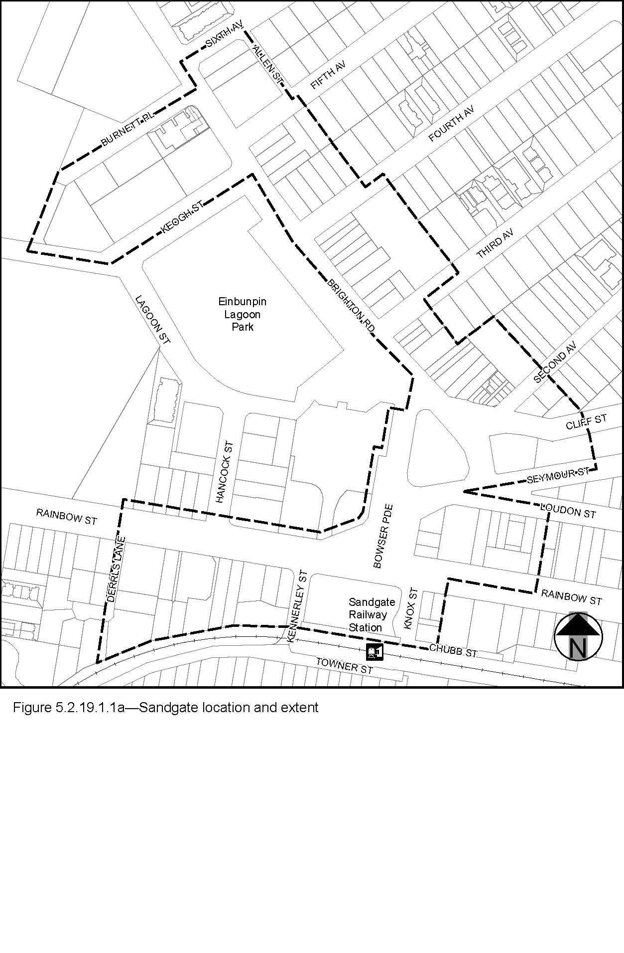

5.2.19.1.2 Locality street specifications
(1) The design specifications for footway surfacing for the Locality streets in the Sandgate SCIP are identified in Table 5.2.19.1.2.A.
(2) These locality guidelines are to be read in conjunction with Chapter 3 – Road corridor design of the Infrastructure design planning scheme policy.
(3) Footway upgrades are to include new surfacing, new or reinstated kerb and channel, driveways, pedestrian kerb crossings, tactile markers, roof water drainage line connections, service pit lids, street trees, garden beds, furniture and pedestrian lighting applicable to the streetscape type.
(4) The scope, layout and detail of the footway upgrades are to be agreed on a site by site basis through the development assessment process.
Table 5.2.19.1.2.A— Sandgate SCIP Locality streetscape type and specifications
Component | Design specifications
Verge width | As existing
Description | Full width pavement
Unobstructed pavement width | 2.4m
Paving materials | Type: Exposed aggregate concrete  Supplier: Hanson or approved equivalent  Colour: ‘Country Gold’
Tactile markers  (consistent with BSD-5218) | Type: Concrete paver  Supplier: Chelmstone, Urbanstone or approved equivalent  Colour: CCS 'Voodoo'
Driveways | To match adjacent footpath finish.
Furniture | All furniture is to be located outside of the unobstructed pavement area.  Paint colour and finish:  - For tree grates – Interpon D1000 Sable Bass Texture GN297A, or approved equivalent.  - For all other furniture – Dulux ‘Metropolis Storm Pearl’ (88471) in 'Satin' finish, or approved equivalent.  Refer to 3.7.6 Design standards for street furniture.
Trees | All tree centrelines are 750mm from the nominal face of the kerb and a minimum of 600mm from the edges of the pavement.  Streets trees include:  - a mix of tree species laid out in an informal manner with clusters of trees;  - medium and small crown trees to be planted at minimum 2m spacing, if within garden beds, or minimum 6m spacing outside of garden beds;  - large crown feature trees to be planted at minimum 10m centres.  Layout:  - a mix of species, in a single row at the rear of kerb;  - to be planted as singles and in pairs or clusters.  Planting: Trees are planted in garden beds or tree grates (1.6m x 1.2m minimum).
Garden beds | A garden bed located adjacent to the kerb has a:  - 1.5m minimum spacing between garden beds;  - maximum length of 10m;  - layout and length to accommodate car parking and other kerbside allocation.  Garden bed minimum width: 1.2m

    - 5.2.19.1.3 Preferred plant species
The preferred plant species for the Locality streets in Sandgate are stated in Table 5.2.19.1.3.A.

Table 5.2.19.1.3.A—Plant species
Trees | Shrubs and groundcovers
Cupaniopsis anacardioides  Delonix regia  Ficus benjamina  Jacaranda mimosifolia  Waterhousia floribunda | Abelia grandiflora – dwarf  Cuphea hyssopifolia – mauve  Dianella caerulea  Dietes bicolour  Erigeron karvinskianus  Helichrysum aplexans  Helichrysum ramossissimum  Liriope ‘Evergreen Giant’  Liriope muscari  Ophiopogon japonicus  Pittosporum ‘Miss Muffett’  Rondeletia amoena  Serissa foetida
’.

6.3 Amendment to Schedule 6.16 (Infrastructure design planning scheme policy) – Section 5.3
- Schedule 6 Planning scheme policies, SC6.16 Infrastructure design planning scheme policy, Chapter 5 Streetscape locality advice, Section 5.3 Neighbourhood plans and other locations–

insert 5.3.19.3:

‘
    - 5.3.19.3 Sandgate district
    - 5.3.19.3.1 Location and extent
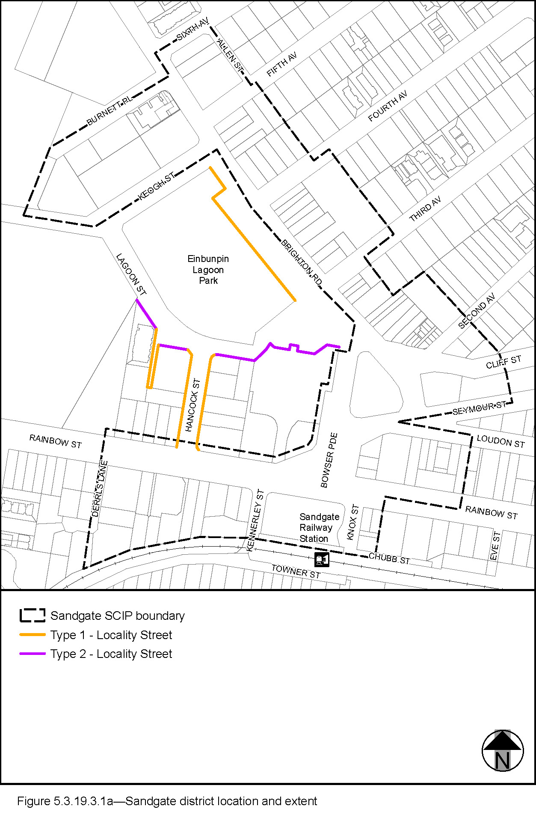

    - 5.3.19.3.2 Locality street specifications
      - The locality streets in the Sandgate district neighbourhood plan area are indicated on the Sandgate district locality streetscape extent map in Figure 5.3.19.3.1a.
      - All streetscape works occurring within the locality streets indicated in Figure 5.3.19.3.1a must comply with the character specified in this document.
      - Streetscapes outside these areas may be developed in keeping with this character, at the discretion of the developer and subject to Council approval.
    - 5.3.19.3.3 Standard footway elements and materials
      - These locality guidelines are to be read in conjunction with Chapter 3 – Road corridor design of the Infrastructure design planning scheme policy.
      - Footway upgrades are to include new surfacing, new or reinstated kerb and channel, driveways, pedestrian kerb crossings, tactile markers, roof water drainage line connections, service pit lids, street trees, garden beds, furniture and pedestrian lighting applicable to the streetscape type.
      - The scope, layout and detail of the footway upgrades are to be agreed on a site by site basis through the development assessment process.
    - 5.3.19.3.4 Streetscape hierarchy
    - 5.3.19.3.4.1 Streetscape types overview
      - The locality streets within the Sandgate district neighbourhood plan area are exceptions to the standard streetscape hierarchy.
      - The streetscape type and specifications for locality streets in this area are outlined in Table 5.3.19.3.4.1A and shown in Figure 5.3.19.3.1a.

Table 5.3.19.3.4.1A – Streetscape type and specifications
Component | Locality Streets Type 1 in the Sandgate district neighbourhood plan area
Verge width | 3.75m
Description | Full width pavement
Unobstructed pavement | 2.4m
Paving Materials | Type: Exposed aggregate concrete  Supplier: Hanson or approved equivalent  Colour: ‘Country Gold’
Tactile markers  (consistent with BSD-5218) | Type: Concrete paver  Supplier: Chelmstone, Urbanstone or approved equivalent  Colour: CCS 'Voodoo'
Driveways | To match adjacent footpath finish.
Furniture | All furniture is to be located outside of the unobstructed pavement area.  Paint colour and finish:  - For tree grates – Interpon D1000 Sable Bass Texture GN297A, or approved equivalent.  - For all other furniture – Dulux ‘Metropolis Storm Pearl’ (88471) in 'Satin' finish, or approved equivalent.  Refer to 3.7.6 Design standards for street furniture.
Trees | All tree centrelines are 750mm from the nominal face of the kerb and a minimum of 600mm from the edges of the pavement.  Streets trees include:  - a mix of tree species laid out in an informal manner with clusters of trees;  - medium and small crown trees to be planted at minimum 2m spacing, if within garden beds, or minimum 6m spacing outside of garden beds;  - large crown feature trees to be planted at minimum 10m centres.  Layout:  - a mix of species, in a single row at the rear of kerb;  - to be planted as singles and in pairs or clusters.  Planting: Trees are planted in garden beds or tree grates (1.6m x 1.2m minimum).
Garden beds | A garden bed located adjacent to the kerb has a:  - 1.5m minimum spacing between garden beds;  - maximum length of 10m;  - layout and length to accommodate car parking and other kerbside allocation  - minimum width of 1.2m.
Component | Locality Streets Type 2 in the Sandgate district neighbourhood plan area
Verge width | 5m
Description | Full width pavement
Unobstructed pavement | 2.4m
Paving Materials | Type: Exposed aggregate concrete  Supplier: Hanson or approved equivalent  Colour: ‘Country Gold’
Tactile markers  (consistent with BSD-5218) | Type: Concrete paver  Supplier: Chelmstone, Urbanstone or approved equivalent  Colour: CCS 'Voodoo'
Driveways | To match adjacent footpath finish.
Furniture | All furniture is to be located outside of the unobstructed pavement area.  Paint colour and finish:  - For tree grates – Interpon D1000 Sable Bass Texture GN297A, or approved equivalent.  - For all other furniture – Dulux ‘Metropolis Storm Pearl’ (88471) in 'Satin' finish, or approved equivalent.  Refer to 3.7.6 Design standards for street furniture.
Trees | All tree centre-lines are 950mm from the nominal face of the kerb and a minimum of 600mm from the edges of the pavement.  - a mix of tree species laid out in an informal manner with clusters of trees;  - medium- and small-crown trees to be planted at minimum 2m spacing, if within garden beds, or minimum 6m spacing outside of garden beds;  - large-crown feature trees to be planted at minimum 10m centres.  Street trees are:  - a mix of species, in a single row at the rear of kerb;  - to be planted as singles and in pairs or clusters.  Trees are planted in garden beds or tree grates.
Garden beds | A garden bed located adjacent to the kerb has a:  - 1.5m minimum spacing between garden beds;  - maximum length of 10m;  - layout and length to accommodate car parking and other kerbside allocation  - minimum width of 1.2m.
’.

6.4 Amendment to Schedule 6.29 Structure planning scheme policy
- Schedule 6 Planning scheme policies, SC6.29 Structure planning planning scheme policy, 1 Introduction, 1.1 Relationship to planning scheme–
insert before The Gap neighbourhood plan code Table 7.2.20.5.3.A, PO8 note, All:
‘
Sandgate district neighbourhood plan code
Table 7.2.19.1.3.A | AO15 and AO15 note | All
Table 7.2.19.1.3.A | PO21 note | All
’.

Part 7 Amendment of Appendix 2 (Table of amendments)

7.1 Amendment to Appendix 2 (Table of amendments)
- Appendix 2 Table of Amendments, Table AP2.1—Table of amendments–
insert after v25.00/2023:
‘
29 November 2022 (adoption) and 10 March 2023 (effective) | V26.00/2023 | Major | Major amendment to planning scheme (Chapter 2, Part 4 of MGR).  Amendment to planning scheme policy (Chapter 3, Part 1 of MGR).  Refer to Amendment v26.00/2023 for further detail.
’.

Supplement 1—A3 Map Tiles

Supplement 1a: Zone map ZM-001 (Tile 6)
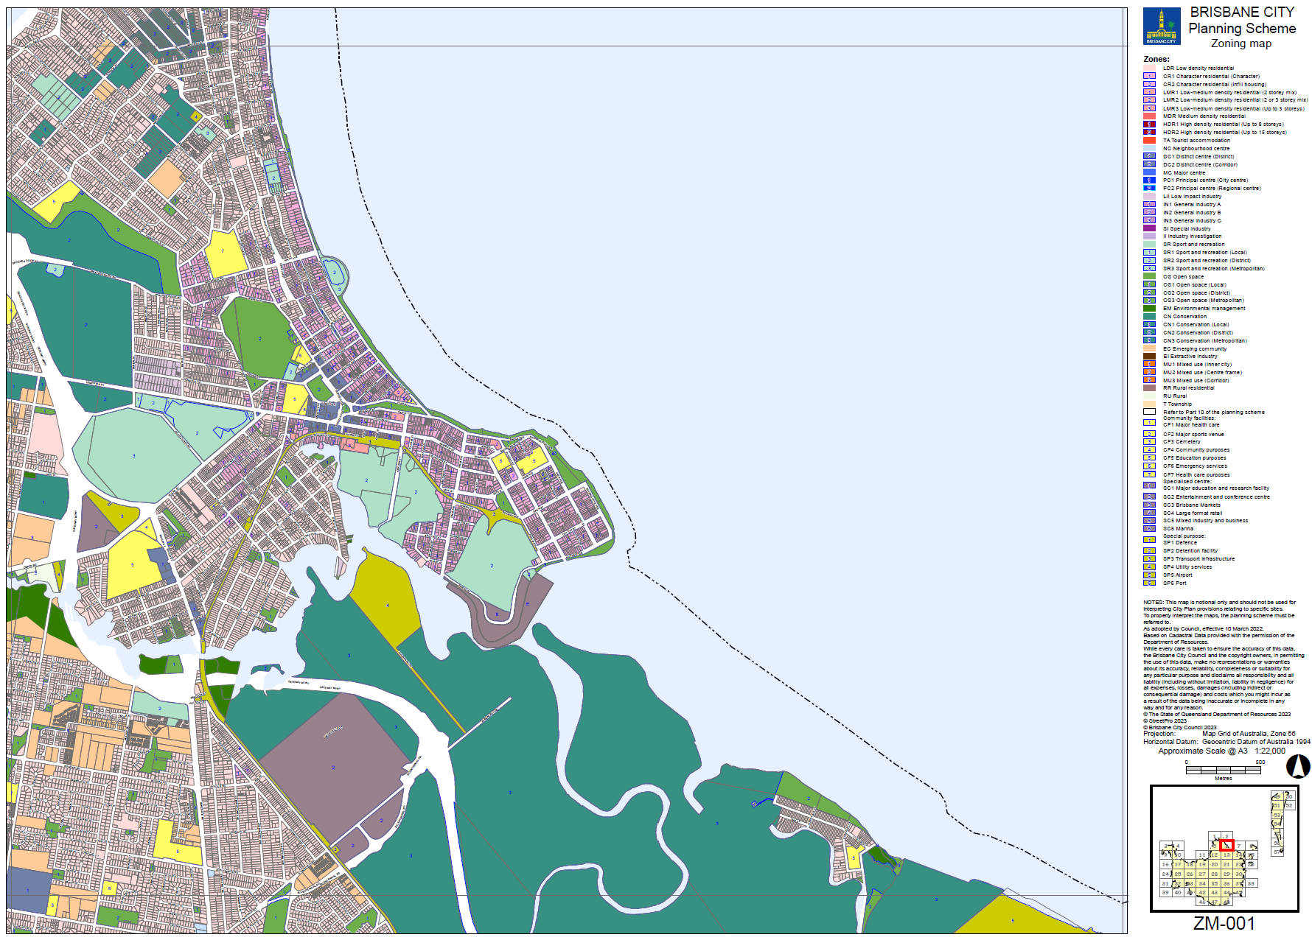

Supplement 1b: Neighbourhood plan map NPM-019.1 (Tile 6)
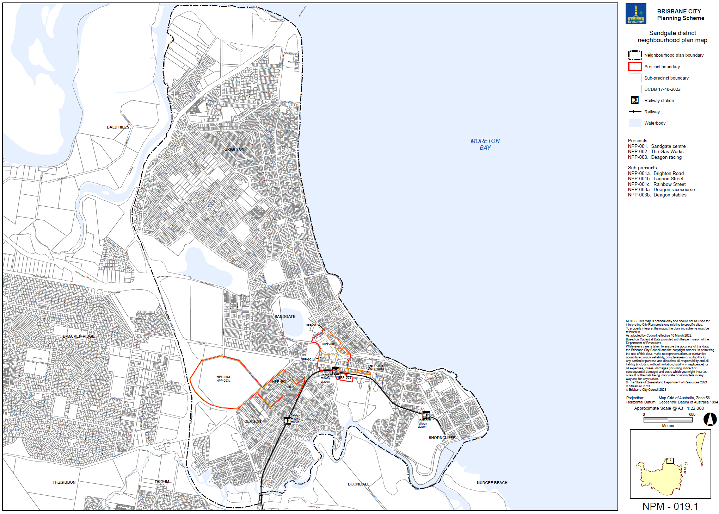

Supplement 1c: Commercial character building overlay map OM-003.2 (Tile 6)
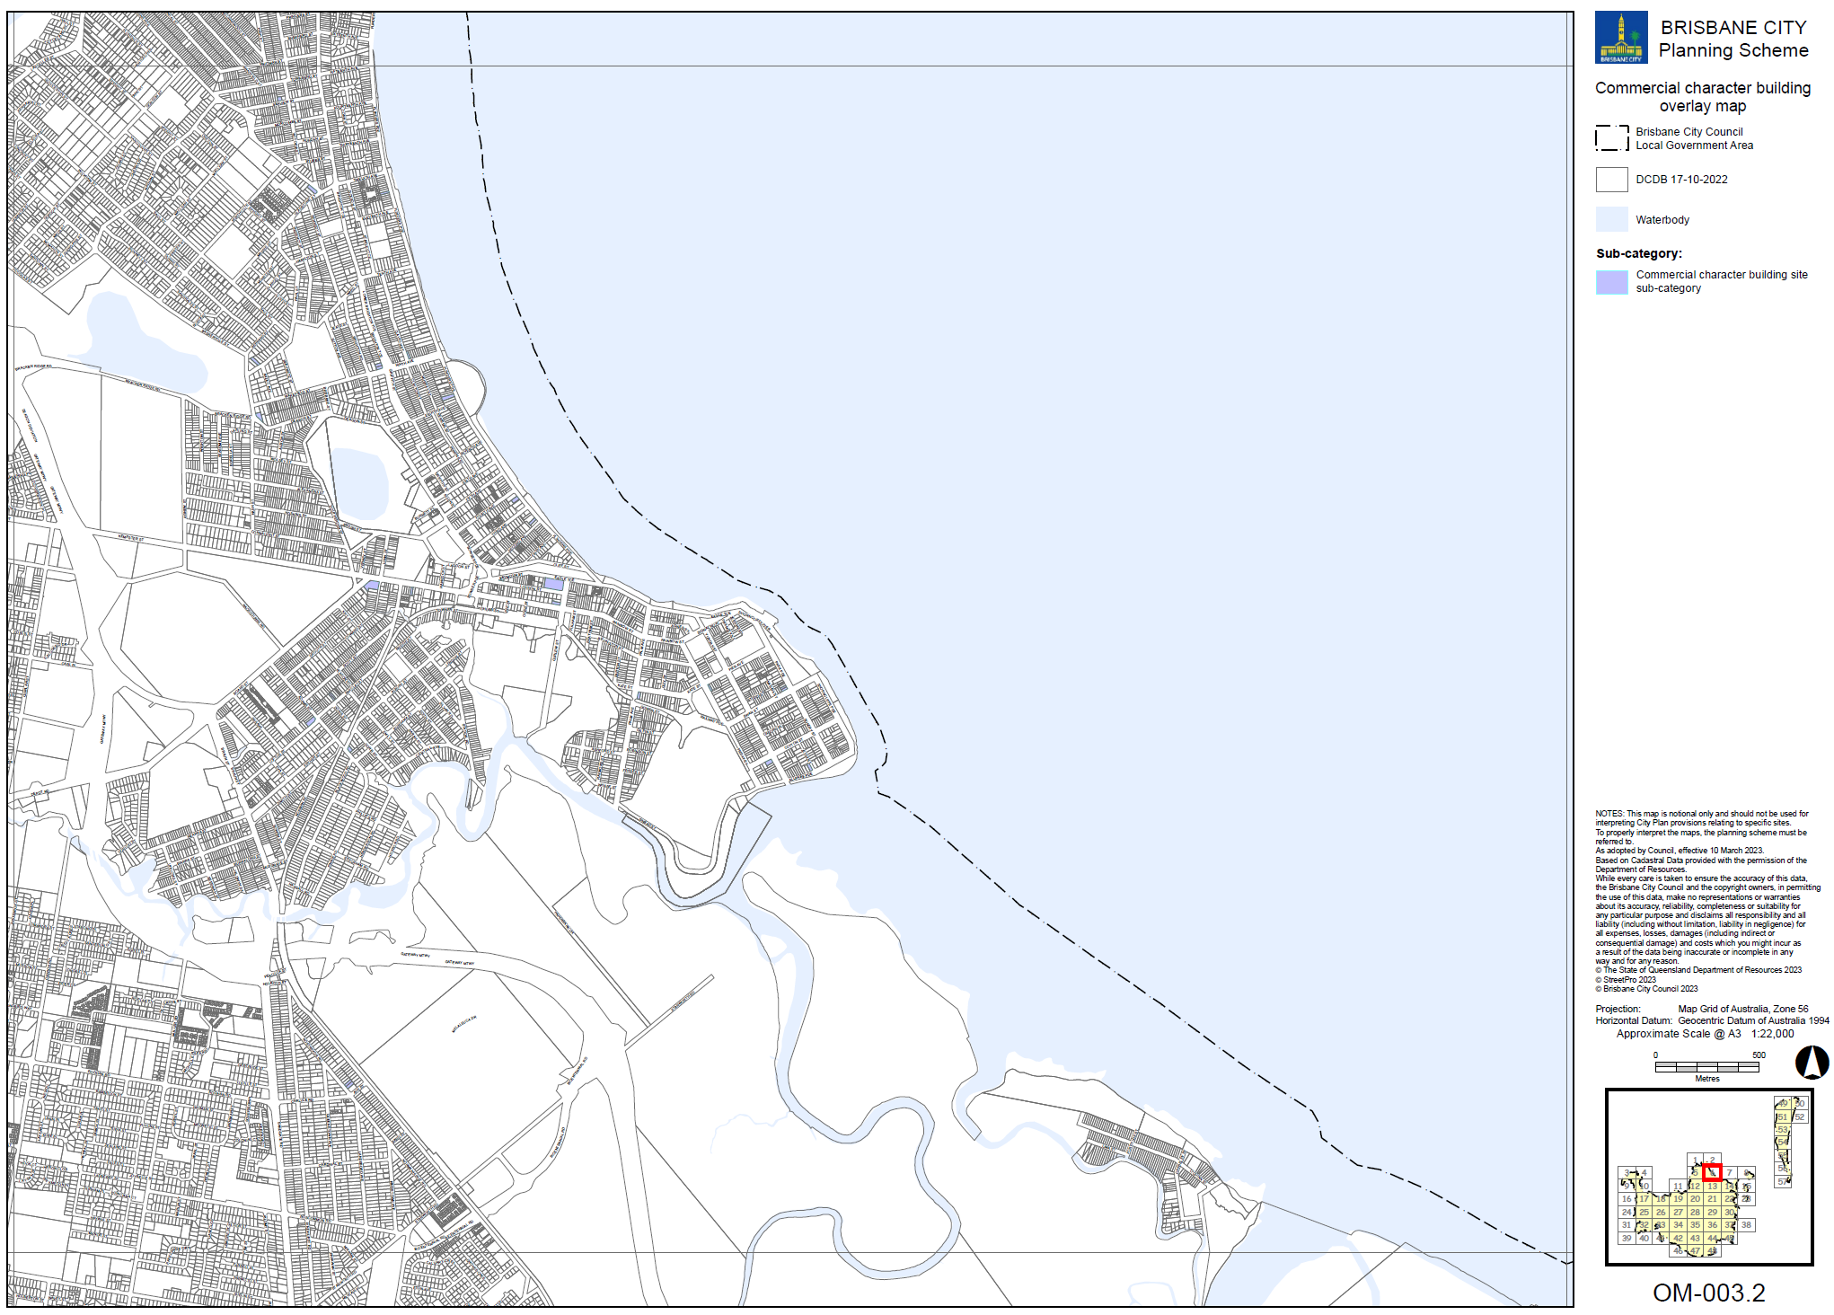

Supplement 1d: Dwelling house character building overlay map OM-004.1 (Tile 6)
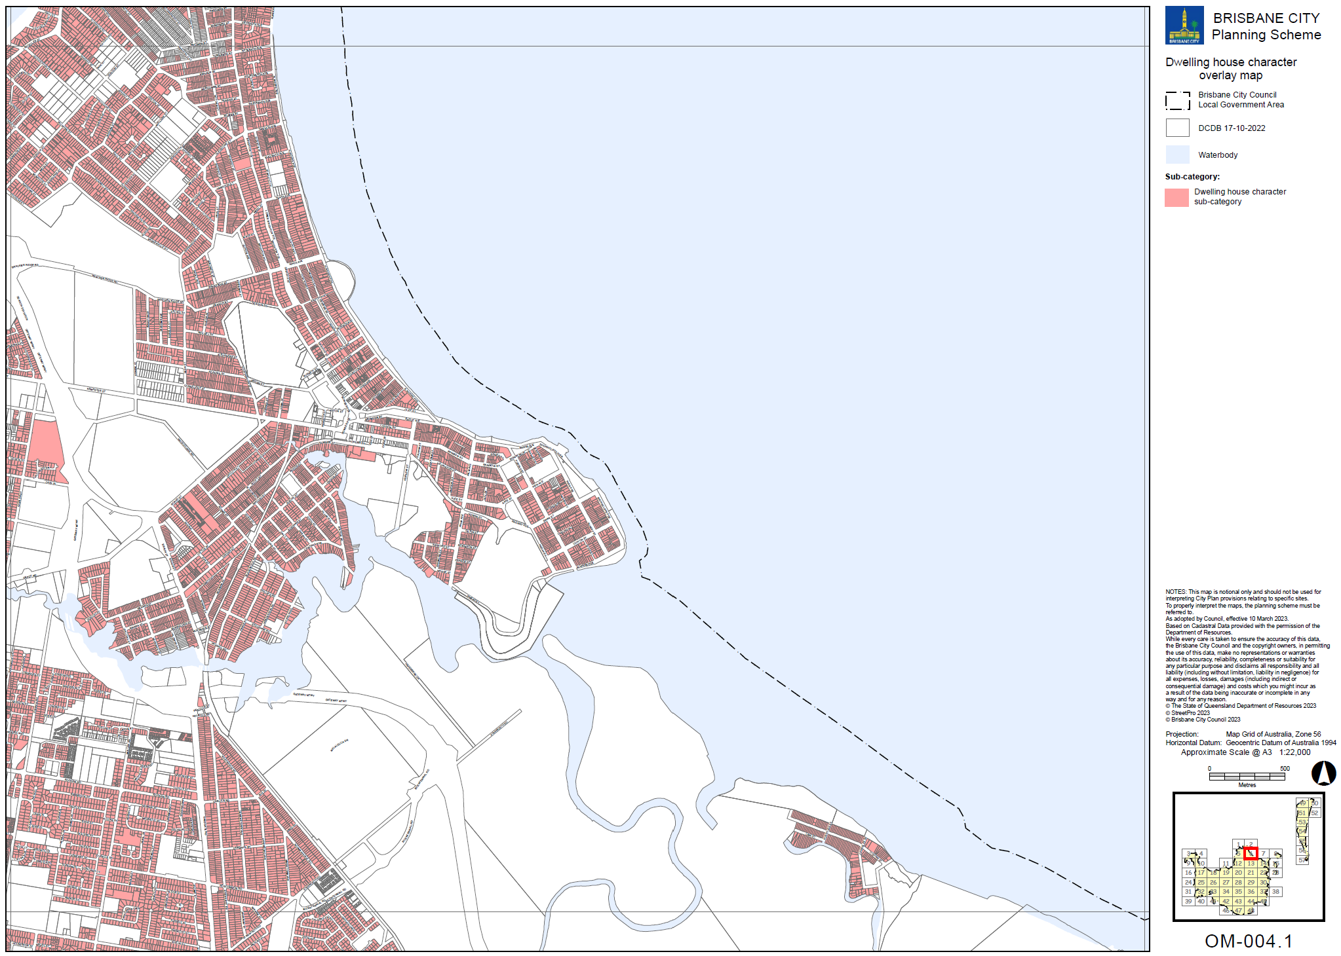

Supplement 1e: Heritage overlay map OM-008.1 (Tile 6)
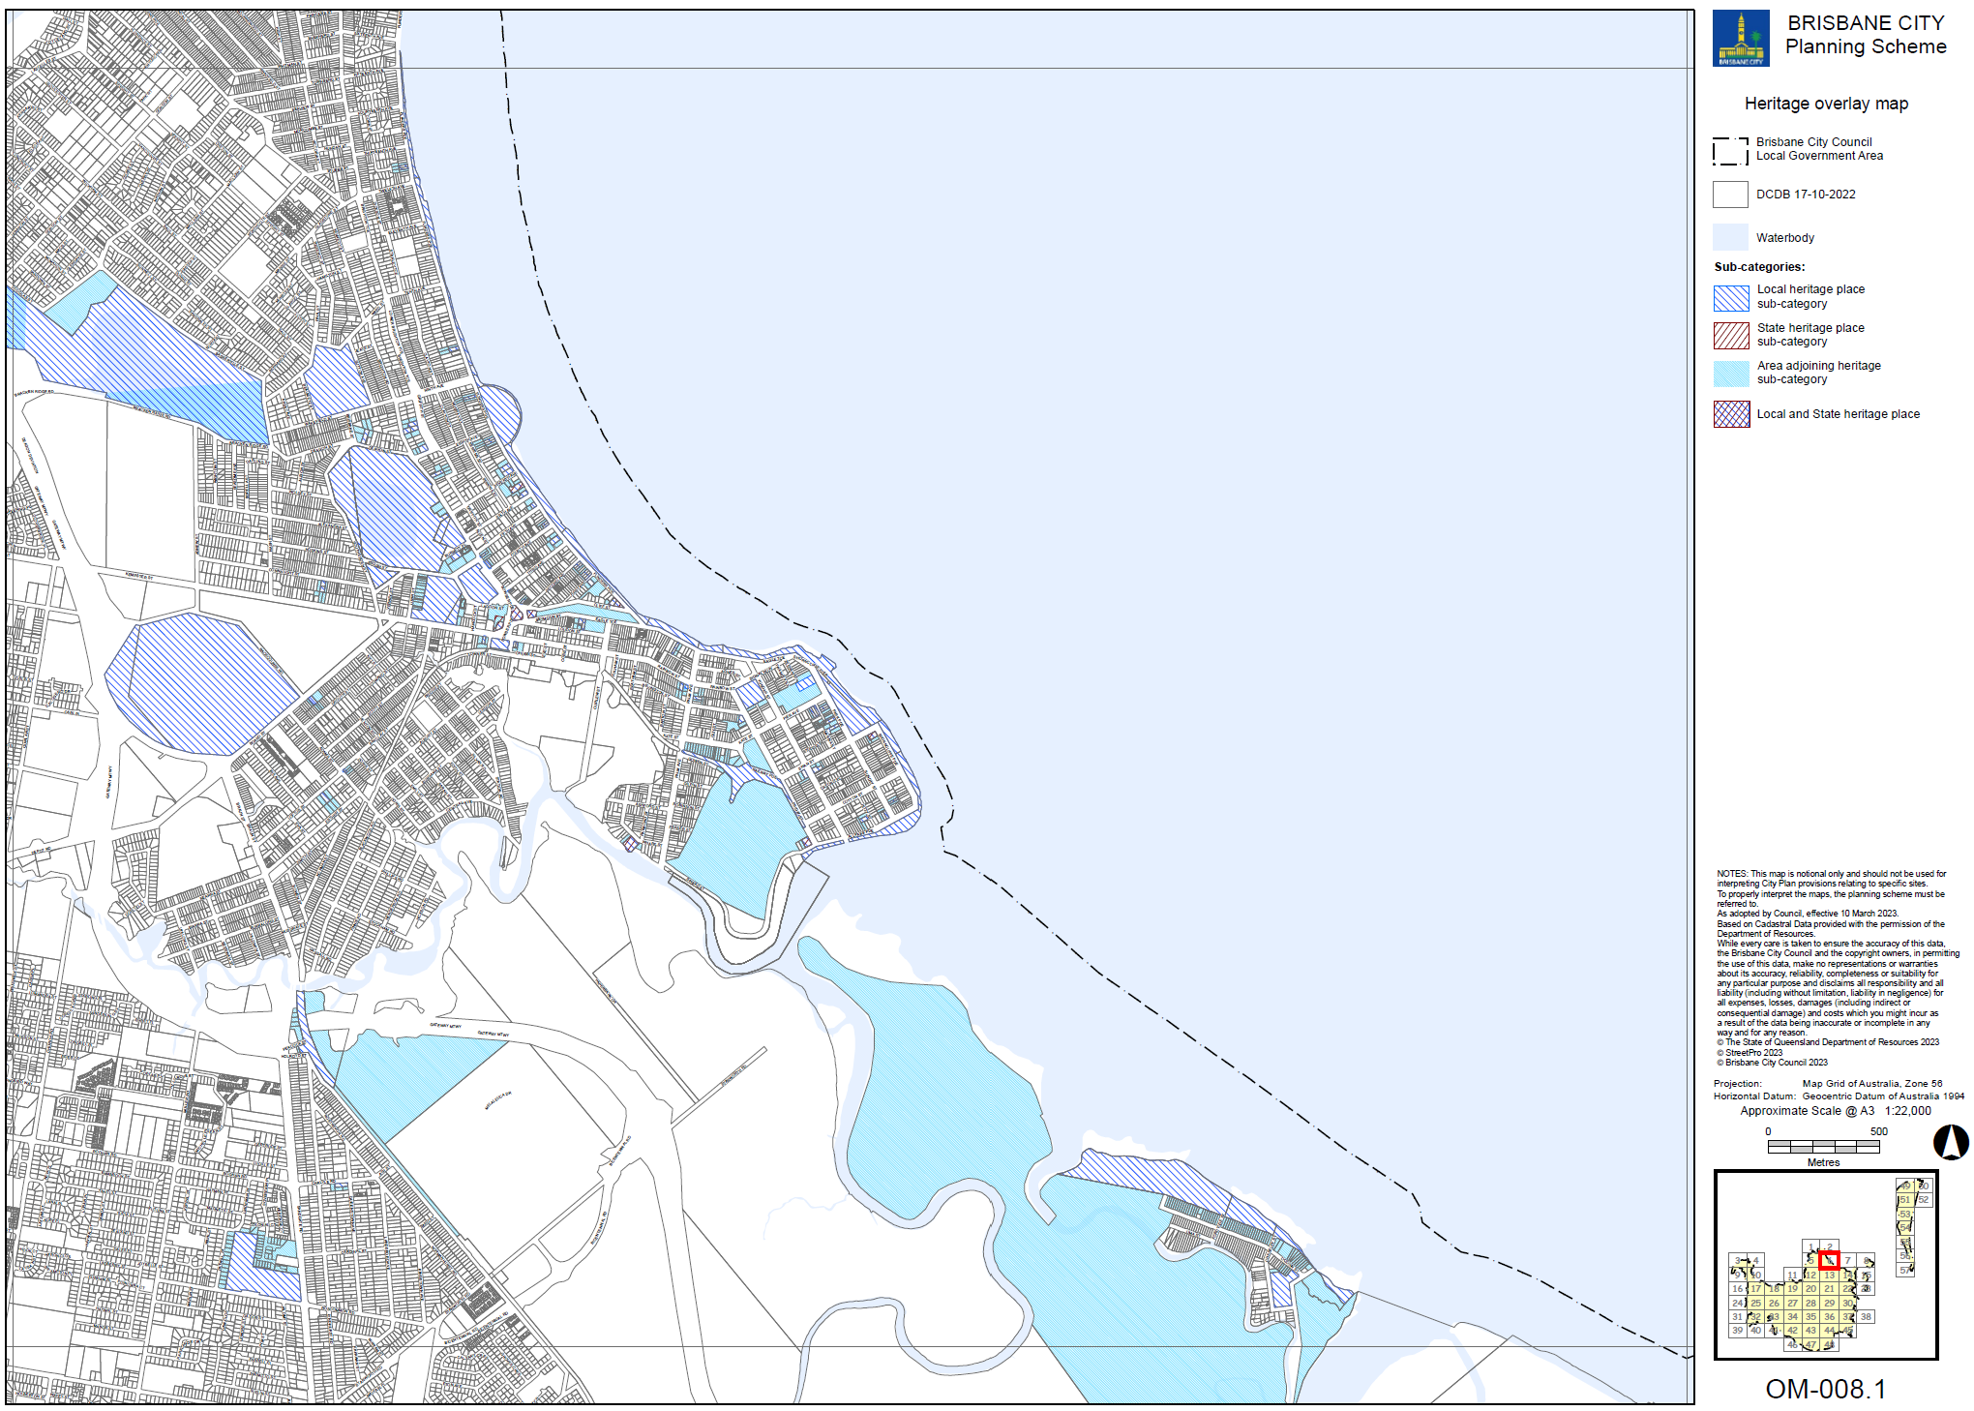

Supplement 1f: Pre-1911 building overlay map OM-016.2 (Tile 6)
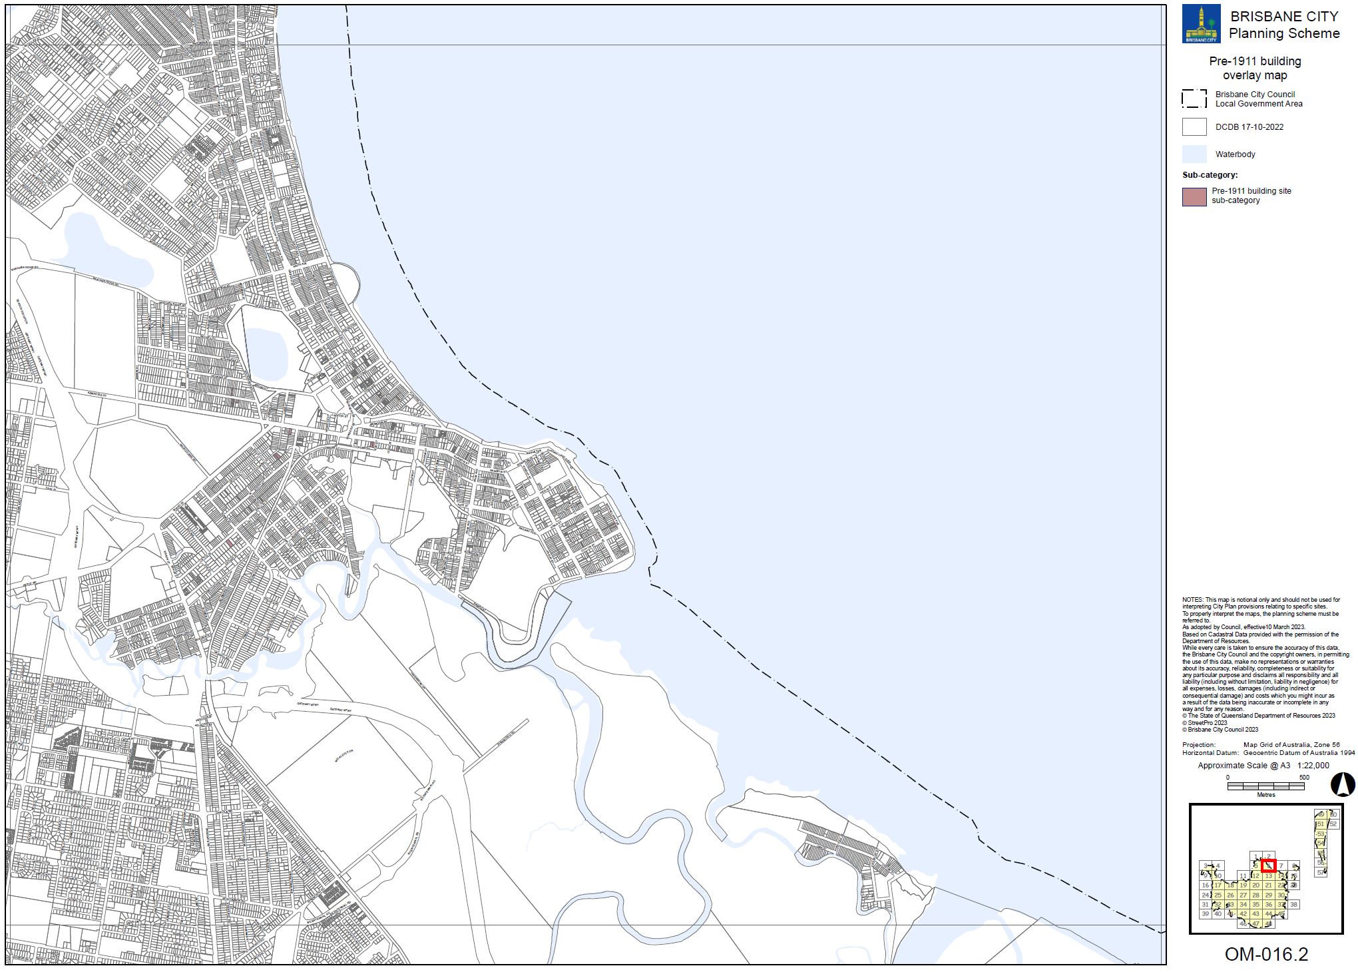

Supplement 1g: Significant landscape tree overlay may OM-019.1 (Tile 6)
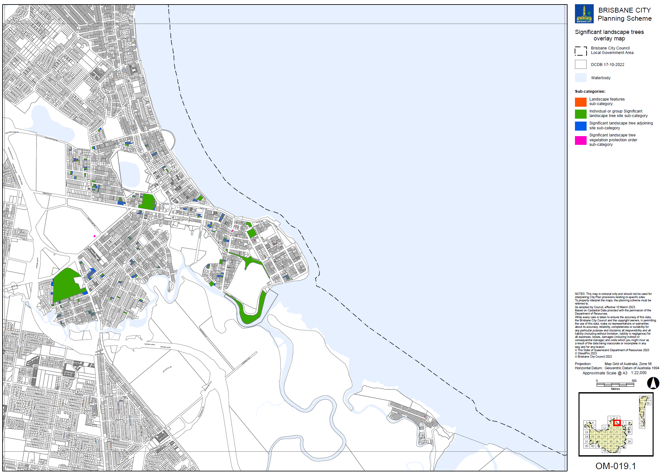

Supplement 1h: Streetscape hierarchy overlay map OM-019.2 (Tile 6)
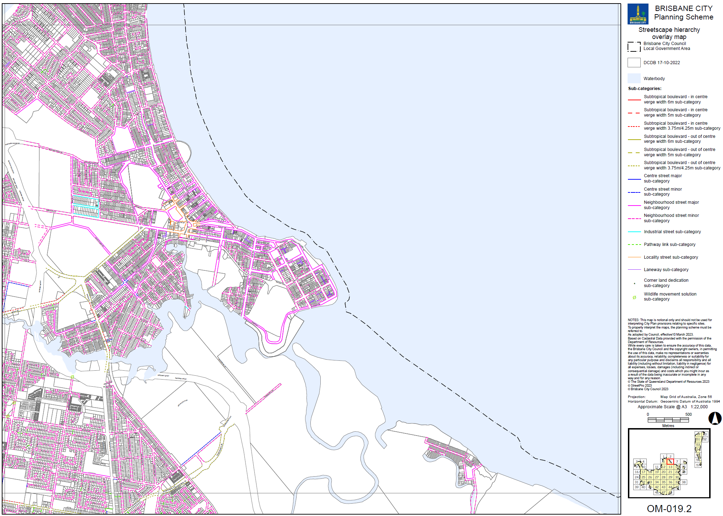

Supplement 1i: Traditional building character overlay map OM-020.1 (Tile 6)
