Eight Mile Plains Gateway Neighbourhood Plan draft strategy

November 2019

Eight Mile Plains Gateway Neighbourhood Plan study area
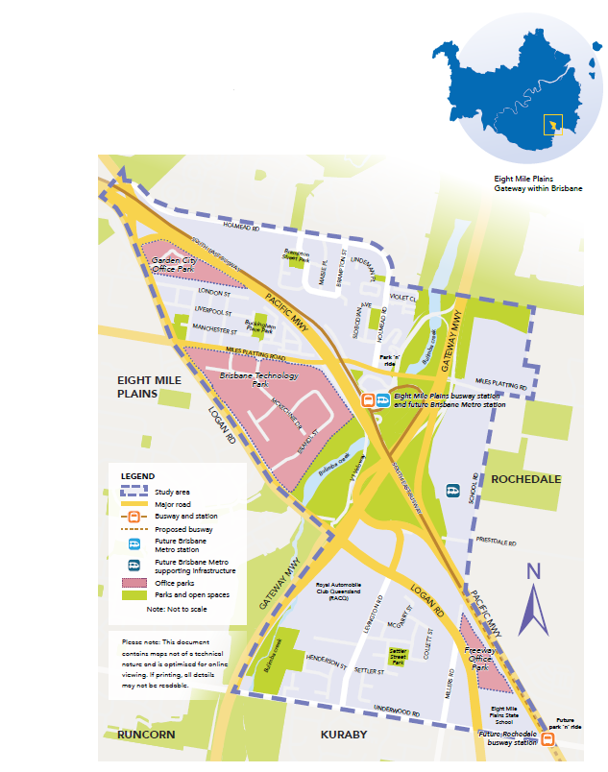

The Eight Mile Plains Gateway study area is located approximately 15 kilometres south of the Brisbane city centre and includes parts of the suburbs of Eight Mile Plains and Rochedale.

Have your say

Complete an online feedback form
Visit brisbane.qld.gov.au and search ‘Eight Mile Plains Gateway Neighbourhood Plan’.

Email
neighbourhood_planning@brisbane.qld.gov.au

Post your feedback to:
Neighbourhood Planning (Eight Mile Plains Gateway Neighbourhood Plan)
Brisbane City Council, GPO Box 1434, Brisbane Qld 4001

Want to find out more?

Attend an information kiosk
Saturday 30 November 2019, 12 noon - 2pm
The Glen Hotel (Elaine Room), 24 Gaskell Street, Eight Mile Plains

Wednesday 4 December 2019, 3 - 7pm
BTP Conference and Exhibition Centre, 1 Clunies Ross Court, Eight Mile Plains

Feedback closes 5pm, Monday 16 December

Stay up-to-date by visiting brisbane.qld.gov.au and registering for email updates.

Introduction
Every day, Brisbane City Council works with residents and local communities to to make sure the Brisbane of tomorrow is even better than the Brisbane of today.

Since May 2019, Council has been working with local communities in and around Eight Mile Plains and Rochedale to help plan for the area’s future.

This draft strategy combines initial community input, including online survey responses and insights from the Eight Mile Plains Gateway neighbourhood Community Planning Team, with the findings of background research and technical studies undertaken by Council.

A draft strategy:
- is produced so community members can consider the future of their neighbourhood
- introduces a vision and key themes for consideration in the future development of the area
- provides a guide for implementing the strategies and actions identified
- seeks community feedback on ideas for consideration in preparing a draft neighbourhood plan.

Community feedback received on the draft strategy will be used to prepare a draft neighbourhood plan. Once completed, neighbourhood plans form part of Brisbane City Plan 2014 (City Plan), which sets out how land can be used and developed across the city.

The Eight Mile Plains Gateway Neighbourhood Plan is just one way Council is ensuring Brisbane is a city of neighbourhoods, where residents are close to the services they need and the lifestyle and leisure opportunities they want.

Eight Mile Plains Gateway
The Eight Mile Plains Gateway locality is a dynamic area hosting Brisbane Technology Park, 33 hectares of land dedicated to knowledge-based industries, surrounded by residential areas old and new. The locality is also characterised by numerous business and technology parks that support advanced manufacturing and technology industries, and forms a key part of the Upper Mount Gravatt and Eight Mile Plains Global Precinct.

The locality is one of the most easily accessible locations in South East Queensland, positioned at the junction of three major roads - the Gateway Motorway, the M3 Pacific Motorway and Logan Road. The locality is also well served by public transport with a new Brisbane Metro station set to improve connections to the Garden City shopping centre, Griffith University and the Brisbane city centre. The Veloway 1 (V1) Cycleway is currently under construction, which will provide a 17-kilometre cycle path from Eight Mile Plains to the Brisbane city centre.

The Bulimba Creek corridor travels through the study area, providing a central green corridor of amenity, wildlife habitat and ecological value. As well as diverse local employment opportunities, the locality and surrounds have a high proportion of primary and high schools, places of worship, local parks and open spaces, creating unique neighbourhoods where people live, work and relax.

What’s important to you:
- access to major road infrastructure
- access to public transport
- proximity to major shopping centres at Garden City and Sunnybank Plaza
- parks and greenspace
- proximity to Brisbane city centre and places of work and study
- recreation activities in the area, such as walking and cycling.

Your priorities are:
- increase access to public transport
- improve traffic flow, road safety and the availability of car parking
- upgrade footpaths and cycling connections
- improve the amenity and access to open space areas
- increase and improve dining and shopping options.

Community planning team
21 members
three meetings

Community survey
283 responses

Interactive map
204 local insights

Growing a global precinct
Council has developed a vision for Brisbane to grow into a globally connected, prosperous city with an enviable lifestyle quality. Brisbane’s Global Precincts: A shared vision for Australia’s new world city provides a framework to achieve this and identifies eight priority global precincts as being instrumental in driving the city’s continued growth and evolution.

These global precincts have been identified for their scalable industrial activity, world-class business environments and global research. From lifestyle, entertainment and culture to specialised medical research, technology-based employment and advanced manufacturing, these priority global precincts play a unique and critical role in Brisbane’s economy.

The Upper Mount Gravatt and Eight Mile Plains Global Precinct
Upper Mount Gravatt and Eight Mile Plains is identified as one of Brisbane’s priority global precincts, extending from Griffith University and QEII Hospital in Nathan, through Garden City, and connecting with the Business Technology Park. The Eight Mile Plains Gateway locality
forms an important component within the broader global precinct and is strategically positioned along the city’s southern boundary to build Brisbane’s reputation for business and high-quality lifestyle opportunities.

The Upper Mount Gravatt and Eight Mile Plains precinct is a knowledge-intensive business technology hub on major transport routes. With a global trading economy and advanced technology manufacturing, the precinct displays a commitment to achieving global prominence and ongoing engagement with the international community.

What makes a global precinct?
- supports enterprises and institutions with products and services that have global application and/or significance.
- Possess’ at least one asset, investment, connection, product or expertise that distinguishes it in the global market.
- connection to a network of international centres to leverage cross-cultural exchanges and economic opportunities.

Council has a vision for Brisbane to be an internationally recognised city to live, learn, invest and grow. This vision is outlined in the Brisbane 2022 New World City Action Plan and Brisbane’s Global Precincts: A shared vision for Australia’s new world city. This draft strategy is another way we are working towards this goal.

Vision
Council has combined ideas from the community and stakeholders into a draft vision that identifies opportunities to manage how the area will change over the next 10 years and beyond, as it evolves into an integral part of the Upper Mount Gravatt and Eight Mile Plains global precinct.

The vision statement was created in consultation with the community and is an important element of this draft strategy.

Eight Mile Plains Gateway is a globally-competitive precinct and ideal location for advanced manufacturing and technology-focused business. The Brisbane Technology Park is the centre point for business technology, innovation, employment and support services within the locality. Other employment nodes such as RACQ, Garden City Office Park and new opportunities along School Road and Miles Platting Road reinforce the importance of the area within the Upper Mount Gravatt and Eight Mile Plains global precinct.

The locality is well connected to the Brisbane city centre, Brisbane Airport and the Port of Brisbane. Excellent public transport connections, including the Brisbane Metro, serve the region alongside cycleways and pedestrian paths that allow residents to walk and ride to work.

With a broad range of desirable housing options, Eight Mile Plains Gateway offers opportunities to live, work and relax locally. Bulimba Creek forms an integral corridor for wildlife and people, providing habitat, a range of ecological functions and recreation opportunities, enriching the liveability and amenity of the locality.

This vision is supported by four themes.

- A network of vibrant places
- Global business and local jobs
- Connecting places and spaces
- A grid of green

A network of vibrant places
Creating a network of vibrant places where the community can live, work, gather and socialise is important in helping the neighbourhood grow its lifestyle opportunities and contribute to its status as part of the global precinct. Such places include residential pockets, employment clusters and facilities for the community to gather.

There are already a number of precincts that contribute to the area’s lifestyle, such as the new Rochedale Town Centre, Garden City and The Glen Hotel.

There is an opportunity to add more vibrant places within the locality that support community interactions and economic vitality. These places will evolve over time and will each serve a unique role and function for residents and workers.

The locality already contains a range of residential living areas including conventional detached housing, townhouses, relocatable home parks and new apartments. The draft strategy supports continuing housing types and encourages greater housing diversity and density around employment clusters, public transport, community facilities and shops so residents can continue to live in housing suitable to their needs.

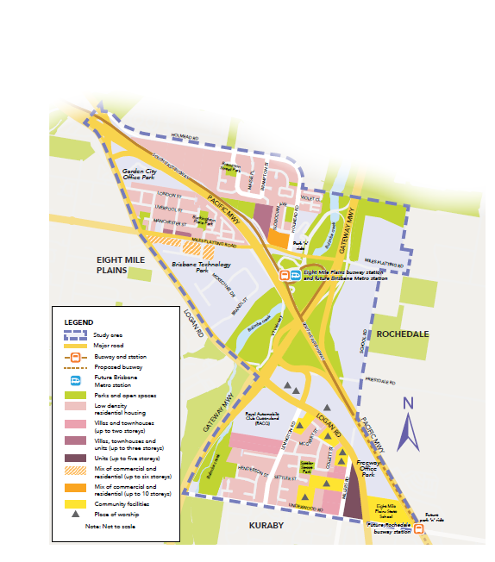
Map 1: A network of vibrant places.

Strategies and actions

Strategy 1.1 Provide greater choice of housing close to vibrant places.
1.1.1 Maintain and enhance opportunities for people to live in low density residential suburban
neighbourhoods, characterised by housing up to two storeys in height (see map 1).

1.1.2 Continue to support residential uses within the existing caravan parks on Holmead Road. In the event of an existing caravan park ceasing operation, redevelopment of the sites should encompass low density housing.

1.1.3 Expand the opportunity for people to live in villas and townhouses in suitable locations around the area, particularly next to existing established townhouses on Levington Road, on the corner of Millers Road and Underwood Road, near Slobodian Avenue and on a portion of Miles
Platting Road (see map 1).

1.1.4 Provide opportunities for people to live in well-designed units up to five storeys in height
close to the proposed Rochedale busway station and local schools and shops on Millers and
Underwood roads (see map 1).

1.1.5 Encourage people to live close to employment and above offices, cafes and shops in mixed use buildings up to six storeys in height along a portion of Miles Platting Road (see Map 1).

1.1.6 Maintain existing units up to 10 storeys in height, close to the Eight Mile Plains busway station and the future Brisbane Metro station, so that residents can live near to employment, services and public transport.

Strategy 1.2 Provide a diversity of facilities and places.
1.2.1 Investigate opportunities to provide a community service space that meets the needs of residents and workers. The community space could be located west of the Pacific Motorway.

1.2.2 Investigate opportunities to provide a multi-functional community and arts facility. This space could be delivered in partnership with local businesses.

1.2.3 Continue to protect heritage places such as the St John’s Lutheran Church, and character buildings. Investigate opportunities to protect additional buildings that have heritage and character values.

1.2.4 Continue to support existing community facilities in the area, including the range of established places of worship.

1.2.5 Identify opportunities to incorporate public art within activity nodes.

Strategy 1.3 Encourage high quality development design to create a series of unique neighbourhoods.
1.3.1 Development should incorporate the design principles outlined in Design-led city – A design strategy for Brisbane with architecture and a public realm that contributes to the locality’s identity as a global precinct. Additional height is supported in some locations (see map 3) to realise the development potential of each site and make efficient use of the land, while providing generous setbacks, pedestrian connections and a comfortable and attractive public realm to create a sense of place.

1.3.2 Ensure development of vacant parcels of land are well integrated with adjoining land uses by providing appropriate infrastructure, access and protection of existing environmental values.

Strategy 1.4 Provide the necessary infrastructure to support neighbourhoods and employment clusters.
1.4.1 Provide new infrastructure, as required, that meets the needs of the community and is designed to meet Council’s desired standards of service.

1.4.2 Protect the existing infrastructure in the locality, including substations and powerlines, which support development.

The new Rochedale Town Centre is located nearby and services the daily needs of local residents including groceries, dining and retail shops.

Global business and local jobs
There are already a range of commercial uses within the locality, as well as local schools, places of worship, health services and other community facilities. Not only are these businesses and facilities providing goods and services the community needs and wants, they also provide employment, allowing locals to live and work in the same area.

The draft strategy supports the continued evolution of the Eight Mile Plains Gateway locality as a key economic and employment hub in Brisbane. This includes encouraging business and employment growth at a rate higher than originally planned for the area.

The draft strategy proposes new employment nodes and greater building heights at key locations to encourage global and high-tech businesses to co-locate and make the best use of the available land, take advantage of significant investments in transport infrastructure, and facilitate information sharing and collaboration.

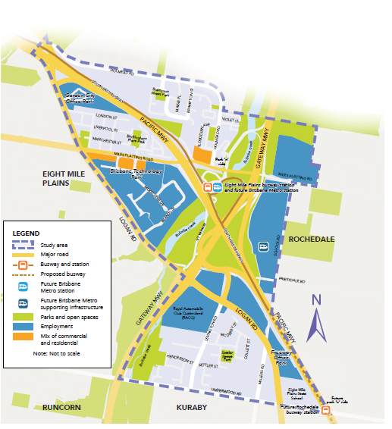
Map 2: Global business and local jobs in the locality.

Strategies and actions

Strategy 2.1 Encourage the growth of the Brisbane Technology Park into a vibrant and unique economic precinct.
2.1.1 Maximise the capacity of the Brisbane Technology Park by increasing maximum building height to eight storeys in the centre of the site, transitioning to four storeys along Miles Platting and Logan roads (see map 3).

2.1.2 Encourage local workers and businesses to interact and collaborate by creating an identifiable focal point within the Brisbane Technology Park, which features diverse land uses such as small-scale health and medical facilities, food and beverage outlets, entertainment venues and public spaces that complement the broader retail network and the Rochedale Town Centre.

2.1.3 Allow commercial and residential development up to six storeys west of the Pacific Motorway on the southern side of Miles Platting Road, which face the street and create an entry statement to the global precinct.

2.1.4 Encourage the provision of open space and streetscape improvements such as shade trees, landscaping, public seating and artwork throughout the Brisbane Technology Park. This will create spaces for events as well as gathering areas for workers and residents.

2.1.5 Encourage enhancements to the public realm such as wide footpaths, street trees and lighting along Miles Platting Road, to make it safe, accessible and comfortable and provide a unique entry statement to the Brisbane Technology Park.

Strategy 2.2 Provide diversity of employment uses to support global businesses and local jobs.
2.2.1 Encourage and attract a range of commercial, warehousing and office uses of different sizes at various locations throughout the locality. This includes supporting logistics and warehousing uses close to the Gateway Motorway and identifying additional parcels of land for employment uses on the corner of School and Miles Platting roads (see Map 2).

2.2.2 Continue to support the boutique business environments that have already established along Logan Road, particularly the Garden City Office and Freeway Office parks.

2.2.3 Support the ongoing operation of the RACQ headquarters across the majority of the existing site on Logan and Levington roads.

2.2.4 Continue to support existing employment opportunities in health, education, community
services and local retail throughout the locality, such as at Eight Mile Plains State School, places of worship and childcare centres.

2.2.5 Support and encourage additional business and employment areas along Logan Road, in the long-term to provide more opportunities for office and business uses to provide local jobs (see Map 2).

2.2.6 Support the development of an employment hub through the creation of the new Brisbane Metro depot on School Road.

2.2.7 Investigate opportunities for creative maker spaces and community arts spaces to be integrated into employment areas.

2.2.8 Investigate opportunities for vocational training facilities to be incorporated into employment areas.
The Brisbane Technology Park already supports national and global leaders in niche, advanced manufacturing and information technology. Broadening the mix of land uses, increasing density for business park and technology uses, extending business hours, and improving public space and connectivity will further support the growth of these industries.

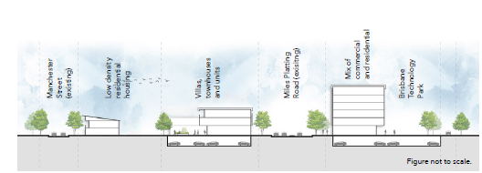
Figure 1: Cross-section of Miles Platting Road looking east.

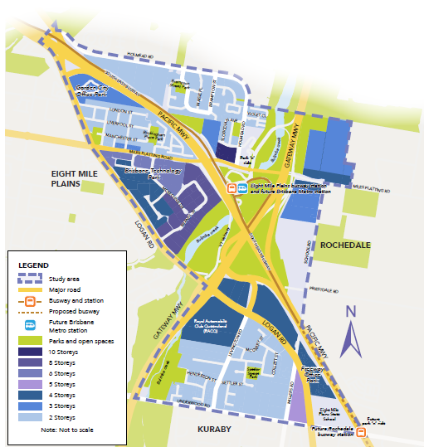
Map 3: Proposed maximum building heights in the locality.

Connecting places and spaces
The Eight Mile Plains Gateway locality is strategically located with excellent connections to the Brisbane Airport, Port of Brisbane and Brisbane city centre. Locals enjoy quick, direct bus services to the Brisbane city centre, which will be improved by the future Brisbane Metro station and other infrastructure such as upgrades to the Gateway Motorway and the proposed Rochedale busway station.

Walking around the area is difficult in some areas due to crossing large roads, varying street and footpath quality, and a lack of street trees. Improved pedestrian crossings, upgrades to connecting paths and improved streetscapes will make it easier to walk and cycle in the locality. Supporting connections to cycle paths and extending existing paths are also important.

Many locals already use the Eight Mile Plains busway station, and patronage of public transport services is expected to increase with the future Brisbane Metro station. Residents commuting to work daily make up the majority of people using the Eight Mile Plains busway station. Council will investigate ways to help residents and workers to more easily travel the ‘last mile’ between their home or workplace and the Brisbane Metro station.

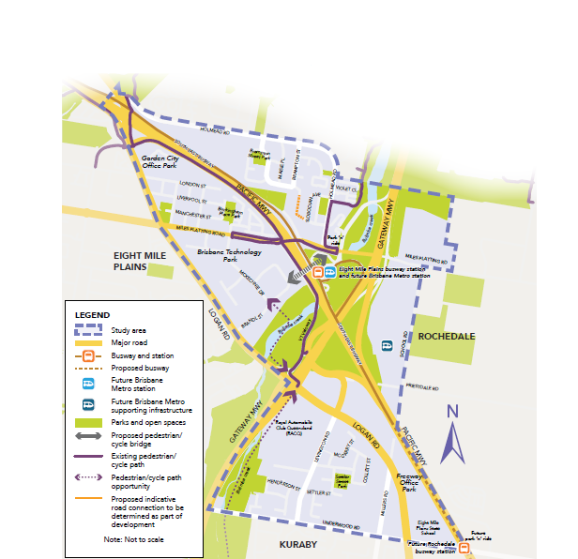
Map 4: Connections to places and spaces.

Strategies and actions

Strategy 3.1 Provide critical pedestrian connections between employment nodes and public transport.
3.1.1 Work with the Queensland Government to provide a direct pedestrian connection across the Pacific Motorway, linking the future Brisbane Metro station directly to the Brisbane Technology Park. See the text box below for more information.

3.1.2 Work with the Queensland Government to investigate a pedestrian crossing at the Holmead Road and Miles Platting Road intersection, providing direct and convenient pedestrian access to the future Brisbane Metro station.

Strategy 3.2 Preserve and enhance regional connections and infrastructure.
3.2.1 Work with the Queensland Government to maintain the existing transport network and investigate opportunities to enhance local roads and infrastructure to ensure significant employment areas are easily accessible to the Brisbane city centre and broader region.

3.2.2 Maintain the park ‘n’ ride function of the Eight Mile Plains busway station.

3.2.3 Support opportunities to expand the existing public transport network and locate employment and housing close to public transport facilities.

3.2.4 Encourage provision of taxi ranks, set down areas and disability car parking bays around shops, public transport, community facilities and employment centres.

A pedestrian bridge over the Pacific Motorway, connecting the future Brisbane Metro station with key employment destinations, is a critical connection for the locality.

Not only would the bridge connection encourage workers and residents to walk to the Brisbane Metro station, it would also support businesses and public spaces throughout the Brisbane Technology Park as more people walk through and use the space.

The Queensland Government has responsibility for the Pacific Motorway and infrastructure around and over the motorway. Council will work with the Queensland Government to investigate options for a pedestrian bridge.

Strategy 3.3 Enhance the public realm to create walkable neighbourhoods.
3.3.1 Improve street trees and shade planting to make it more pleasant for people to walk, cycle or get to public transport.

3.3.2 Encourage new streets to provide accessible, whole-of-journey paths of travel that connect to public transport, employment and services. In addition, these streets should be attractive and encourage people to walk, cycle and gather at local points of interest.

3.3.3 Identify priority locations for footpath improvements to enhance the pedestrian environment
and provide all-abilities access along local streets.

3.3.4 Increase lighting and passive surveillance on key connections to make it safer for pedestrians during the day and night.

Strategy 3.4 Connect Brisbane Metro patrons to jobs and homes.
3.4.1 Improve local cycling connections to existing bikeways such as the Veloway 1 (V1) cycleway and Bulimba Creek bikeway.

3.4.2 Investigate opportunities to improve cycling and walking facilities along the Bulimba Creek corridor, particularly along the Gateway Motorway (including along the RACQ site) to connect with Wally Tate Park and Karawatha Forest (see map 4).

3.4.3 Encourage new office buildings to provide showers and bike lockers so that workers can walk or cycle to work.

3.4.4 Work with the Queensland Government and TransLink to provide more local bus connections to local areas, including the new Rochedale Town Centre and future employment clusters on School Road.

Brisbane Metro will be a key part of Brisbane’s greater transport network connecting the city to the suburbs. With a Metro station proposed at Eight Mile Plains, peak services will operate every three minutes connecting the locality to Griffith University, The University of Queensland, Roma Street and the Royal Brisbane and Women’s Hospital.

A grid of green
The Bulimba Creek corridor is a large green space that winds its way through this part of Brisbane. The corridor is a valuable ecological resource for the city and provides substantial local amenity.

The corridor also provides opportunities for managing stormwater through natural treatments as well as providing regional habitat linkages. Enhancing the ecological function of the corridor could be achieved by continuing to partner with local community groups to assist with the ecological preservation and maintenance of the corridor through weed removal and re-vegetation programs.

There is an opportunity to further improve the appeal of the locality with shady street trees, green street boulevards and by beautifying and adding facilities to parks. This will create a leafy and green character for the area and contribute to the unique local identity and high-quality urban environment. Council will also encourage water-smart development that embraces green design and leaves plenty of room for large trees.
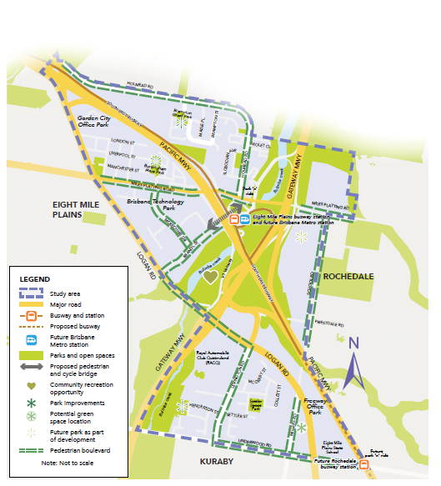
Map 5: A grid of green.

Strategies and actions

Strategy 4.1 Protect and enhance the ecological values and function of the Bulimba Creek corridor.
4.1.1 Continue to protect and enhance natural assets within the locality including remnant native trees, mature vegetation in residential areas, and vegetation found within the major transport corridors.

4.1.2 Investigate incorporating wildlife movement solutions within development and infrastructure upgrades to help overcome movement barriers created by infrastructure and roads throughout the locality.

4.1.3 Continue to support local community groups to help restore and maintain habitat and environmental values of the Bulimba Creek corridor.

4.1.4 Ensure residential development provides appropriate design and site layout to protect environmental features and physical land constraints.

Strategy 4.2 Encourage green streets that contribute to the environmental, character and visual amenity of the locality.
4.2.1 Investigate opportunities to reach Council’s target of 50% shade cover for residential footpaths and bikeways to help cool the urban environment, such as community street tree planting events and conducting a street tree inventory audit.

4.2.2 Identify and protect trees on private property that contribute to the landscape character and visual amenity values of the locality through the Significant landscape tree overlay in City Plan.

4.2.3 Investigate ways to retain and plant street trees and for future development to provide shade and comfort for pedestrians through changes to the Streetscape hierarchy overlay in City Plan.

4.2.4 Require development to leave enough room onsite for deep planting and landscaping along the street frontage to provide comfort, shade and an attractive urban environment.

4.2.5 Encourage new development to incorporate water-smart urban design principles, sensitively manage stormwater and investigate ways to support rooftop gardens, green walls, raingardens and onsite stormwater treatment devices within buildings.

Strategy 4.3 Provide green spaces to increase amenity for workers and residents.
4.3.1 Investigate opportunities to better connect the green spaces at Priestdale Road and Logan Road with the Brisbane Technology Park, providing shade and amenity for workers and residents. Any connections or improvements should consider existing biodiversity, flooding, infrastructure, safety constraints and opportunities.

4.3.2 Identify local park enhancements that could create local community focal points, relative to
community needs and expectations.

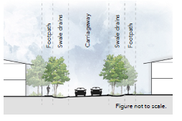
Figure 2: Cross-section of water sensitive urban design street treatment.

Did you know that community members worked with Council’s Habitat Brisbane program to plant approximately 340 plants in Eight Mile Plains in March 2019? Council values trees and vegetation in urban areas and has a target to increase tree shade cover to 50% for footpaths and bikeways in residential areas by 2031.

Implementation and delivery
The implementation of the strategies, actions and ideas outlined in this draft strategy will not be achieved by Council alone. The delivery of actions and strategies will be influenced by several factors including funding sources, market influences and partnerships between the private sector and all levels of government.

Supporting change with infrastructure
Delivering infrastructure in the Eight Mile Plains Gateway locality is particularly complex due to land ownership patterns, physical barriers hindering infrastructure connections such as the Gateway and Pacific motorways, and the sequencing of development that affects which elements of infrastructure are delivered first. Many of the large road corridors are owned by the Queensland Government and are outside of Council’s control.

Council delivers infrastructure for Brisbane in many ways including capital works programs, infrastructure contributions and through development. Infrastructure that Council is responsible for includes local roads, public transport (except those under Queensland Government control), active transport, stormwater, parks and community facilities. Drinking water and sewer infrastructure is the responsibility of Queensland Urban Utilities.

Council has already planned for the following new infrastructure in the locality as part of the Local
Government Infrastructure Plan.
- Road upgrades: Miles Platting Road (Pacific Motorway to School Road); School Road (Miles Platting Road to Priestdale Road); Miles Platting Road (School Road to West Street).
- Intersection upgrades: Miles Platting Road and School Road intersection; School Road and Priestdale Road intersection.
- Park: recreation corridor park of 2000 square metres (Levington Road, Eight Mile Plains - next to RACQ); local recreation park of 5000 square metres (23-25 School Road, Rochedale); local recreation park of 8000 square metres (next to Rochedale Town Centre).
- Cycling upgrades: Bulimba Creek Bikeway (Underwood Road to Logan Road - western side of Gateway Motorway); Bulimba Creek Bikeway (Maisie Dixon Park to Holmead Road); Rochedale Bikeway (Miles Platting Road to a future road).
- Natural waterway: Bulimba Creek (east of the Gateway Motorway, north of Miles Platting Road).
- Stormwater improvements: various locations in Eight Mile Plains.

For more information about planning for infrastructure, visit brisbane.qld.gov.au and search ‘infrastructure planning’.

Implementation plan
The implementation plan outlines the next steps needed to realise the vision for Eight Mile
Plains Gateway.

Implementation will involve both statutory changes through the development of a new neighbourhood plan, and the delivery of non-statutory actions to unlock potential and attract public and private investment in key locations.

These initiatives may be delivered by Council, Queensland Government, Australian Government,
the community, private businesses or individuals.
Action | Responsibility | Planning scheme/policy | Private businesses or individuals
Theme One: A network of vibrant places
Strategy 1.1 Provide greater housing choice close to vibrant places.
1.1.1 | Council | Yes
1.1.2 | Council | Yes
1.1.3 | Council | Yes
1.1.4 | Council | Yes
1.1.5 | Council | Yes
1.1.6 | Council | Yes
Strategy 1.2 Provide a diversity of facilities and places.
1.2.1 | Council/private | Yes | Yes
1.2.2 | Council | Yes
1.2.3 | Council | Yes
1.2.4 | Council/private | Yes | Yes
Strategy 1.3 Encourage high quality design of development to create a series of unique neighbourhoods
1.3.1 | Council/private | Yes | Yes
1.3.2 | Council/private | Yes | Yes
Strategy 1.4 Provide the necessary infrastructure to support neighbourhoods
and employment clusters.
1.4.1 | Council/Queensland Government/private | Yes | Yes
1.4.2 | Council/Queensland Government/private | Yes | Yes
Theme Two: Global business and local jobs
Strategy 2.1 Encourage the growth of the Brisbane Technology Park into a vibrant
and unique economic precinct.
2.1.1 | Council | Yes
2.1.2 | Council/private | Yes | Yes
2.1.3 | Council/private | Yes | Yes
2.1.4 | Council/private | Yes | Yes
2.1.5 | Council/private | Yes | Yes
Strategy 2.2 Provide diversity of employment uses to support global businesses
and local jobs.
2.2.1 | Council | Yes
2.2.2 | Council | Yes
2.2.3 | Council | Yes
2.2.4 | Council | Yes
2.2.5 | Council | Yes
2.2.6 | Council | Yes
2.2.7 | Council/private | Yes | Yes
2.2.8 | Council/private | Yes | Yes
Theme Three: Connecting places and spaces
Strategy 3.1 Provide critical pedestrian connections between employment nodes
and public transport.
3.1.1 | Council/Queensland Government | Yes
3.1.2 | Council/Queensland Government | Yes
Strategy 3.2 Preserve and enhance regional connections and infrastructure.
3.2.1 | Council/Queensland Government | Yes
3.2.2 | Council/Queensland Government | Yes
3.2.3 | Council/Queensland Government | Yes
3.2.4 | Council/private | Yes | Yes
Strategy 3.3 Enhance the public realm to create walkable neighbourhoods.
3.3.1 | Council/private | Yes | Yes
3.3.2 | Council/private | Yes | Yes
3.3.3 | Council | Yes
3.3.4 | Council | Yes
Strategy 3.4 Connect Brisbane Metro patrons to jobs and homes.
3.4.1 | Council/Queensland Government | Yes
3.4.2 | Council/Queensland Government | Yes
3.4.3 | Council/private | Yes | Yes
3.4.4 | Council/Queensland Government | Yes
Theme four: A grid of green
Strategy 4.1 Protect and enhance the ecological values and function of the
Bulimba Creek corridor.
4.1.1 | Council | Yes
4.1.2 | Council/Queensland Government | Yes
4.1.3 | Council | Yes
4.1.4 | Council | Yes
Strategy 4.2 Encourage green streets that contribute to the environmental,
character and visual amenity of the locality.
4.2.1 | Council/Queensland Government/private | Yes | Yes
4.2.2 | Council | Yes
4.2.3 | Council | Yes
4.2.3 | Council/private | Yes | Yes
4.2.4 | Council/private | Yes | Yes
Strategy 4.3 Provide green spaces to increase amenity for workers and residents.
4.3.1 | Council | Yes
4.3.2 | Council | Yes

Have your say

Are we on the right track?

- Visit brisbane.qld.gov.au and search ‘Eight Mile Plains Gateway Neighbourhood Plan’.
- Send an email to; neighbourhood_planning@brisbane.qld.gov.au
- Write to:
Neighbourhood Planning
(Eight Mile Plains Gateway Neighbourhood Plan) Brisbane City Council,
GPO Box 1434, Brisbane Qld 4001
- Attend an information kiosk session to find out what the draft strategy means for you and share your thoughts.

Saturday 30 November 2019, 12 noon - 2pm
The Glen Hotel (Elaine Room), 24 Gaskell Street, Eight Mile Plains

Wednesday 4 December 2019, 3 - 7pm
BTP Conference and Exhibition Centre, 1 Clunies Ross Court, Eight Mile Plains

Feedback closes on 5pm, Monday 16 December

Stay up to date on the project by visiting brisbane.qld.gov.au and registering for email updates.

Next steps
Council will review and consider all feedback as part of developing a draft neighbourhood plan.
You will have an opportunity to review the draft plan and provide your comments.

Neighbourhood plan timeline

Background research
Early-mid 2019
Council conducted background research and technical studies and sought community input to understand key issues and opportunities affecting the area.

Draft strategy (Current Stage)
Late 2019
Council seeks community input on a draft strategy that will set the direction of the neighbourhood plan.

Draft neighbourhood plan
Late 2020
Council will prepare a draft plan, including specific proposals such as changes to zones or overlays, which will be reviewed by the Queensland Government and released for further community feedback.

Adoption
Mid 2021
Adoption and gazettal of the neighbourhood plan, which will then form part of City Plan.

