
Indooroopilly Roundabout Upgrade

Better Roads for Brisbane

Business Case Summary Report

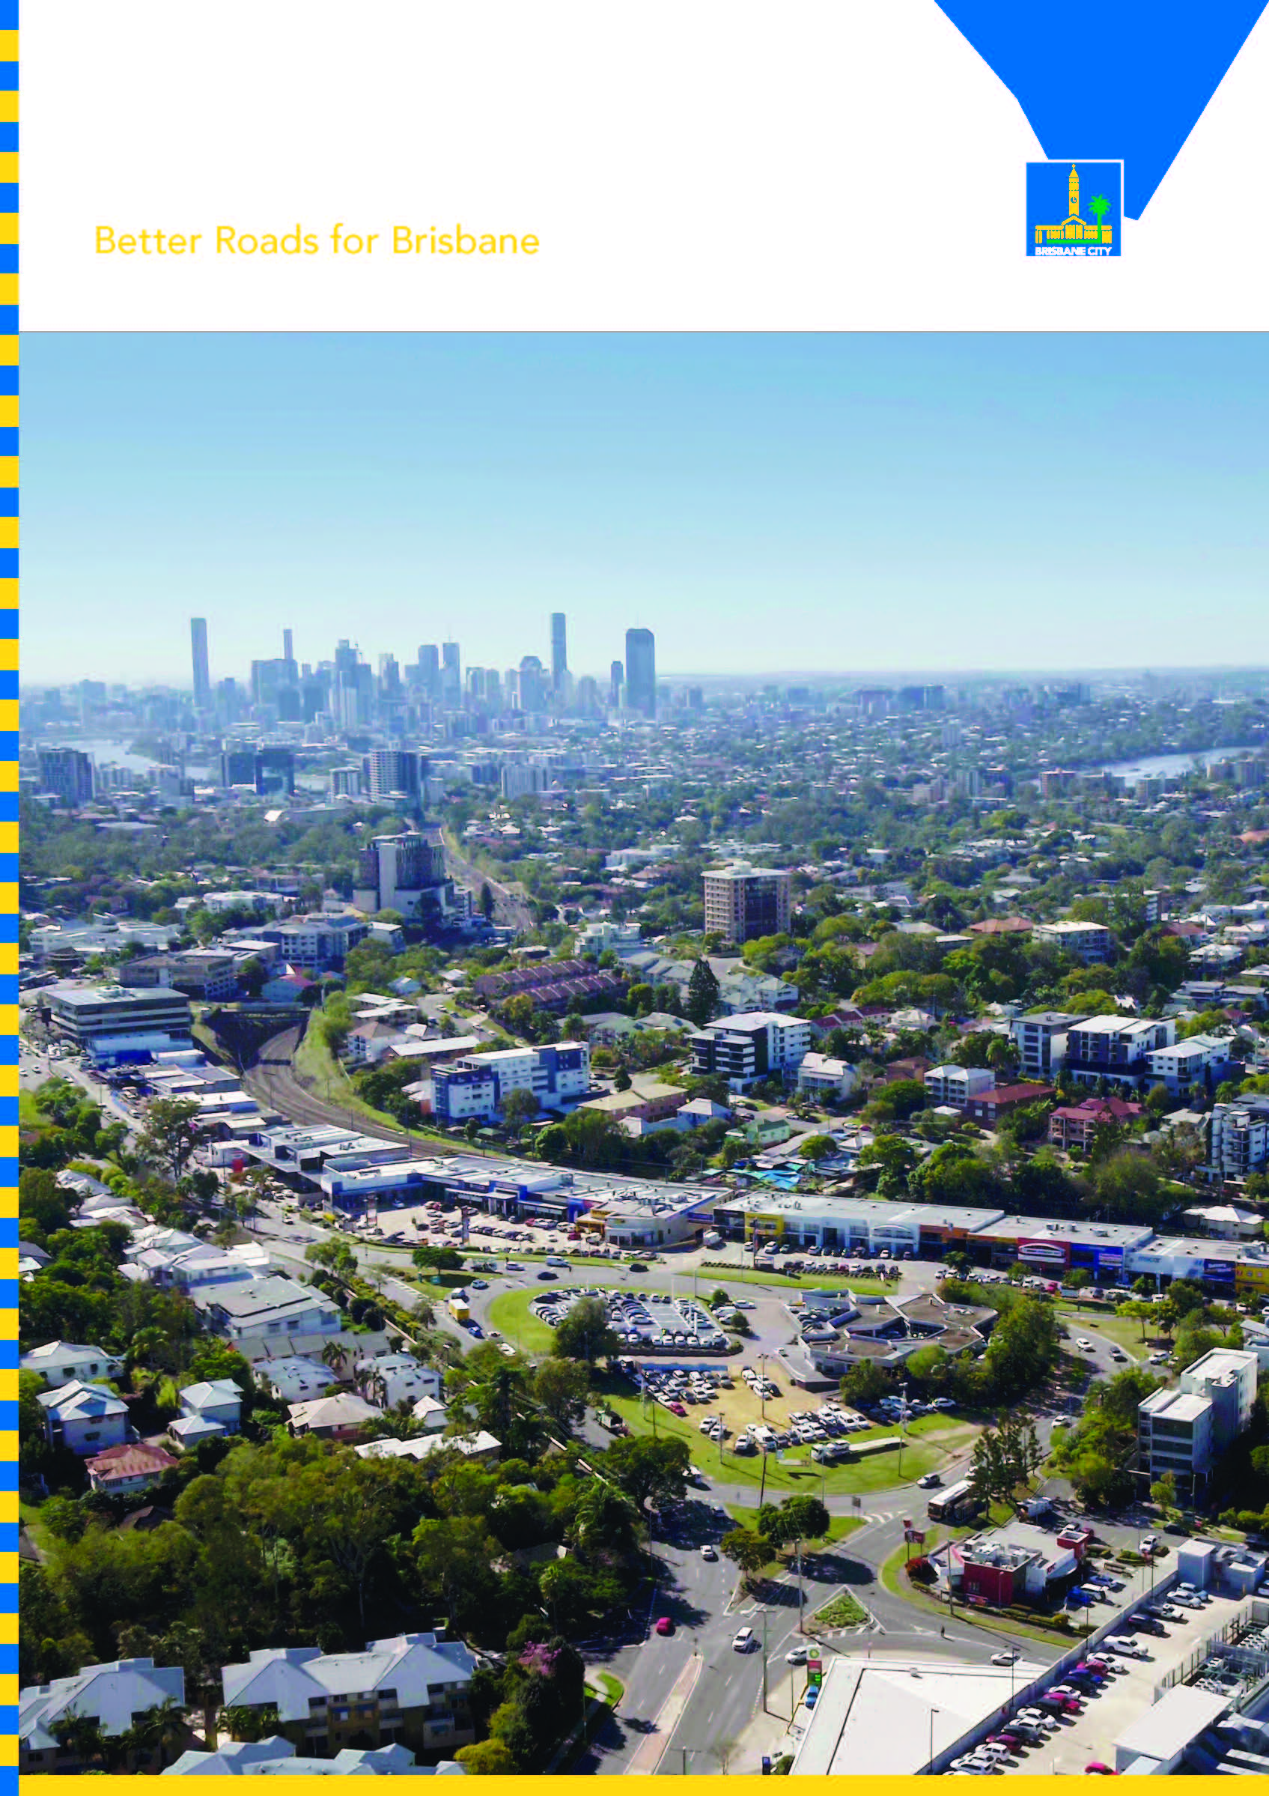

Following previous studies, Brisbane City Council completed a business case in 2020. The business case
recommended the replacement of the roundabout at the Moggill Road and Coonan Street intersection with an overpass, allowing free flowing traffic on Moggill Road.
This summary provides a brief outline of the key findings of the business case including:
- why an upgrade is required for the intersection of
- Moggill Road and Coonan Street
- timeline of key milestones
- why the project is needed now
- the benefits of delivering the project
- summary of the options analysis.

Moggill Road and Coonan Street are two major arterial roads linking Brisbane’s outer west and south-west suburbs and the Central Business District (CBD), intersecting in a semi-controlled roundabout at Indooroopilly.

The corridors serve critical roles in supporting the growth in commercial activities and residential land areas that border the intersection and surrounding suburbs, including the Indooroopilly Principal Regional Activity Centre. Figure 1 shows the intersection location within the broader urban context.

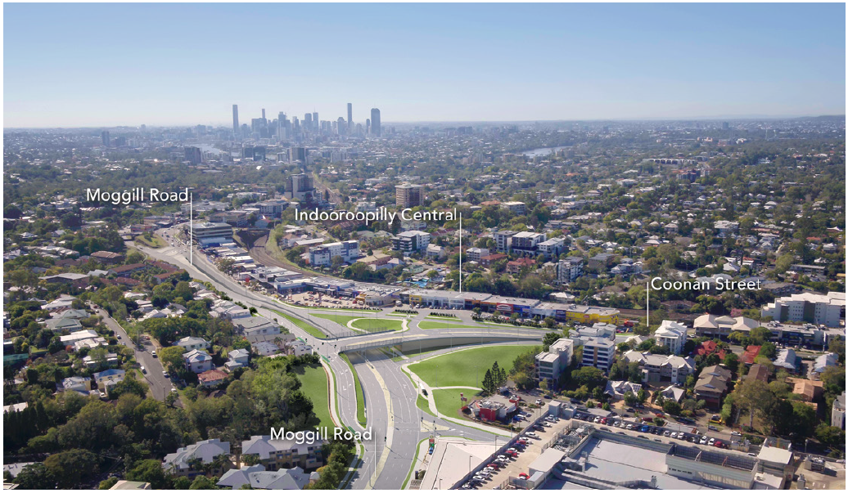

The intersection has a high crash history with limited active transport connectivity and accessibility. The intersection caters for high traffic volumes and experiences significant congestion in peak hour periods.
Congestion is anticipated to increase as surrounding commercial and residential land uses grow in size and density, increasing local transport pressures and needs. Major queue lengths are experienced on approaches to the intersection, resulting in delays for all road users and congestion through adjacent intersections.

Project timing
Key activity/milestone | State date | End date
Finalisation of concept design | Mid 2019 | Mid 2020
Finalisation of business case | Mid 2019 | Late 2020
Initial stakeholder consultation | Mid 2019 | Late 2019
Detailed planning, design and consultation | Mid 2019 | Early 2021
Land acquisition | Late 2020 | Late 2021
Engage with tenderers | Mid 2021 | Late 2021
Award contracts | Late 2021 | Late 2021
Public utility plan relocations and early/demolition works | Mid 2021 | Late 2021
Road and civil construction Late | Late 2021 | Early 2024

Why an upgrade is needed

Safety
- The intersection has a high crash history, with 32 recorded incidents between 2013 and 2018. Ten of these resulted in hospitalisation, 17 required medical treatment, and five resulted in minor injuries. There were 12 further incidents between 2018 and 2020 including 3 hospitalisations, five medical treatment and four minor injuries.
- There is a significant safety issue at the Coonan Street and Keating Street intersection, where road users make right turn movements under high-risk circumstances during peak periods. This is due to impacted sight lines of oncoming traffic and a continuous traffic flow in both directions on Coonan Street.

Congestion
- The Moggill Road and Coonan Street intersection currently experiences significant congestion in peak hour periods, with 55,000 vehicles per day passing through the existing roundabout. Heavy vehicles make up approximately 2.5% of the traffic flow.
- Traffic modelling indicates that the intersection is currently operating at capacity in both the morning and afternoon peak hour periods, with traffic performance worsening through to 2031. This is due to continued background traffic growth along both corridors and growing commercial and residential land uses significantly increasing local transport pressures and needs.
- If an upgrade to the intersection is not undertaken, anticipated traffic growth on Moggill Road between 2020 and 2031 will lead to significant deterioration in the network performance, resulting in queues of more than 1km.

Active transport
- Although Moggill Road is designated as a Principle Cycle Route, there are few existing, dedicated bicycle facilities within the area, resulting in low volumes of cyclists at this location.
- Installing new shared paths along Moggill Road will allow cyclists to travel along it, with the installation of a dedicated on-road bike lane between Nelson Parade and Payne Street on the northern side of Moggill Road.
- The current Moggill Road and Coonan Street intersection is considered a barrier to cycling, with cyclist volumes at this location extremely low.
- The lack of controlled pedestrian crossing points also poses a significant safety issue for public transport users required to cross the road in order to access public transport services.

Bus and train services
- The project location is a vital public transport link for the western suburbs of Brisbane, accommodating commuters accessing the bus and train services for their travel journeys.
- There is a total of 29 bus routes travelling along Moggill Road from the bus station, with the majority travelling west to east. Three existing bus stops are located within close proximity to the intersection and are located in the kerbside traffic lanes.
- Congestion issues at the roundabout impact bus travel times and travel time reliability.

Why now?
The intersection of Moggill Road and Coonan Street is currently experiencing significant congestion issues, especially in the PM peak period. This results in significant travel time delays, unreliable travel times and a high number of safety issues. Inaction on the Moggill Road and Coonan Street intersection will result in:

- Increased traffic congestion over time as the local surrounding commercial and residential land uses grow in size and density, increasing local transport pressures and needs.
- Not addressing the issue of continued background traffic growth along both corridors, which will also contribute to increased congestion at the intersection.
- Increasing the crash risks at the Indooroopilly Roundabout intersection as identified in the road safety audit.
- Continued safety risk for pedestrians and cyclist conflicts due to the absence of signalised pedestrian crossings at the intersection.

Project benefits
Once completed, the Indooroopilly Roundabout Upgrade will:

- Improve safety for road users and pedestrians at the intersection and nearby streets
- Improve traffic flow and reduce travel times with the construction of an overpass
- Upgrade shared pedestrian and cycle paths, improving active travel opportunities and connectivity
- Improve the overall visual appeal of the intersection through new landscaping spaces.

Project objectives
- Improve safety for all modes of traffic
- Reduce traffic congestion
- Increase capacity to accommodate existing and future traffic demands
- Improve the reliability of travel times for all modes of traffic
- Minimise property impacts
- Maximise environmental and sustainability opportunities
- Improve active transport opportunities
- Enhancing liveability – Better journey experience
- Urban street place-making — to better integrate road space with adjacent land use and activity, and improve the public realm
- Place-making transport — develop a strong sense of place with the delivery and upgrade of transport

Options analysis

Options developed
- The project considered three main solution types including a major signalised intersection, a Moggill Road overpass and a Coonan Street overpass. From these solutions, over 20 options were developed. These options are detailed within the business case, which is available on Council’s website.

Community feedback and options refinement
- Option 2.1 (Consultation Option A) and Option 16d (Consultation Option B) were released to the community in late 2019, with Council seeking feedback on these two concept design options.
- During the project’s consultation phase, which included two public information sessions, the overwhelming majority of feedback received supported Option 16d (Consultation Option B) and the construction of an overpass. This option provides greater travel time savings to reduce congestion and can cater to existing and future traffic demand. The community however, was dissatisfied with the removal of the left-turn in movement from Moggill Road into Stamford Road.
- After receiving feedback from residents and stakeholders who wanted to maintain the left-turn access from Moggill Road into Stamford Road, Council developed and is now proceeding with a revised design to retain this left-turn access. This revised overpass option is known as Option 16g.
- This refined option further reduces travel time delays, while still providing the reduced crash frequency benefits via grade separation and will allow the overall inner western Brisbane road network to operate more efficiently.

Economic Assessment
- After a thorough Multi Criteria Assessment (MCA) was completed on the shortlisted design options, the highest scoring short listed design options were analysed through a rapid benefit cost ratio (BCR). This provided Council with an indication of the benefits for existing users, which included savings in vehicle operating costs and travel time costs, against the costs of the project.
- In addition, the final preferred option for the Indooroopilly Roundabout upgrade was assessed for its road network capacity and crash reduction benefits, using a cost-benefit analysis (CBA) methodology consistent with AUSTROADS – Benefit Cost Analysis Manual and the Guide to Project Evaluation. The CBA indicated a benefit/cost ratio of 2.08. A BCR greater than 1.0 indicates the benefits outweigh the financial costs. The total project cost is estimated at $126.2 million.

More information
- Call 1800 572 132 (business hours), 3403 8888 (after hours)
- Email the Project Team at cityprojects@brisbane.qld.gov.au
- Visit brisbane.qld.gov.au and search ‘Indooroopilly Roundabout Upgrade’
- Write to City Projects Office, Brisbane City Council, GPO Box 1434, Brisbane Qld 4001

