BALLYMORE TRAFFIC AREA
LOCAL LAW 2001

Consolidated as at 19 February 2013

BRISBANE CITY COUNCIL

BALLYMORE TRAFFIC AREA LOCAL LAW 2001

TABLE OF PROVISIONS

PART 1—Preliminary 1
- Short title 1
- Objects 1
- Definitions 1
PART 2—THE BALLYMORE TRAFFIC AREA 2
- Traffic area 2
- Name of Traffic area 2
PART 3— REGULATION OF PARKING 2
- Regulation of Parking 2
- Commencement of Regulation of Parking 2
THE SCHEDULE 3
PART 3 REGULATION OF PARKING 4

BRISBANE CITY COUNCIL

BALLYMORE TRAFFIC AREA LOCAL LAW 2001

PART 1—Preliminary

Short title

1. This local law may be cited as Ballymore Traffic Area Local Law 2001.

Objects

2. The object of this local law is to provide for Council's regulation of parking by time in a particular part of the City (a "traffic area").

Definitions

3. In this local law:-

“City” means the area comprised in the City of Brisbane under the City of Brisbane Act 1924;

“Council” means the Brisbane City Council;

“official traffic sign” has the meaning given to it in the Transport Operations (Road Use Management) Act 1995;

“park” has the meaning given to it in the Transport Operations (Road Use Management) Act 1995;

“traffic area” has the meaning given to it in the Transport Operations (Road Use Management) Act 1995.

PART 2—THE BALLYMORE TRAFFIC AREA

Traffic area

4. The part of the City the boundaries of which are defined by the black bordering
indicated on the map in the Schedule is declared to be a traffic area.

Name of Traffic area

5. The traffic area declared under section 4 is named Ballymore Traffic Area.

PART 3— REGULATION OF PARKING

Regulation of Parking

6. Parking in Ballymore Traffic Area is allowed only for the maximum time specified on the official traffic signs mentioned in section 7 at the dates and times specified on those official traffic signs.

Infringement notice penalty – 0.75 penalty units.

Commencement of Regulation of Parking

7. The regulation of parking under section 6 commences on the day after official traffic signs indicating how parking is regulated are installed by Council on the road at every road entry to Ballymore Traffic Area.

THE SCHEDULE
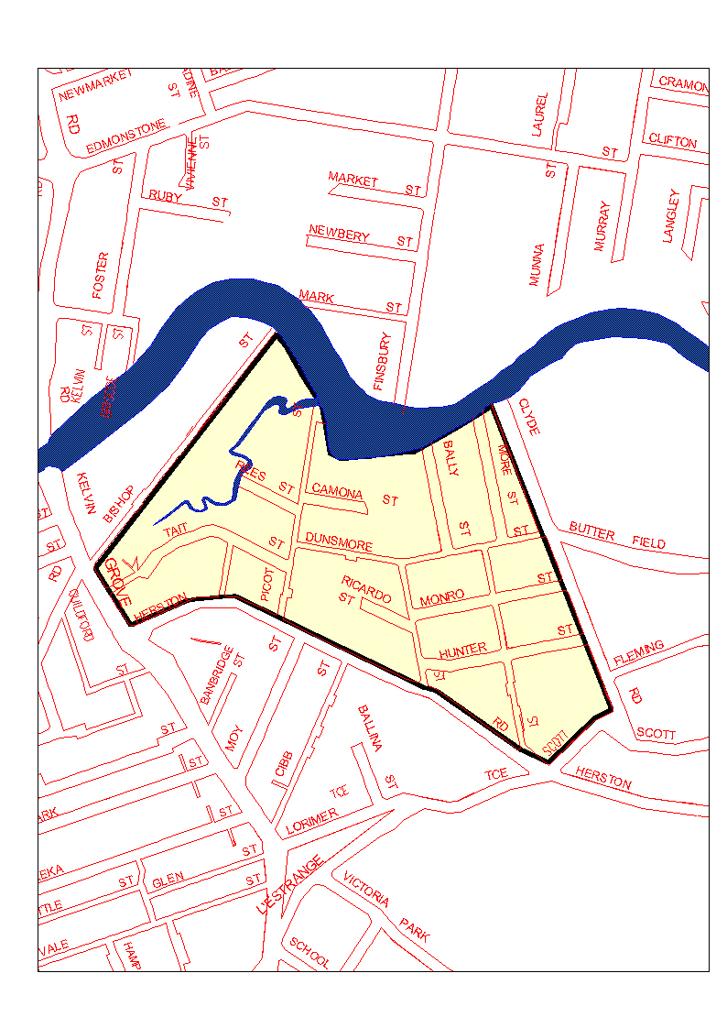
Endnotes

List of amendments

PART 3 REGULATION OF PARKING
s 6 amd Parking and Control of Traffic and other Local Laws Amending Local Law 2009 s9;
Administrative Arrangements Amending Local Law 2013 s 29

See section 108 of the Transport Operations (Road Use Management) Act 1995

