Brisbane City Council

DUTTON PARK PARKING CONTROL AREA LOCAL LAW 2006

Consolidated as at 19 February 2013

Brisbane City Council

DUTTON PARK PARKING CONTROL AREA LOCAL LAW 2006

made under the
City of Brisbane Act 2010

Contents

Page
Part 1 Preliminary 4
1 Short title 4
2 Objects 4
3 Definitions 4
Part 2 Dutton Park Parking Control Area 4
Division 1 Declaration of Traffic Area 4
4 Traffic Area 4
5 Name of Traffic Area 4
6 Regulation of parking 4
7 Commencement of regulation of parking in Dutton Park Parking Control Area 5
Division 2 Official traffic signs 5
8 Meaning of certain information on official traffic signs 5
9 Parking regulated by another sign 5
Part 3 Use of motor vehicles on park and cemetery land 5
10 Application 5
11 Restriction on the use of motor vehicles on park and cemetery land 6
12 Council signs 6
13 Restriction of application of other local laws 6
Part 4 Further offence 6
14 Further offence after infringement notice placed on a vehicle 6
Schedule 1 Boundaries of the Dutton Park Parking Control Area 7
Schedule 2 Boundaries of the Park and Cemetery Land 8
Schedule 3 Dictionary 9
Endnotes ………………………………………………………………………….10

Part 1 Preliminary

- Short title

This local law may be cited as the Dutton Park Parking Control Area Local Law 2006.

- Objects

The objects of this local law are to—
(a) create a Traffic Area called the Dutton Park Parking Control Area; and
(b) regulate parking within the Dutton Park Parking Control Area; and
(c) regulate the driving and parking of motor vehicles on certain Council lands in the Dutton Park Parking Control Area.

- Definitions

The dictionary in Schedule 3 defines particular words used in this local law.
Part 2 Dutton Park Parking Control Area

Division 1 Declaration of Traffic Area

- Traffic Area

The part of the City, the boundaries of which are defined by the blue bordering indicated on the map in Schedule 1, is declared to be a Traffic Area.

- Name of Traffic Area

The Traffic Area declared under section 4 is named "Dutton Park Parking Control Area".

- Regulation of parking

Parking in The Dutton Park Parking Control Area is allowed only for the maximum time specified on the official traffic signs mentioned in section 7 at the days and times specified on those official traffic signs.
Infringement notice penalty – 0.75 penalty units.

- Commencement of regulation of parking in Dutton Park Parking Control Area

For the Dutton Park Parking Control Area, the regulation of parking commences on the day after Council installs official traffic signs indicating how parking is regulated on the road at every road entry to the Dutton Park Parking Control Area.
Division 2 Official traffic signs

- Meaning of certain information on official traffic signs

- This section explains the meaning of certain information on or with an official traffic sign installed by Council.

(2) Except as signed means, “unless permitted or restricted by information on or with another traffic control device”.

(3) For subsection (2), traffic control device has the meaning given in the Transport Operations (Road Use Management—Road Rules) Regulation 1999.

- Parking regulated by another sign

A Council sign installed within the Dutton Park Parking Control Area may allow a longer or shorter parking time than that allowed by the official traffic sign for the entire Dutton Park Parking Control Area.
Part 3 Use of motor vehicles on park and cemetery land

- Application

This Part applies to Council land within the Dutton Park Parking Control Area, the boundaries of which are defined by the red bordering indicated on the map in Schedule 2 (“the park and cemetery land”).

- Restriction on the use of motor vehicles on park and cemetery land

A person must not drive or park a motor vehicle on the park and cemetery land in contravention of a Council sign.
Infringement notice penalty – 0.75 penalty units.

- Council signs

- A person parking anywhere within the park and cemetery land is taken to have notice of the contents of a Council sign installed at the entry to the park and cemetery land.

- If a Council sign is installed at or near a place so that a person parking at the place is likely to see the sign, the person is taken to have notice of the contents of the sign.

- Restriction of application of other local laws

(1) Section 8 of Part 1 of the Parks Local Law does not apply to the park and cemetery land.

(2) Section 6 of Part 13 of the Legal Proceedings Local Law does not apply to the park and cemetery land.

(3) To remove any doubt, an area referred to in section 10 is not a "parking station" as defined in Part 1 of the Parking and Control of Traffic Local Law.
Part 4 Further offence

- Further offence after infringement notice placed on a vehicle

If—
(a) a person commits an offence against section 6 or section 11; and
(b) an infringement notice for the offence, under the State Penalties Enforcement Act 1999, is placed on or attached to the vehicle; and
(c) the vehicle in relation to which the offence is committed remains parked in the same place after the notice is affixed;
then the person commits a separate and further offence under that provision, for each further time (equal to the maximum time indicated on the sign) that the vehicle remains parked in the place.
Schedule 1 Boundaries of the Dutton Park Parking Control Area
Section 4

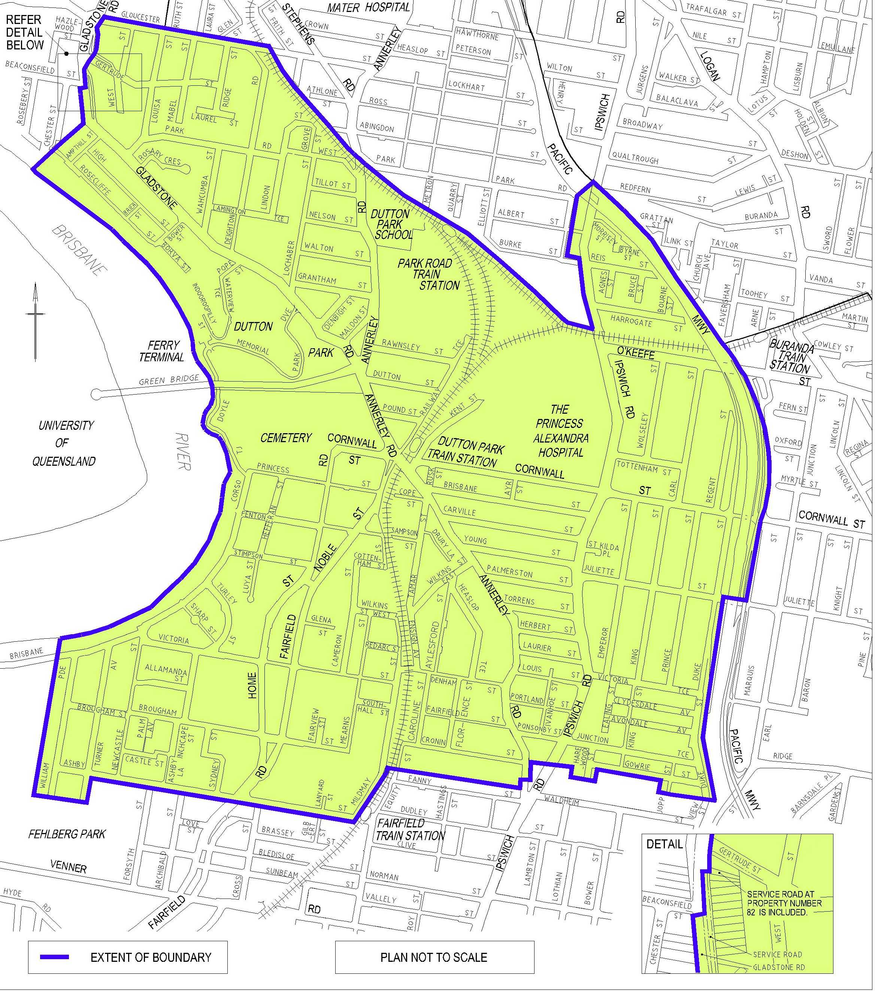

Schedule 2 Boundaries of the Park and Cemetery Land

Section 10
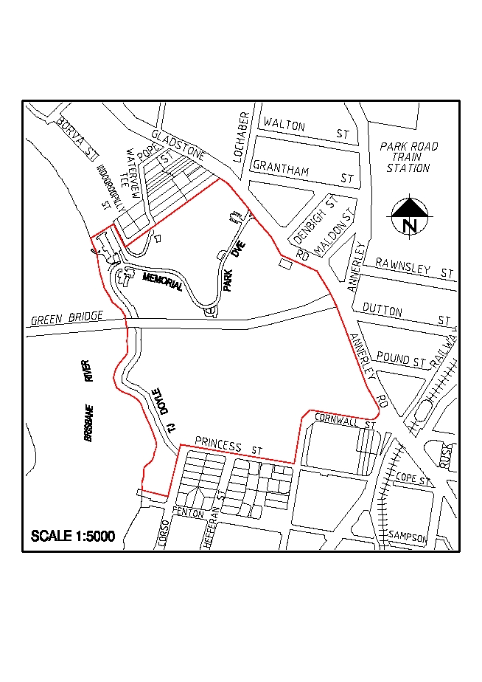

Schedule 3 Dictionary
Section 3
In this Local law—

City means the area comprised in the City of Brisbane under the City of Brisbane Act 1924.

Council means the Brisbane City Council.

Council sign means a sign installed by Council that is not an Official Traffic Sign.

Drive includes push, wheel, ride and bring upon by any means.

Official traffic sign has the meaning given in the Transport Operations (Road Use Management) Act 1995.

Park has the meaning given in the Transport Operations (Road Use Management) Act 1995.

Road has the meaning given in Schedule 4 to the Transport Operations (Road Use Management) Act 1995.

Vehicle includes part of a vehicle.
Endnotes

List of amendments

PART 2 — DUTTON PARK PARKING CONTROL AREA
Regulation of Parking
s 6 amd Administrative Arrangements Local Law 2013 s 33

PART 3 – USE OF MOTOR VEHICLES ON PARK AND CEMETERY LAND
Restriction on the use of motor vehicles on park and cemetery land
s 11 amd Administrative Arrangements Local Law 2013 s 34

See Part 3. Section 102 Transport Operations (Road Use Management) Act 1995 deals with other official traffic signs in a Traffic Area.

