Brisbane City Council

Queensland Tennis Centre Parking Area Local Law
2009

Consolidated as at 19 February 2013

Brisbane City Council

Queensland Tennis Centre Parking Area Local Law 2009

made under the
City of Brisbane Act 2010

Contents

Page
Part 1 Preliminary 2
1 Short title 2
2 Objects 2
3 Definitions 2
Part 2 Queensland Tennis Centre Parking Areas 3
4 Traffic Area 3
5 Name of Traffic Area 3
6 Regulation of parking 3
7 Commencement of regulation of parking 3
Schedule 1 Queensland Tennis Centre Parking Area 4
Endnotes ……………………………………………………………………………5

Part 1 Preliminary

- Short title

This local law may be cited as the Queensland Tennis Centre Parking Area Local Law 2009.

- Objects

The objects of this local law are to –

    - create Traffic Areas collectively called the Queensland Tennis Centre Parking Area; and
    - regulate parking within the Queensland Tennis Centre Parking Area.

- Definitions

(1) In this local law:-

“city” means the area comprised in the City of Brisbane under the City of Brisbane Act 1924;

“Council” means the Brisbane City Council;

“official traffic sign” has the meaning given to it in the Transport Operations (Road Use Management) Act 1995;

“park” has the meaning given to it in the Transport Operations (Road Use Management) Act 1995;

“road” has the meaning given in the Transport Operations (Road Use Management) Act 1995;

“traffic area” has the meaning given to it in the Transport Operations (Road Use Management) Act 1995;

Part 2 Queensland Tennis Centre Parking Areas

- Traffic Area
The parts of the City the boundaries of which are defined by the black bordering indicated on the map in Schedule 1, and labelled 1, 2 and 3, are declared to be Traffic Areas.

- Name of Traffic Area
The Traffic Areas declared under section 4 are collectively called the Queensland Tennis Centre Parking Area.

- Regulation of parking
Parking in the Queensland Tennis Centre Parking Area is allowed only for the maximum time specified on the official traffic signs mentioned in section 7 at the days and times specified on those official traffic signs.

Infringement notice penalty – 0.5 penalty units.

- Commencement of regulation of parking
For the Queensland Tennis Centre Parking Areas, the regulation of parking commences on the day after Council installs official traffic signs indicating how parking is regulated on the road at every road entry to the Queensland Tennis Centre Parking Area.

Schedule 1 Queensland Tennis Centre Parking Area

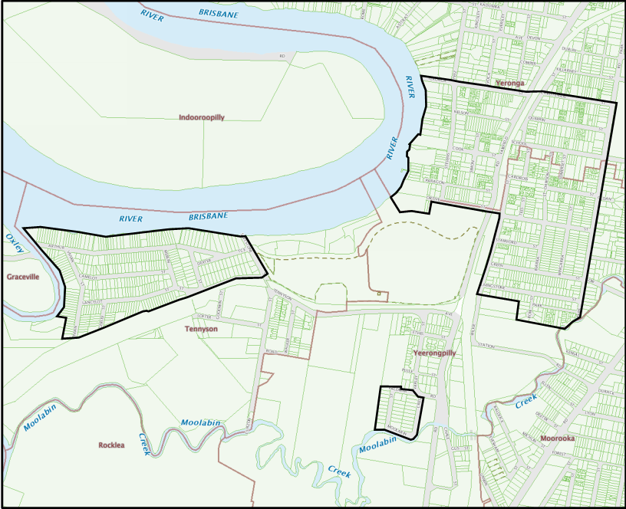

1

2

3

Endnotes

List of amendments

PART 2 – QUEENSLAND TENNIS CENTRE PARKING AREAS
s 6 - Regulation of Parking
s 6 amd Administrative Access Arrangements Amending Local Law 2013 s38

