BRISBANE CITY COUNCIL

ROBERTSON/MACGREGOR TRAFFIC AERA REGULATED PARKING LOCAL LAW 1996

consolidated as at 19 February 2013

Brisbane City Council

ROBERTSON/MACGREGOR TRAFFIC AREA REGULATED PARKING LOCAL LAW 1996

TABLE OF PROVISIONS

Section Page
PART 1 - PRELIMINARY

1 Short title ……………………………………………………………………………………… 1

2 Definitions ……………………………………………………………………………………… 1

3 Object ……………………………………………………………………………………… 1

PART 2 - TRAFFIC AREA

4 Traffic Area ……………………………………………………………………………… 1

5 Name of traffic area …………………………………………………………………………. 1

PART 3 - REGULATION OF PARKING

6 Regulation of parking …………………………………………………………………………. 1

7 Commencement of regulation of parking ………………………………………………………. 2

PART 4 - REGULATED PARKING POLICY

8 Times for parking by policy …………………………………………………………… 2

SCHEDULE …………………………………………………………………………. …... 3

ENDNOTES ………………………………………………………………………………. 4

PART 1 - PRELIMINARY

Short title

- This local law may be cited as the Robertson/Macgregor Traffic Area Regulated parking Local Law 1996.

Definitions

- (1) In this local law -

"City" means the area comprised in the City of Brisbane under the City of Brisbane Act 1924.

"Council" means the Brisbane City Council.

(2) In this local law any term defined in the Transport Operations (Road Use Management) Act 1995 has the meaning given to it in that Act.

Object

- The object of this local law is to provide for the Council's regulation of parking by time in a particular part of the City (a "traffic area").

PART 2 - TRAFFIC AREA

Traffic area

- The part of the City the boundaries of which are defined by the black bordering indicated on the map in the Schedule is declared to be a traffic area.

Name of traffic area

- The traffic area declared under section 4 is named the Robertson/Macgregor Traffic Area.

PART 3 - REGULATION OF PARKING

Regulation of parking

- (1) The regulation of parking under this section applies to parking –

(a) during the hours and on the days specified by the Council; and

(b) throughout the Robertson/Macgregor Traffic Area.

(2) However, the regulation of parking under this section is subject to –

(a) any regulation of parking which does not apply throughout the Robertson/Macgregor Traffic Area; and

(b) any indication on an official traffic sign not regulating parking.

(3) Parking in the Robertson/Macgregor Traffic Area is only allowed for the maximum time specified by the Council.

(4) The Council may from time to time specify –

(a) the hours during and days on which parking is regulated under this section, and

(b) the maximum time for which parking is allowed in the Robertson/Macgregor Traffic Area.

(5) The penalty with respect to a failure to comply with the regulation of parking under this section that is prescribed pursuant to section 108 of the Transport Operations (Road Use Management) Act 1995 is 0.75 penalty units.

Commencement of regulation of parking

- The regulation of parking under section 6 commences on the day after official traffic signs indicating how parking is regulated under section 6 are installed by the Council on the road at every road entry to the Robertson/Macgregor Traffic Area.

PART 4 - REGULATED PARKING POLICY

Times for parking by policy

- The Council may in a regulated parking policy specify –

(a) the hours during which and days on which parking should be regulated under section 6; and

(b) the maximum time for which parking regulated under section 6 should be allowed in the Robertson/Macgregor Traffic Area.
SCHEDULE
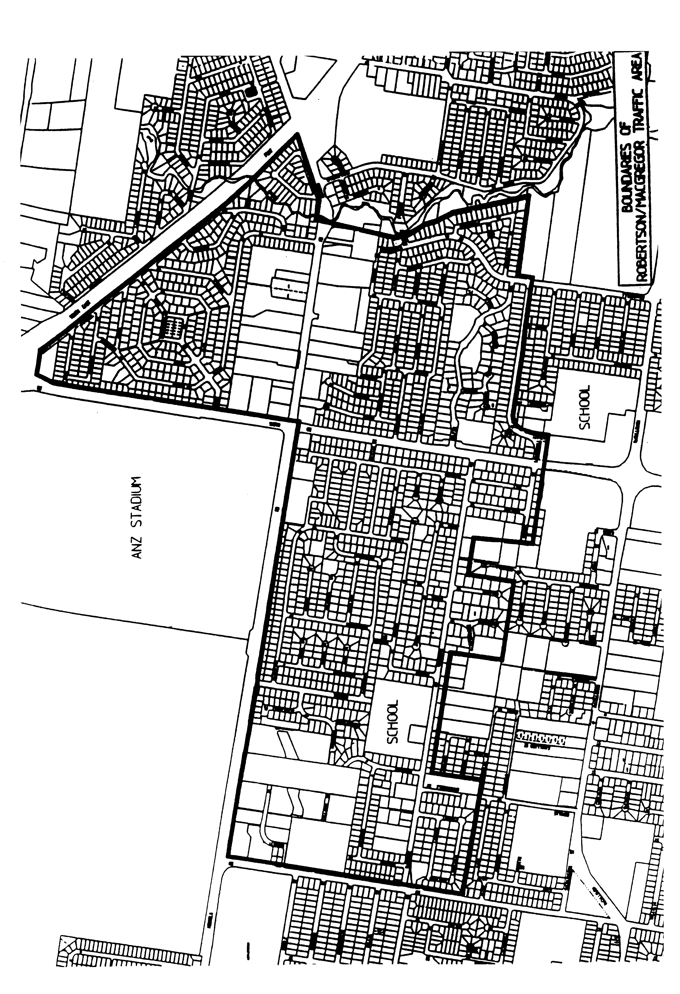
Endnotes

List of amendments

PART 3 - REGULATION OF PARKING
S 2 amd Parking and Control of Traffic and other Local Laws Amending Local Law 2009 s 17
s 6(5) amd Parking and Control of Traffic and other Local Laws Amending Local Law 2009; s 18 Administrative Arrangements Amending Local Law 2013 s 40
s 6(6) om Parking and Control of Traffic and other Local Laws Amending Local Law 2009 s 18
s 7 amd Parking and Control of Traffic and other Local Laws Amending Local Law 2009 s 19

