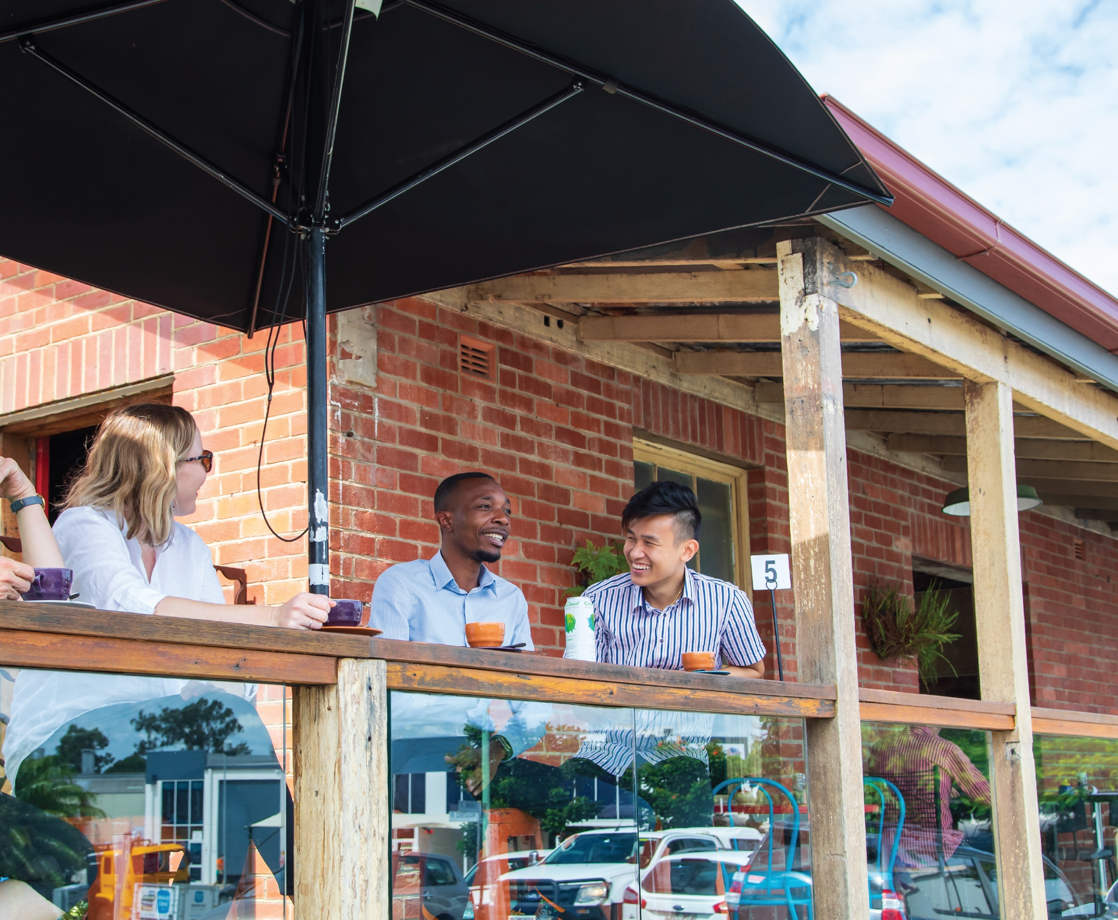

Nathan, Salisbury, Moorooka Neighbourhood Plan draft strategy
June 2021

Nathan, Salisbury, Moorooka Neighbourhood Plan study area

The study area includes the suburbs of Nathan, Salisbury and Moorooka as shown on the map below. These suburbs are approximately 10 kilometres south of the Brisbane city centre.

Brisbane City Council acknowledges that Nathan, Salisbury and Moorooka are parts of the ancestral homelands of the Traditional Custodians of Brisbane who have walked and cared for this land for thousands of years. Council also recognises and respects the specific role of Traditional Custodians and their spiritual relationship with their Country.

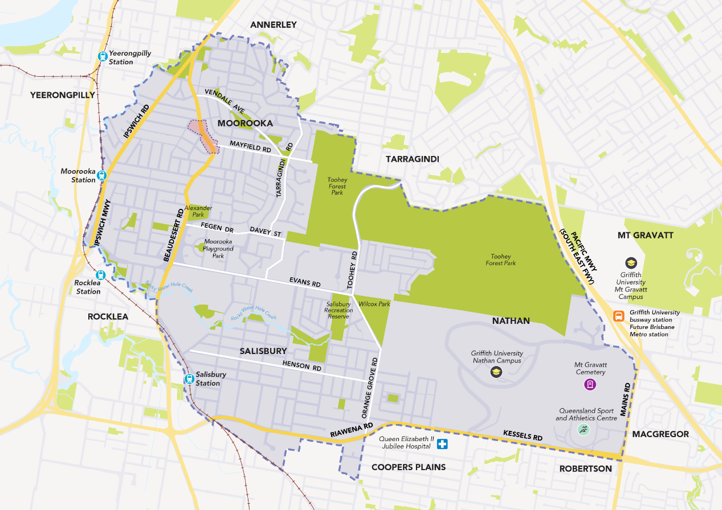
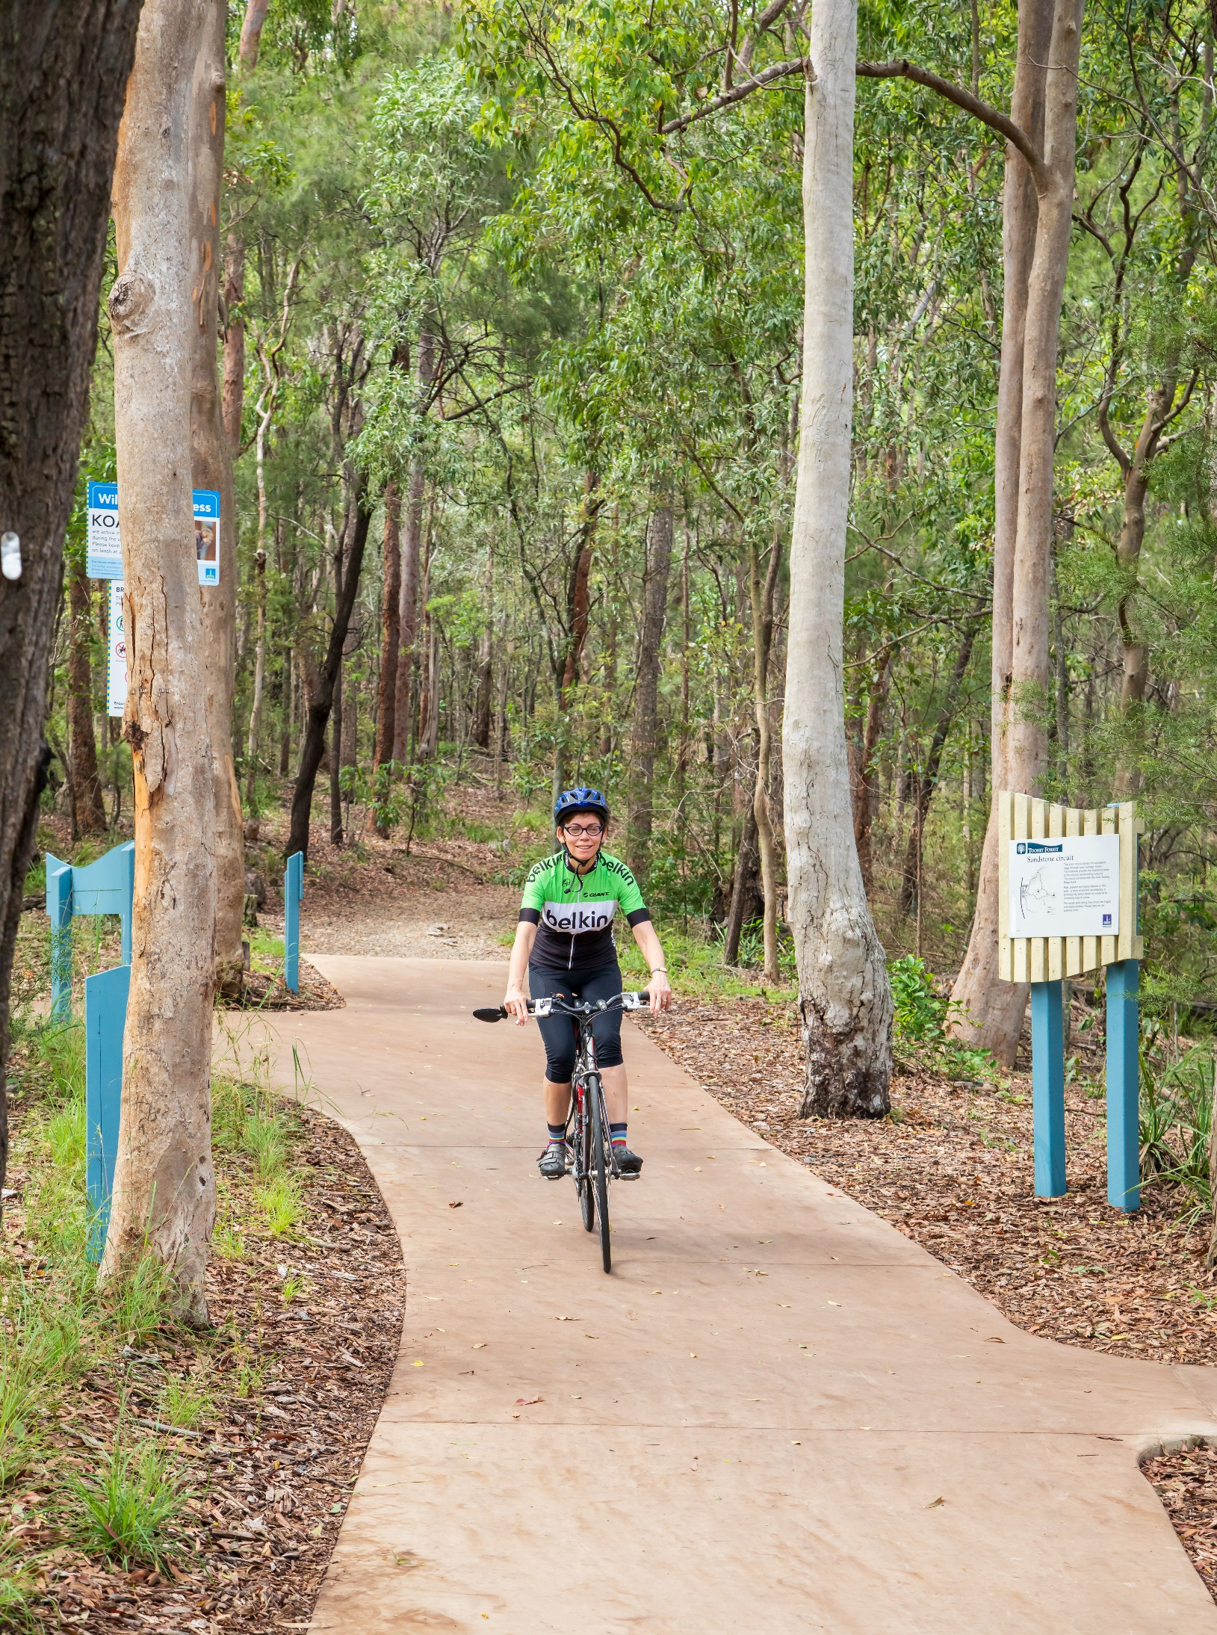

Contents

Introduction 4
The Nathan, Salisbury and Moorooka area 5
What you’ve told us so far 5
Setting the scene 6
Yesterday and today 6
Planning for exceptional connectivity 7
Employing tomorrow’s workforce 7
Planning for the future 7
Neighbourhood planning 7
Vision 8
Theme 1: Places for everyone 10
Theme 2: Local industries and employment 14
Theme 3: A grid of green and blue 18
Theme 4: Connecting places and spaces 22
Bringing it all together 24
Supporting change with infrastructure 27
Implementation 27
Have your say 27
Next steps 27

Introduction

Every day, Council works with residents and local communities to grow our city while maintaining the character of our suburbs and planning for the future. Council undertakes neighbourhood planning to ensure our local areas are great places to live, facilitate economic prosperity and provide the range of infrastructure and facilities required by the community.

Since September 2019, Council has been working with local communities in Nathan, Salisbury and Moorooka to create a neighbourhood plan for the area’s future.

This draft strategy combines initial community input with the findings of background research and technical studies undertaken by Council.

This draft strategy:
- introduces a vision and key themes for community feedback
- provides information about key proposed strategies and catalyst projects
- seeks community feedback on ideas for consideration in preparing a draft neighbourhood plan.

Releasing the draft strategy for community feedback gives everyone a chance to have their say before the neighbourhood plan is prepared. Neighbourhood plans form part of Brisbane City Plan 2014 (City Plan), which sets out how land can be used and developed across the city. You will also have the opportunity to comment on the draft neighbourhood plan when it is released for consultation.

Neighbourhood plan timeline
Background research | Draft strategy  (current stage) | Draft neighbourhood plan | Adoption
Early-mid 2019 – mid 2021 | Mid 2021 | Late 2021-early2022 | Late 2022
Council conducted background research and technical studies and sought community input to understand key issues and opportunities affecting the area. | Council seeks community input on this draft strategy that will be used to set the direction of the neighbourhood plan. | Council will prepare a draft plan, including proposed changes to zones or overlays, which will be reviewed by the Queensland Government and released for further community feedback. | 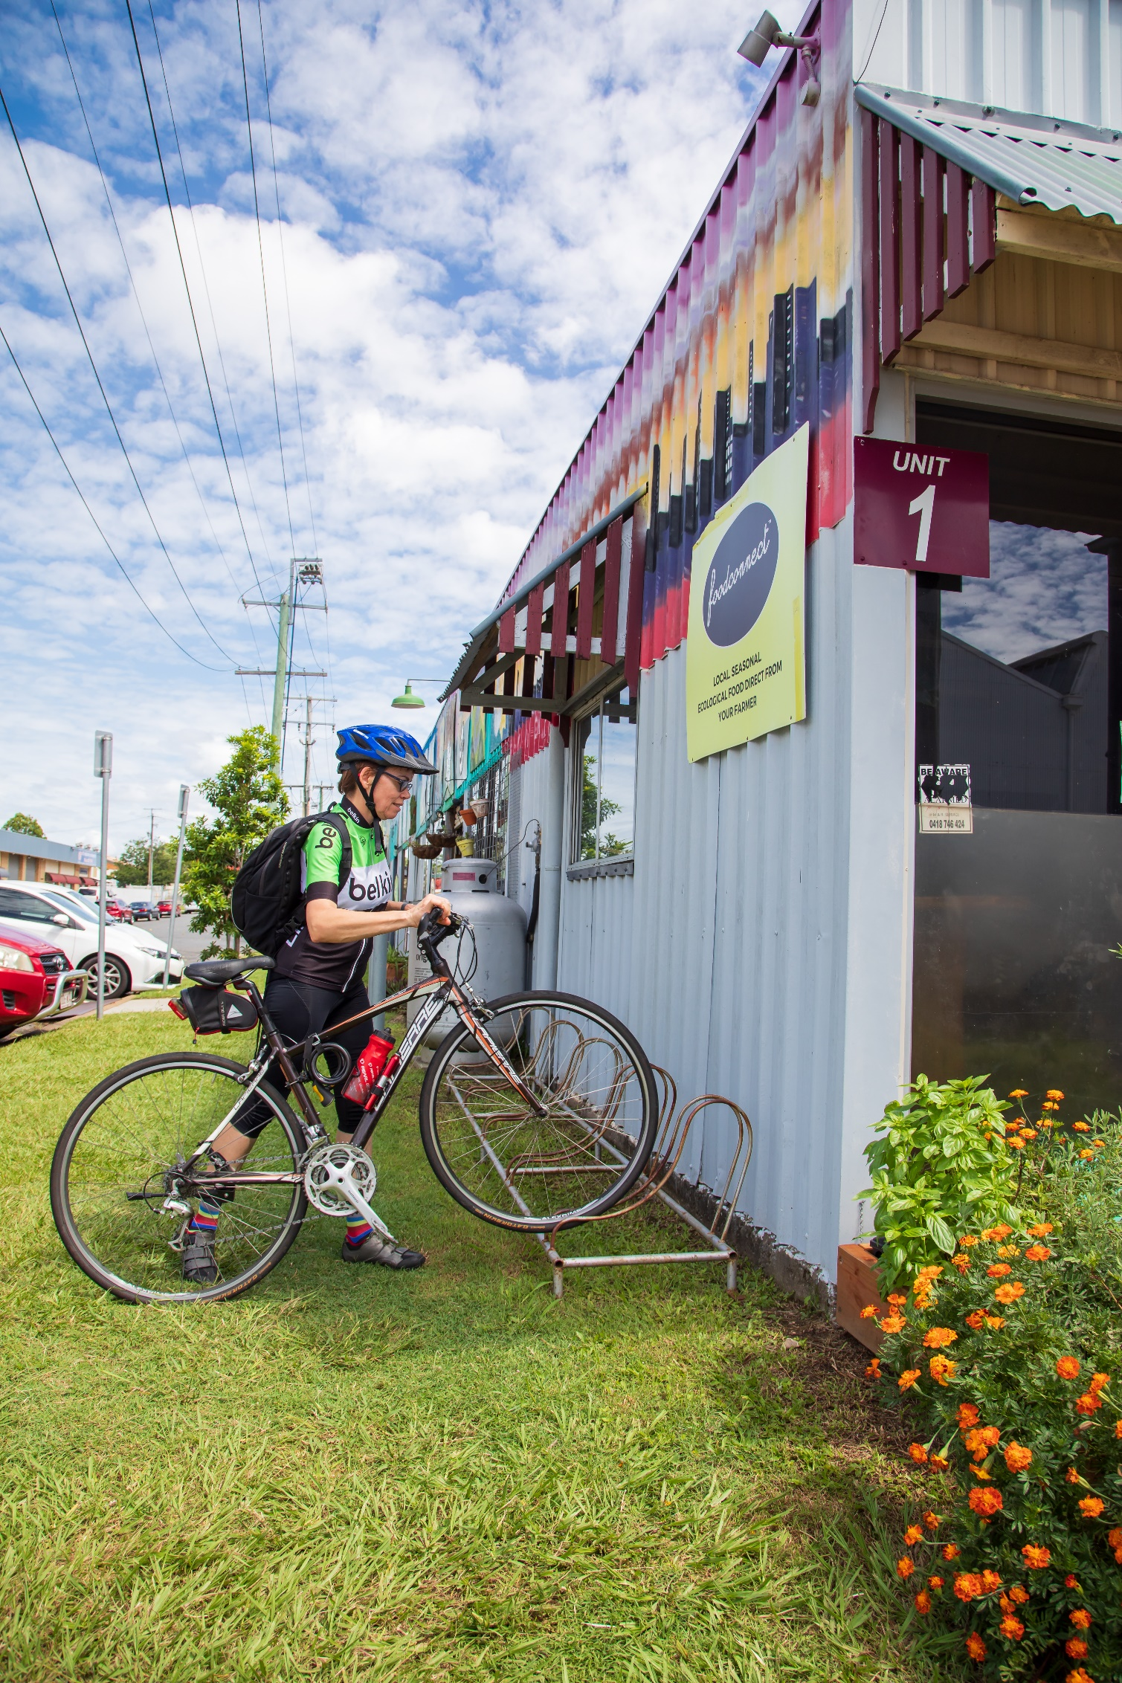  Adoption and gazettal of the neighbourhood plan, which will then form part of City Plan.

The Nathan, Salisbury and Moorooka area

The suburbs of Nathan, Salisbury and Moorooka are located approximately 10 kilometres south of Brisbane’s city centre. The area features a mix of residential, commercial, industrial and forested land, with world class education and sporting facilities including Griffith University’s Nathan Campus and the Queensland Sports and Athletics Centre.

The area has a rich Aboriginal history. Aboriginal groups used the land in this region as camping grounds and for traditional sacred rite ceremonies before and after European settlement. Many of the roads and streets in the area are based on the original tracks and pathways created by Aboriginal people living and moving through the region. It is thought that the name Moorooka is based on an Aboriginal word meaning ‘place of ironbark’ or ‘nose-like’ (the latter referring to the shape of nearby Toohey Mountain).
Salisbury’s back streets are filled with factories and warehouses where the manufacturing of ammunition was carried out during World War II as part of the Rocklea Munitions Works. A trans-shipping point known as the Clapham Rail Yards was also established adjacent to Moorooka station, and was used to transport munitions, supplies and troops during World War II.

Long-term residents, new arrivals to Brisbane and businesses are drawn to the area’s green leafy streets, convenient location, employment opportunities and strong sense of community. The local economy attracts talent and investment which strengthens the city’s economic prosperity and broadens job options. Moorvale shopping centre and other local shops service the area’s retail needs.

The area is serviced by Moorooka and Salisbury train stations, bus routes, busway and the Veloway 1 Cycleway. Connectivity will be further improved through the Brisbane Metro, Cross River Rail and upgraded cycling and walking paths. The area is also well connected by existing infrastructure to surrounding suburbs and facilities, including Westfield Garden City, the Queen Elizabeth II Jubilee Hospital, Queensland Tennis Centre, Oxley Common and Archerfield Airport to the south.

As the area’s popularity grows, balancing the demand for land for homes, businesses, shops and industrial operations will become important. Planning today can help ensure the area keeps its much-loved character into the future.

What you’ve told us so far

In late 2019 locals provided feedback to Council on what they loved about the area and what they thought could be improved.

Council has listened to resident feedback and identified four key community priorities:
- improve housing diversity while retaining character buildings
- make the most of local industry and expertise
- enhance our neighbourhoods and enjoy more to see and do
- improve connectivity within the area and to Brisbane city.

For more information about what you told us in the initial feedback stage, you can view the survey results, interactive map and Community Planning Team meeting notes on Council’s project page.

Setting the scene

Yesterday and today

Nathan, Salisbury and Moorooka’s rich history, vibrant present and future potential is evident across the area. Diverse industrial buildings and character residences reflect the area’s manufacturing heritage and friendly neighbourhoods. Over the years, migration has also shaped the area’s bustling high streets into cultural, creative and culinary destinations.

Did you know?
The median age of residents is under 35. Students, young professionals and young families are likely attracted to the area’s proximity to Brisbane City, Griffith University’s Nathan campus, public and private schools and Toohey Forest.

Housing tends to be single detached dwellings with three or more bedrooms with isolated pockets of units and duplexes.

Without a spectrum of housing choice, residents will find it harder to find a home of the right size as their requirements change over time. People who want to stay in this area may find it unaffordable without a supply of a range of dwellings.

By 2041
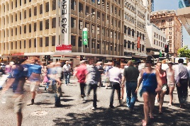 | More than 1.5 million people are predicted to live across Brisbane. | 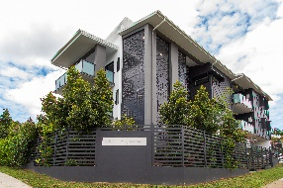 | Nathan, Salisbury and Moorooka are close to Brisbane city, so the area is an ideal location to provide some of the new homes that Brisbane needs.
 | Employment in the Brisbane local government area is expected to grow more than any other local government area, providing almost half of South-east Queensland’s new jobs. | 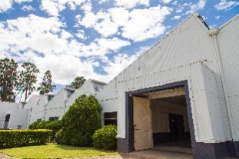 | The Nathan, Salisbury, Moorooka area has a proven track record of supporting new enterprises and renewing older industrial precincts.
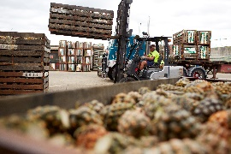 | Industry will contribute more than $22 billion in gross regional product and will employ 13% of our workforce. | 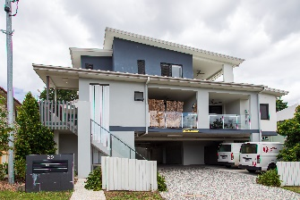 | Salisbury and Moorooka’s industrial areas form part of the South West Industrial Gateway (SWIG) which contains half of Brisbane’s industrial land. Council expects the SWIG to contribute $6.5 billion to Brisbane’s industrial gross regional product in 2041.

Planning for exceptional connectivity

Major transport projects are predicted to accelerate connectivity with Brisbane City and surrounding suburbs.

The new Brisbane Metro operating along dedicated busways will include a station at Griffith University and will link with suburban bus and train services as part of a better-planned network. The fleet of 60 battery electric Brisbane Metro vehicles will offer high capacity, high frequency, turn-up-go service.

Cross River Rail’s significant upgrades to train services and facilities at Salisbury and Moorooka stations (including platform improvements, new overpasses and accessible parking bays) will make it easier and more convenient to access and use public transport.

Employing tomorrow’s workforce

The area’s diverse employment base presents opportunities for a future digitally-enabled workforce.
Knowledge and technology precincts with research, medical and educational establishments will be supported by services, shops, eateries and entertainment options.

The South West Industrial Gateway will also continue to grow, as major infrastructure projects (such as the Inland Rail and the Acacia Ridge Intermodal terminal) are delivered. Detailed precinct plans will help to make the most of associated industrial renewal opportunities in Salisbury and Moorooka. Bustling high streets, creative spaces, new health care services and well-designed industrial precincts will attract investment and local talent, as well as bring vibrancy to the immediate and surrounding areas.

Planning for the future

Brisbane has an ageing population. Planning can accommodate the needs of an older population by enabling new models of living, services and lifestyle, including improved access to health care services, inter-generational living and the ability to age in place.

Technological change is transforming how people live, work and communicate. The rapid pace of technological advancement is likely to intensify and impact our neighbourhoods particularly as more people may choose to work from home.

As our climate changes, Brisbane must remain prepared for natural threats including droughts, bushfires, storms and flooding. Our buildings and neighbourhoods need to be designed to mitigate impacts and be ready for such changes.

Neighbourhood planning

Draft strategies are prepared by Council to seek community feedback and new planning ideas. Community responses on draft strategies and technical reports inform changes to zones, overlays or planned infrastructure.

Neighbourhood plans are legal documents that sit within City Plan and form part of Brisbane’s planning framework.

Following review by the Queensland Government, Council will invite further community comment. Once complete, neighbourhood plans are adopted as part of City Plan to guide development in the area.

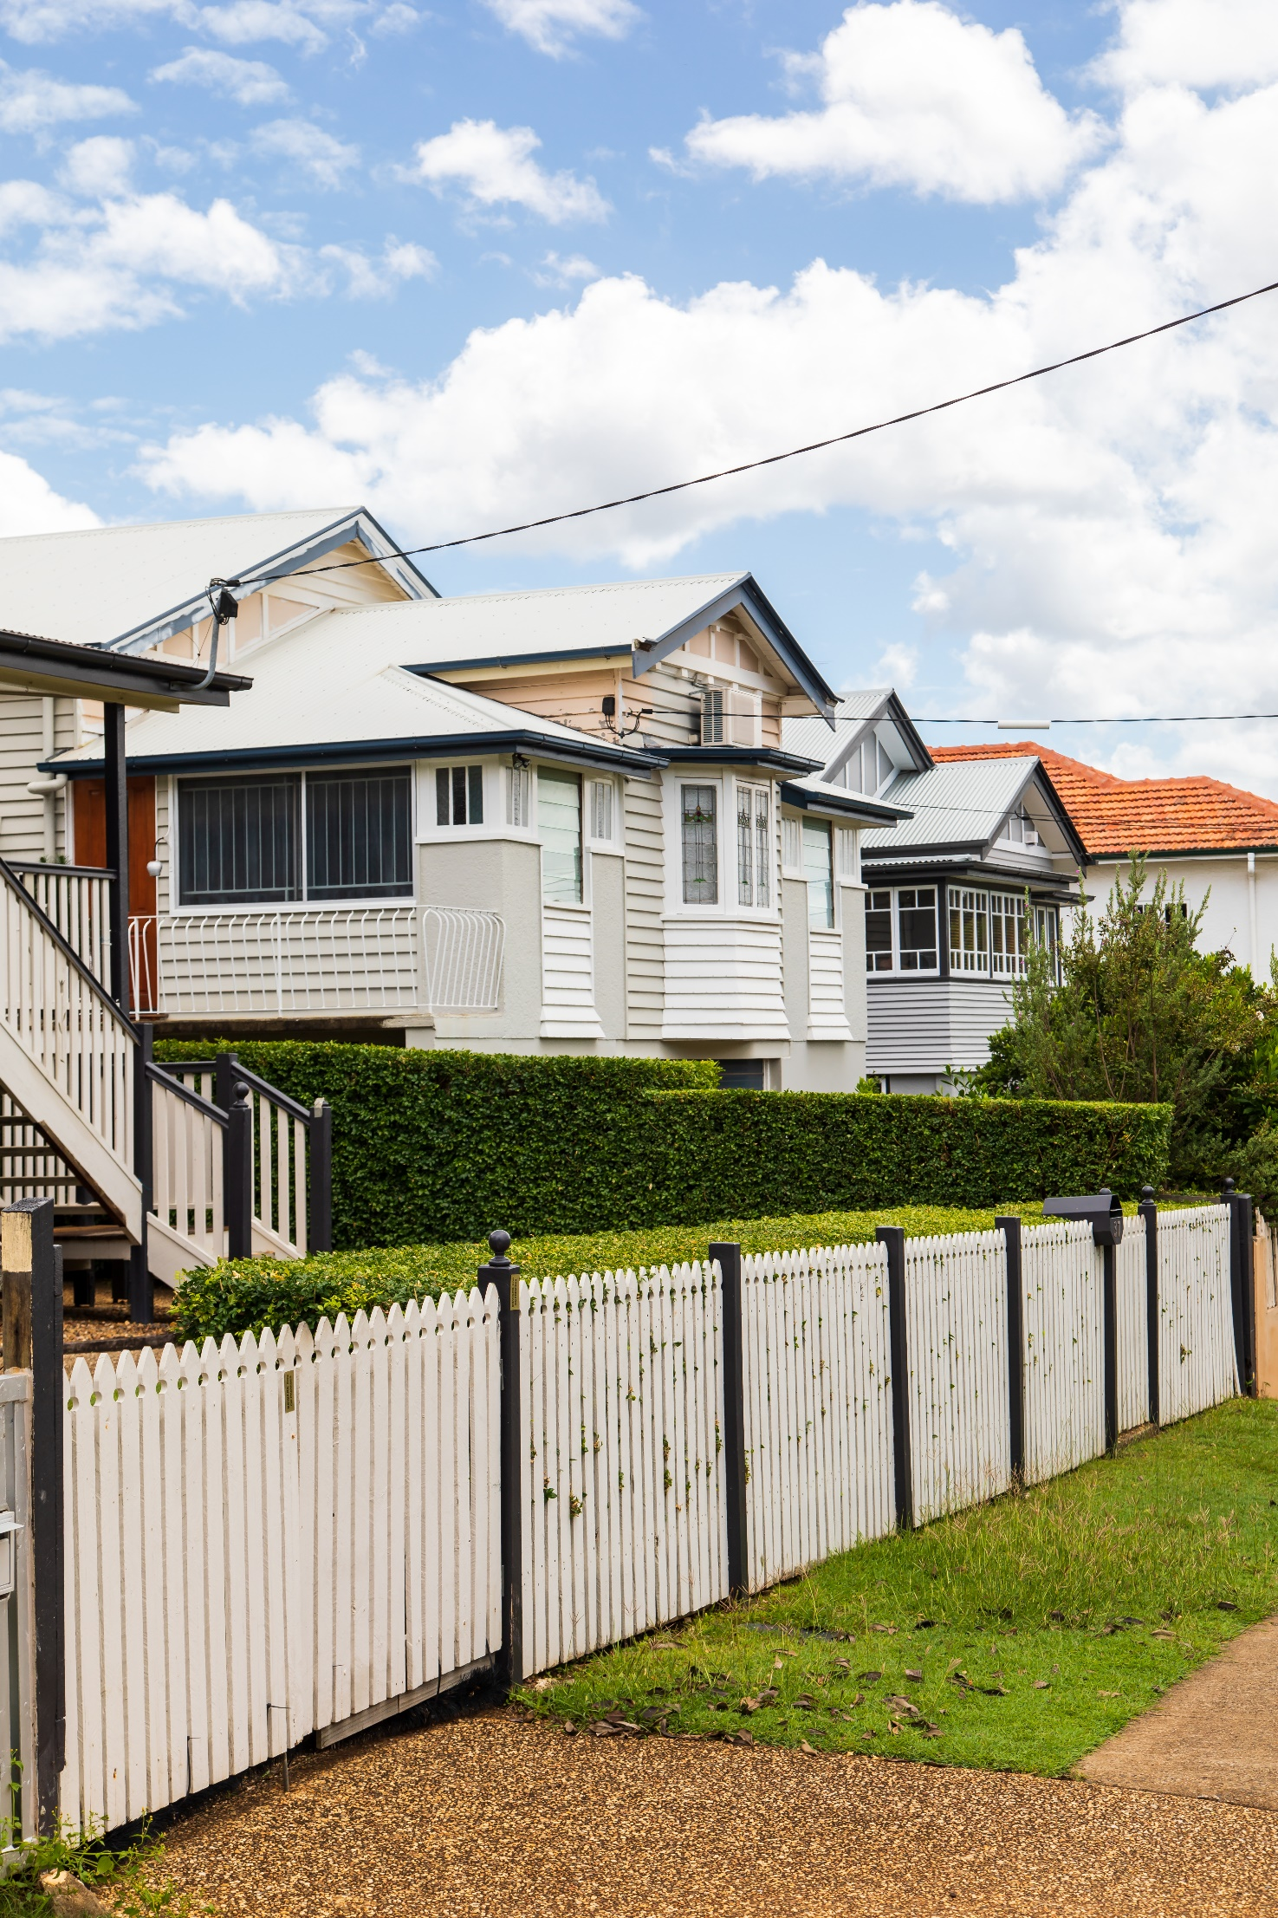

Vision

Nathan, Salisbury and Moorooka have proud and culturally diverse histories. Development in the area creates new opportunities for the future, with more jobs close to home, renewal of employment areas, greater housing choice, improved amenity, restored creeks and better transport connections.

This vision is supported by four themes:

- Places for everyone
A mix of apartments, duplexes, terrace houses and units over shops near public transport and shops will provide housing choice. Older character houses and heritage places in key locations will continue to be protected for their contribution to the area’s identity and appeal.

- Local industries and employment
Supporting knowledge and technology precincts, renewal of employment areas and encouraging services and amenities will make industrial areas more attractive and functional. The Magic Mile and local high streets will be reinvigorated.

- A grid of green and blue
Shady paths connecting to creek corridors will make getting around easy and comfortable. Toohey Forest will continue to be protected as one of the city’s natural areas, important for its diversity of native species and recreational opportunities.

- Connecting places and spaces
Brisbane Metro, Cross River Rail, Veloway 1 Cycleway and new active transport linkages will improve the area’s connectivity to Brisbane City and surrounding suburbs. Local green corridors will improve walking, scootering and cycling in the area.

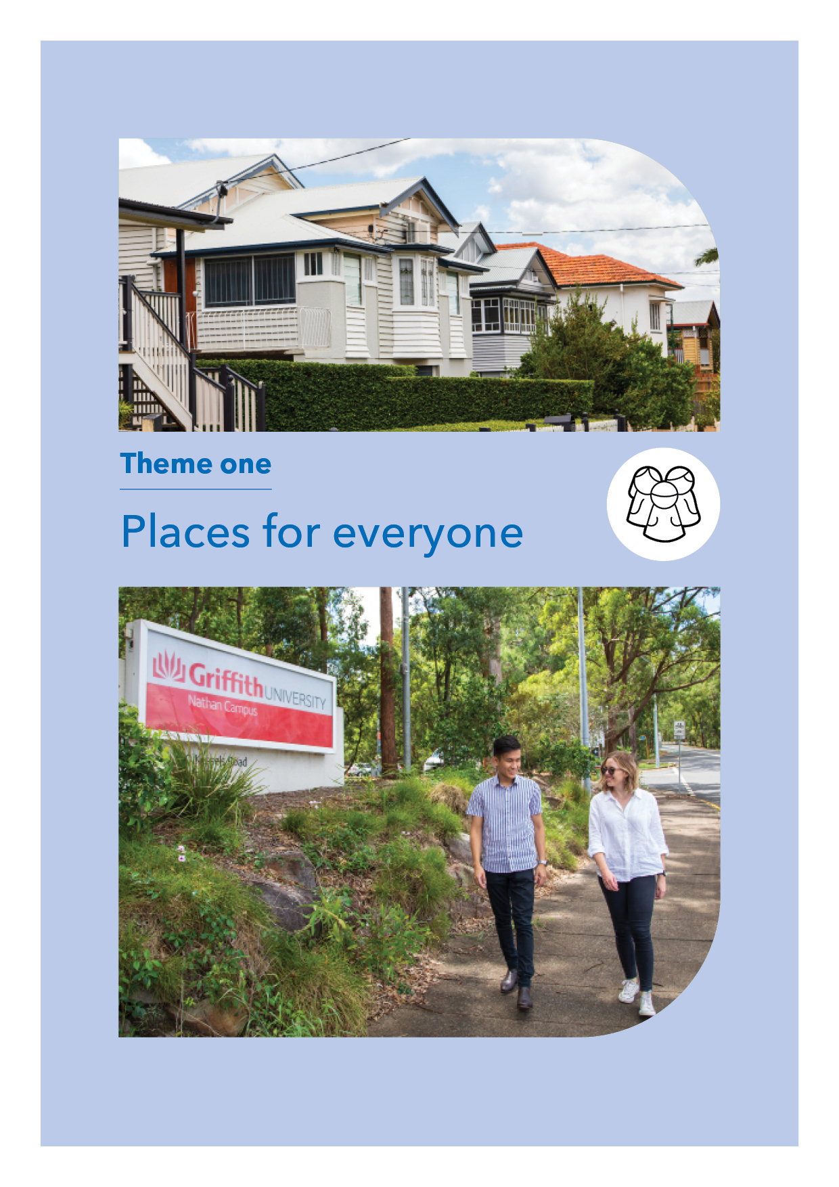

Theme 1: Places for everyone

Brisbane’s population is both growing and ageing so a range of different housing types will be needed in the future. Many people will need different housing options to continue living in their community as their needs change.

Moorooka and Salisbury train stations are classified as future ‘growth nodes’ in Brisbane City Plan. To make the best use of public transport it is proposed to provide for residential buildings (up to 5 storeys) closest to Moorooka and Salisbury stations. Some surrounding streets, within walking distance of each station, may be suitable for businesses and low-rise units, duplexes or terrace homes (up to 3 storeys). This would ensure more housing choice, in walking distance of public transport, shops and services.

Recent research shows that demand for small, easy-maintenance and affordable homes will increase in this area. It is important that these new homes are well designed to retain Brisbane’s lifestyle and help create great places.
While there will be a future need to accommodate more people in the area, it will also be important to continue to respect our past. Residents value character housing in Nathan, Salisbury and Moorooka. Council is conducting a review of character and heritage places in the area. It will be important to achieve the right balance between allowing change and growth while protecting what residents love.

Brisbane is a vibrant, creative and livable city where cultural diversity is celebrated. Moorvale shopping centre, at Moorooka, is a vibrant hub for multicultural cuisine, hairdressing and clothing. We will continue to recognise Moorooka as a cultural, creative and culinary destination in Brisbane.

Across the area community activities (such as festivals and gatherings) are bringing residents and visitors together. Improving local connectivity to these activities will also become increasingly important as more people work from home and spend more time in their local communities.

Strategy 1.1 Provide greater housing choice

    - Ensure the plan area has a diversity of homes to meet the needs of the community by 2041. This includes single detached homes, duplexes, apartments, terrace homes, units over shops and aged care facilities to help residents stay in their own neighbourhoods.
    - Investigate opportunities to provide residential buildings (up to 3 storeys) within easy walking distance of the Moorooka train station (see map below).
    - Investigate opportunities to provide residential buildings up to 5 storeys closest to the Moorooka train station (see map below).
    - Investigate opportunities to provide a mix of residential and commercial buildings (up to 8 storeys) immediately opposite the Moorooka station (see map below).
    - Investigate opportunities to provide a mix of residential and commercial buildings (up to 5 storeys) immediately opposite the Salisbury station (see map below).
    - Investigate opportunities to provide a mix of residential housing types (up to 3 storeys) on blocks which do not contain character housing and are within easy walking distance of high frequency bus stops on Lillian Avenue and around the Moorvale shopping centre (see map below).
    - Ensure new housing provides real choice for seniors, people with disabilities and young families by being easy to access, easy to navigate and by being responsive to the changing needs of occupants. Applying guides such as the Livable Housing Design Guidelines 2017 (Silver level) to new development would be appropriate.
    - New residential buildings close to industrial areas and major road corridors must meet air and noise impact criteria.

Strategy 1.2 Protect neighbourhood character

    - Investigate and update character protections (including retaining intact streetscapes).
    - Explore the heritage and character values of a variety of buildings and precincts developed before, during and after World War II.
    - Celebrate Salisbury’s significant role in supporting the allied war effort by developing a local history trail.
    - Continue to protect heritage and character through encouraging appropriate adaptations and reuse of existing buildings and places.

Strategy 1.3 Support community life through facilities and services

    - Continue to support community groups to access Council facilities for meetings, cultural celebrations and community gatherings.
    - Support the creative use of Council-owned public space, including parks and reserves, walking trails, and laneways.
    - Encourage local community activities (including festivals and events) to enhance the vibrancy of the area.
    - Undertake a review of community facilities in the area.
    - Identify opportunities to better connect with the Queensland Sports and Athletics Centre as a key sporting destination for the city.

Strategy 1.4 Making great places

    - Encourage high-quality housing that meets the needs of all ages and abilities, promotes sustainable use of resources and is designed for Brisbane’s subtropical climate through use of shading devices, cross ventilation and appropriate materials.
    - Encourage new residential, commercial and industrial building designs that improve outlook and interface to creeks.
    - Encourage building design which improves the pedestrian experience along Ipswich Road.
    - Encourage non-residential building designs for industrial areas that support industrial investment and renewal.
    - Identify place-making opportunities around Cross River Rail station upgrades at Moorooka and Salisbury.

Catalyst project

Celebrate the area's World War II history by developing a history trail through the area.

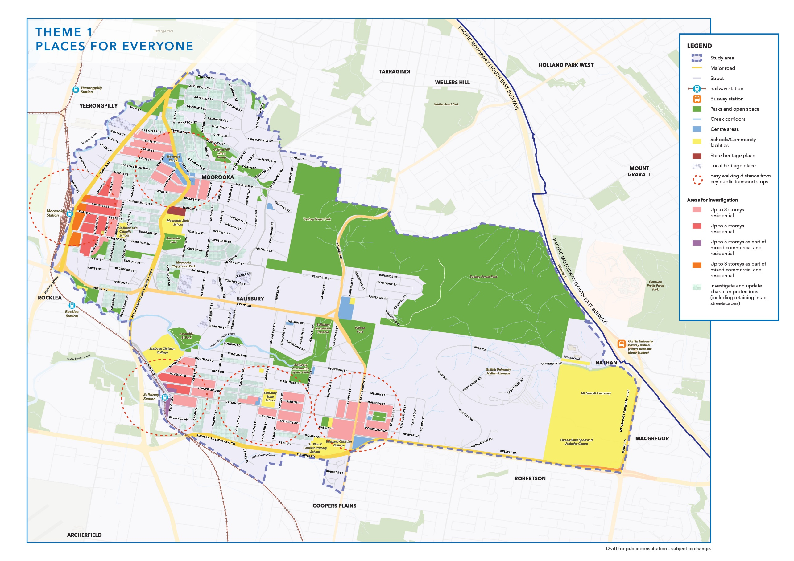

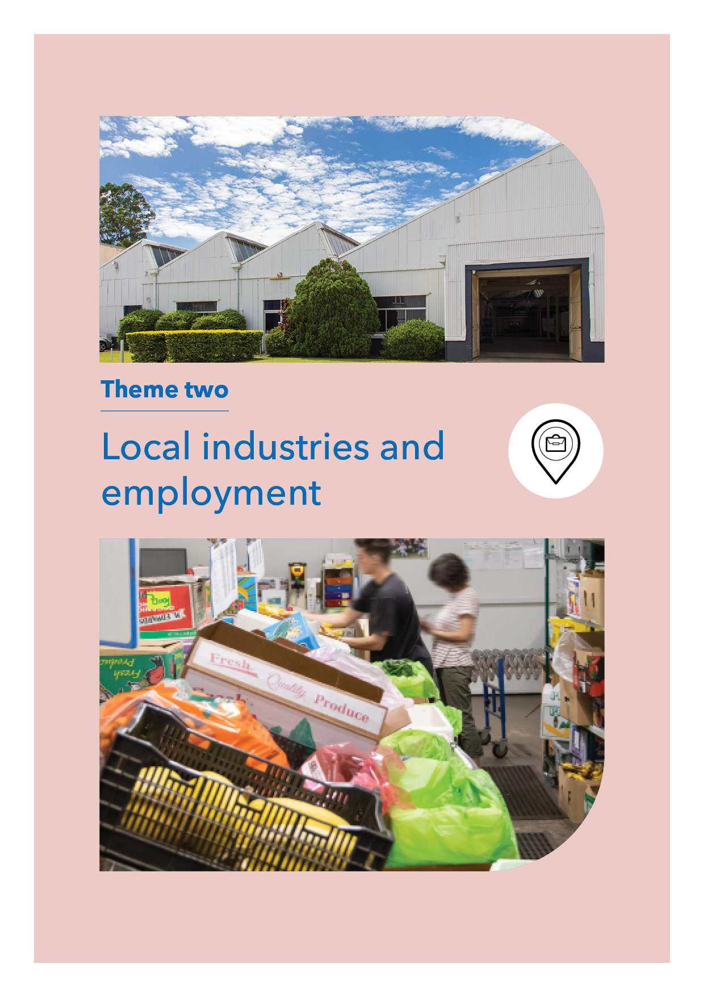

Theme 2: Local industries and employment

Knowledge and technology precincts are vibrant, collaborative places driving innovation and creativity in the market and attracting investment. Griffith University’s Nathan Campus is identified as a knowledge and technology precinct under the Shaping SEQ, South East Queensland Regional Plan 2017 with potential to attract further investment through partnerships and space-sharing opportunities.

Salisbury and Moorooka’s industrial areas form part of the South West Industrial Gateway and play an important role in Brisbane’s economy. These areas provide the necessary land for existing and emerging industries (such as niche manufacturing) to operate and generate local jobs.

Industrial businesses are changing globally. Effective planning is needed for Brisbane to remain competitive and to support innovation and the digitally-enabled workforce. Industrial buildings will be designed to provide flexibility and evolve over time to meet changing needs. While more traditional industrial activities will continue to be important, new enterprises are expected to renew industrial land and small-scale services and amenities will attract skilled workers to the area.

The Queensland Government’s planned upgrades to Moorooka train station provide an opportunity to reimagine the iconic Magic Mile as a pedestrian-friendly urban destination for living and working. Once considered the go-to spot for car buyers, this commercial strip along Ipswich Road has the potential for renewal to create a new mixed-use precinct.

As work arrangements continue to change, including work from home, neighbourhood centres will become more important. Revitalising these centres by encouraging retail, health care, entertainment, education and other essential services will provide local employment and a focus for community life. These lifestyle and amenity improvements will help keep the area’s competitive advantage.

Strategy 2.1 Protect and renew industrial areas and enable a range of industries to continue to thrive and evolve

    - Retain industrial land to maintain Salisbury and Moorooka’s key role in providing for service industry and manufacturing uses as part of the South West Industrial Gateway.
    - Identify and facilitate renewal of underused industrial sites to support new economic opportunities.
    - Ensure large industrial buildings are designed to support the changing needs of industrial businesses over time.
    - Improve services, amenities and active transport connections in industrial areas (including streetscape and open space improvements) to help attract and retain workers.

Strategy 2.2 Foster the area’s knowledge and technology precincts and support new and emerging industries

    - Support opportunities to grow the area’s knowledge and technology precincts and allow them to intensify over time.
    - Promote opportunities to manufacture new products and support emerging niche industries.
    - Facilitate partnerships and space-sharing opportunities with community groups, private industry, the university, hospitals, and commercial developers.
    - Support the continued evolution of the Chrome Street into a vibrant community hub for artisans, innovators and creative enterprises, where suitable for co-location with industry (see map below).

Strategy 2.3 Reimagine the Moorooka Magic Mile

    - Investigate opportunities for renewal of the Moorooka Magic Mile (part of Ipswich Road) to become an attractive urban destination for new businesses as part of a mixed residential and commercial precinct immediately opposite the station (up to 8 storeys) (see map below).
    - Encourage new businesses and clean industries to locate along the Moorooka Magic Mile to create a new mixed business and industry precinct and investigate opportunities to provide buildings of up to 4 storeys in Salisbury (see map below).

Strategy 2.4 Encourage the continued operation and revitalisation of local centres and shops

    - Consider the suitability of existing centres for local healthcare services with particular focus on Nathan and Moorooka.
    - Investigate the need for a new, small hub with offices, shops, cafés and educational facilities near the upgraded Salisbury train station (up to 5 storeys with residential uses) (see map below).
    - Seek cost-effective ways to celebrate and support existing centres, including Moorvale shops. For example, activating shops and public spaces with pop-up art exhibitions and markets.

Catalyst projects

- Plant trees in industrial areas to improve streetscapes.
- Revitalise industrial areas by creating precinct plans for key areas in Moorooka and Salisbury to help ensure they are well positioned to attract and retain a range of businesses.

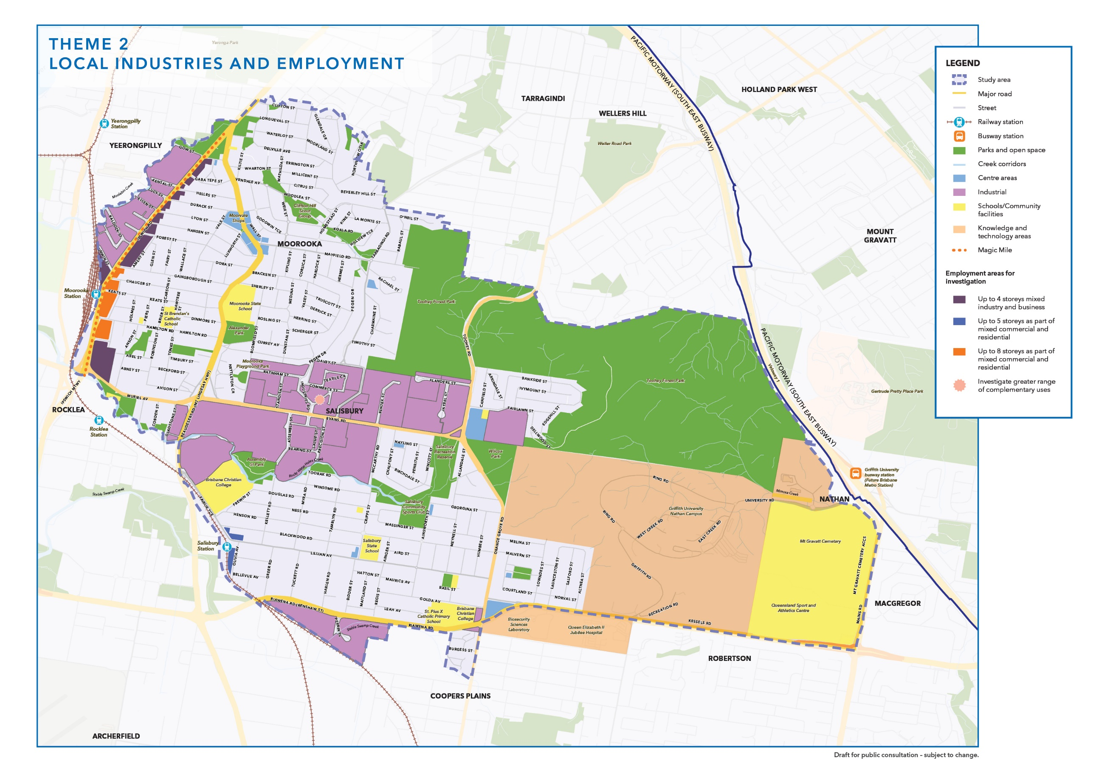

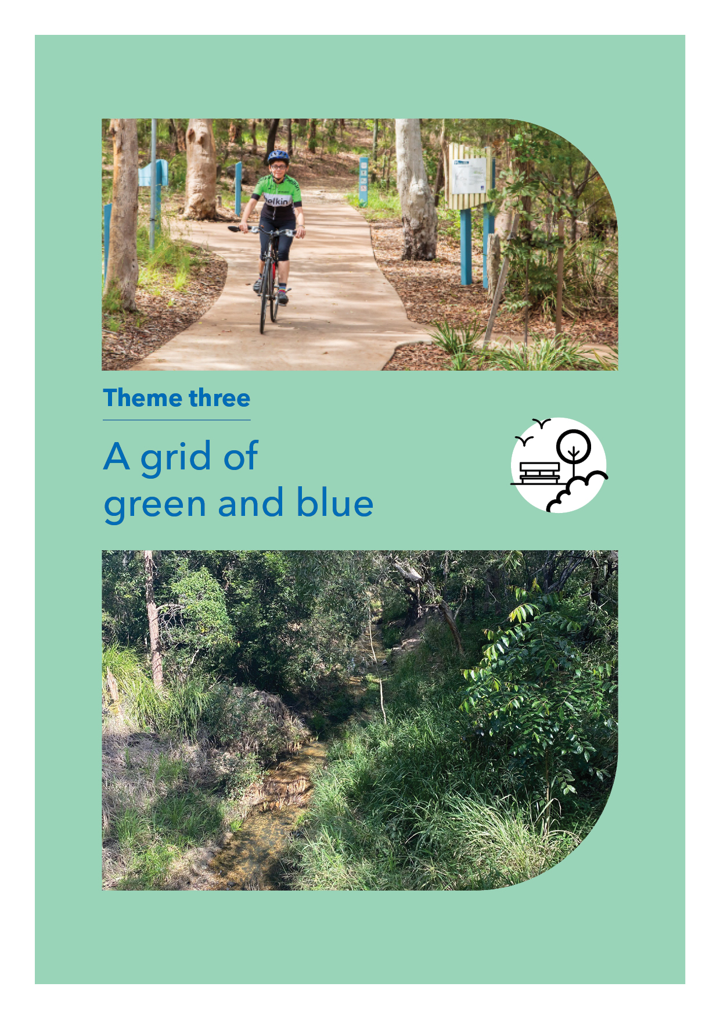

Theme 3: A grid of green and blue

In Nathan, Salisbury and Moorooka parks, tree-lined streets and creeks create a striking grid of green and blue. Toohey Forest Park contributes approximately 260 hectares to this grid. As one of Brisbane’s most visited natural areas, the bushland reserve offers barbeques, picnic areas, walking and cycling trails, and is home to more than 400 native plant and wildlife species. Toohey Forest will remain a well-loved recreation space and a safe place for local wildlife.

This area contains Rocky Water Holes, Moolabin, Mimosa and Stable Swamp creeks, which feed into three catchments – Oxley, Bulimba, and Norman creeks. Rocky Water Holes Creek has the potential to provide a much-needed east-west connection from Nathan to Salisbury train station, connecting parks, playgrounds, small shops and local businesses along the way.

Walking, scootering and cycling is not just for parks. One of Council’s priorities is to shade and improve local streets to encourage people to use footpaths and bikeways. Council is exploring options to expand the existing shadeways along Lillian Avenue and other key suburban streets and establish subtropical boulevards along arterial roads and recreation spaces.

Strategy 3.1 Creeks and their corridors

    - Encourage people to visit creeks and waterways by improving access to these areas and providing for some small-scale cafes in appropriate locations.
    - Encourage new building design to orientate or face waterways through building design (including windows, decks and balconies to overlook creeks).
    - Continue to support community groups to restore local creeks, waterways and bushland reserves.

Strategy 3.2 Make it more enjoyable to walk and cycle around the area

    - Transform Lillian Avenue into a shady main street (see map below).
    - Support the development of subtropical boulevards along Beaudesert Road, Evans Road, Toohey Road and Orange Grove Road (see map below).
    - Facilitate the creation of shadeways connecting walkers and cyclists to key local destinations including Salisbury and Moorooka train stations, shops and green space.
    - Plant trees in industrial areas to improve amenity and provide shade.
    - Survey the area to identify significant landscape trees which may require statutory protection.

Strategy 3.3 Conserve wildlife habitat

    - Investigate opportunities for wildlife to move safely along corridors and through Brisbane’s urban forest.
    - Explore land tenure options to further protect wildlife habitat adjoining Toohey Forest.

Strategy 3.4 Improve the area’s recreation and open space network

    - Explore opportunities to connect parkland along Rocky Waterholes Creek to create a green spine from Toohey Forest to Rocklea train station.
    - Investigate the need for new public open space close to Salisbury or Moorooka train stations and key neighbourhood centres.
    - Investigate opportunities to enable greater community use of parks through new facilities or by activating these spaces with free or low-cost activities for people of all ages and abilities.

Catalyst project

Investigate opportunities to activate and connect pedestrian and cyclist routes to Rocky Water Holes Creek.

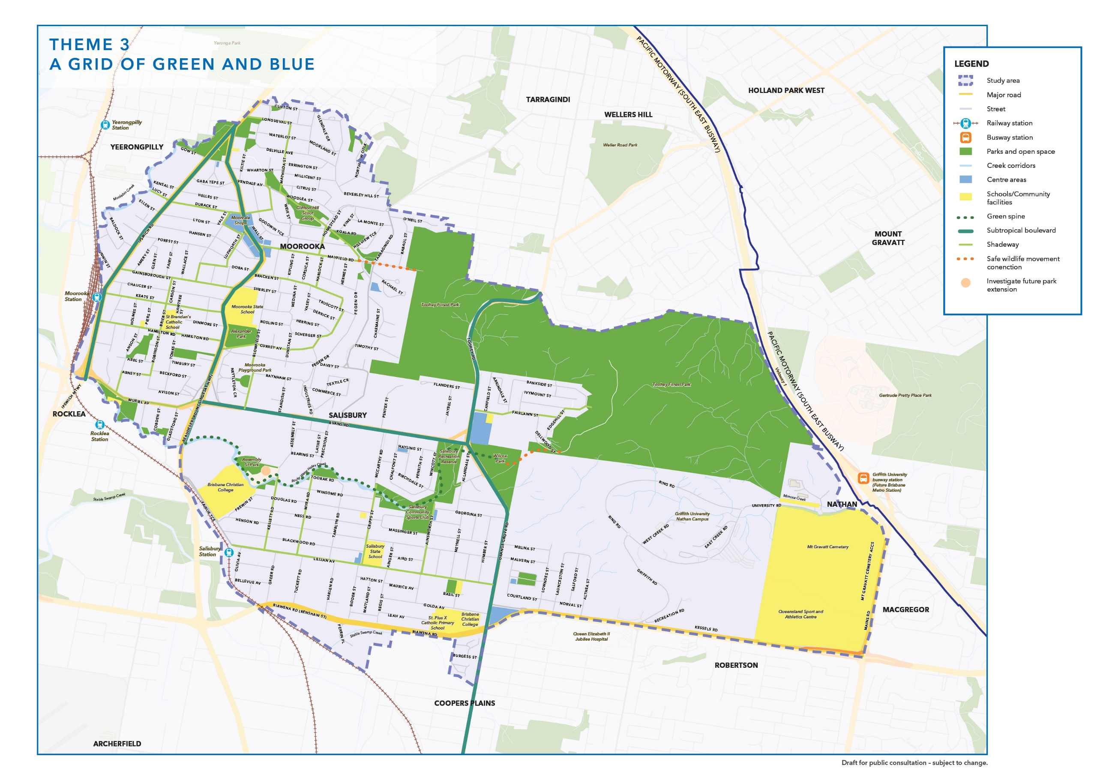

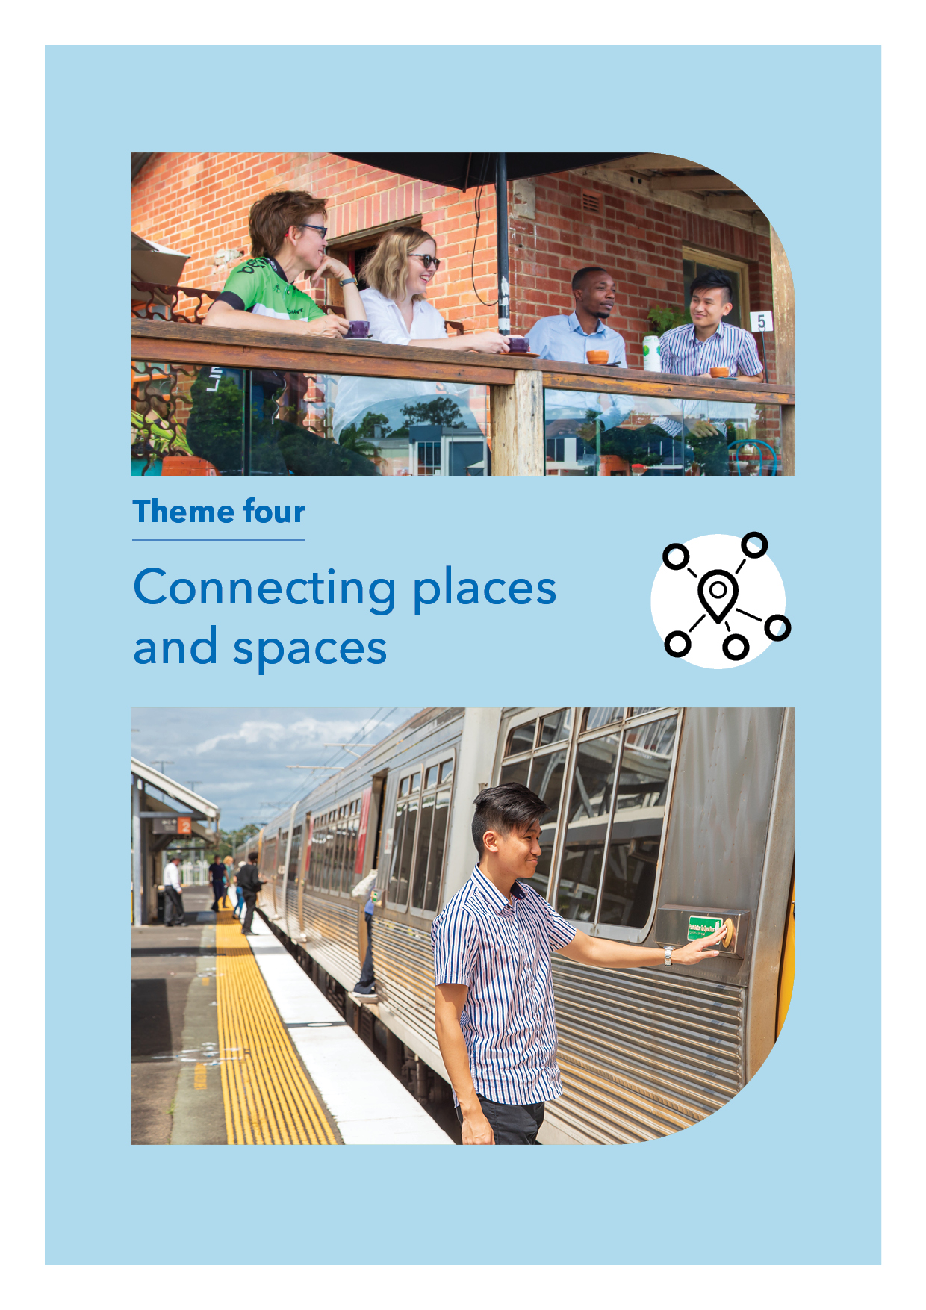

Theme 4: Connecting places and spaces

Nathan, Salisbury and Moorooka are well connected to surrounding suburbs with convenient public transport, major arterial roads to the east and west and extensive cycling networks. Brisbane City is short train ride or drive via Ipswich Road or the nearby Pacific Motorway, and cycling is just as easy along the Veloway 1 Cycleway.

Just outside the area the Ipswich Motorway has been recently upgraded from four to six lanes and new bridges, service roads, cycling connections and traffic signals have been created. Close to the area the Australian Government is currently progressing the Inland Rail connection between the Acacia Ridge Intermodal Terminal and the Port of Brisbane.

Brisbane Metro and Cross River Rail will significantly improve public transport options. Council will continue to work with the Queensland Government to improve access for all users and make it easier to transfer between modes of transport.

Council is currently exploring other improvements to make it easier and safer to walk and cycle across the area. As part of the Safe Paths for Seniors program Council recently reduced the speed limit along Beaudesert Road, Moorooka. Providing missing links in the active travel network (such as Lucy Street and Durack Street) is also a priority.

Strategy 4.1 Safely connect pedestrians and cyclists to public transport, services and employment

    - Work with the Queensland Government to improve pedestrian and commuter (including mobility impaired) access to Salisbury and Moorooka train stations.
    - Investigate options to improve pedestrian connections to schools, Griffith University, QEII Jubilee Hospital, parks and centres.
    - Continue to work with the Queensland Government to identify opportunities to integrate bus and rail services at Moorooka train station.
    - Identify priority locations for mid-block crossings along busy roads to make it easier and safer to access transport, services and shops.

Strategy 4.2 Facilitate active recreation across the area

    - Explore options for incorporating safe cycling facilities, without impacting efficient access to properties, along Ipswich Road.
    - Investigate options to complete the main north-south cycle route through the area, from Salisbury Recreation Reserve through to Riawena Road.
    - Investigate options for improving pedestrian connectivity at both ends of Lillian Avenue from Orange Grove Road through to west of Salisbury train station.
    - Ensure development provides smooth and shady footpaths to promote walking and riding across the area.

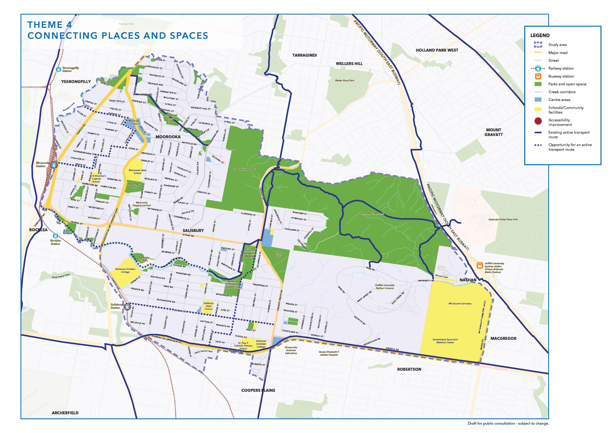

Bringing it all together

This draft strategy outlines a range of potential strategies and actions for realising the vision for Nathan, Salisbury and Moorooka.
These ideas are illustrated in the four theme maps on the preceding pages and the following maps below bring together all these ideas.
They identify where different types of housing could be located and what employment opportunities are available, including potential building heights for further consideration and investigation. The maps also indicate proposed accessibility improvements, shadeways and active transport connections to help make Nathan, Salisbury and Moorooka even better places to live and work in the future.

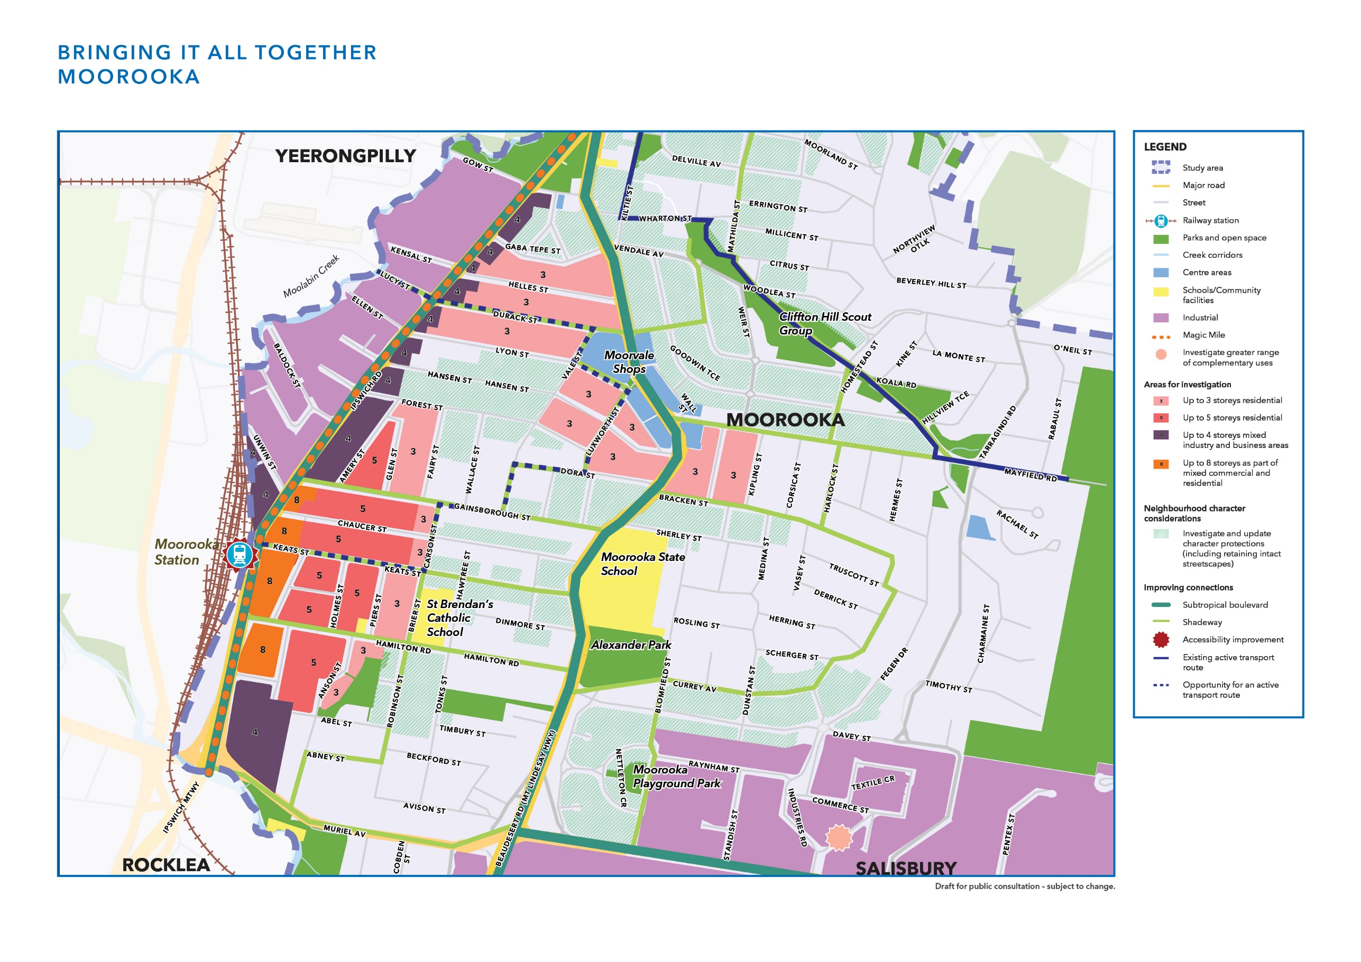

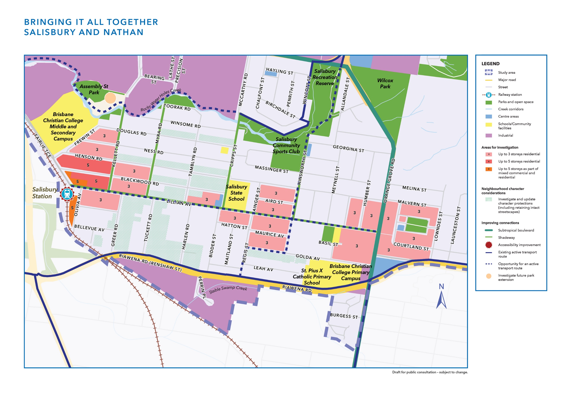

Supporting change with infrastructure

Council delivers infrastructure for Brisbane in many ways including capital works programs, infrastructure contributions and through development. Infrastructure that Council is responsible for includes local roads, public transport (except those under Queensland Government control), active transport, stormwater, parks and community facilities. Drinking water and sewer infrastructure is the responsibility of Urban Utilities.

Implementation

Some of the ideas proposed can be achieved via the neighbourhood plan and City Plan. This includes rules to protect character buildings, significant landscape trees and zoning. Not all changes can be achieved via legislation, but City Plan can permit new property types to be built or for businesses to be located in specific areas. It then becomes a decision for property owners and businesses to make changes to existing buildings and establish services, shops and eateries. Transport is another aspect where Council can allow for change, but certain items such as trains, bus routes and some roads are the responsibility of the Queensland Government.

Council can use the final Nathan, Salisbury, Moorooka neighbourhood plan as a basis to prioritise Council’s investment and identify potential locations for additional infrastructure.

Have your say

Have your say before midnight Monday 12 July 2021 via:
- Completing the survey
- Emailing the team (neighbourhood_planning@brisbane.qld.gov.au)
- writing to:
Neighbourhood Planning Brisbane (Nathan, Salisbury, Moorooka Neighbourhood Plan)
Brisbane City Council
GPO Box 1434
Brisbane Qld 4001.

Next steps

Tell us what ideas you like and what additional items you’d like us to consider before Monday 12 July 2021. The next step is for Council to review all community feedback for the draft strategy. Community responses on the draft strategy and technical reports will inform the development of a statutory neighbourhood plan. This will include details of all proposed changes to zones, overlays or planned infrastructure and accompanying technical maps. The draft will be reviewed by the Queensland Government before further community consultation.

After consultation, the plan is updated with your feedback, reviewed a second time by the Queensland Government, and is then adopted by Council as part of City Plan. It is then a legal document used to assess all property development applications and will guide future development in the area.

