Brisbane City Plan 2014

Infrastructure amendment 1a – Long term infrastructure plans (the proposed amendment)
- Guide to this document

- In this document, proposed amendments to Brisbane City Plan 2014 (v.22) are detailed as follows:
  - in the Schedule of text amendments:
  - text identified in strikethrough and red highlight (e.g. example) represents text to be omitted
  - text identified in underlining and green highlight (e.g. example) represents text to be inserted
  - in the Schedule of mapping amendments, insertions or omissions are as detailed in the tables.
- Text that is preceded by the heading ‘Reason for change’ does not form part of the proposed amendment and is included as explanatory information about the reason for the proposed amendment only.

SCHEDULE OF TEXT AMENDMENTS

Part 10 Other plans / 10.3 Long term infrastructure plans / 10.3.1 Community purposes network

Table 10.3.1A—Long term infrastructure plans for the park network

Reason for change: This item is being removed as it is no longer feasible to deliver the park in this location.

Bulimba | Acquire and embellish land to provide DISTRICT OR METRO ACCESS/RECREATION CORRIDOR PARK | Riverfront land (10m from Brisbane River MHWS) part take on LOTPLAN: 3RP826285 | District | 0.04 | BUL-P1 | N/A
Chandler | Acquire and embellish land to provide METROPOLITAN SPORT infrastructure | Acquire land at 1350, 1360 & 1370 New Cleveland Road and 100, 101, 110, 111, 120, 130, 140 & 142 Sunnydene Road, LOTPLAN: 1RP842921, 1RP818947, 2RP818947, 3RP818947, 1RP110225, 1RP76607, 2RP76607, 1RP92521, 2RP92521 and 3RP92521. | Metropolitan | 20.00 | CND-P1 | N/A

Reason for change: This item has a change in timing to move it inside the planning horizon of Council’s Local Government Infrastructure Plan 2016-2026 (the LGIP). This item has been removed from Council’s Long term infrastructure plans (the LTIP) and included in the LGIP.

Corinda | Acquire and embellish land to provide DISTRICT OR METRO ACCESS/RECREATION CORRIDOR PARK | Land along river between Fort Road Bushland D2176 and Blackheath Road Park D0314. Part take on LOTPLAN: 10RP29775 and 9RP29775. | Metropolitan | 0.70 | COR-P1 | N/A
Corinda | Acquire and embellish land to provide DISTRICT OR METRO ACCESS/RECREATION CORRIDOR PARK | Riverfront land (40m from Brisbane River MHWS). LOTPLAN: 900SP277477. | Metropolitan | 1.00 | COR-P2 | N/A

Reason for change: This item has a change in timing to move it inside the planning horizon of the LGIP. This item has been removed from the LTIP and included in the LGIP.

Ellen Grove | Acquire and embellish land to provide LOCAL RECREATION infrastructure | Land east of Bagnall Street and west of Lovat Street. Part take on LOTPLAN: 62RP90235, 63RP90235, 70RP90235, 71RP90235. | Local | 1.00 | ELG-P1 | N/A
Ferny Grove | Acquire and embellish land to provide LOCAL ACCESS/RECREATION CORRIDOR PARK | Land along Cedar Creek corridor between Nelson Place Park D3052 and Keperra Picnic Ground Park D0631. Part take on LOTPLAN: 106SP259861 and 43RP167933. | Local | 3.50 | FGR-P1 | N/A

Reason for change: This item has a change in timing to move it outside the planning horizon of the LGIP. This item has been removed from the LGIP and included in the LTIP.

Mitchelton | Acquire and embellish land to provide DISTRICT OR METRO ACCESS/RECREATION CORRIDOR PARK | Land along Kedron Brook between St Helens Road Park (No.100) D1669 and Lansvale Street Park D0667 - part take on LOTPLAN: 1RP18816, 2RP18816, 4RP18816, 5RP18816, 6RP18816, 320RP18816, 14RP18831, 15RP18831, 17RP197666, 6RP70396, 2RP68760 and 1SP149702. | District | 5.16 | MIT-P3 | N/A
Mitchelton | Acquire and embellish land to provide URBAN COMMON infrastructure | Land within south-west  corner of Brookfield Shopping Centre site | Urban Common | 0.32 | MIT-P5 | N/A

Reason for change: This item has a change in timing to move it inside the planning horizon of the LGIP. This item has been removed from the LTIP and included in the LGIP.

Pinjarra Hills | Acquire and embellish land to provide DISTRICT OR METRO ACCESS/RECREATION CORRIDOR PARK | Land along Brisbane River between John Wilson Reserve D1918 and Houston Street road reserve, approximately 50m wide. Part take on LOTPLAN: 39S151826. | Metropolitan | 1.86 | PIH-P1 | N/A
Rochedale | Acquire and embellish land to provide LOCAL RECREATION infrastructure | Part take of property L.2 RP135209 | Local | 0.7 | ROC-P1 | N/A

Reason for change: This item has a change in timing to move it outside the planning horizon of the LGIP. This item has been removed from the LGIP and included in the LTIP.

Rochedale | Acquire and embellish land to provide LOCAL RECREATION infrastructure | Part take of property L.2 SP218990 | Local | 0.55 | ROC-P2 | N/A
Runcorn | Acquire and embellish land to provide DISTRICT OR METRO ACCESS/RECREATION CORRIDOR PARK | Land along Bulimba Creek corridor connecting separate sections of Wally Tate Park D0685. Part take on LOTPLAN: 42SP211392. | District | 4.00 | RUN-P1 | N/A

10.3.2 Stormwater network

Table 10.3.2—Long term infrastructure plans for the stormwater network

Reason for change: This item has a change in timing to move it outside the planning horizon of the LGIP. This item has been removed from the LGIP and included in the LTIP.

Albion | SQID | - | - | ALB-SW38 | Albion
Albion | SQID | - | - | ALB-SW39 | Albion
Albion | SQID | - | - | ALB-SW40 | Albion
Albion | SQID | - | - | ALB-SW41 | Albion
Albion | SQID | - | - | ALB-SW42 | Albion
Alderley | Pipe | 1,050 | 13 | ALD-SW1 | Kedron Brook

Reason for change: This item has a change in timing to move it outside the planning horizon of the LGIP. This item has been removed from the LGIP and included in the LTIP.

Gumdale, Tingalpa, Wakerley | Land Acquisition | - | 1,370 | GUM-SW2 | Wakerley (b)
Hamilton | SQID | - | - | HAM-SW1 | Albion
Heathwood, Pallara | Culvert | 1,200 | 40 | HEA-SW1 | Oxley Creek

Reason for change: This item has a change in timing to move it inside the planning horizon of the LGIP. This item has been removed from the LTIP and included in the LGIP.

Pallara | Culvert | 1,500 | 50 | PAL-SW4 | Oxley Creek
Pallara | Culvert | 600 | 30 | PAL-SW5 | Oxley Creek
Pallara | Culvert | 750 | 30 | PAL-SW6 | Oxley Creek
Pallara | Culvert | 750 | 30 | PAL-SW7 | Oxley Creek
Pallara | Culvert | 1,200 | 30 | PAL-SW8 | Oxley Creek
Pallara | Culvert | 900 | 30 | PAL-SW9 | Oxley Creek
Pallara | Pipe | 1,050 | 130 | PAL-SW10 | Oxley Creek
Pallara | Pipe | 1,350 | 250 | PAL-SW11 | Oxley Creek
Pallara | Pipe | 2,100 | 135 | PAL-SW12 | Oxley Creek
Pallara | Pipe | 2,400 | 110 | PAL-SW13 | Oxley Creek
Pallara | Pipe | 2,700 | 645 | PAL-SW14 | Oxley Creek
Pallara | Pipe | 2,400 | 430 | PAL-SW15 | Oxley Creek
Pallara | Pipe | 2,700 | 740 | PAL-SW16 | Oxley Creek
Pallara | Pipe | 2,400 | 500 | PAL-SW17 | Oxley Creek
Pallara | Pipe | 2,100 | 115 | PAL-SW18 | Oxley Creek
Pallara | Pipe | 1,950 | 100 | PAL-SW19 | Oxley Creek
Pallara | Pipe | 1,800 | 80 | PAL-SW20 | Oxley Creek
Pallara | Pipe | 1,200 | 60 | PAL-SW21 | Oxley Creek
Pallara | Pipe | 1,650 | 60 | PAL-SW22 | Oxley Creek
Pallara | Pipe | 1,500 | 95 | PAL-SW23 | Oxley Creek
Pallara | Pipe | 1,350 | 70 | PAL-SW24 | Oxley Creek
Pallara | Pipe | 1,200 | 35 | PAL-SW25 | Oxley Creek
Pallara | Pipe | 1,050 | 40 | PAL-SW26 | Oxley Creek

Reason for change: This item has a change in timing to move it outside the planning horizon of the LGIP. This item has been removed from the LGIP and included in the LTIP.

Rochedale | SQID | - | - | ROC-SW62 | Rochedale (a)
Rochedale | Culvert | 2100 | 21 | ROC-SW63 | Rochedale (c)

Rochedale | Pipe | 1050 | 55 | ROC-SW64 | Rochedale (d)

Rochedale | Pipe | 1200 | 58 | ROC-SW65 | Rochedale (c)

Rochedale | Pipe | 1500 | 24 | ROC-SW66 | Rochedale (c)

Rochedale | SQID | - | - | ROC-SW67 | Rochedale (c)
Rocklea | Land Acquisition | - | 303 | ROK-SW1 | Oxley Creek

Reason for change: This item has a change in timing to move it outside the planning horizon of the LGIP. This item has been removed from the LGIP and included in the LTIP.

Wynnum West | Culvert | 1,200 | 19 | WYW-SW4 | Wynnum West (b)
Yeronga | Pipe | 1,500 | 44 | YER-SW1 | BBnePrec3

Yeronga | Pipe | 1,500 | 47 | YER-SW2 | BBnePrec3

Yeronga | Pipe | 1,500 | 7 | YER-SW3 | BBnePrec3

Yeronga | Pipe | 1,500 | 80 | YER-SW4 | BBnePrec3

Yeronga | Pipe | 1,650 | 9 | YER-SW5 | BBnePrec3

Yeronga | Pipe | 1,650 | 47 | YER-SW6 | BBnePrec3

Yeronga | Pipe | 1,650 | 10 | YER-SW7 | BBnePrec3

Yeronga | Pipe | 1,650 | 7 | YER-SW8 | BBnePrec3

Yeronga | Pipe | 1,800 | 11 | YER-SW9 | BBnePrec3

Yeronga | Pipe | 1,800 | 7 | YER-SW10 | BBnePrec3

Yeronga | Pipe | 1,800 | 20 | YER-SW11 | BBnePrec3

Yeronga | Pipe | 1,800 | 25 | YER-SW12 | BBnePrec3

Yeronga | Pipe | 1,800 | 64 | YER-SW13 | BBnePrec3

Yeronga | Pipe | 1,800 | 14 | YER-SW14 | BBnePrec3

Yeronga | Pipe | 1,800 | 66 | YER-SW15 | BBnePrec3

Yeronga | Pipe | 1,800 | 14 | YER-SW16 | BBnePrec3

Yeronga | Pipe | 1,800 | 59 | YER-SW17 | BBnePrec3

Yeronga | Pipe | 1,800 | 8 | YER-SW18 | BBnePrec3

Yeronga | Pipe | 1,800 | 43 | YER-SW19 | BBnePrec3

Yeronga | Pipe | 1,800 | 33 | YER-SW20 | BBnePrec3

Yeronga | Pipe | 1,800 | 72 | YER-SW21 | BBnePrec3

Yeronga | Pipe | 1,800 | 10 | YER-SW22 | BBnePrec3

Schedule 2 Mapping / SC2.4 Overlay maps
Table SC2.4.1—Overlay maps

Reason for change: This section has been updated to reflect the proposed amendment.

C | OM-003.1 | Coastal hazard overlay map  (all tiles, other than where specified below) | 30 June 2014
 | OM-003.1 | Coastal hazard overlay map  Map tiles 1, 2, 5, 6, 7, 8, 13, 14, 15, 20, 21, 22, 23, 27, 28, 29, 30, 32, 33, 34, 35, 41, 42, 43, 49, 50, 51, 52, 53, 54, 55, 56 and 57 | 9 September 2016
 | OM-003.1 | Coastal hazard overlay map  Map tile 18 | 24 March 2017
 | OM-003.2 | Commercial character building overlay map (all tiles, other than where specified below) | 30 June 2014
 | OM-003.2 | Commercial character building overlay map  Map tile 28 | 4 September 2015
 | OM-003.2 | Commercial character building overlay map  Map tile 20 | 9 September 2016
 | OM-003.2 | Commercial character building overlay map  Map tile 20 | 24 March 2017
 | OM-003.2 | Commercial character building overlay map  Map tile 6 | 1 December 2017
 | OM-003.2 | Commercial character building overlay map  Map tile 28 | 16 February 2018
 | OM-003.2 | Commercial character building overlay map  Map tiles 20 and 28 | 14 September 2018
 | OM-003.2 | Commercial character building overlay map  Map tile 13 | 23 November 2018
 | OM-003.2 | Commercial character building overlay map  Map tile 36 | 26 July 2019
 | OM-003.2 | Commercial character building overlay map  Map tile 13 | 28 February 2020
 | OM-003.3 | Critical infrastructure and movement network overlay map | 30 June 2014
 | OM-003.3 | Critical infrastructure and movement network overlay map  Map tile 18 | 24 March 2017
 | OM-003.4 | Community purposes network overlay map | 29 June 2018
 | OM-003.4 | Community purposes network overlay map  Map tiles 13, 19, 20, 21, 28, 29, 30, 34, 35, 36, 37, 41, 43, 44, 46 and 47 | 10 December 2021

Schedule 2 Mapping / SC2.5 Other plan maps
Table SC2.5.1—Other plan maps

Reason for change: This section has been updated to reflect the proposed amendment.

L | OPM-012.1 | Long term infrastructure plans Other plan map Stormwater Network | 29 June 2018
 | OPM-012.1 | Long term infrastructure plans Other plan map Stormwater Network  Map tiles 153, 232, 275, 276, 312 and 332 | 10 December 2021

Appendix 2 Table of amendments
Table AP2.1—Table of amendments

Reason for change: This section has been updated to reflect the proposed amendment.

23 November 2021 (adoption) and 10 December 2021 (effective) | v23.00/2021 | Tailored amendment | Tailored amendment to Brisbane City Plan 2014: Long term infrastructure plans (Section 18(3) of the Planning Act 2016)  Refer to Amendment v23.00/2021 for further detail.

SCHEDULE OF MAPPING AMENDMENTS

Overlay maps / Community purpose network overlay

Table 1: Existing map tiles listed in Map tile numbers column below are deleted and replaced with the corresponding map tile inserted below.

Item no. | Map number | Map tile numbers | Reason
 | OM-003.4 | 13, 19, 20, 21, 28, 29, 30, 34, 35, 36, 37, 41, 43, 44, 46, 47 | These map tiles have been updated to reflect changes to Part 10 Other plans Table 10.3.1A Long term infrastructure plans for the parks network.

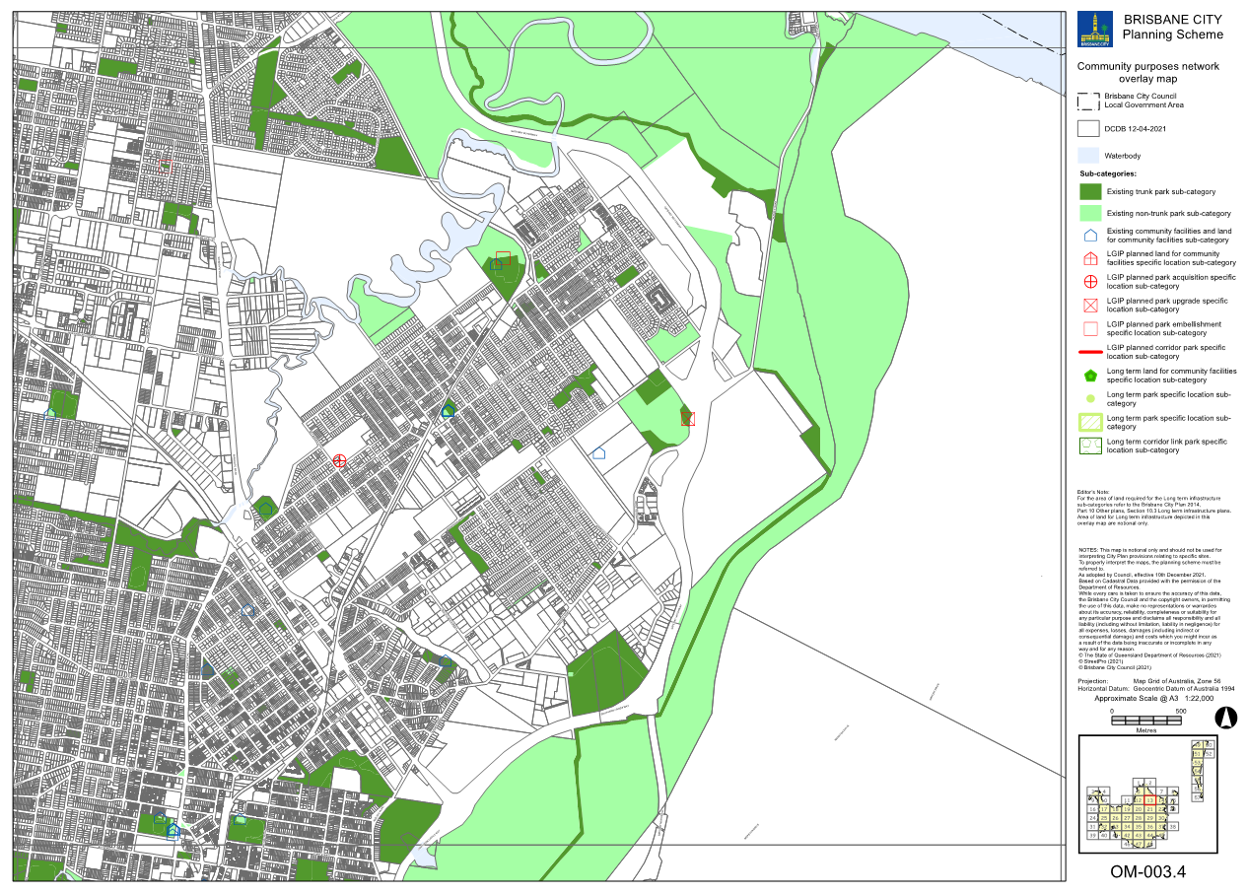
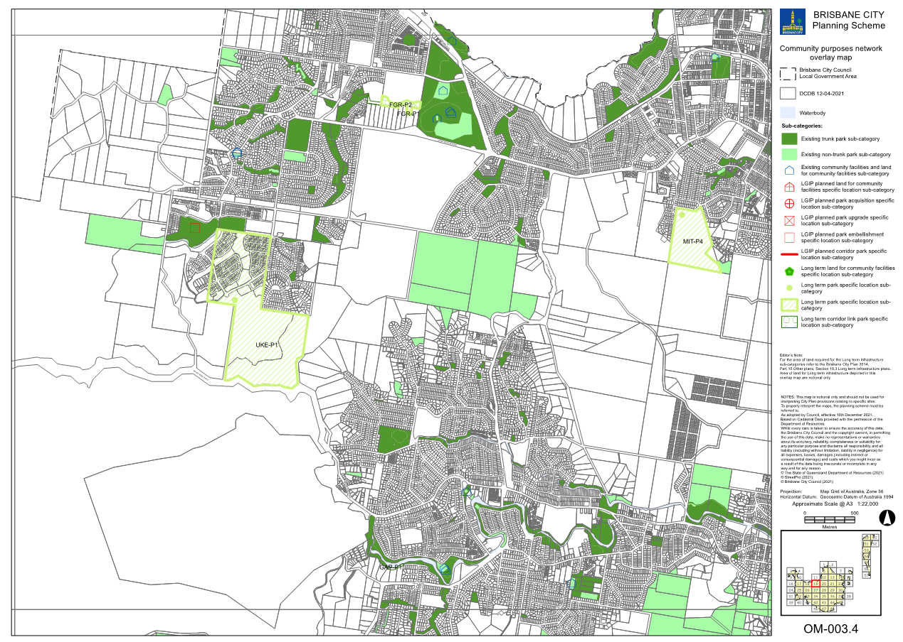
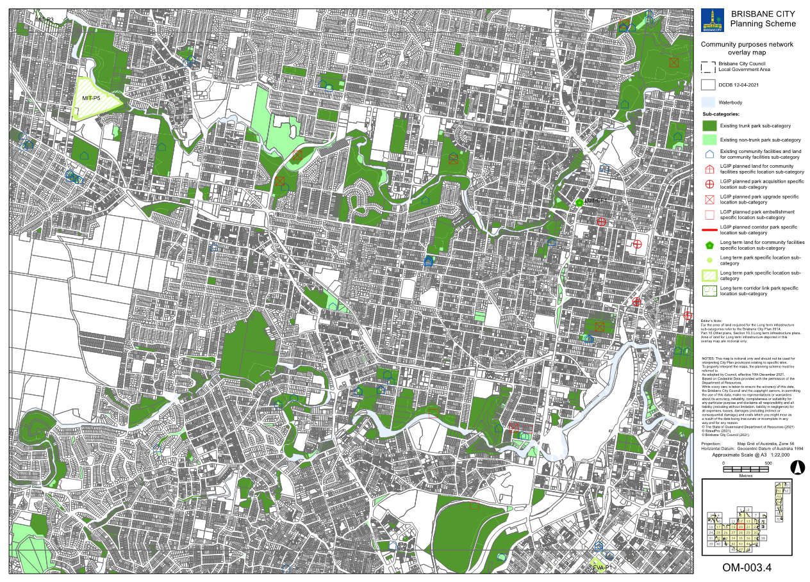

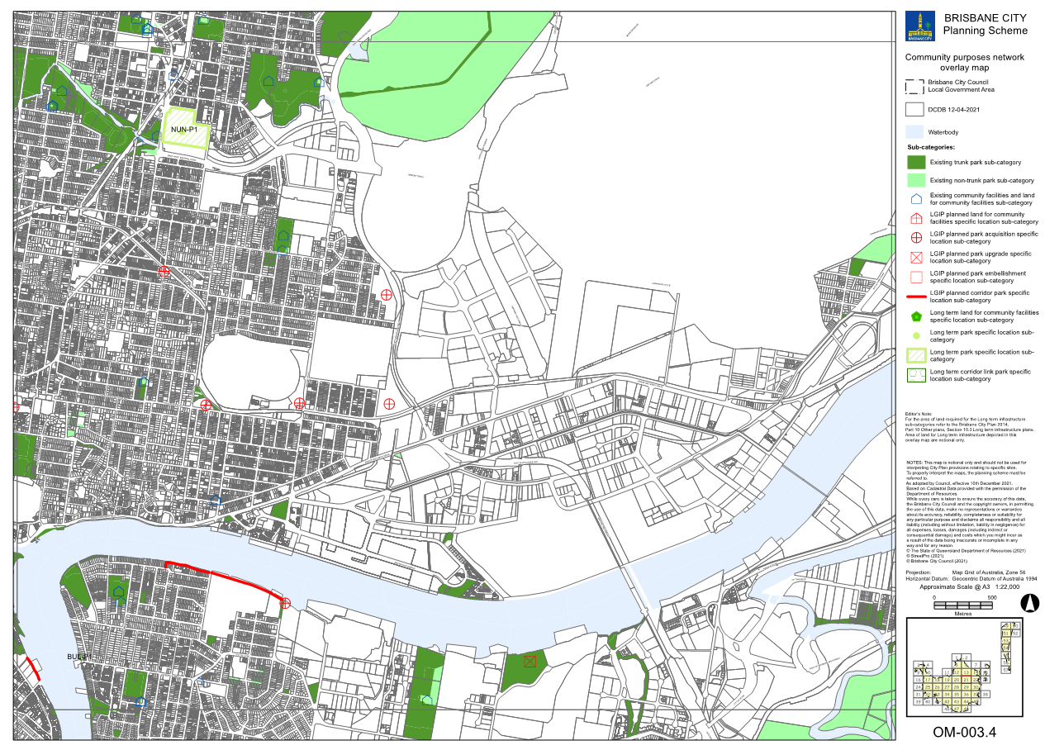
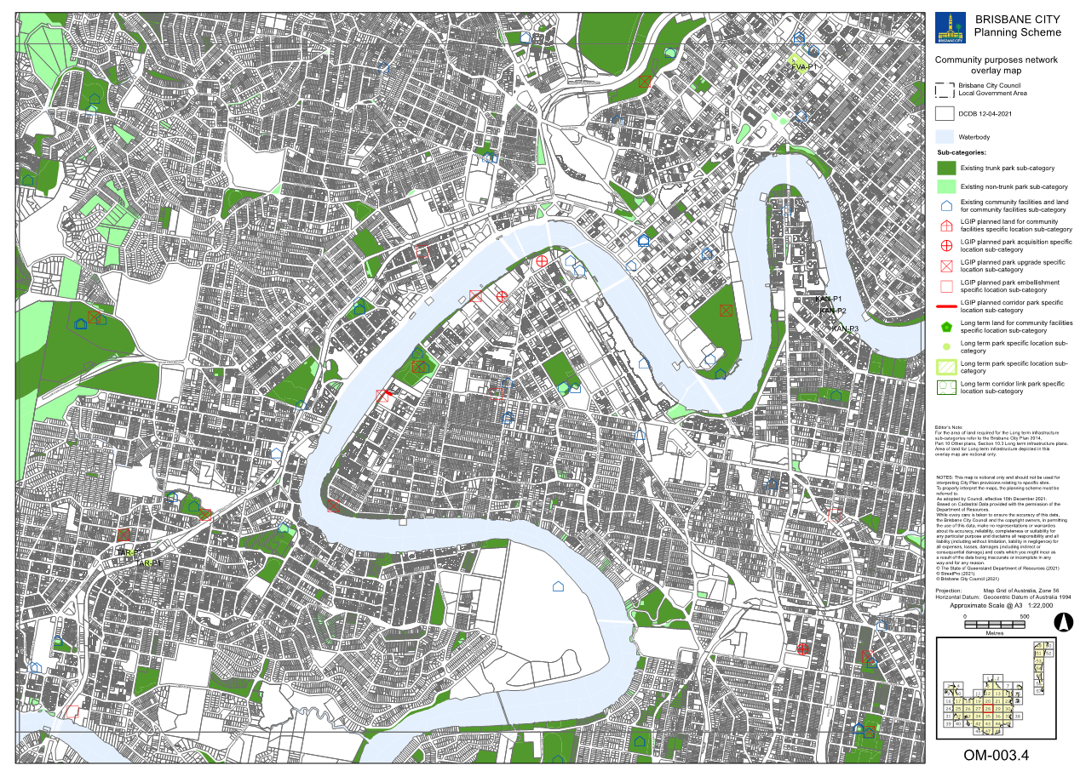
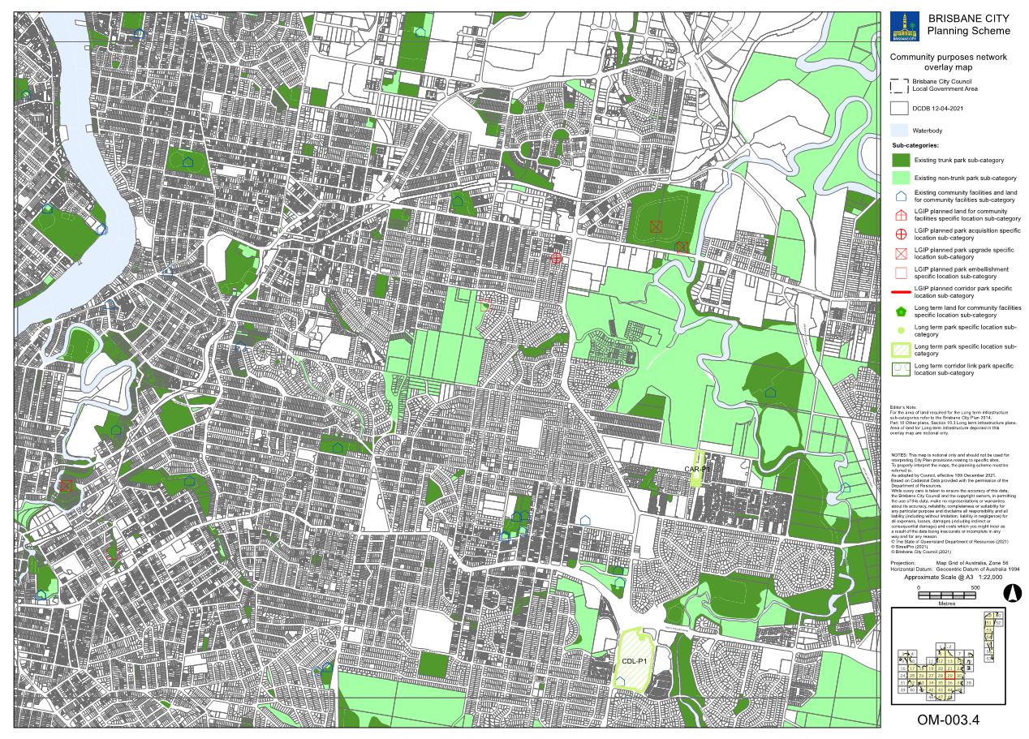
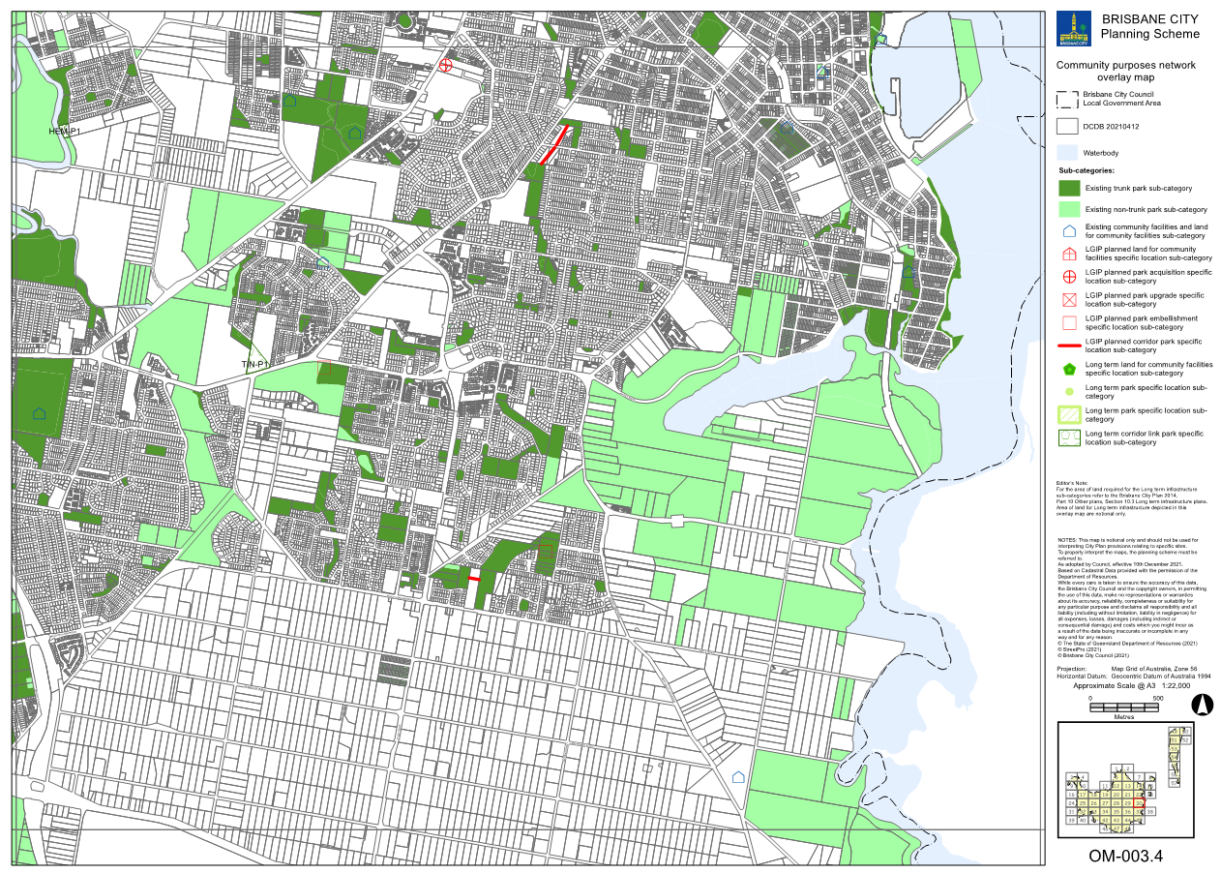
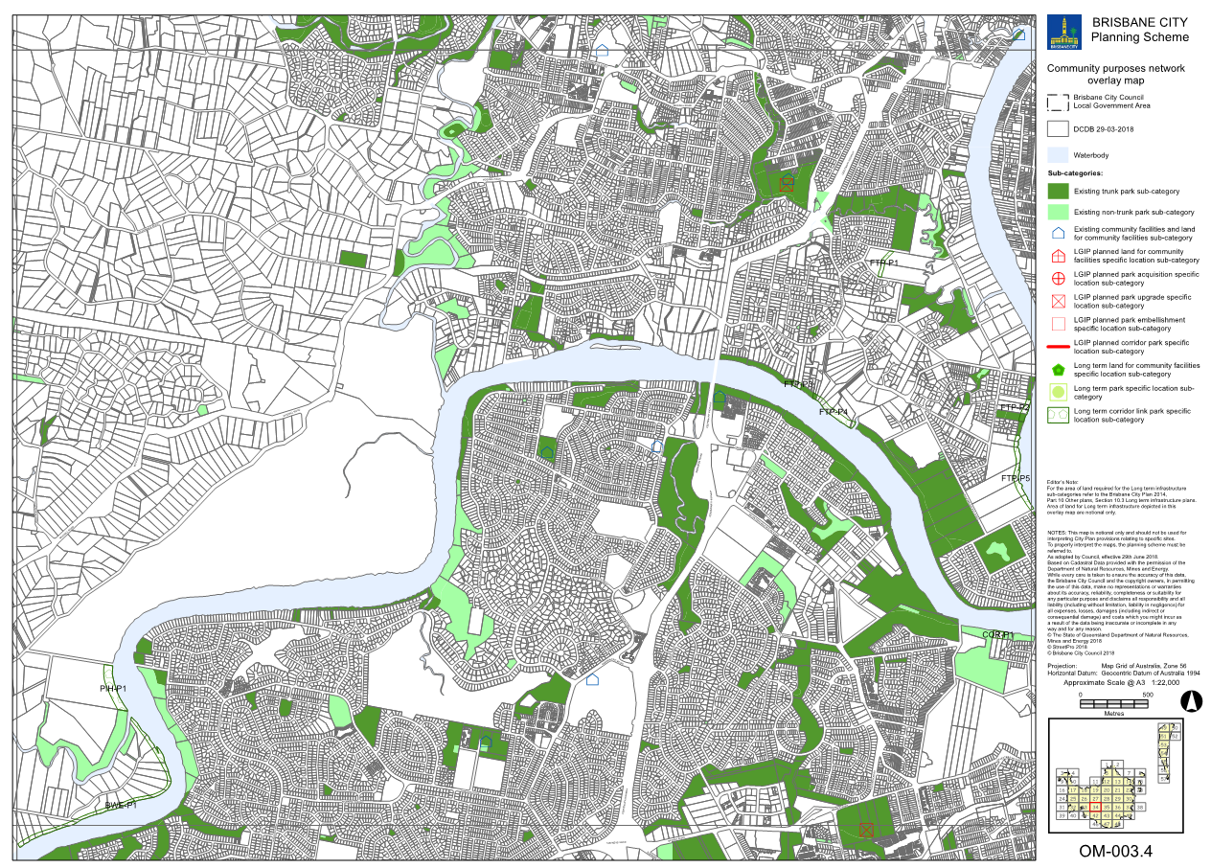
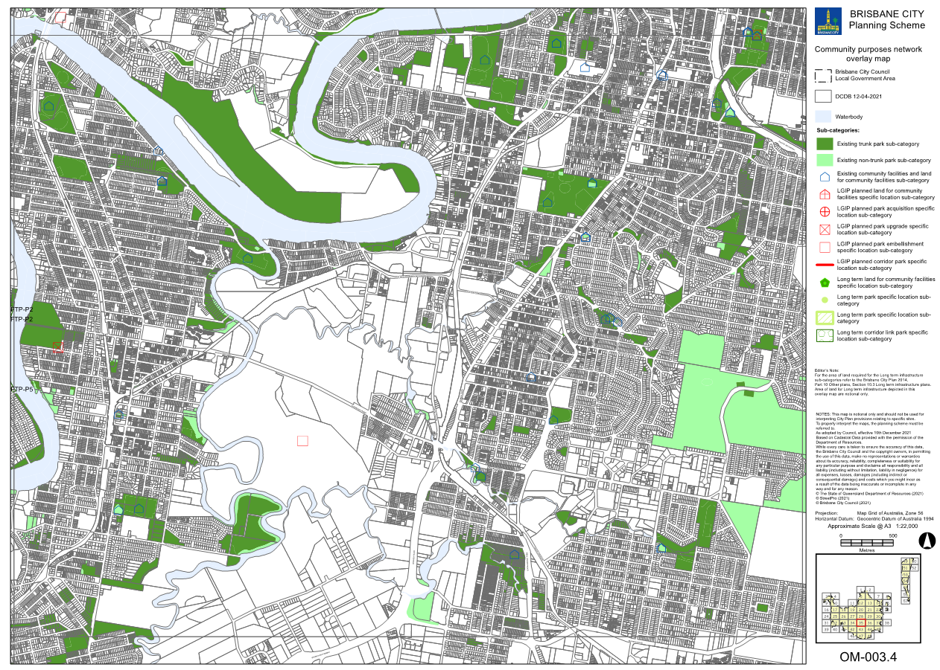
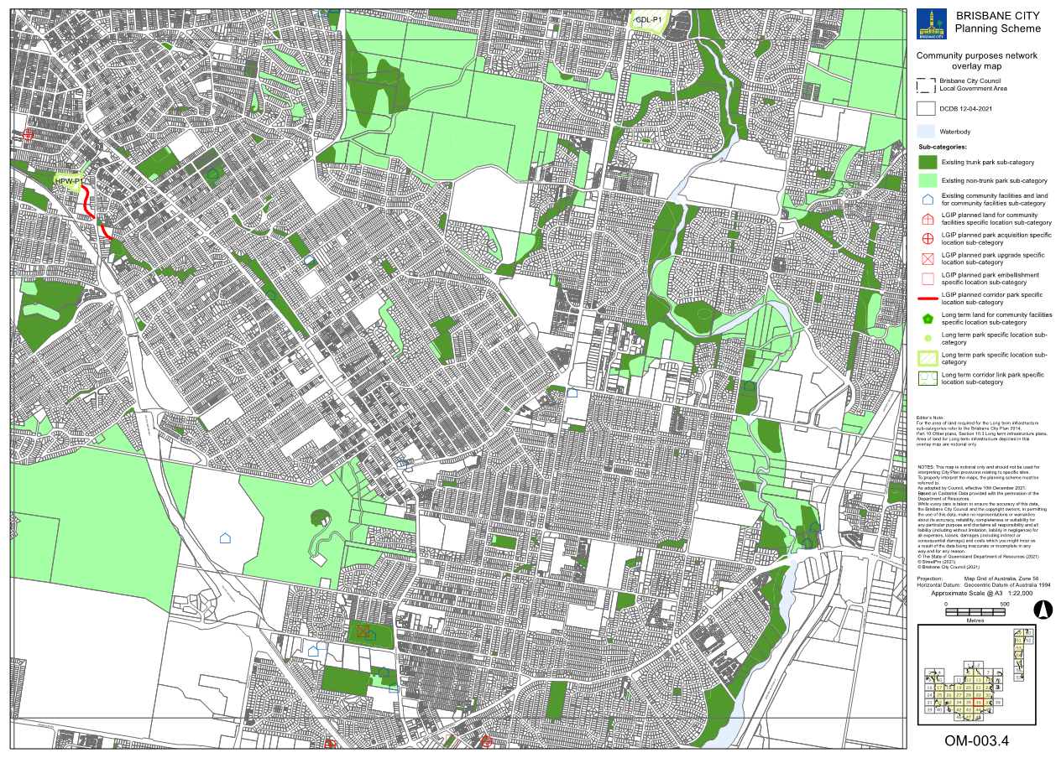
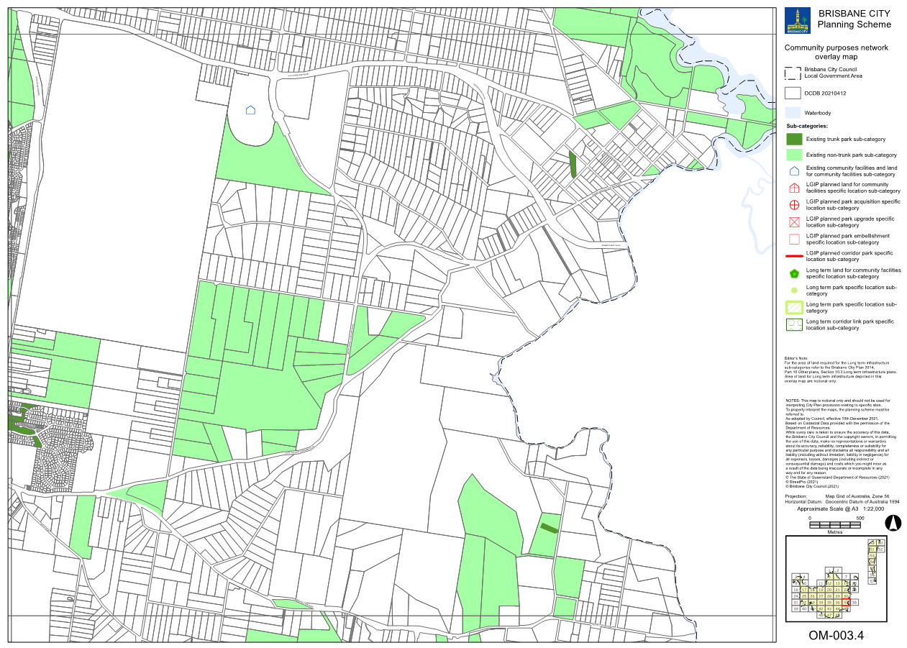
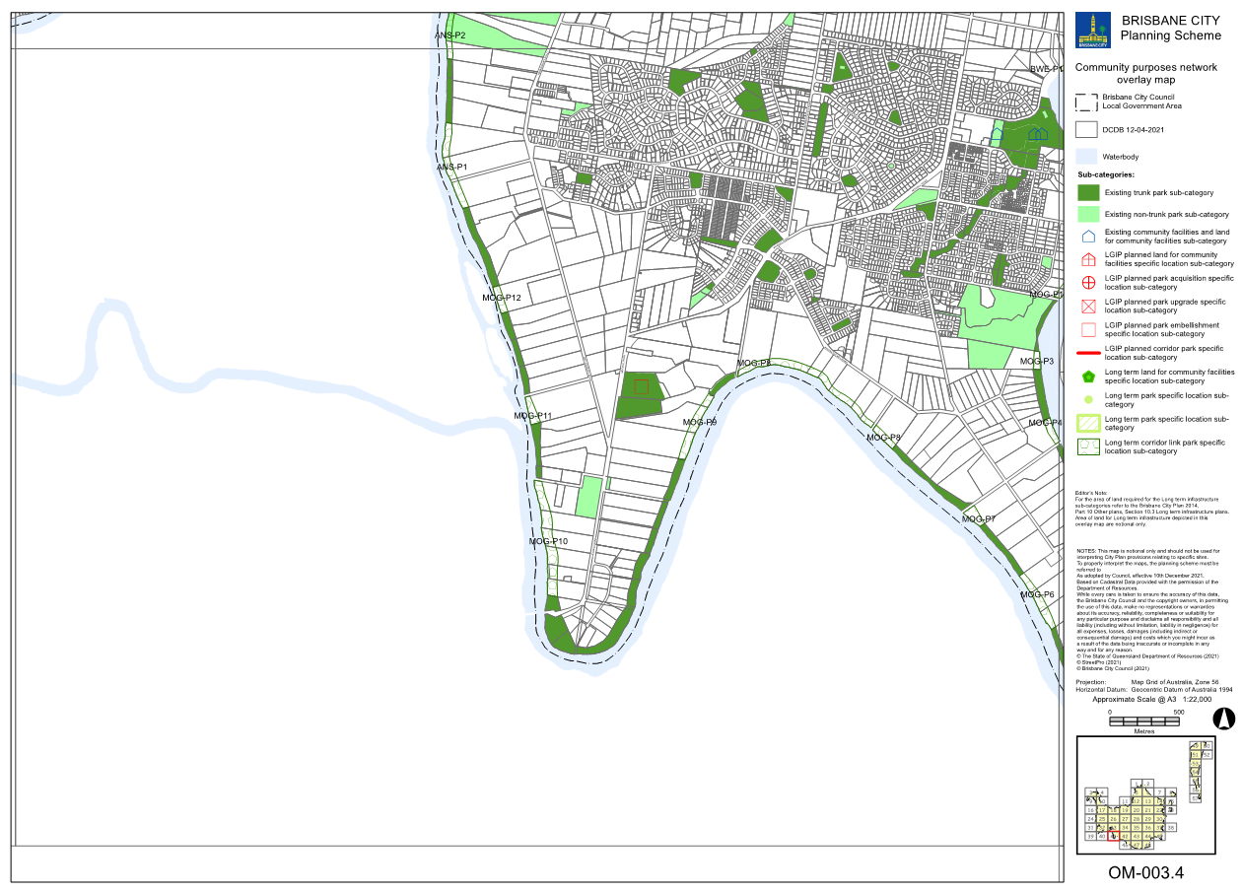
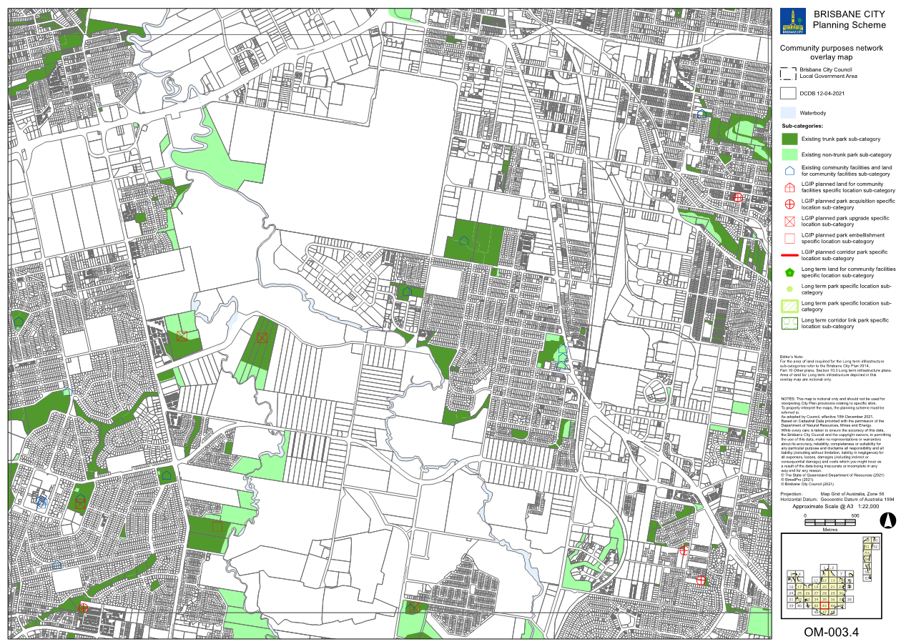
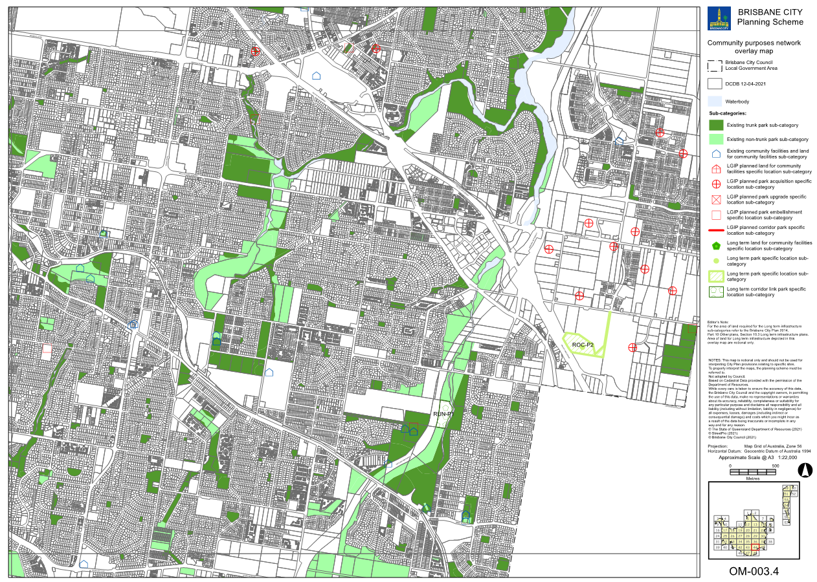
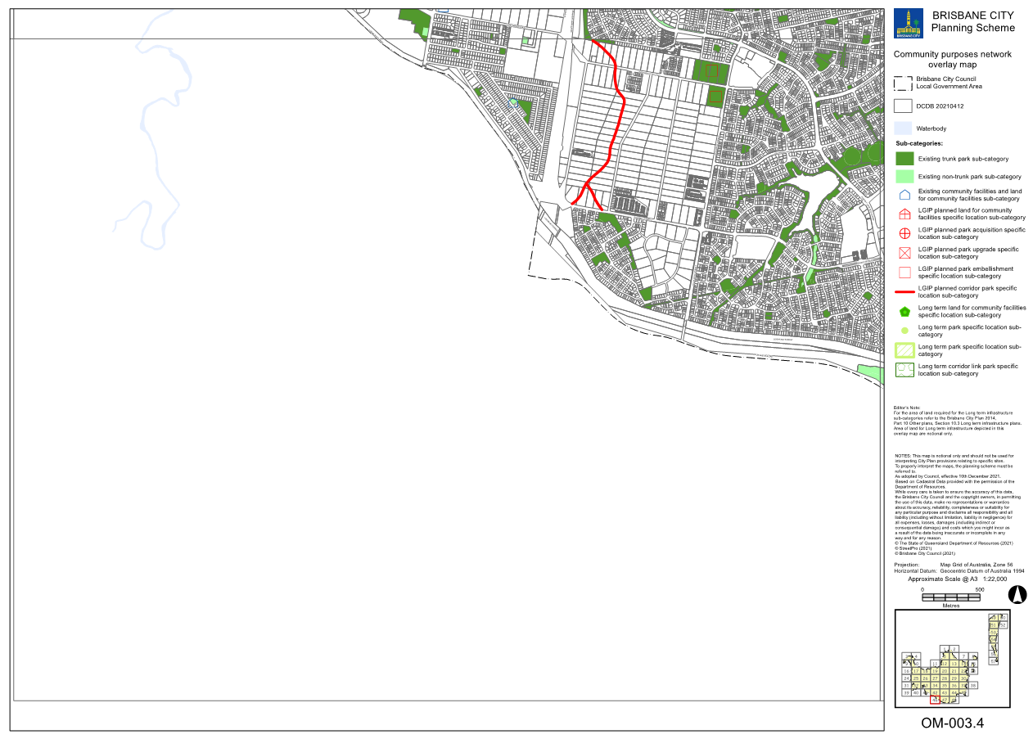
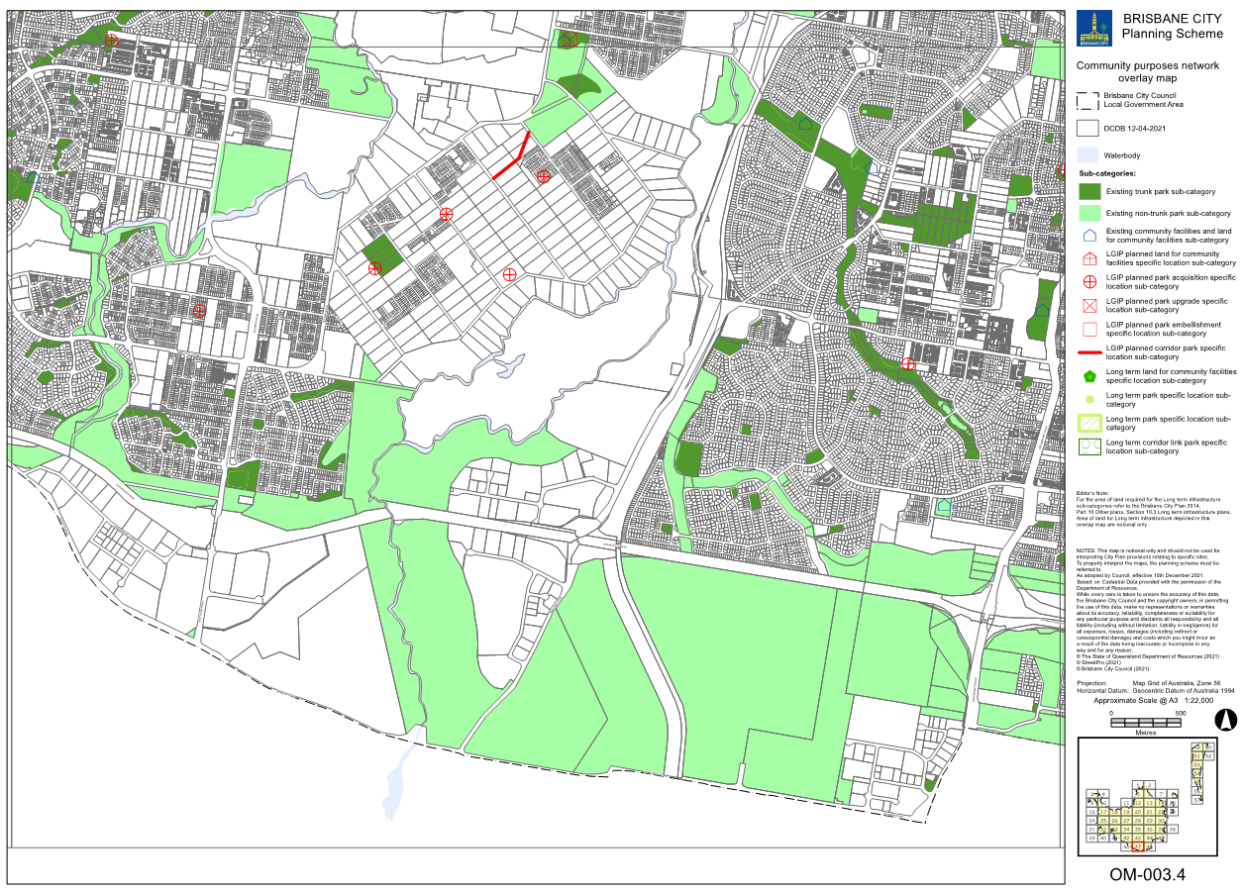

Other plan maps / Long Term Infrastructure Plans Other Plan Maps

Table 2: Existing map tiles listed in Map tile numbers column below are deleted and replaced with the corresponding map tile inserted below.

Item no. | Map number | Map tile numbers | Reason
 | OPM-12.1 | 153, 232, 275, 276, 312, 332 | These map tiles have been updated to reflect changes to Part 10 Other plans Table 10.3.2 Long term infrastructure plans for the stormwater network

