Carbon Neutral

Public Disclosure Summary

BRISBANE CITY COUNCIL

CARBON NEUTRAL REPORTING PERIOD: 2016-17

FINAL REPORT

Declaration

To the best of my knowledge, the information provided in this Public Disclosure Summary is true and correct and meets the requirements of the National Carbon Offset Standard (NCOS).

Date:
Colin Jensen
CHIEF EXECUTIVE OFFICER

Verification

Type of carbon neutral claim: Organisation
Date of verification: 13 November 2017
Auditor: Point Advisory

1. Carbon neutral information

1A. Introduction

Brisbane City Council (Council) is Australia’s largest local government authority in terms of both population and budget. It is dedicated to ensuring Brisbane is a great place to live and providing leadership and good governance for the people of Brisbane.

As Queensland’s capital, Brisbane has a thriving economy and significant infrastructure investment. The Greater Brisbane economy was valued at $153 billion in 2016-17, accounting for 48.5% of Queensland’s economic output and 9% of Australia’s output. Brisbane has a warm, sub-tropical climate, extensive parklands and recreational facilities, a diverse natural environment and vibrant central business district, retail, arts and entertainment precincts.

Brisbane City Council is made up of 26 wards, spanning a geographic area of 1,338 square kilometres. It provides a broad array of services for the city’s 1,180,825 residents, manages local infrastructure and assets valued at more than $22 billion and has an annual operating and capital budget in the order of $2.7 billion.

The City of Brisbane Act 2010 creates a framework for the city’s day to day operations and long term plans. The Act provides for the way in which Council is constituted and its responsibilities and powers.

Brisbane Vision is Council’s long term community plan for the city. The main priorities for the plan are to maintain and improve quality of life for the Brisbane community and ensure Brisbane meets the liveability and sustainability opportunities of the future. The Brisbane Vision outlines aspirations for the city’s future and identifies targets to be achieved by 2031, including carbon neutral status for Council operations.

Brisbane has been a leader in sustainability practices for more than 20 years and was named Australia’s Most Sustainable City by the Keep Australia Beautiful Foundation in 2014 and again in 2016. Council has been active in responding to climate change, focusing on the performance of its own operations, as well as delivering initiatives to support Brisbane residents and businesses to reduce their greenhouse gas emissions. To further demonstrate its sustainability leadership, Council committed to achieve and maintain carbon neutral status for its operations from 2016-17.

As at December 2016, Council had met all requirements to self-declare that it had achieved carbon neutral status for its operations in accordance with the National Carbon Offset Standard (NCOS). Council’s self-declaration applied to the 2016-17 reporting period and was based on the audited carbon accounts for 2015-16 and projected changes in emissions in 2016-17. An Interim 2016-17 Carbon Neutral Public Disclosure Summary was published in February 2017 providing details of the basis for Council’s self-declaration, including offsets purchased and cancelled in advance to negate projected annual emissions.

This Final 2016-17 Carbon Neutral Public Disclosure Summary outlines Council’s audited carbon accounts and offset reconciliation for the reporting period. The final carbon accounts underpin Council’s application for formal certification of its carbon neutral status under the NCOS Carbon Neutral Program and will form the baseline for future reporting under the program.

1B. Overview of Council operations

In 2016-17, Council provided the following services to the residents of Brisbane:

- land use planning and development assessment
- operation of public transport services, including one of the largest bus fleets in Australia and the iconic CityCat and CityFerry network
- transport network development and maintenance
- waste management services, including operation of a landfill facility
- provision of on and off-street parking services
- development and maintenance of urban parks
- provision and management of arts and cultural facilities and events
- provision and maintenance of libraries, community halls and sports and recreational facilities
- street cleaning and graffiti removal
- animal management
- vaccination services
- mosquito control and pest management
- disaster response and recovery
- flood risk management
- biodiversity conservation
- green community initiatives, including programs and events to support greater sustainability action by households, students and businesses.

An overview of the infrastructure and assets managed by Council in 2016-17 is provided in Diagram 1.

Diagram 1: Council infrastructure and assets (2016-17)
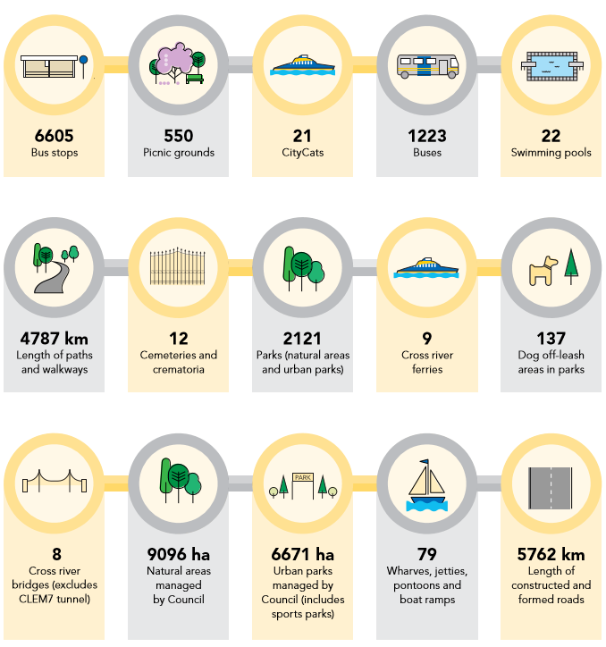

1C. Council’s organisational emissions boundary

Council’s 2016-17 emissions inventory was prepared in accordance with the NCOS (Version 3.0) and relevant national legislation and international standards. These included:

- National Greenhouse and Energy Reporting (Measurement) Determination 2008, Compilation No. 8, Registered 1 July 2016
- Greenhouse Gas (GHG) Protocol Corporate Accounting and Reporting Standard, 2004
- GHG Protocol Corporate Value Chain (Scope 3) Accounting and Reporting Standard, 2011

The organisational emissions boundary was defined in accordance with section 3.3.1 of the NCOS using an “operational control” approach. It included all entities and activities for which Council had the authority to introduce or implement: (i) operating policies; (ii) health and safety policies; or (iii) environmental policies.

The entities included within the organisational emissions boundary are Brisbane City Council and its six operational divisions, the Brisbane Waste Innovation Alliance (BWIA) and Council’s seven wholly-owned subsidiaries. These include:

- Brisbane Marketing
- Brisbane Powerhouse
- City of Brisbane Investment Corporation (CBIC)
- City Parklands Services
- CitySmart
- Museum of Brisbane
- TradeCoast Land

In addition to the wholly-owned subsidiaries, Council has part or shareholder interests in a number of other entities. However, as Council does not have operational control of these entities, they are excluded from the organisational boundary. The excluded entities and Council’s equity share are as follows:

- Brisbane Bus Build (50%)
- Brisbane Housing Company (6.6%)
- Major Brisbane Festivals (50%)
- Queensland Urban Utilities (85%)
- SEQ Regional Recreational Facilities (12.5%)

All direct emissions (scope 1) and indirect emissions from purchased electricity (scope 2) associated with the activities of the included entities were identified and included within the emissions boundary, where technically feasible and cost-effective relative to their significance. Other indirect emissions occurring as a result of the included entities’ activities (scope 3) were also considered by Council and included within the emissions boundary, where they were deemed to be relevant and material. There were no emissions generating activities associated with TradeCoast Land in 2017-18.

The GHG Protocol Corporate Value Chain (Scope 3) Accounting and Reporting Standard was applied in the consideration of scope 3 emissions sources. Council considered emissions from the 15 categories listed in section 5.4 of the standard and sought to quantify emissions from all relevant sources. The following criteria, listed in section 3.3.3 of the NCOS, were applied in determining the relevance of identified scope 3 emissions sources:

- the source is likely to be large relative to Council’s scope 1 and 2 emissions
- the source has the potential to contribute to Council’s greenhouse gas risk exposure
- the source is deemed to be relevant to key stakeholders
- Council has the potential to influence reductions from the source
- the source relates to emissions from outsourced activities previously performed in-house or activities outsourced by Council that are typically performed in-house by other local government authorities.

All emissions sources listed in Appendix 1 of the NCOS Carbon Neutral Program Guidelines (Version 4.0) were deemed to be relevant to key stakeholders and were included in the emissions boundary on this basis, regardless of size. When assessing whether other scope 3 emissions sources were large relative to scope 1 and 2 emissions, a one percent materiality threshold was applied to the overall carbon footprint, in line with section 3.6.5 of the NCOS. The total amount of emissions excluded (not quantified) on the basis of materiality does not exceed five percent.

As noted above, Council provides municipal waste management services to the residents of Brisbane. These services are delivered by Council and BWIA, either directly or under contract, and include kerbside waste collection, operation of four waste transfer stations and resource recovery centres, transportation of waste from transfer stations for final disposal or processing and operation of the city’s landfill at Rochedale. Where these services are delivered directly by Council or BWIA, they are accounted for under scope 1 and 2 emissions. Where the services are provided by contractors, they are accounted for as scope 3 emissions.

As Council (through BWIA) is deemed to have operational control of the Rochedale landfill, all emissions generated from waste disposal at the site, including the disposal of municipal waste, is included in the organisational emissions boundary and accounted for as scope 1 emissions. However, any emissions occurring as a result of the disposal or processing of municipal waste at sites operated by third parties (e.g. private landfill, composting or recycling facilities) are excluded from the emissions boundary on the basis that they are associated with the resident population, rather than Council operations.

Emissions of carbon dioxide (CO₂), methane (CH₄), nitrous oxide (N₂O), hydro-fluorocarbons (HFCs), per-fluorocarbons (PFCs) and sulphur hexafluoride (SF₆) were considered in preparing Council’s emissions inventory. All emissions are accounted for in tonnes of carbon dioxide equivalent (tCO₂-e). No PFC or SF₆ emissions were identified in 2016-17.

1D. Emission sources within the organisational emissions boundary

The emissions sources included within Council’s emissions boundary are outlined in Table 1.

Table 1: Included emissions sources

Scope | Emissions source
1 | Explosives
1 | Fuel combustion – stationary energy
1 | Fuel combustion – transport
1 | Fuel use – oils and greases
1 | Fugitive emissions – landfill
1 | Fugitive emissions – refrigerants
1 | Industrial gas use
2 | Electricity use – buildings and facilities
2 | Electricity use – Council controlled streetlights
3 | Asphalt production input materials
3 | Business travel – accommodation
3 | Business travel – flights
3 | Business travel – rental cars
3 | Business travel – taxis
3 | Cleaning services
3 | Construction materials and services
3 | Contracted bus services
3 | Downstream leased assets
3 | Employee commuting
3 | Energy extraction, production and transportation (E,P&T)
3 | Food and catering
3 | Green waste transportation
3 | Hired vehicles and equipment
3 | Horticultural services
3 | ICT applications and services
3 | ICT equipment
3 | Mowing services
3 | Municipal waste transportation
3 | Office supplies
3 | Paper use
3 | Postage, courier and freight
3 | Printing and publications
3 | Professional services
3 | Purchased vehicles
3 | Quarry services
3 | Third party controlled streetlights
3 | Transportation components and systems
3 | Transportation repairs and maintenance
3 | Upstream leased assets – base building services
3 | Venue hire
3 | Waste
3 | Water use

Emissions from the following sources have not been quantified in line with the above mentioned NCOS provisions. The exclusion of these sources is not expected to materially affect Council’s overall emissions.

Table 2: Excluded emissions sources

Scope | Emissions source | Justification for exclusion
1 | Fugitive emissions – landfill gas management | Council works with a third party to manage fugitive emissions at its operating landfill at Rochedale, through landfill gas capture and combustion via electricity generation or flaring. Any emissions (or reductions) associated with the capture and combustion of landfill gas at the site are excluded from Council’s organisational boundary on the basis these activities are undertaken by an independent third party and are outside of Council’s operational control. The third party retains all rights and responsibilities in relation to landfill gas captured and transferred.
1 | Fugitive emissions – closed landfill sites | Council is responsible for managing around 150 closed landfill sites, all of which ceased operations between 1940 and 1996, long before Council committed to achieve carbon neutral status for its operations. While active landfill gas management still occurs at five of these legacy sites, the vast majority have been converted for alternative use as public parks or sporting fields and are no longer identifiable as landfills. In most cases, limited (or no) information is available about the waste that was deposited, making it impossible to generate reasonable estimates of emissions continuing to be released (if any).
3 | Investments | Council has interests or shareholdings in a number of entities that are excluded from the organisational emissions boundary on the basis that they are outside of Council’s operational control.
3 | Machinery and equipment | Emissions from machinery and equipment are estimated to be less than one percent of total emissions and do not meet other relevance criteria.
3 | Office equipment | Emissions from office equipment are estimated to be less than one percent of total emissions and do not meet other relevance criteria.
3 | Other purchased goods and services (not captured in categories listed in Table 1) | Emissions from other purchased goods and services are individually estimated to be less than one percent of total emissions and do not meet other relevance criteria.

The following emissions sources are included in the emissions boundary, but were only partially accounted for in 2016-17, due to gaps in the available data. Council will continue to work towards filling these gaps in 2017-18 and beyond by taking the steps outlined in Table 3.

Table 3: Data management plan for emissions sources partially accounted for in 2016-17

Scope | Emissions source | Data management plan
3 | Downstream leased assets | Council has over 650 downstream leases, including 42 commercial and retail leases, 22 pools, three golf courses and more than 600 community leases (e.g. halls, sporting venues etc.). Electricity consumption data has been obtained for five commercial leases and 15 pools and associated emissions have been accounted for in the 2016-17 carbon accounts. Council will continue to seek data from all lessees and work towards comprehensive reporting of emissions from downstream leased assets in future carbon accounts.
3 | Upstream leased assets – base building services | Council and its subsidiaries occupy 20 leased facilities where base building services are provided by the lessor. In 2016-17, emissions have been quantified for one site occupied by Brisbane Marketing only, due to the unavailability of data for other sites. Data will continue to be sought from all lessors to enable quantification in future carbon accounts.
3 | Water use | Water consumption data is currently available and associated emissions have been estimated for all Council owned facilities and 16 buildings leased by Council. Data will continue to be sought for all remaining upstream leases to enable comprehensive quantification in future carbon accounts.

In addition, Council is currently relying on expenditure data and emissions factors developed using generalised input-out analysis to estimate emissions associated with several large scope 3 sources, including construction materials and services. While the input-output factors are expected to generate conservative estimates of emissions associated with these sources, Council will work to improve the accuracy of its emissions calculations in future years by moving to alternative activity-based methods, where available. Any future changes to the emissions estimation methodology will be reflected in a recalculation of the emissions baseline and reported in future carbon neutral reports.

1E. Diagram of organisational emissions boundary

See Appendix A.

2. Emissions reduction measures

2A. Emissions reduction strategy

Council is reducing its carbon footprint through investments in energy efficiency and emissions reduction projects, as well as renewable energy purchases. From 2016-17, carbon offsets will be purchased on a financial year basis to negate remaining emissions and maintain Council’s carbon neutral status.

The Corporate Plan 2016-17 to 2020-21 - 2017 Update outlines Council’s objective to continually improve energy and carbon management (Program 3 – Clean, Green and Sustainable City). This is to be achieved through the ongoing identification, analysis and prioritisation of a pipeline of energy and carbon abatement opportunities. Diagram 2 below provides a visual representation of Council’s approach to continuous improvement in energy and carbon management.

Diagram 2: Council’s continuous improvement process

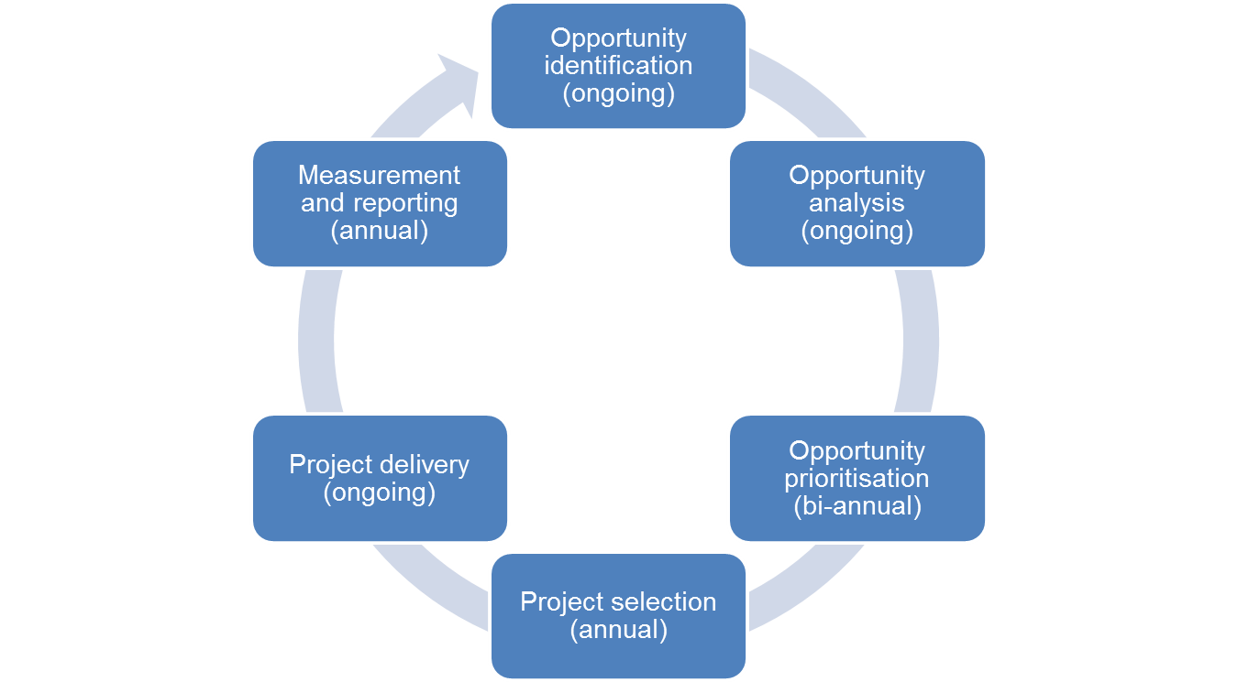

The Carbon Neutral Council Emissions Management Plan (EMP) 2017-18 to 2020-21 outlines Council’s emissions reduction strategy. It comprises a four year rolling program of priority energy efficiency and emissions reduction projects and actions in the following areas:

- Improve the energy efficiency and emissions profile of existing assets and services, where possible and cost-effective.
- Ensure the design and delivery of new assets and services is informed by an understanding of expected energy consumption and associated emissions and, where practical, incorporates measures to improve energy and emissions performance.
- Encourage changes in employee behaviour to support improved energy efficiency and emissions reduction outcomes.
- Develop organisational capacity to identify and deliver ongoing improvements in energy and carbon management across Council operations.

The EMP is to be reviewed and updated annually and will form the basis of Council’s future reporting on its emissions reduction actions and achievements.

2B. Emissions reduction actions

Council has determined the carbon emissions from its major emissions sources, including landfill, fuel and electricity use since 2008 and has a strong track record of delivering energy efficiency and emissions reduction projects, including:

- retrofitting 25,000 streetlights with energy efficient lamps
- retrofitting the Story Bridge and King George Square and Wickham Terrace carparks with LED lighting
- installing solar photovoltaic (PV) systems on Council buildings and facilities, including the Brisbane Powerhouse, a former coal-fired power station now operating as a multi-arts entertainment venue
- including electric vehicles in Council’s passenger fleet
- trialling the use of smart transmission technology in public transport.

In addition, over the 12 years from 2003 to 2015, Council purchased more than 860,000 megawatt hours (MWh) of electricity from renewable energy sources, reducing its greenhouse gas emissions by more than 670,000tCO₂-e, and purchased and cancelled around one million carbon offsets.

In 2016-17, Council implemented a range of emissions reduction actions, including:

- purchasing 29,225MWh of electricity from renewable energy sources
- installation of an additional 100 kilowatt (kW) solar PV system at the Toowong bus depot
- LED lighting upgrades at the Grant Thornton Building and Hibiscus Sports Complex
- initial installations of LED lights as part of Council’s commitment to install 40,000 LEDs in street and other public lighting applications
- piloting eco-driving training with 370 Council bus drivers
- upgrading the heating system and insulation in the storage bins at the Eagle Farm asphalt plant, reducing energy consumed in maintaining the temperature of asphalt produced prior to delivery.

Table 4 provides a summary of the estimated emissions reductions achieved as a result of measures implemented in 2016-17.

Table 4: Emissions reduction measures (2016-17)

Scope | Emissions source | Action undertaken | Status | Annual emissions reduction (tCO₂-e)
1 | Fuel combustion – transport | Eco-driving training pilot for 370 Council bus drivers | Training completed in 2016-17 – measurement ongoing | Not yet quantified
1 | Fuel combustion – stationary energy | Heating system and insulation upgrade for storage bins at Eagle Farm asphalt plant | Completed in 2016-17 | Not yet quantified
2 | Electricity – buildings and facilities | Purchased and voluntarily surrendered Large-scale Generation Certificates (LGCs) | Purchased for electricity consumed in 2016-17 | 22,796
2 | Electricity – buildings and facilities | Retrofitted traffic signal lights at 49 intersections across the city with more efficient LEDs | Completed in 2016-17 | 156
2 | Electricity – buildings and facilities | Retrofitted Grant Thornton Building and Hibiscus Sports Complex with LED lighting | Completed in 2016-17 | 104
2 | Electricity – buildings and facilities | Installed 100kW solar PV system at Toowong bus depot | Completed in 2016-17 | 120
2 | Electricity – buildings and facilities | Installed 3kW solar PV system at Karawatha Environment Centre | Completed in 2016-17 | 4
2,3 | Electricity – Council Controlled streetlighting  Third party streetlights | Installation of LED lights in street and other public lighting applications | Completed in 2016-17 | 17
3 | Asphalt production input materials | Utilisation of recycled asphalt to reduce requirements for sand and aggregate in asphalt production | Completed in 2016-17 | 235
TOTAL |  |  |  | 23,432

As noted in Table 2, while these sources are excluded from the organisational emissions boundary, Council continues to work with third parties to actively manage landfill gas at the Rochedale landfill and other closed landfill sites, where it remains technically feasible to do so. Landfill gas capture and combustion at the Rochedale landfill reduced greenhouse gas emissions by 261,058tCO₂-e in 2016-17. Gas captured and combusted at closed landfill sites reduced greenhouse gas emissions by a further 53,407tCO₂-e.

3. Emissions summary

3A. Final 2016-17 carbon accounts

Council’s carbon footprint is made up of emissions from landfill, fuel combustion, and electricity use and other indirect emissions sources, such as construction materials and services, third party controlled streetlighting, municipal and green waste transportation and catering services.

In 2016-17, the four largest emissions sources accounted for around 66% of Council’s total carbon footprint. These were fugitive emissions from Council’s operating landfill at Rochedale (23%), fuel combustion for stationary energy and transport purposes (19%), electricity use at buildings and facilities and for Council controlled streetlighting (8%) and construction materials and services (16%).

Council’s operational divisions accounted for the vast majority of emissions with 74% of the total emissions footprint. BWIA accounted for 24% of total emissions with the subsidiaries contributing the remaining 2%.

Table 5 provides a summary of emissions by source in the reporting period. Table 6 provides a summary of emissions by responsible entity.

Table 5: Council’s emissions by source (2016-17)

Scope | Emissions source | Emissions (tCO₂-e)
1 | Explosives | 87
1 | Fuel combustion – stationary energy | 15,006
1 | Fuel combustion – transport | 109,828
1 | Fuel use – oils and greases | 78
1 | Fugitive emissions – landfill | 157,051
1 | Fugitive emissions – refrigerants | 3,304
1 | Industrial gas use – CO2 | 22
2 | Electricity use – buildings and facilities | 49,404
2 | Electricity use – Council controlled streetlights | 2,159
3 | Asphalt production input materials | 4,265
3 | Business travel – accommodation | 184
3 | Business travel – flights | 468
3 | Business travel – rental cars | 7
3 | Business travel – taxis | 60
3 | Cleaning services | 1,220
3 | Construction materials and services | 106,146
3 | Contracted bus services | 1,820
3 | Downstream leased assets | 9,808
3 | Employee commuting | 7,701
3 | Energy E,P&T | 21,740
3 | Food and catering | 725
3 | Green waste transportation | 770
3 | Hired vehicles and equipment | 27,086
3 | Horticultural services | 13,429
3 | ICT applications and services | 9,422
3 | ICT equipment | 10,480
3 | Mowing services | 1,389
3 | Municipal waste transportation | 9,427
3 | Office supplies | 575
3 | Paper use | 183
3 | Postage, courier and freight | 238
3 | Printing and publications | 3,237
3 | Professional services | 14,633
3 | Purchased vehicles | 4,718
3 | Quarry services | 6,168
3 | Third party controlled streetlights | 34,720
3 | Transportation components and systems | 23,467
3 | Transportation repairs and maintenance | 6,760
3 | Upstream leased assets – base building services | 64
3 | Venue hire | 788
3 | Waste | 7,572
3 | Water use | 626
TOTAL GROSS EMISSIONS |  | 666,835
EMISSIONS REDUCED THROUGH VOLUNTARILY RETIRED LGCs |  | 22,796
TOTAL NET EMISSIONS |  | 644,039

Table 6: Council’s emissions by responsible entity (2016-17)

Responsible entity | Emissions (tCO₂-e)
Council operational divisions | 493,552
BWIA | 162,398
Brisbane Marketing | 2,203
Brisbane Powerhouse | 2,242
CBIC | 533
City Parklands Services | 5,578
CitySmart | 269
Museum of Brisbane | 60
TradeCoast Land | 0
TOTAL GROSS EMISSIONS | 666,835
EMISSIONS REDU CED THROUGH VOLUNTARILY RETIRED LGCs | 22,796
TOTAL NET EMISSIONS | 644,039

3B. Changes from Interim 2016-17 Carbon Neutral Public Disclosure Summary

The Interim 2016-17 Carbon Neutral Public Disclosure Summary outlined Council’s emissions forecast for 2016-17, based on the audited 2015-16 carbon accounts (763,668tCO₂-e) and projected changes in emissions in the reporting period (an additional 45,000tCO₂-e). However, the final 2016-17 carbon accounts show that net emissions were substantially lower than forecast at 644,039 tCO₂-e.

The change in net emissions is largely due to improved expenditure reporting in 2016-17, which has led to reductions in expenditure figures across several categories, including large scope 3 emissions sources, such as construction materials and services. In 2015-16, expenditure data was based on purchase orders raised for the reporting period. However, in 2016-17, reporting capability was improved, enabling a shift to actual expenditure against purchase orders within the financial year. A comparison of expenditure data using the two reports indicates that the expenditure was previously over-estimated by around 40%.

Given the magnitude of the change, emissions for the 2015-16 reporting period have been re-calculated using expenditure data consistent with the 2016-17 carbon accounts. Total net emissions have been revised to 594,307tCO₂-e. Table 7 provides details of the affected emissions sources.

Table 7: Revised 2015-16 emissions by source

Scope | Emissions source | Previous estimate  (tCO₂-e) | Revised estimate  (tCO₂-e)
3 | Cleaning services | 1,952 | 1,249
3 | Construction materials and services | 214,088 | 90,100
3 | Food and catering | 1,073 | 881
3 | Hired vehicles and equipment | 42,091 | 28,111
3 | Horticultural services | 34,678 | 24,582
3 | ICT applications and services | 9,511 | 9,166
3 | ICT equipment | 13,504 | 12,058
3 | Office supplies | 872 | 600
3 | Postage, courier and freight | 403 | 229
3 | Printing and publications | 3,180 | 2,902
3 | Professional services | 12,331 | 14,021
3 | Quarry services | 8,357 | 6,166
3 | Transportation components and systems | 38,913 | 21,574
3 | Transportation repairs and maintenance | 6,829 | 6,782
3 | Venue hire | 123 | 123

In addition, there were some minor changes to the definition of the emissions boundary in 2016-17. Mowing services, previously reported under Horticultural Services using expenditure data, is now accounted for separately using fuel use data provided by mowing contractors. Green Waste Transportation is also now reported separately to Municipal Waste Transportation. Both sources were previously reported together as Upstream Waste Transportation.

4. Carbon offsets

4A. Offsets summary

A total of 18,382 offset units were banked by Council in 2015-16 and carried over for use in the 2016-17 reporting period. An additional 1,662,130 units were purchased in December 2016 and January 2017, bringing Council’s total available offset holdings to 1,680,512tCO₂-e.

To support its self-declaration of carbon neutral status in February 2017, Council retired 808,668 carbon offset units to negate forecast emissions in the 2016-17 reporting period. As the final audited carbon accounts for 2016-17 are substantially lower than forecast, 164,629 surplus units retired in advance of Council’s self-declaration of carbon neutral status have been carried over for use in the 2017-18 reporting period. A further 490,298 units have been allocated in advance to cover projected 2017-18 emissions of 660,7127tCO2-e. These units will be retired prior to submitting the 2017-18 report.

After accounting for 2016-17 offset requirements and the forward retirement of units to cover projected 2017-18 requirements, Council maintains holdings of 381,546 units for use in future years.

Offset units retired in advance to negate Council’s 2016-17 emissions are detailed in Table 8. Units carried over from 2016-17 and allocated for use in 2017-18 are detailed in Table 9.

Table 8: Offset units retired to negate 2016-17 emissions

Offset type | Registry | Serial numbers | Year retired | Quantity
VCU | APX | 3515-156452358-156470739-VCU-002-APX-KP-1-786-01012011-31122011-0 | 2014-15 | 18,382
VCU | APX | 4806-198720343-198830027-VCU-002-APX-KR-1-786-01012011-31122011-0 | 2016-17 | 109,685
VCU | APX | 4805-197812970-198288507-VCU-015-APX-KR-1-786-01012012-31122012-0 | 2016-17 | 475,538
ACCU | ANREU | 3,747,555,459 - 3,747,567,690 | 2016-17 | 12,232
ACCU | ANREU | 3,736,294,638 - 3,736,300,387 | 2016-17 | 5,750
ACCU | ANREU | 3,744,990,326 - 3,744,995,655 | 2016-17 | 5,330
ACCU | ANREU | 3,745,017,913 - 3,745,023,707 | 2016-17 | 5,795
ACCU | ANREU | 3,746,960,719 - 3,746,964,845 | 2016-17 | 4,127
ACCU | ANREU | 3,746,846,837 - 3,746,854,036 | 2016-17 | 7,200
TOTAL OFFSETS RETIRED TO NEGATE 2016-17 EMISSIONS |  |  |  | 644,039
TOTAL NET EMISSIONS AFTER ACCOUNTING FOR OFFSETS |  |  |  | 0

Table 9: Offset units carried over and allocated in advance to negate projected 2017-18 emissions

Offset type | Registry | Serial numbers | Year retired | Quantity
VCU | APX | 4805-198288508-198328136-VCU-015-APX-KR-1-786-01012012-31122012-0 | 2016-17 | 39,629
VCU | APX | 2960-130880970-130980969-VCU-010-MER-CN-1-438-01012011-25062011-1 | 2016-17 | 100,000
VCU | APX | 4813-199726754-199751753-VCU-010-MER-ID-1-487-01012011-31122011-1 | 2016-17 | 25,000
CER | CDM | CN-5-777472750-1-1-0-4138 to CN-5-777481674-1-1-0-4138 | 2016-17 | 8,925
CER | CDM | CN-5-822207955-1-1-0-4401 to CN-5-822337067-1-1-0-4401 | 2016-17 | 129,113
CER | CDM | CN-5-811348616-1-1-0-3862 to CN-5-811477906-1-1-0-3862 | 2016-17 | 129,291
CER | CDM | CN-5-746231094-1-1-0-4416 to CN-5-746356043-1-1-0-4416 | 2016-17 | 124,950
NKACCU | ANREU | 3,746,854,037 - 3,746,860,446 | Active | 6,410
NKACCU | ANREU | 3,747,063,944 - 3,747,081,582 | Active | 17,639
NKACCU | ANREU | 3,747,154,791 - 3,747,158,980 | Active | 4,190
NKACCU | ANREU | 3,747,637,112 - 3,747,638,877 | Active | 1,766
NKACCU | ANREU | 3,746,964,919 - 3,746,981,609 | Active | 16,691
VCU | APX | 4816-199814907-199822862-VCU-048-APX-IN-1-1315-18082012-31122012-0 | Active | 7,956
VCU | APX | 4819-199927863-199954917-VCU-048-APX-IN-1-1315-01012013-31122013-0 | Active | 27,055
VCU | APX | 4815-199786204-199802515-VCU-048-APX-IN-1-1315-01012014-31122014-0 | Active | 16,312
VCU | APX | 4814-199756754-199762543-VCU-048-APX-IN-1-1315-01012015-31122015-0 | Active | 5,790
TOTAL OFFSETS CARRIED OVER/ALLOCATED TO NEGATE 2017-18 EMISSIONS |  |  |  | 660,717
TOTAL OFFSETS BANKED FOR FUTURE USE |  |  |  | 375,756

4B. Offsets purchasing and retirement strategy

In line with section 5.3 of the NCOS, Council will forward purchase and cancel offsets early in the reporting period for which a carbon neutral claim is made, wherever practical. Forward purchases are to be based on the final carbon accounts for the previous reporting period, with adjustments to account for any projected changes in the emissions profile in the current reporting year.

A “true-up” will occur following finalisation of the carbon accounts for the financial year, with any surplus offsets carried over for use in the subsequent reporting period. In the unlikely event that Council underestimates its emissions, additional offsets will be purchased and retired to cover the shortfall. Details of any carryover or shortfall will be included in the Carbon Neutral Public Disclosure Summary for the subsequent reporting period.

The purchase of financial instruments, including carbon offsets and Renewable Energy Certificates (RECs), is covered by Council’s Financial Risk Management Framework and must be undertaken by Corporate Finance, under delegation from the Chief Executive Officer (CEO). Carbon offsets may be purchased in a single annual transaction or at regular intervals throughout the year, depending on market conditions, including availability and price.

Council will take delivery of carbon offset units in its own public registry accounts, wherever possible. In this case, units may be retired as used or allocated for use in a given reporting period. Where Council does not have an account in the registry that holds the particular type of carbon offset units purchased, the units may be transferred into the supplier’s registry account and retired by the supplier on Council’s behalf. In these instances, retirement is to occur at the time of purchase. Council will maintain an internal record of its carbon offset holdings, including status of units, registry accounts and the reporting period to which the units are allocated.

Council considers the following criteria when undertaking carbon offset purchases:

- NCOS-eligible – all purchased offsets must be eligible for use under the NCOS
- Cost – all purchased offsets are to represent value for money in line with Council’s procurement principles, measured by price as well as merit against other criteria
- Potential negative impacts – any offset projects with negative economic, social, or environmental outcomes are to be avoided
- Location – it is desirable to purchase some offsets from local or Australian projects, where available
- Technology – consideration is to be given to the technology applied in the offset project with a view to broadening the offset portfolio to include a range of technologies and spread investment risk
- Positive impacts – Council will favour offset projects that have a positive economic, social or environmental impact or provide co-benefits.

Council will only purchase offsets where it can be verified that the emissions reductions have occurred.

4C. Offset projects (co-benefits)

Table 10 provides details of the co-benefits provided by the offset projects supported via Council’s 2016-17 offset purchase and cancellation.

Table 10: Co-benefits provided by supported offset projects (2016-17)

Project name | Co-benefit verification standard | Location | Proportion  of offset purchase (%) | Co-benefits
Old Mapoon Savanna Burning | - | Australia | 1.9% | - Protects local environment, cultural sites, infrastructure and communities from devastating bushfires.  - Supports local economic development including job creation within remote aboriginal communities.
Re-generation of native forest in marginal farming lands (various projects) | - | Australia | 4.3% | - Support improved local environmental, economic and social outcomes including:  - increased biodiversity and habitat value  - mitigation of soil erosion and salinity risk  - increased awareness of and access to opportunities for farmers in the delivery of environmental services  - diversification of on-farm income streams.

Appendix A: Council’s organisational emissions boundary

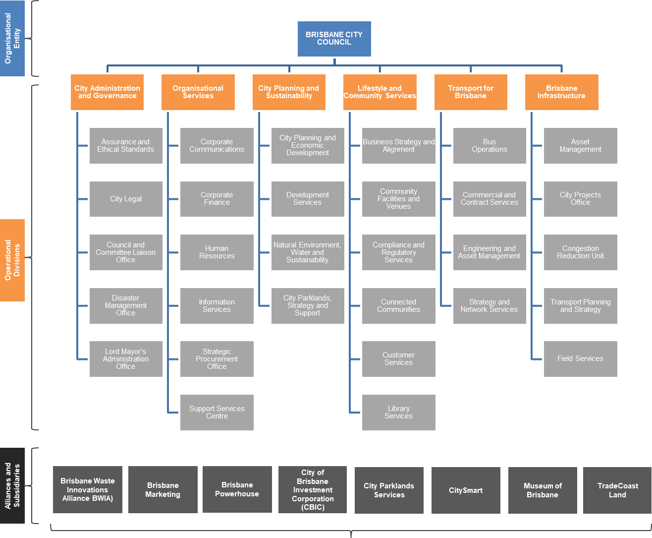

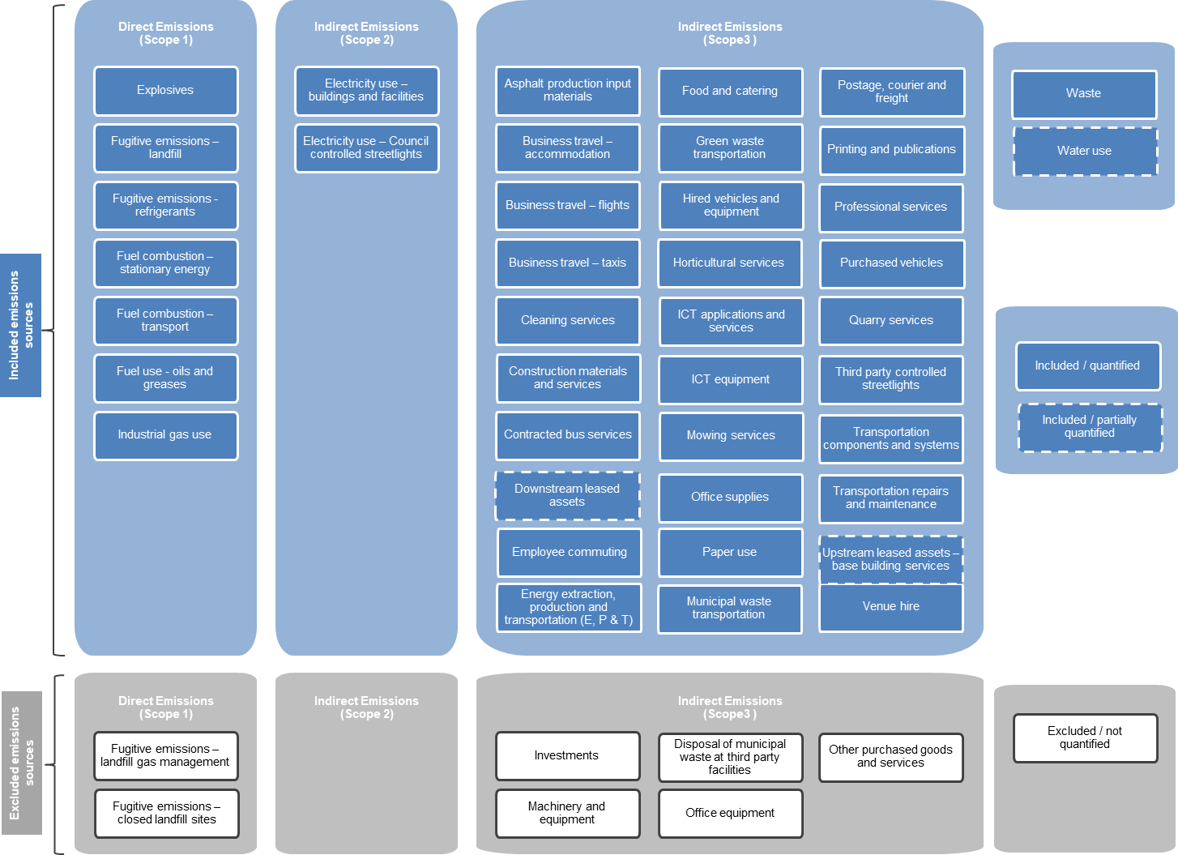

Brisbane City Council estimate based on Australian Bureau of Statistics (ABS) and Queensland Treasury data.
The BWIA is an alliance arrangement between Council and a third party contractor for the innovative and environmentally sustainable management of Council’s waste transfer stations and Rochedale landfill facility.
Input-output factors represent the emissions intensity of a dollar spent in a particular sector of the Australian economy and are derived from Australian Bureau of Statistics (ABS) data for total sector emissions and expenditure.
Net emissions are expected to be lower in 2017-18 largely due to increased renewable energy purchases in this period.

