Kelvin Grove Road and Lower Clifton Terrace intersection upgrade – Red Hill
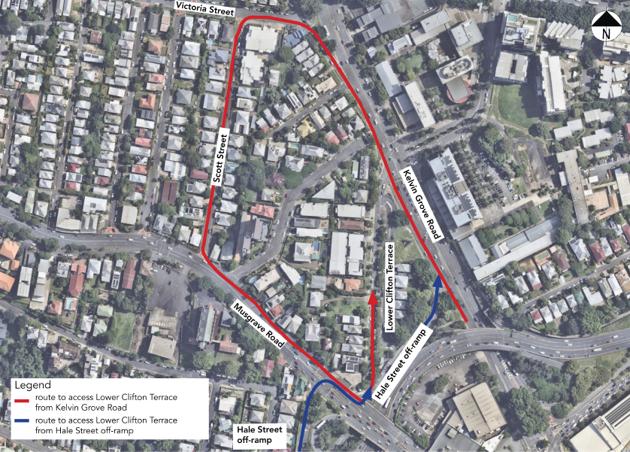

For more information about this project, please call the project team on 1800 884 681 or email cityprojects@brisbane.qld.gov.au

