Kelvin Grove Roade and Lower Clifton Terrace

Intersection upgrade – Kelvin Grove
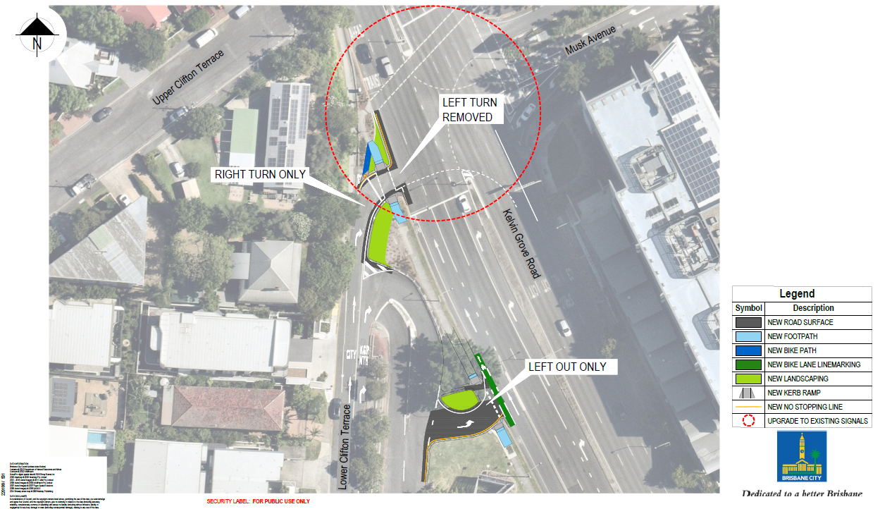

For more information about the project, please call the Project Team on 3178 5413

