Lutwyche Road and Harris Street intersection upgrade

Design A - consultation plan – July 2024
Concept design layout detail subject to change

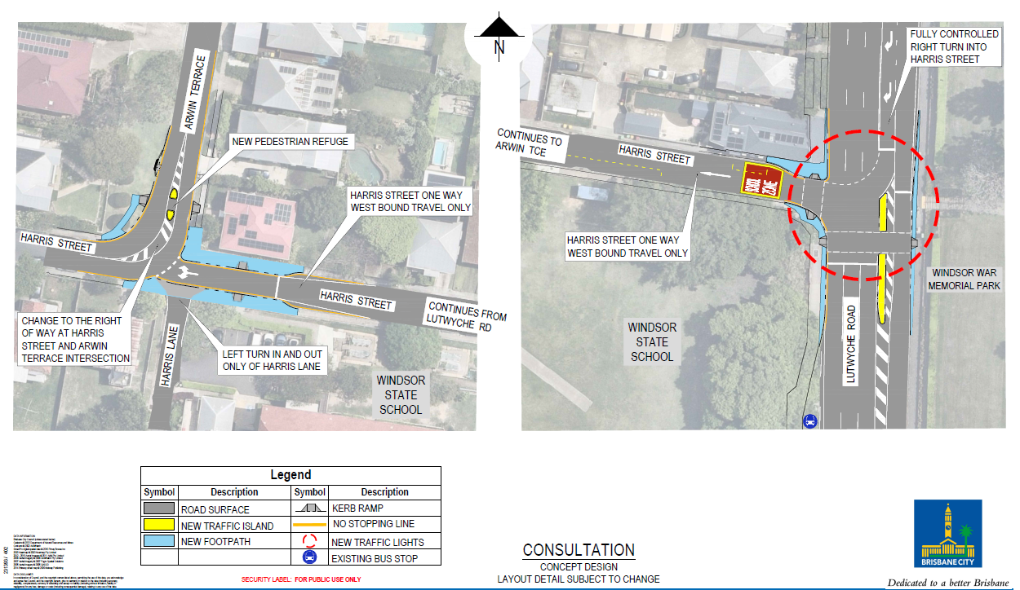
For more information about this project, please call the project team on 3178 5413 or email cityprojects@brisbane.qld.gov.au

