# Lutwyche Road and Harris Street intersection upgrade - Windsor

## Have your say

## July 2024

Council is investigating an upgrade to improve safety for all road users at the intersection of Lutwyche Road and Harris Street in Windsor and we want to hear from you.

### What are we doing?

potential designs to improve safety at the intersection to ensure we understand your thoughts, perspectives and insights.

Your valued feedback will be used to progress a design for this upgrade, however, a final design and construction is dependent on future budget allocation and city-wide priorities.

### Why are we planning an upgrade of this intersection?

The intersection of Lutwyche Road and Harris Street is a T-intersection, with movements out of Harris Street currently controlled by a give way sign. There is a signalised pedestrian crossing on Lutwyche Road, which is frequently used by local primary students and the wider public.

High traffic volumes, extended wait times and poor sightlines of vehicles turning right from Harris Street into Lutwyche Road contributes to safety issues. The intersection has a high crash rate with 8 crashes recorded since 2015. In 2023, a study of the intersection identified 26 near misses over the course of only one week.

Council’s 3 potential designs to upgrade the intersection and improve safety, shown over the page, each have different impacts to the local community and have different benefits and considerations. All designs remove the right turn out of Harris Street into Lutwyche Road to address the intersection’s biggest safety concern of cars conflicting with other road users on Lutwyche Road.

### Have your say

To find out more and provide your feedback on each of the proposed designs to improve safety for all road users at the intersection, please complete our online survey.

We are seeking your feedback to ensure the project team has insight from the local community who frequent the intersection.

To complete the survey and view the designs in more detail, please scan the QR code or visit Council’s website and search ‘Lutwyche Road and Harris Street’. Alternatively, you can phone or email the project team via the details over the page.

The survey will open at 9am Thursday 18 July 2024 and will close at 11:59pm Sunday 1 September 2024



### What’s next

Once the online survey closes, the project team will review and investigate the feedback provided.

### Register for updates

To complete the online survey and register to receive project updates as they become available, please visit brisbane.qld.gov.au and search ‘Lutwyche Road and Harris Street.’ We encourage anyone who lives, works, or travels through the area to subscribe to receive updates.

### Contact the project team

You can provide feedback via the QR Code or by contacting the project team via the details below.

* phone Call 3178 5413 (8:30am to 4:30pm, Monday to Friday) or 3403 8888 (24 hours, 7 days)
* email [cityprojects@brisbane.qld.gov.au](mailto:cityprojects@brisbane.qld.gov.au)
* visit brisbane.qld.gov.au and search ‘Lutwyche Road and Harris Street’.
* write to City Projects Office, Brisbane City Council, GPO Box 1434, Brisbane QLD 4001.

# Potential designs for Lutwyche Road and Harris Street intersection upgrade

## Design A – Harris Street one way westbound

## 

Design A improves safety by introducing one way travel westbound on Harris Street, installing a new signalised crossing on Harris Street and implementing changes at the Harris Street and Arwin Terrace intersection. The right turn into Harris Street is retained and the Lutwyche Road signalised crossing is realigned. New travel routes will be required for people accessing Harris Street and Harris Lane.

## Design B – Harris Street left in left out

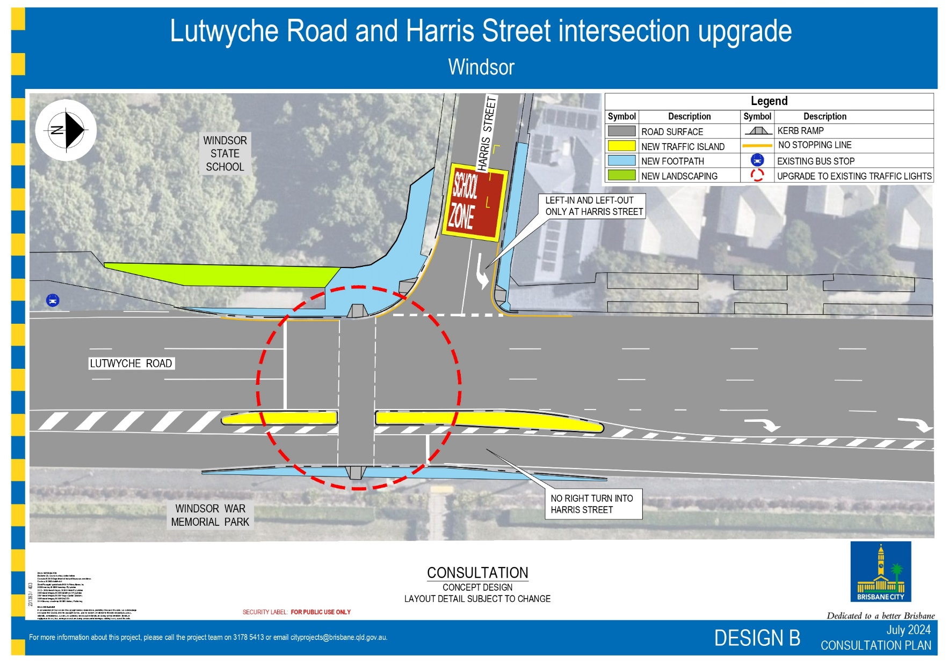

Design B improves safety by modifying Harris Street to be left in and left out and only realigning the Lutwyche Road signalised crossing. New travel routes will be required for people accessing Harris Street.

## Design B – Harris Street left in left out

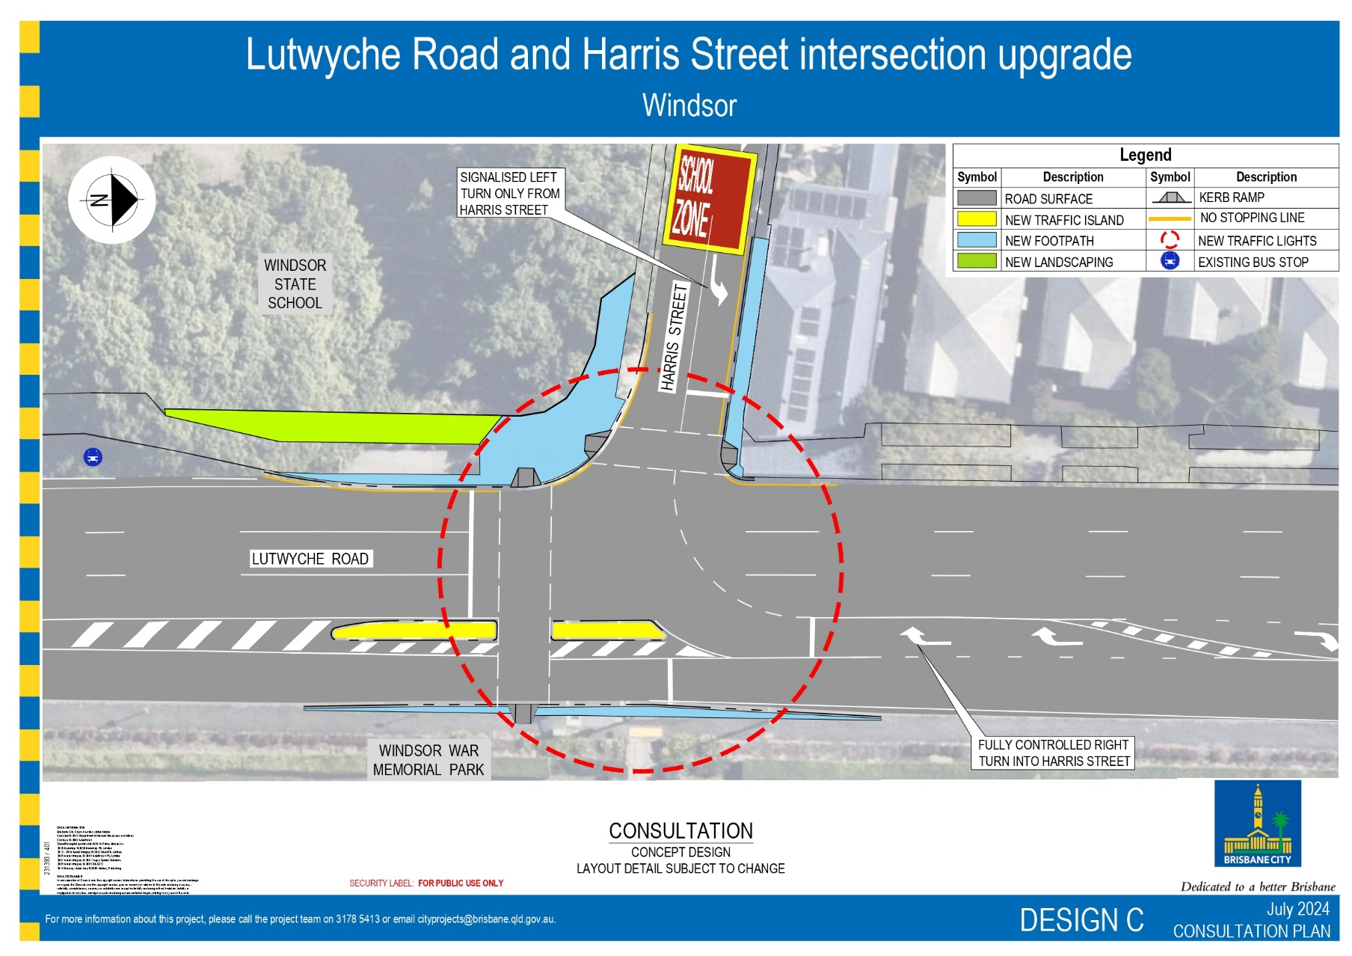

Design C improves safety by removing the right turn out of Harris Street and upgrading the traffic signals to control all movements. It introduces a new signalised crossing on Harris Street. New travel routes will be required for people accessing Harris Street.