Lutwyche Road and Harris Street intersection upgrade

Potential new travel routes - Design A – Harris Lane

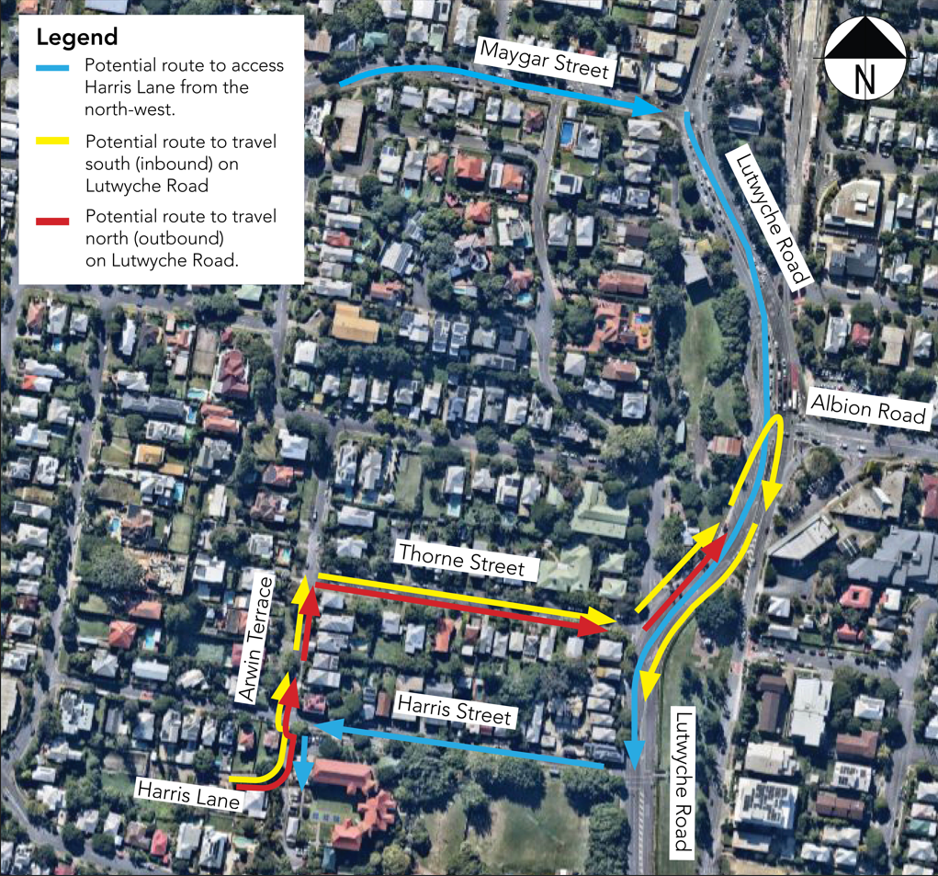

Potential route to access Harris Lane from the north-west (blue lines)
If travelling on Maygar Street (from the north-west), turn right onto Lutwyche Road and travel south (inbound), then turn right onto Harris Street and left onto Harris Lane.

Potential route to travel south (inbound) on Lutwyche Road (yellow lines)
Turn left onto Harris Street then immediately right onto Arwin Terrace. Take the first right onto Thorne Street, then at the end of Thorne Street turn left onto Lutwyche Road and travel north (outbound). Perform a U-turn at the signalised intersection of Lutwyche Road and Albion Road, then travel south (inbound) on Lutwyche Road.


Potential route to travel north (outbound) on Lutwyche Road (red lines)Turn left onto Harris Street then immediately right onto Arwin Terrace. Take the first right onto Thorne Street, then at the end of Thorne Street turn left onto Lutwyche Road to travel north (outbound).

