Lutwyche Road and Harris Street intersection upgrade

Potential new travel routes - Design B

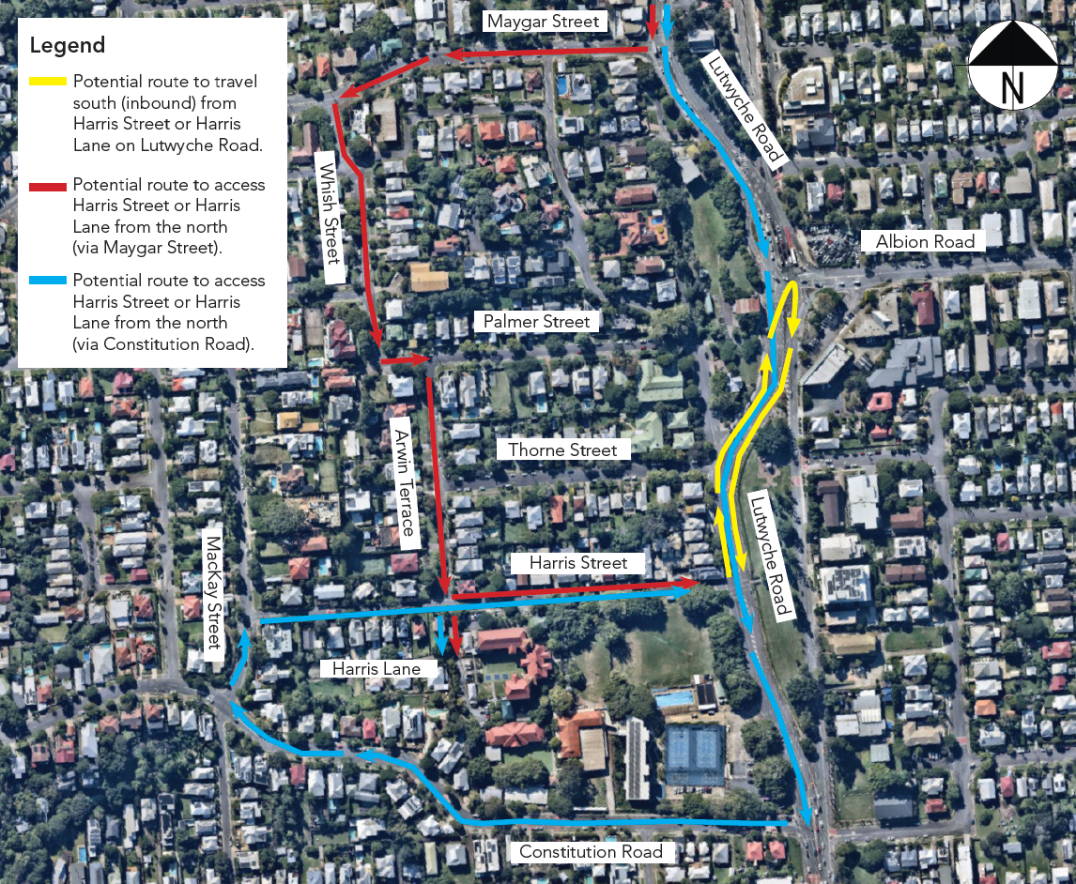

Potential route to travel south on Lutwyche Road (yellow lines)
Turn left out of Harris Street onto Lutwyche Road, continue north (outbound) on Lutwyche Road and perform a U-turn at the signalised intersection of Lutwyche Road and Albion Road to then travel south (inbound) on Lutwyche Road.

Potential route to access Harris Street or Harris Lane from the north via Maygar Street
(red lines)
Turn right from Lutwyche Road onto Maygar Street, then take the second left onto Whish Street and travel south onto Palmer Street, then take the first right onto Arwin Terrace. Take the second left onto Harris Street or onto Harris Lane.

Potential route to access Harris Street or Harris Lane from the north via Constitution Road
(blue lines)
Travel south (inbound) on Lutwyche Road, continuing past Harris Street, and turn right onto Constitution Road at the signalised intersection. Then take the first right onto Mackay Street and then the first right onto Harris Street.

*Please note, due to the double continuous centre lines on Lutwyche Road it not possible to turn right onto Thorne Street from Lutwyche Road.

