First compliance check of

Brisbane City Council

Local Government Infrastructure Plan

Amendment 1B

Prepared by:

IIP Pty Ltd



Version | Date | Reviewer name
Final | 26 October 2022 | IIP | 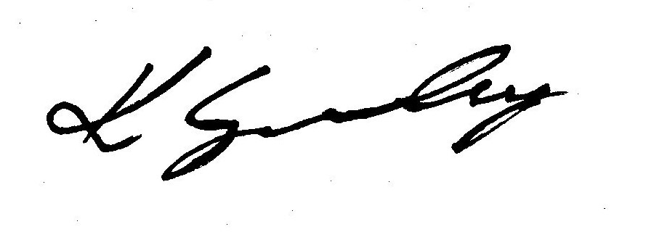  Kylie Grimley

Introduction
IIP Pty Ltd has been engaged by Brisbane City Council (“Council”) to undertake a first compliance check of its proposed amendment of the current Local Government Infrastructure Plan (LGIP).

IIP is required to:

- evaluate whether a proposed LGIP or amendment complies with the requirements outlined under the Planning Act 2016 and the Minister’s Guidelines and Rules, including:
  - the SOW model requirements in Schedule 7 of the Guideline and Rules;
  - the LGIP template;
  - the approved form MGR5.1 – LGIP Review Checklist; and
- comply with the fundamental ethical principles of integrity, objectivity, professional competence, due care and professional behaviour when reviewing the LGIP; and
- provide a written statement and the completed checklist to the local government detailing the findings of the compliance check.

Scope exclusions
The following items are outside the scope of this review:
- A verification of the accuracy of individual inputs used in the preparation of an LGIP.
- A review of the local government’s Long-term Financial Forecast (LTFF) or asset management plan (LTAMP) other than to determine the extent of their alignment with the LGIP.

Compliance check process
The process used to undertake the first compliance check comprised the following steps:
Stage | Description
Engaged | - First compliance check review commenced on upon receipt of several emails and attachments containing documents and other supporting information from Council 8 and 9 August 2022.
Review | - Review commenced on 8 August.  - Initial comments provided 10 August and 23 August.  - Additional information provided 18 August.  - Updated documents to respond to initial comments provided 24 October.
Compliance check review report | - Issued 26 October, 2022.

The following local government personnel were involved in the compliance check:

Name | Title | Date of communication(s) | Scope of communication
Tamara Bergmans | Planner, Infrastructure Coordination | 8/8/2022 (email) and 9/8/2022 | - Request to complete first compliance check and required information
Anna Scott | Principal, Infrastructure Coordination | 18/8/2022 (meeting) | - Discussion regarding compliance check
Pemba Amuri/ Rick Evans | Infrastructure Coordination | 24/10/2022 | - Response to initial comments and updated documents (where relevant)

Compliance check findings
Council advises the SOW model represents an expenditure which is sustainable through the capital works program. Council advises the SOW model aligns with the financial forecast for trunk infrastructure expenditure.
Council has consulted with
- the State Government on transport and planning matters; and
- QUU as the distributor-retailer responsible for providing water and wastewater services for Brisbane.

Conclusions
The LGIP is compliant with the Planning Act and associated guidelines.

Recommendations
IIP recommends to the Council that the proposed LGIP amendment should proceed to the Minister seeking approval for public notification.

Recommended conditions to be imposed
There are no outstanding issues or necessary conditions.

